# Explore project management roles

You are about to start on your path to securing a high-demand position as a project manager. One of the greatest benefits of the project management field is that it encompasses a wide variety of positions across numerous industries. As you complete this certification, you will acquire skills that will qualify you for various job titles. Here, we will discuss some different project management job categories and some common roles within those categories. We’ll also describe the great potential for career progression in project management, from entry-level positions to senior program management roles, and the many opportunities in between!

## ****Project management job categories and common roles****

### **Introductory-level project management roles**

Entry-level project management positions are a great opportunity to get your foot in the door and learn the ins and outs of how a company operates and manages projects. The lessons you learn from these experiences are extremely valuable to your growth in project management. Some entry-level project management positions include:

* **Junior Project Manager:** Performs all aspects of being a project manager alongside a more experienced professional.
* **Project Administrator:** Assists the rest of the project team with administrative tasks.
* **Project/Program Assistant**: Supports team members working on a project and offers administrative support. May perform research or create training documents along with other jobs as assigned by program leaders.
* **Project/Program Coordinator:** Participates in hands-on project work and administrative tasks. Works under a project manager to make sure projects are completed on time and within budget.
* **Project Support Specialist:** Works alongside a project manager and team members to oversee assigned projects. May also be responsible for training and developing employees to perform designated tasks.

### **Traditional project management roles**

Once you have gained some experience in introductory-level positions, you can explore traditional project management roles, such as:

* **Project Manager:** Responsible for the initiating, planning, executing, monitoring, and closing of a project. Includes industry-specific titles like IT project manager, construction project manager, or engineering project manager, which utilize skills that are transferable among industries.
* **Project Analyst:** Moves a project along by sharing information, providing support through data analysis, and contributing to strategy and performance.
* **Project Leader/Director:** Drives core decision-making and sets the direction for the project. Usually knowledgeable about the product or deliverable.
* **Project Controller:** Primarily responsible for project planning. You are likely to see this job title in industries like engineering and construction.
* **Technical Project Manager:** Conducts project planning and management for identified goals within a company. Ensures that projects are completed to the requirements within a defined time frame and budget.
* **Project Management Office (PMO) Analyst:** Manages the progress of complex projects to ensure timely execution and completion.

### **Program and portfolio management roles**

As you have learned, project managers are responsible for the day-to-day management of projects. They shepherd projects from start to finish and serve as a guide for their team. Project managers must apply the right tools, techniques, and processes to complete the project successfully, on time, and within budget.

After you have carried out projects successfully and feel you are ready for a step up in responsibility, a program manager position may be the next step for you. While a project is one single-focused endeavor, a **program** is a collection of projects. Program managers are responsible for managing many projects. At Google, all project managers are called program managers because they manage multiple projects simultaneously.

Successfully implementing programs as a program manager can eventually make you a great fit for more senior positions, such as a senior program manager or a portfolio manager. A **portfolio** is a collection of projects and programs across an entire organization. Portfolio managers are responsible for portfolios of projects or programs for one client. Over the course of your career, you might progress from project manager to program manager to portfolio manager roles.

While project, program, and portfolio managers hold different types and levels of responsibility, they are all project managers. In Course 4 of this certificate program, you will learn more about differentiating projects, programs, and portfolios.

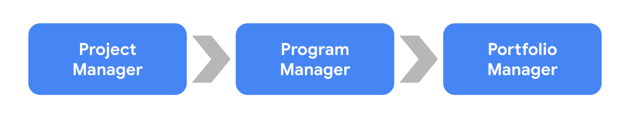

* **Program managers:** Manage a group of projects that are related or similar to one another and handle the coordination of these projects. They facilitate effective communication between individual project managers and provide support where necessary. They also help create and manage long-term goals for their organization.
* **Portfolio managers**: Responsible for managing a group of related programs within the same organization. They coordinate various programs in order to ensure they are on track and that the organization is meeting its strategic initiatives. Portfolio managers look at all projects and programs within the organization and prioritize work as necessary.

### **Operational management roles**

In operational management roles, you will get the opportunity to experience several different departments and how they interact and operate. Operational management roles allow you to work alongside peers and management from various business segments, giving you an appreciation for what each segment does on a daily basis. Key elements of project management include making sure a project is on budget and on schedule. This course, and your experience as a project manager, will give you the tools to be able to apply those skills to running a business. Some operational management positions include:

* **Operations Analyst:** Manages and coordinates research, investigates workflows, creates business procedures, and recommends changes to improve the project and company.
* **Operations Manager:** Oversees strategic decision-making and rolls out plans of action based on financial, schedule, and resource reporting.
* **Chief Operating Officer:** Responsible for overseeing the day-to-day administrative and operational functions of a business.

### **Agile roles**

We will discuss the Agile project management approach in depth later, but here are a couple of the positions you may see that are related to that approach:

* **Scrum Master:** Coordinates and guides the Scrum team. Knowledgeable in Agile framework and Scrum and is able to teach others about the Scrum values and principles. May also be listed as a Technical Program Manager or Technical Project Manager.
* **Product Owner:** Drives the direction of product development and progress.

### **Industry-specific management roles**

As you search for project management roles, you may see positions with titles like “engineering project manager” or “construction project manager.” Keep in mind that the skills you learn in one industry can be applied to another industry. For example, you may have experience as a software engineer but are interested in pursuing a career in project management. You will be able to apply what you’ve learned working in a technical field, as well as with the skills you have picked up in this certification course, to a project manager position in multiple industries. Having experience working on a team to achieve a task and understanding how to execute an effort on schedule and on budget are aspects of your professional experience—combined with your project management knowledge—that make it possible for you to move between industries.



## ****Key takeaway****

Project management is a career path with a great deal of potential!

With each step along your career path, you are building yourself up to be a significant contributor to any company.  We have discussed a number of possible job titles for you to search for when you start exploring project management roles. Regardless of the industry in which you currently work, you have gained **transferable skills**. Transferable skills are abilities that can be used in many different jobs and career paths. Your transferable skills can likely be utilized in project management roles in many other industries.

Using buzzwords in your job search

*You can save this reading for future reference. Feel free to download a PDF version of this reading below:*

You now know how to start searching for project management jobs! Job searching can be a time of self-reflection, growth, and excitement. Add a career path change into the mix, and it can also seem intimidating. We are about to give you some tips to help you in your job search efforts, including introducing you to some common buzzwords and skills that commonly appear in job descriptions.

**Using buzzwords and skills in your job search**

In an earlier video, we mentioned **buzzwords**—words or phrases that are popular for a period of time or in a particular industry. In today’s job market, buzzwords like data-driven, team player, and self-starter are common. You may see terms like these show up throughout your searches.

Similarly, many job descriptions list the specific skills they require candidates to have. These skills can become some of the terms that you use in your job search. Examples of these skills include:

* **Coordination**, or getting people and teams to work together. You may see responsibilities in job descriptions such as “coordination of efforts to achieve project deliverable” or “coordinate internal resources to ensure successful project completion.” Being a project manager is essentially managing the coordination of resources to achieve your end goal. Coordination is one of the top skills a project manager should have, so searching for this term can lead you to appropriate positions.
* **Organization**, or the ability to stay focused on different tasks. You may come across phrases like “solid organizational skills, including attention to detail and multitasking skills” or something as simple as “highly organized.” Organization is key to being a great project manager. We will discuss many ways to sharpen this skill in the upcoming lessons.
* **Leadership**, or being able to lead a group of people. You may see phrases like “strong leadership qualities” or “ability to lead” in job descriptions. A project manager needs to display leadership in a number of ways, including effective planning, efficient task coordination, inspiring team members, and key decision-making. You are working on many of the skills needed to become a great leader in this program!

Take a look at the skills required for this position. The job description lists each of the terms that we talked about or a variation of these terms.

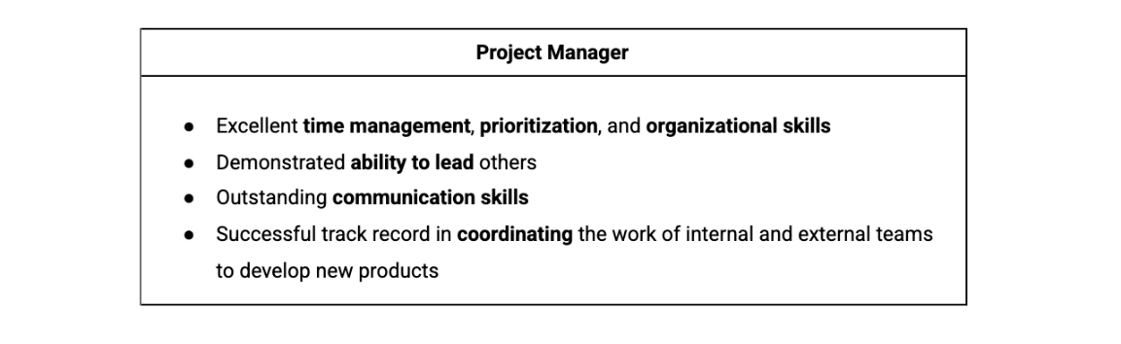

Excellent time management, prioritization, and organizational skills Demonstrated ability to lead others Outstanding communication skills Successful track record in coordinating the work of internal and external teams to develop new products

You may also come across positions in your search that do not include the title “Project Manager” or any of the job titles we previously discussed, but you shouldn’t rule these positions out. In many cases, the job description will include project management experience and expectations, but the position may be called something else entirely.

Look at some of the job responsibilities required for a position titled “Operations Associate.” This position is a type of project manager. You will find that most project management-related job descriptions call for the **ability to plan**, **organize**, **monitor**, and **execute tasks**—all skills you will be able to do once you complete this certification.

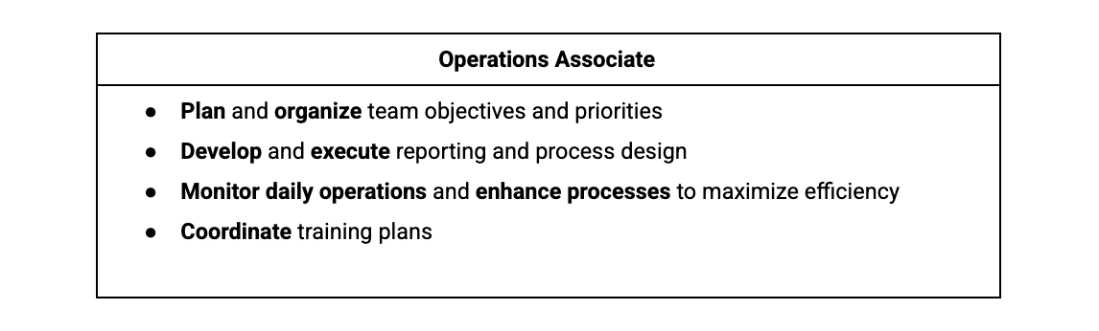

Plan and organize team objectives and priorities Develop and execute reporting and process design Monitor daily operations and enhance processes to maximize efficiency Coordinate training plans

**Common project management buzzwords**

Including buzzwords and skills in your job search can help you find jobs that are ideal for you and your skill set. Once you have found a position you want to apply for, listing buzzwords and skills that are relevant to the position can also help recruiters and hiring managers identify you as a qualified and knowledgeable candidate.

Some common project management-related buzzwords and skills you could include on your resume are:

* Analytical
* Assertive
* Assessing outcomes
* Assessing progress
* Attention to detail
* Conflict resolution
* Collaborative
* Coordination
* Communication
* Development
* Evaluation
* Executing plans
* Financial analysis
* Impact assessment
* Leadership engagement
* Managing meetings
* Managing client expectations
* Managing conflicts
* Managing relationships with stakeholders
* Managing vendors
* Meeting deadlines
* Monitoring
* Multitasking
* Planning
* Prioritizing
* Problem-solving
* Process development
* Process improvement
* Project coordination
* Project implementation
* Project initialization
* Project planning
* Project reporting
* Quality control
* Risk assessment
* Risk management
* Solution development
* Strategic planning
* Strong interpersonal skills
* Strong verbal communication
* Strong written communication

**Key takeaway**

Job searching for your first (or next) project management position can be easier if you enter the right search terms. Search for the skills you’re learning throughout this project management certificate program or skills you’ve acquired in your current or previous positions. These terms will help you determine if you have found a potential match. As you start your project management career, don’t let the requirement for project management experience stop you from applying for project management-adjacent roles. Once you have completed this certification course, you'll see how many skills you already have that can be translated and correlated to a project management role.

# How project managers impact organizations

You can save this reading for future reference. Feel free to download a PDF version of this reading below:

You have learned that project managers can prioritize, delegate, and effectively communicate to deliver value to their projects. This reading will focus on the main ways that project managers can add value to projects and impact organizations, which include:

* Focusing on the customer
* Building a great team
* Fostering relationships and communication
* Managing the project
* Breaking down barriers

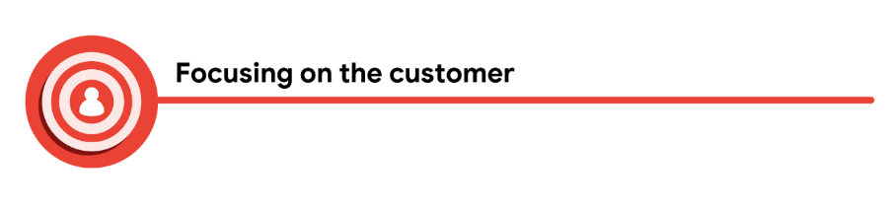

Customers are always a key element to success in any business. There is no exception to that in the field of project management. In project management, the word “customer” refers to a person or an organization that defines the requirements of the project and sets important guidelines, such as budget and deadlines. In projects, customers can be internal or external. Internal customers are stakeholders within your organization, such as management, project team members, resource managers, and other organizational departments. External customers are customers outside of your organization, such as clients, contractors, suppliers, and consumers.

To successfully deliver a project, it has to meet the customer’s standards. To meet the customer’s standards, you have to make sure you clearly understand their expectations. The customer is at the center of a successful project. Project managers can add a lot of value to the project by building relationships with customers and taking the time to make sure the customer is heard and satisfied with the result.

### **Asking the customer questions**

Let’s discuss how you can focus on the customer in a project. First, sit with the customer and ask what problem they are trying to solve. You might ask if they have a specific vision of the final outcome they would like delivered. Sometimes, customers will lean on project managers to find the solution to their problem. It’s your job to ask questions like:

* What is the problem you would like us to help solve? Example response: The customer wants help developing a new process that would allow their company to be more efficient.
* How is the problem impacting your organization? Example response: The customer states that they are losing clients because of their current inefficient processes since clients are sometimes receiving their orders late.
* What prompted you to ask for help now? Example response: The customer says that they may lose department funding if they do not improve efficiency.
* What is your hope for the outcome of this project? Example response: The customer states that their ultimate goal is to increase the speed at which they fill orders without sacrificing quality.

Taking the time to dig a little deeper into the “why” behind the project can help a project manager better support and understand the customer. The more you understand the customer’s goals, the more likely you will be able to produce what the customer is seeking.

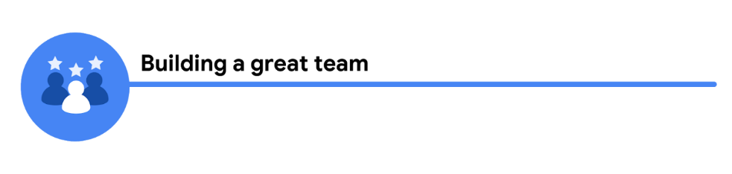

The team is a project’s biggest asset. A successful project manager knows that and takes the time to understand each person’s motivations, strengths, and weaknesses. Project managers add value to the project by identifying the right team for the project and enabling the team to be successful and make decisions.

When you work to build a great team, you have to consider the skills needed for the project, as well as the resources available. Understanding the customer’s requirements helps shape the skills needed for your team. If you are working on a project that requires people with medical expertise and you hire people who do not have a medical background, no matter how hard that team works, they will not have the right skill set to complete the project. As project manager, you should bring on people with the right skills and ensure the team knows that each individual is valued, trusted, and appreciated. You can demonstrate how you feel about the team’s value by allowing them to have input and ask questions, and by addressing their needs as soon as possible.

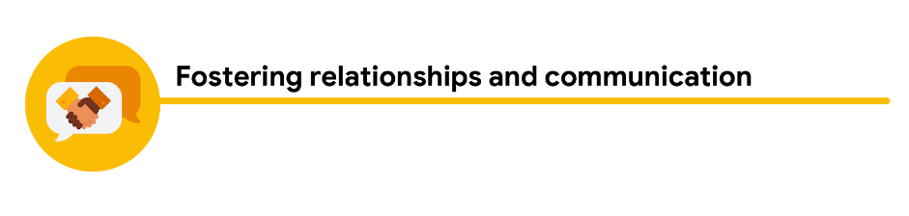

Maintaining customer satisfaction and building a great team are two ways that you, as a project manager, can add value to a project. Both of these skills are built on the foundation of relationships and communication. The project managers who add the most value are the ones who take the time to build relationships, communicate, and treat others with consideration and respect.

Project managers can set the tone for a project and build relationships within their teams and with stakeholders. Taking the time to check in daily with your team, see how they’re doing, and ask if there is anything they need help with can go a long way towards making them feel valued and heard.

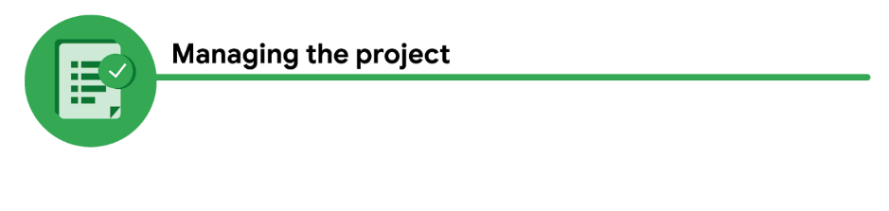

When you build teams, each person is generally assigned specific project tasks. Once each task is done, the person responsible for that task hands that part of the project over to the next person. Your team members don’t always see the whole picture and how they impact others in a project. A successful project manager sees the impacts of each process within the project and communicates those impacts to the team. This ensures that everyone working on the project understands their task goal as well as the big picture goal for the finished product. For example, if a graphic designer working on marketing materials for your project doesn't understand the customer’s overall goal to appeal to educators, they may not be able to fully capture the vision for the campaign. Helping this team member understand the big picture allows them to tailor their tasks to meet the needs of the project end goal.

Managing a project can be busy, but if you take the time to build relationships and maintain open lines of communication, you will increase the chances of the project’s success as well as the customer’s and your team members’ satisfaction.

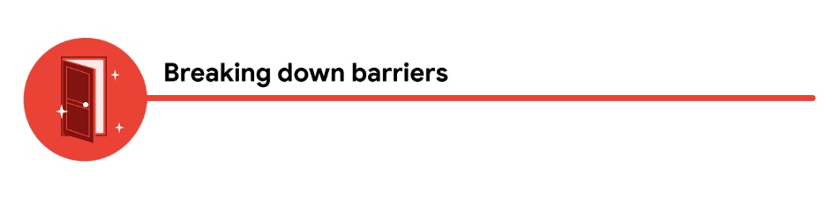

Sometimes, when you ask why something is being done a certain way, the response you get is, “Because we’ve always done it this way.” A project manager adds value to a project when they break down barriers, allow their team to innovate new ways to do things, and empower them to share ideas. As a project manager, you have to model ingenuity and collaboration, and encourage your team to do the same.

How can you break down barriers on a project? You can provide support for your team as they try new approaches to find solutions, and you can advocate for additional resources for your team. If your team is having a hard time getting an answer from another organization, you can reach out to the organization yourself in order to keep the team on track and on schedule.

## ****Key takeaway****

You have now learned some of the ways that project managers can add value to projects and impact organizations. By focusing on the customer, building a great project team, fostering relationships and communication, managing the project, and breaking down barriers, you can overcome obstacles and find solutions to succeed.

# Responsibilities that utilize interpersonal skills

**What are the core job responsibilities of project managers?** Let’s recap what we learned in the previous video.

The project manager is responsible for planning, organizing, managing tasks, budgeting, controlling costs, and other factors to help keep the project within budget and on time.

What does that mean? Basically, as the project manager, you will be responsible for tracking the day-to-day details of the project, but you will also have an opportunity to step back and see the bigger picture of the overall project.

Depending on the project and organization, you may also have responsibilities that utilize your interpersonal skills. **Interpersonal skills** are the behaviors you use to interact with others, such as communication, active listening, and leadership.

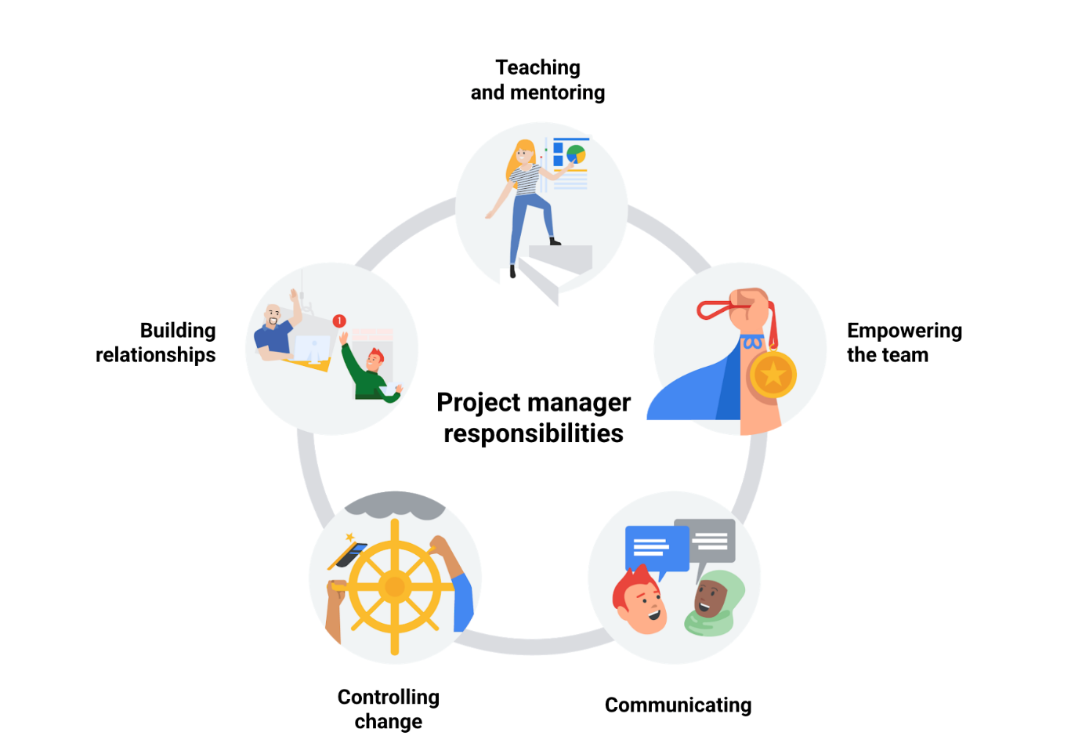

## ****Teaching and mentoring****

As a project manager, you can serve as a mentor to your team. When you take the time to fully explain the expectations, you eliminate rework, confusion, and frustration. Mentoring and teaching others the lessons that you, as a project manager, have learned allows your team to make better choices and build on your experience. Mentoring also involves supporting each individual on your team in meeting expectations and helping them to exceed their own sense of personal potential.

## ****Building relationships****

Relationships are everything! Getting to know your team members lets them know that you care about them as people, not just as employees. Taking the time to build relationships with your customers, clients, vendors, and other stakeholders is equally important. Dedicate time to check in with people. Pay attention to the insights they offer you about their work style since their actions can inform how to most effectively interact with them. Ask about their lives beyond the project, and then follow up on those discussions later on to show your interest. When you foster these relationships, you are all more invested in the success of your project.

## ****Controlling change****

The American novelist Louis L’Amour wrote, “The only thing that never changes is that everything changes.” This applies to projects as well. Projects change as you continue to understand the expectations and the needs of your stakeholders. As a project manager, you need to remain flexible and adjust to the stakeholders’ needs. However, it is also important to protect your team from constant change and rework. A good way to do this is by documenting the initial expectations of the project and clearly identifying the changes being requested. It is also helpful to understand the budget and schedule impact of the changes and make sure that the stakeholders understand those impacts. As the project manager, you are responsible for protecting your team.

## ****Empowering your team****

We all enjoy being heard and appreciated in our careers. Giving your team the ability to work directly with the stakeholders and their teams lets them know that you trust and believe in their skills! One of the best things about empowering your team is getting fresh ideas and passionate employees willing to help find solutions to problems. Another way you can empower your team is by delegating responsibilities to them, allowing them to make some decisions for the project, and using their input in the planning and execution of the project. Effective mentoring often leads to more empowered teams.

## ****Communicating status and concerns****

As a project manager, communication is everything. With effective communication, you can work together with your team to find solutions to challenges. The project manager sets the tone for the project. Maintaining an open door policy and building trust within your team and among stakeholders—all while staying positive—will help the success of the project.

## ****Key takeaway****

You have learned that project managers may be responsible for teaching and mentoring project team members, building relationships with the team and various stakeholders, controlling change and the impact to the project, empowering team members to make decisions, and communicating status and potential concerns. These interpersonal responsibilities can be just as important to the success of your projects as your more concrete responsibilities, like scheduling and budgeting.

As you continue through this course, you will learn more about how these project manager responsibilities are embedded into the different phases of a project.

# Working with cross-functional teams

As a project manager, you will likely work with **cross-functional teams**. A cross-functional team includesteam members who have different backgrounds, types of expertise, and job functions. Even though these team members have different skill sets, occupy different roles, and may even work in different departments, they are all working towards a common goal: the successful completion of your project.

Sometimes the members of a cross-functional team are referred to as “T-shaped professionals.” They are skilled in how to collaborate and innovate with those in different job functions and across different departments, but they also contribute their own specific areas of expertise. Each member of a cross-functional team has their own unique perspective and experience, bringing different ideas and strategies to the project.

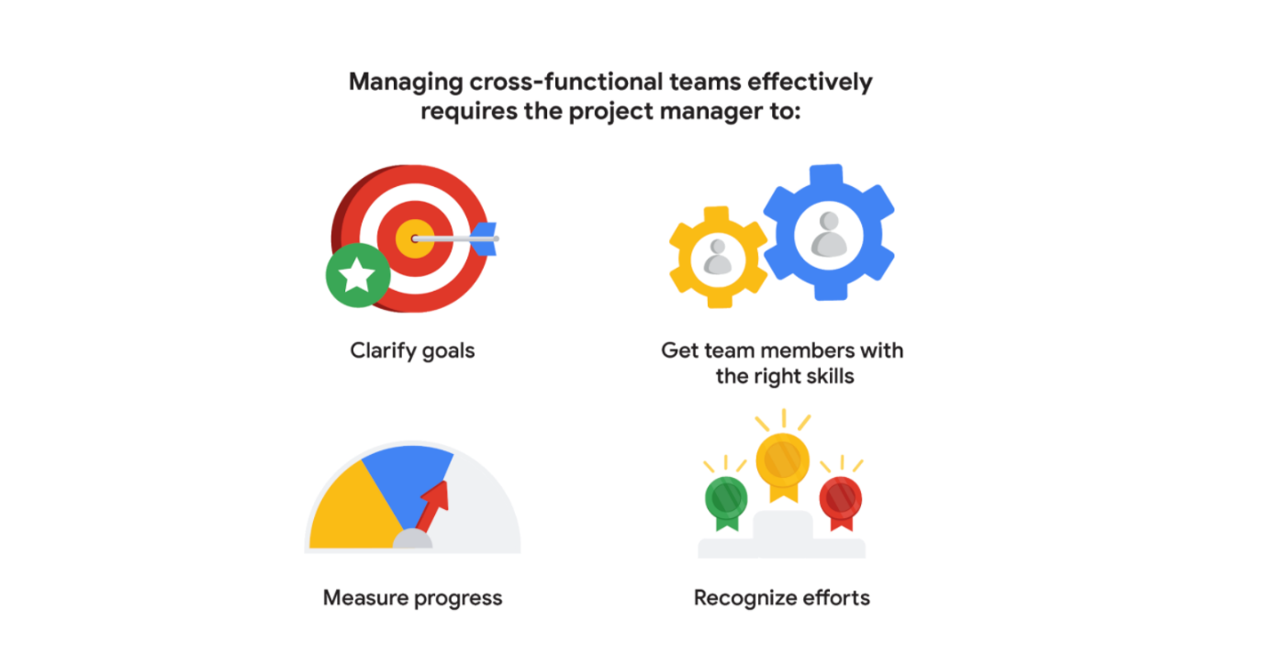

## ****Clarify goals****

When working with cross-functional teams, it is important to ensure that each member of the team understands their role, how they support each other, and the common goals of the project. It is vital to set clear goals for the team and make sure that the team understands those goals. Be direct and concise, avoiding extraneous details and explanations. When communicating task or project goals, make sure you define key items, such as budget, deadlines, quality requirements, or important resources. Ensure your team members understand task and project goals by encouraging them to ask questions and clarify information. It will be up to you to continuously check in with your team to make sure they’re all moving towards their goals, staying on track, and completing quality work. Cross-functional teams may work in different departments, be in different physical locations, and have different leadership, but all team members work together with the project manager to support the current project. Your project may be competing against other priorities, so communicating clearly and often with your team—and vice versa—helps you identify any potential issues or concerns before they arise.

## ****Get team members with the right skills****

Making sure you have team members with the correct skill sets for each of the project functions is critical. If you are building an airplane and you’ve got five engineers but no mechanics, you are missing a key element of your cross-functional team. As the project manager, you must help ensure that your team has the right people with the right skill sets needed for the project to succeed. Later in this program, we will discuss some tools you can use to help you identify the skill sets needed to accomplish your project tasks.

## ****Measure progress****

Showing your team how much they have accomplished helps keep them motivated. Take the time to measure and communicate the project’s progress across the cross-functional team. This helps everyone see the full picture and recognize their impact on the project. You can measure progress in many ways, including meeting key milestones, completing project tasks, and meeting project goals on time and within budget. Regularly communicate with your team members to check on their progress. Ask them if they anticipate being finished on time. If not, ask how you can help them succeed. Keep track of the team’s progress throughout the project by documenting when tasks and goals are completed, and let your team members know if the project is on track or not. Make sure you communicate successes, delays, or issues, to the team so they know how the project is progressing. Keeping everyone informed is essential to the project’s success.

## ****Recognize efforts****

Sometimes, when you work with cross-functional teams, there are certain skills that get recognized more than others. A mechanic could get accolades for coming up with the solution to a problem within the project, while the finance member who sourced the funding might be forgotten. As a project manager, it is your job to make sure that each member of your cross-functional team recognizes the value of their efforts each step of the way. You have learned the importance of building relationships with stakeholders, and building relationships with your cross-functional team members is just as important. Learning what makes your team members feel supported, giving and taking feedback, and being mindful of each individual's background, personal identifiers, and work style can help mediate some of the differences among team members.

## ****Key takeaway****

Being able to communicate clearly with team members, clarify the goals of the project, get team members with the right skills, measure team progress, and recognize team members’ efforts is an important part of your role as the project manager, and is key to your project’s success.

# Key competencies: Flexibility and handling ambiguity

## ****Enabling decision-making****

You can help team members feel empowered from the start of your project by making the decision-making process collaborative. For example, state the goals of specific deliverables and elicit input from your team on how to achieve those goals. You may have an idea of how you would like certain tasks to be accomplished, but your team members may have more creative or efficient approaches. Empowering your team to express their opinions and make their own decisions allows you to focus on the overarching management tasks and prioritize them in order of importance. Additionally, when you allow team members to have a voice in decisions, it helps foster an environment of responsibility, accountability, and team closeness.

## ****Communicating and escalating****

Project management requires clearly communicating project goals and expectations, team member roles and responsibilities, and constructive feedback. Knowing how to effectively communicate and when to escalate issues to management is key to keeping you, your team, and your organization on the path to success. When escalation is required, try to approach management with both the problem and the potential solution or suggestions. This will show that you’re taking initiative as a project manager.

## ****Strong organizational skills****

If you demonstrate that it is important for you, as a leader, to stay organized through efficient tracking and communications, your team will follow suit. One way to do this is by utilizing the abundance of organizational tools available, such as:

* Planning and scheduling software (templates, workflows, calendars)
* Collaboration tools (email, collaboration software, dashboards)
* Documentation (files, plans, spreadsheets)
* Quality assurance tools (evaluations, productivity trackers, reports)

You may need to experiment with different organizational approaches to determine what works best for you and your team.

## ****Flexibility****

All project managers need the ability to adapt and overcome changes and challenges. Let’s further explore why flexibility is such a critical project management skill and discuss how it can help prepare your team for change, mitigate risks, and handle ambiguity.

### **Flexible planning**

Change is inevitable, and the more flexible you are as a project manager, the more successful you will be throughout your career. These flexible planning strategies can help you manage your project during times of unpredictability:

* **Assess external constraints**. When planning your project, take external events into account, such as national holidays and team member vacations and sick leave. Leaving extra time in the schedule for these inevitable events up front can help minimize the impact to your project.
* **Plan for risks and challenges**. If you consider the risks that may occur, you may be able to find solutions for them in advance. For example, what if someone on your team gets sick or decides to quit? Are you able to replace them within the company? If not, can you hire an independent contractor? Come up with a list of people who may be able to join your team if one of your team members becomes unavailable. You can also assess risks by looking at historical data. Review your past projects and examine the challenges you faced. Then evaluate if similar challenges could occur in this project and prepare accordingly. We will discuss risk management at length later in this program.
* **Calculate “float” in your schedule**. Float,or slack, refers to the amount of time you can wait to begin a task before it impacts the project schedule and threatens the project outcome. Identifying float in your schedule can help with resource management, scheduling, and keeping your project on track. You will learn more about calculating float in a later course, when we discuss creating a critical path for your project tasks.

### **Handling ambiguity**

Ambiguity can be a big challenge in managing projects. Project managers often face ambiguity in goals, requirements, schedules, vision, or other areas related to the project. Your team will look to you to lead during times of ambiguity and change, and flexibility is especially important during these instances. Here are some different ways to help your team deal with ambiguity:

* **Keep calm.** In uncertain times, handling ambiguity with grace and poise will help inspire the members of your team to do the same.
* **Express empathy**. As a project manager, it is important to try to understand what your team is thinking and feeling, especially during times of ambiguity. Let your team members know that you care about the challenges they are facing and are there to support them.
* **Communicate what you know clearly**. Define the aspects of the project that are confirmed and will not change. This helps your team get a better sense of what to expect, regardless of any aspects of the project that are still unknown or changing.
* **Make decisions and stick to them**. Try not to second-guess your decisions in front of your team since this can lead to greater uncertainty. If you need to change course, clearly explain why you have chosen to do so to your team.
* **Trust the expertise of your team**. Increase clarity by having everyone on your team discuss what they already know or believe to be true about components of your project, such as what is involved in specific tasks or resources needed, based on their areas of expertise. Then, discuss what you still don’t know and brainstorm ways to gather more information.

## ****Key takeaway****

As a project manager, having the flexibility and ability to handle ambiguity in a rapidly-changing business setting gives you an advantage. Mastering these competencies, along with enabling decision-making, effective communication skills, and strong organizational skills, will allow you to innovate and grow as a project manager and leader.

# Common myths about project managers

We have talked about the skills that project managers need to be successful in their role. Now, let’s debunk some of the common myths about what is needed to be an effective project manager.

## ****Myth: You have to be an expert in the field and have a lot of technical knowledge about the project.****

**Reality:** There are benefits to the project manager not having a lot of technical knowledge about a project. Rather than getting caught up in the technical details when communicating with management and stakeholders, the project manager can look at all of the different pieces that the cross-functional team is working on and assess how they each contribute to the success of the project. As a project manager, you bring on the right team members—with their differing areas of expertise—and trust them to be able to focus on the technical aspects of the project. Your job is to handle the communication, documentation, and organization necessary to get the project successfully to the finish line.

**Scenario:** Jamar just landed his first project management job with a construction company.  He’s been tasked with managing the construction of a new elementary school in his city. He isn’t expected to know how to do all of the technical skills, like engineering, construction, plumbing, and electrical; he hires the right people for the job. He communicates the needs, timelines, and expectations of the project to his team members and stakeholders and helps break down any barriers to completing the project on time. Jamar helps the engineers and construction workers communicate with one another to ensure that they are all on the same page regarding the requirements. He makes sure that the materials are in place as needed for the plumbers and electricians.

**The bottom line:** Project managers hire the experts and help put all the pieces of the project together. Project managers don’t need to be experts in every field.



## ****Myth: Only people with a lot of experience within an organization can manage projects successfully.****

**Reality:** It is a common misconception that anyone who has significant experience and success in an organization can manage projects there. In order to successfully manage projects in any organization, you must acquire the necessary skills, knowledge, tools, and techniques and be able to apply them. You don’t necessarily need to have worked in previous roles at that organization. In taking this certification, you are learning and practicing how to be an effective project manager before taking on a position.

**Scenario:** Sofia is a supervisor at a large customer service call center. She has been recognized by leadership as a top performer. To reward her, management has offered her the role of project manager for the implementation of a new call center software program. It will be her job to oversee the installation, training, and implementation of the new process. Sofia tries to manage the project, but she has no idea how to create a project plan, manage the various members of her team, identify risks, or handle any of the other major project management tasks. She lets her manager know that she does not have the appropriate training to manage the project but that she would like to build those skills. Sofia’s manager enrolls her in a project management training course so that she will have the necessary skills to manage projects in the future.

**The bottom line:** To be a successful project manager at any organization—regardless of whether you have worked there previously—it is essential to master the skills, tools, and techniques of project management.



## ****Myth: You have to know every single detail about the project at all times.****

**Reality:** Details matter in project execution, but as a project manager, you must also focus on the big picture and strategy for the project. What is the end goal? Do you and your team have a clear direction? If the whole team understands their objectives and has what they need to be successful in their tasks, they can work on the individual details and provide you space to supervise the overall project goals. Open lines of communication will help ensure that your team members share any possible risks to the budget or schedule with you.

**Scenario:** Yui is a project manager working for a clothing company. The company is developing a new line of winter sleepwear that is set to launch in late October. Yui meets with the key stakeholders to determine their goals and timeline for the project. She recruits employees from the merchandising, exports, marketing, materials, production, and quality control departments to be a part of the project team. Yui meets with her team at the start of the project to clarify the objectives for the product line and checks in with them regularly to remove any barriers and find out where they need additional support. When a team member from the materials department informs Yui that the fabric they were planning on using for a particular style of pajamas has increased in price, Yui works with the team member to find a new supplier so that the overall project budget is not impacted.

**The bottom line:** Your role as a project manager is to communicate with your stakeholders, clarify objectives, and set expectations. Trust your team to handle the details of each project task and communicate with you when there’s an issue. Through your direct communication and strategic approach to problem-solving, you can provide solutions and help remove barriers for your team. This is where you add value!

We have just busted three project management myths! Recognizing these truths will help you be more confident and successful as you pursue your project manager career.

# Summary of the project phases

The **project life cycle** is the path for your project from start to finish. Each project phase builds toward the subsequent phase and helps to create a structure for the project. To recap, the main phases of the project life cycle are: initiating the project, making a plan, executing and completing tasks, and closing the project.

In this reading, we will summarize each phase of the project life cycle.

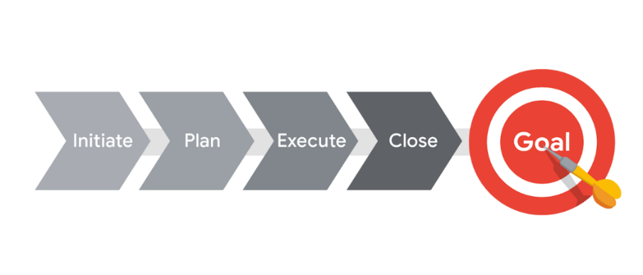

## ****The project life cycle****

### **Initiate the project**

In this phase, ask questions to help set the foundation for the project, such as:

* Who are the stakeholders?
* What are the client’s or customer’s goals?
* What is the purpose and mission of the project?
* What are the measurable objectives for the team?
* What is the project trying to improve?
* When does this project need to be completed?
* What skills and resources will the project require?
* What will the project cost? What are the benefits?

### **Make a plan**

In this phase, make a plan to get your project from start to finish.

* Create a detailed project plan. What are the major milestones? What tasks or deliverables make up each milestone?
* Build out the schedule so you can properly manage the resources, budget, materials, and timeline. Here, you will create an itemized budget.

### **Execute the project**

In this phase, put all of your hard work from the first two phases into action.

* Monitor your project team as they complete project tasks.
* Break down any barriers that would slow or stop the team from completing tasks.
* Help keep the team aware of schedule and deliverable expectations.
* Address weaknesses in your process or examine places where your team may need additional training to meet the project’s goals.
* Adapt to changes in the project as they arise.

### **Close the project**

In this phase, close out the project.

* Identify that your team has completed all of the requested outcomes.
* Release your team so they can support other projects within the company.
* Take time with your team to celebrate your successes!
* Pass off all remaining deliverables and get stakeholder approval.
* Document the lessons you and your team learned during the project.
* Reflect on ways to improve in the future.

## ****Key takeaway****

Each phase of the project life cycle has its own significance and reason for existing. By following the project life cycle, you’re ensuring that you are:

* Capturing the expectations of your customer
* Setting your project up for success with a plan
* Executing project tasks and addressing any issues that arise
* Closing out your project to capture any lessons learned.

As you continue through this course, we will walk through each project phase in more detail.

# Comparing Waterfall and Agile approaches

Now that you know more about some of the different approaches and frameworks associated with project management, let's compare specific aspects of **Waterfall** (also commonly called **traditional**) and **Agile** approaches.



Understanding the fundamentals of—and differences between—these common project management approaches can help you demonstrate your project management knowledge during an interview. It can also help you evaluate a project to determine the right approach when working on the job.

Waterfall and Agile are implemented in many different ways on many different projects, and some projects may use aspects of each. The chart below briefly describes and compares Waterfall and Agile approaches. You can use it as a quick reference tool, but be aware that in practice, the differences between these two approaches may not always be clearly defined. **Waterfall and Agile Comparison**

|  | **Waterfall** | **Agile** |
| --- | --- | --- |
| **Project manager's role** | Project manager serves as an active leader by prioritizing and assigning tasks to team members. | Agile project manager (or Scrum Master) acts  primarily as a facilitator, removing any barriers  the team faces. Team shares more responsibility  in managing their own work. |
| **Scope** | Project deliverables and plans are well-established and documented in the early stages of initiating and planning. Changes go through a formal change request process. | Planning happens in shorter iterations and  focuses on delivering value quickly. Subsequent  iterations are adjusted in response to feedback or  unforeseen issues. |
| **Schedule** | Follows a mostly linear path through the initiating, planning, executing, and closing phases of the project. | Time is organized into phases called Sprints.  Each Sprint has a defined duration, with a set list  of deliverables planned at the start of the Sprint. |
| **Cost** | Costs are kept under control by careful estimation up front and close monitoring throughout the life cycle of the project. | Costs and schedule could change with each  iteration. |
| **Quality** | Project manager makes plans and clearly defines criteria to measure quality at the beginning of the project. | Team solicits ongoing stakeholder input and user  feedback by testing products in the field and  regularly implementing improvements. |
| **Communication** | Project manager continually communicates progress toward milestones and other key indicators to stakeholders, ensuring that the project is on track to meet the customer’s expectations. | Team is customer-focused, with consistent  communication between users and the project  team. |
| **Stakeholders** | Project manager continually manages and monitors stakeholder engagement to ensure the project is on track. | Team frequently provides deliverables to  stakeholders throughout the project.  Progress toward milestones is dependent upon  stakeholder feedback. |

Now that you better understand the differences between Waterfall and Agile project management approaches, you can use this understanding to determine which is most effective for your projects.

Lean and Six Sigma methodologies

Previously you learned about Agile and Waterfall project management approaches. Now, we will define some key concepts from Lean and Six Sigma methodologies. We will learn how these methodologies can be used to organize and manage your projects, and we will discuss which is the most effective for different kinds of projects.

**Lean**

**Lean** methodology is often referred to as Lean Manufacturing because it originated in the manufacturing world. The main principle in Lean methodology is the removal of waste within an operation. By optimizing process steps and eliminating waste, only value is added at each phase of production.

Today, the Lean Manufacturing methodology recognizes eight types of waste within an operation: defects, excess processing, overproduction, waiting, inventory, transportation, motion, and non-utilized talent. In the manufacturing industry, these types of waste are often attributed to issues such as:

* Lack of proper documentation
* Lack of process standards
* Not understanding the customers’ needs
* Lack of effective communication
* Lack of process control
* Inefficient process design
* Failures of management

These same issues create waste in project management.

Implement Lean project management when you want to use limited resources, reduce waste, and streamline processes to gain maximum benefits.

You can achieve this by using the pillars of the Lean 5S quality tool. The term 5S refers to the five pillars that are required for good housekeeping: sort, set in order, shine, standardize, and sustain. Implementing the 5S method means cleaning up and organizing the workplace to achieve the smallest amount of wasted time and material. The 5S method includes these five steps:

1. **Sort:** Remove all items not needed for current production operations and leave only the bare essentials.
2. **Set in order:** Arrange needed items so that they are easy to use. Label items so that anyone can find them or put them away.
3. **Shine:** Keep everything in the correct place. Clean your workspace every day.
4. **Standardize:** Perform the process in the same way every time.
5. **Sustain:** Make a habit of maintaining correct procedures and instill this discipline in your team.

Within the Lean methodology, 5S helps you boost performance.

The final concept of Lean uses a **Kanban** scheduling system to manage production. The Kanban scheduling system, or Kanban board, is a visualization tool that enables you to optimize the flow of your team’s work. It gives the team a visual display to identify what needs to be done and when. The Kanban board uses cards that are moved from left to right to show progress and help your team coordinate the work.

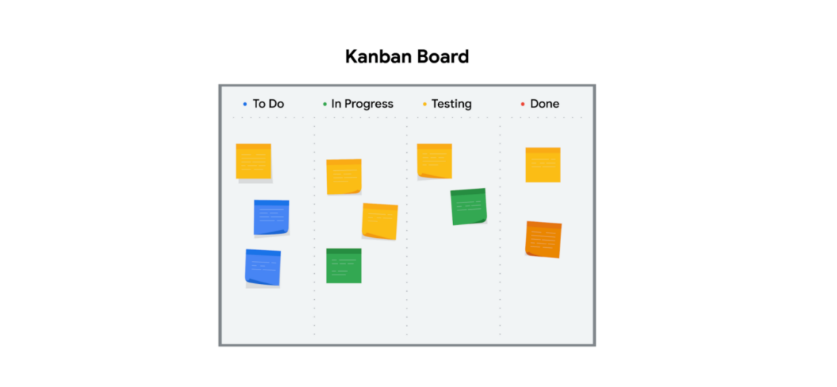

Kanban boards and 5S are core methods of the Lean methodology. They can help you successfully manage your project. Now let’s analyze the Six Sigma method and learn when is the best time to use it.

**Six Sigma**

**Six Sigma** is a methodology used to reduce variations by ensuring that quality processes are followed every time. The term “Six Sigma” originates from statistics and generally means that items or processes should have 99.9996% quality. The seven key principles of Six Sigma are:

1. Always focus on the customer.
2. Identify and understand how the work gets done. Understand how work really happens.
3. Make your processes flow smoothly.
4. Reduce waste and concentrate on value.
5. Stop defects by removing variation.
6. Involve and collaborate with your team.
7. Approach improvement activity in a systematic way.

Use this methodology to find aspects of the product or process that are *measurable* like time, cost, or quantity. Then inspect that measurable item and reject any products that do not meet the Six Sigma standard. Any process that created unacceptable products has to be improved upon.

Now that you understand both Lean and Six Sigma, let's see how they come together to improve the performance of your project!

**Lean Six Sigma**

After both Lean and Six Sigma were put into practice, it was discovered that the two methodologies could be combined to increase benefits. The tools used in Lean, such as Kanban boards and 5S, build quality in processes from the beginning. Products developed using Lean methods are then inspected or tested using Six Sigma standards. The products that do not meet these standards are rejected.

The largest difference between these methodologies is that Lean streamlines processes while Six Sigma reduces variation in products by building in quality from the beginning and inspecting products to ensure quality standards are met. You may find that one of these two methods—or using them both together—can improve the efficiency of your projects.

# Common project management approaches and how to select one

You have been learning a lot about different project management approaches and when to use them. In this reading, we will briefly recap some of the most common ones and recommend a couple of articles with supporting information. You’ll continue to learn more about these approaches throughout this certificate program.

## ****Popular project management approaches****

Below is a brief recap of some of the project management approaches you’ve been introduced to so far:

**Waterfall** is a traditional methodology in which tasks and phases are completed in a linear, sequential manner, and each stage of the project must be completed before the next begins. The project manager is responsible for prioritizing and assigning tasks to team members. In Waterfall, the criteria used to measure quality is clearly defined at the beginning of the project.

**Agile** involves short phases of collaborative, iterative work with frequent testing and regularly-implemented improvements. Some phases and tasks happen at the same time as others. In Agile projects, teams share responsibility for managing their own work. Scrum and Kanban are examples of Agile frameworks, which are specific development approaches based on the Agile philosophy.

**Scrum** is an Agile framework that focuses on developing, delivering, and sustaining complex projects and products through collaboration, accountability, and an iterative process. Work is completed by small, cross-functional teams led by a Scrum Master and is divided into short Sprints with a set list of deliverables.

**Kanban** is a tool used in both Agile and Lean approaches that provides visual feedback about the status of the work in progress through the use of Kanban boards or charts. With Kanban, project managers use sticky notes or note cards on a physical or digital Kanban board to represent the team’s tasks with categories like “To do,” “In progress,” and “Done.”

**Lean** uses the 5S quality tool to eliminate eight areas of waste, save money, improve quality, and streamline processes. Lean’s principles state that you can do more with less by addressing dysfunctions that create waste. Lean implements a Kanban scheduling system to manage production.

**Six Sigma** involves reducing variations by ensuring that quality processes are followed every time. The Six Sigma method follows a process-improvement approach called DMAIC, which stands for define, measure, analyze, improve, and control.

**Lean Six Sigma** is a combination of Lean and Six Sigma approaches. It is often used in projects that aim to save money, improve quality, and move through processes quickly. Lean Six Sigma is also ideal for solving complex or high-risk problems. The 5S organization framework, the DMAIC process, and the use of Kanban boards are all components of this approach.

Despite their differences, all of these project management methodologies require communication and collaboration among various teams and aim to deliver projects on time and within budget.

## ****Selecting a project management approach****

With so many methodologies available, there are many options that would work well for your project. Since projects and the organizations in which you will execute them vary greatly, the approach you choose to implement for each project will vary. At Google, we often use a hybrid of approaches and frameworks to efficiently meet the project goal! All approaches can be combined with others, depending on the needs of your project.

Choosing an approach that works best for the project, the organization, and the team takes time and practice. You’ll learn more about how to choose a project management approach throughout this certificate program. In the meantime, take a look at how this article breaks down common methodologies and when (or when not) to use them: [Which project management methodologies should you use?](https://www.teamwork.com/project-management-guide/project-management-methodologies/" \t "_blank)

# A project manager's role within different organizational structures

Understanding the differences in Classic and Matrix organizational structures can help you ask questions during a job interview to fully understand the role and responsibilities you are considering. This will also help you understand which skills will be most important for you to have if you get the position.

Once you are hired into a role, knowing a company’s organizational structure can help you identify key points of communication and key stakeholders. It can also help you navigate within the organization when you need support or need to determine who has authority in a certain situation. Let’s examine the characteristics of each of these organizational structures in greater depth so you can identify the type of structure an organization has and how to navigate it as a project manager.

## ****Classic organizational structures****

The **Classic organizational structure** is a top-down hierarchy system, where a Chief Executive Officer (CEO) has direct authority over several department managers. The department manager has direct authority over several other sections of employees. This system requires communication both up and down the ladder. In a Classic structure, authority comes from the top and filters to the bottom. Frequent reporting of project status updates may be required to pass up through management levels to keep higher leaders informed.

Classic organizations are also referred to as **functional** **organizations** because the organization is divided into departments based on function. Each department is led by a **functional manager**, and employees are grouped according to the functions of their role. For example, the main function of Friendly Skies Airlines, an airline company, is to fly airplanes. There are typically departments logically arranged to fulfill other important company functions, such as Marketing, Human Resources, and Strategy. Employees usually have a specialty within the organization and may not work within other areas during normal everyday operations.

## ****Managing a project in a Classic organization****

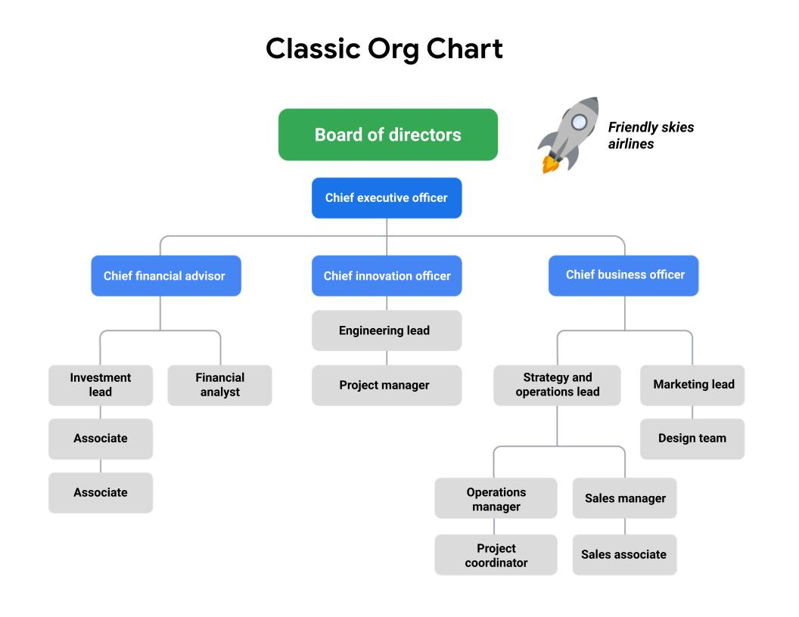

Imagine that the Friendly Skies Airlines Board of Directors approves an initiative to retrofit existing airplanes to carry more passengers. The CEO sponsors a project team to redesign the airplanes. The project will be led by a project manager from the Engineering and Innovation department and will require representatives from Finance, Marketing, Strategy, and Operations, along with several other team members from the Design department, to successfully complete the project.

The project team will typically remain in their reporting lines but act as their own assembled team. They do not fall under any of the existing functional departments. In the Classic organizational structure, the project builds from already existing departments to form teams.

If you are a project manager in this type of structure, you may need to consult with functional managers to understand your resources and the capacity of each teammate, as well as to familiarize yourself with each function’s internal processes and approval structure. Your authority may be slightly limited due to competing priorities, approval chains, and other complexities, but setting expectations up front will enable you to navigate the organization and execute your project successfully.

## ****Matrix organizational structures****

The **Matrix** structure differs from the Classic structure in that the employees have two or more managers. In Matrix structures, you still have people above you, but you also have people in adjacent departments with whom you will need to communicate on your work progress. Functional areas tend to cross paths more frequently, and depending on the nature of the work, the responsible manager for each area has the most authority.

As a project manager in a Matrix organization, a team will essentially have at least two chains of command, or managers. You can think of the project manager as being a temporary manager while assigned to the team. The functional manager is consistent regardless of the project a project manager is supporting. The visual below illustrates what the Friendly Skies Airlines would look like if it had a Matrix organizational structure.

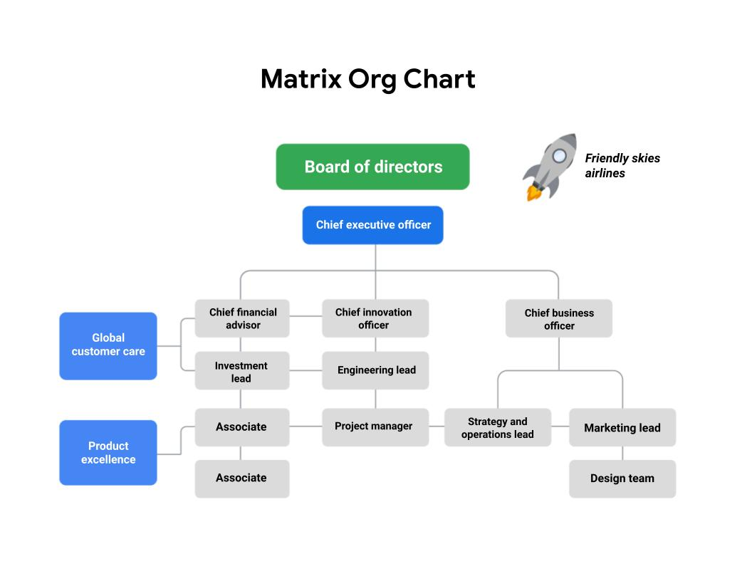

## ****Managing a project in a Matrix organization****

Imagine that Friendly Skies Airlines is organized in a Matrix structure. Their Product Excellence team develops a new amenity kit for long-haul flights. They ask the Project Manager to help gather marketing materials that present research data about how this product fulfills passenger desires. The Project Manager is working on behalf of the Product Excellence team, but they are able to work in partnership with the Marketing team to create these materials.

You can read more about an overview of Matrix organizations in this [PMI article](https://www.pmi.org/learning/library/matrix-organization-structure-reason-evolution-1837" \t "_blank).

## ****Key takeaway****

In both Classic and Matrix organizations, project managers must clearly define roles and responsibilities in order to work effectively. However, within most Matrix organizations, some project managers or department leads may have the same level of authority as the functional managers and operate more directly.

Now you know how to identify Classic and Matrix organizational structures, how project managers fit into them, and how an organization’s structure may affect projects. You are well on your way to becoming a great project manager in any organizational structure!

# The role of a Project Management Office

In this lesson, you are learning about different types of organizational structures. Project managers serve key functions in both Classic and Matrix organizations. Within both of these types of structures, there is sometimes a group devoted specifically to program management with the organization: the **Project Management Office.** In this reading, we will discuss the purpose and functions of a Project Management Office.

## ****What is a PMO?****

A Project Management Office, or PMO, is a group within an organization that defines, sets, and helps maintain project management standards and processes throughout that organization. It often acts as a coordinated center for all of the organization’s projects, helping them run more smoothly and efficiently.

An organization’s project managers may operate within the PMO itself or within other departments. At Google, for example, there are project managers who work in a PMO focused on operational excellence, but there are numerous project and program managers in other departments throughout the organization, as well.

## ****What are the functions of a PMO?****

PMOs offer guidance and support to their organization’s project managers. They share best practices, project statuses, and direction for all of the organization’s projects while often taking on strategic projects themselves. The main functions of a PMO include:

### **Strategic planning and governance**

This is the most important function of a PMO. This involves defining project criteria, selecting projects according to the organization’s business goals, and then providing a business case for those projects to management.

### **Best practices**

PMOs help implement best practices and processes within their organization. They also share lessons learned from previous successful projects. They help ensure consistency among their organization’s projects by providing guidance about processes, tools, and metrics.

### **Common project culture**

PMOs help set common project culture practices by training employees about optimal approaches and best practices. This helps keep project management practices consistent and efficient across the entire organization.

### **Resource management**

PMOs are often responsible for managing and allocating resources—such as people and equipment—across projects throughout the organization based on budget, priorities, schedules, and more. They also help define the roles and responsibilities needed on any given project. PMOs provide training, mentoring, and coaching to all employees, but project managers in particular.

### **Creation of project documentation, archives, and tools**

PMOs invest in and provide templates, tools, and software to help manage projects. They also play an important role in maintaining their organization’s project history. Once a project closes, they archive all of the documents created during the project for future reference and to capture lessons learned.

## ****Key takeaway****

To recap, the key purposes of a PMO include: strategic planning and governance, implementing project management best practices, establishing common project culture, resource management, and creating project documentation, archives, and tools. PMOs support their organizations in managing large numbers of projects and help keep all employees working in the same direction towards the organization’s goals.

# Learning about an organization’s culture

It is important to learn about the culture of the organization where you work or want to work. Understanding the company’s culture can help you navigate your team through a project. Consider this quote from Peter Drucker, an expert on management: ”Culture eats strategy for breakfast.” Drucker is implying that the culture of a company always influences its success, regardless of how effective the company’s business model may be. Organizational culture is critical to the health of a company, the people who work there, and the customers it serves.

## ****The importance of organizational culture****

* **Identity:** An organization’s culture defines its identity. Its identity essentially describes the way the company conducts  business, both internally and externally. A company’s values and organizational culture go hand-in-hand; its values are part of its identity. You can almost think of an organization’s culture as its personality. That is why it is important to learn your company’s (or target company’s) mission and value statements. The mission and value statements will help you understand why the company exists and will give you insight into what the company believes in and how it will behave.
* **People:** Strong, positive organizational culture helps retain a company’s best employees. People who feel valued, engaged, and challenged are more likely to give their best and want to drive for success. An organization’s culture can help keep talented employees at a company, and it can attract great people too! On the other hand, a toxic culture can have the opposite effect. It is important to find an organization with a culture that fits your personality. One way to find out more about an organization's culture is to talk to the people who work there. You can also take note of the current employees’ attire, expressions, and overall behavior.
* **Processes:** Organizational culture can have direct impacts on a company's processes, and ultimately, its productivity. The organization’s culture is instilled throughout the company—from its employees to how its employees do their job. For example, a company that values feedback and employee involvement might have that reflected in their processes by including many opportunities for employees to comment. By allowing employees to feel their voices are heard, this company is adhering to its culture.

## ****Understanding an organization’s culture****

As a project manager, it is important to understand your company’s culture, especially because it could affect the projects you work on. Some aspects of an organization’s culture that are directly related to how you will manage projects are communication, decision-making, rituals, previous management styles, and values. To learn more about a company’s culture and how it applies to you as a project manager, you can:

## ****Ask questions****

You can learn about an organization's culture by asking questions of management and peers. It can be helpful to ask these questions in the interview phase to better understand the company’s culture before accepting a position. You might want to ask questions about:

### **Atmosphere**

* What is the company’s dress code?
* How do people typically share credit at this company?
* Is risk-taking encouraged, and what happens when people fail?
* How do managers support and motivate their team?
* How do people in this role interact with customers and users?
* When and how do team members give feedback to one another?
* What are some workplace traditions?
* What are some of the ways the company celebrates success?

### **Policies**

* What are the policies around sick days and vacation?
* Does the company allow for employee flexibility (e.g., working from home, flexible working hours)?
* What policies are in place that support employees sharing their identity in the workplace?

### **Processes**

* What is the company’s onboarding process?
* How do employees measure the impact of their work?

### **Values**

* What are the company’s mission and value statements?
* How might the person in this role contribute to the organization’s mission?
* How does the organization support professional development and career growth?

## ****Listen to people’s stories****

Listening to what current employees have to say and how they portray the company will give you great insight.

* What were employees' experiences with similar projects in the past?
* What can they tell you about key stakeholders and customers?

## ****Take note of company rituals****

Rituals can be powerful drivers of culture. They engage people and help instill a sense of shared purpose and experience.

* How are birthdays and holidays celebrated?
* Do employees generally eat lunch at the same time and in the same place?
* Watch employee interactions**:** Observing how employees interact can help you tailor your interaction style to the company norm.
* Are employee interactions more formal or informal in nature?
* Are ideas solicited from employees in different roles?

## ****Understand your impact****

As a project manager, you become a **change agent**. Remember: a change agent is a person from inside an organization who helps the organization transform by focusing on improving organizational effectiveness and development. When you begin a new role, sit down with management to better understand what is expected of you and how you can make the most of the opportunity.

## ****Sharpen your communication skills****

Interpersonal communication skills are a major part of project management. How a company communicates is directly tied to its organizational culture. You will most likely have interactions with various departments and management levels while executing projects. To communicate effectively, you will need to understand how to navigate the different channels in your company. Ask questions about communication practices when you start a new role such as: Is it customary to sign emails from the team rather than from you individually? Should presentations include team members or be solely presented by the project manager? This can help you make sure you are adhering to expectations.

Approaching projects differently from how similar projects were managed in the past may be met with some resistance. Although some projects may call for you to break the status quo, when you show an appreciation of your organization’s culture, you may help your team members accept any improvements you are implementing.

## ****Key takeaway****

Organizational culture is important because it has a direct impact on you as a project manager, and learning how to navigate organizational culture gives you a great advantage when you are executing projects. Being able to navigate departmental interactions, communicate effectively, and plan your project in line with the organization’s culture will help set you up for success in your project management career path.

# Case study: Balancing company culture and strategic goals

As you’ve learned, **organizational culture** refers to the values employees share and an organization’s values, mission, history, and more. In other words, organizational culture can be thought of as a company's personality. A company’s organizational culture can help drive its internal and external success. When a company’s culture is aligned with its corporate strategy and goals, the level at which it can perform is impressive. When researching a company for a possible new job, understanding the company’s culture can help you decide if it is a good fit for you and your priorities. Also, understanding a company's culture as a project manager can help you make informed choices about when you want your actions and decisions to fit within the culture or when you might choose to intentionally push back against the culture to effect change or create improvements. Let’s explore an example of a positive organizational culture and how a project manager fits into that culture.

## ****The Family Java culture****

The Family Java coffeehouse has over 2,000 stores worldwide. The Family Java’s culture is closely linked to their strategy and capabilities—this is what they feel sets them apart from other coffee shops. The company has invested in a relationship-driven, employees-first approach. Their culture establishes that the employees are what makes the company unique. This helps foster a warm, comfortable, and calm environment for both employees and customers alike. Because The Family Java’s organizational culture has cultivated employees who genuinely care about the company and their jobs, those employees create the same environment for their customers to enjoy.



The Family Java’s mission and values speak to this approach directly:

**Mission**

* To provide a welcoming environment where our employees become our family and our guests become our friends

**Values**

* To create a place where everyone is welcome
* To always give our best and hold ourselves accountable for the results
* To treat others with respect and kindness

The Family Java has worked hard to be able to create the structure to put their mission and values into practice daily. They practice these values, all while achieving new levels in sales and growth. For example, The Family Java believes in expressing their employees-first value by spending more on employee healthcare than on coffee beans! Each employee is crucial to the success of the company and their ability to fulfill their mission and adhere to their values. In turn, the company makes their employees feel valued by offering substantial training, education scholarships, assistance with daycare, and growth within the company.

The Family Java is able to capitalize on the critical link between culture and strategic goals to achieve optimal performance. When evaluating their organizational culture, the company focuses on their positive attributes and adapts to what works and has proven to be beneficial. By taking the time to perfect what the company does well, The Family Java has created a culture that drives out negativity, empowers employees to be their best selves, and aligns with their strategic goals.

## ****A project manager’s relationship to organizational culture****

### **Learning the company’s values**

Avi was excited to begin his role as a project manager at The Family Java. He had asked questions about the organization’s culture during his job interview and was told about the company’s people-first approach. Avi’s previous company prioritized profitability over teamwork and mentorship. While his previous company was very successful, it was difficult for Avi to engage meaningfully in his work because the culture was so focused on financial results rather than on their employees’ job satisfaction. Avi felt like The Family Java’s approach better aligned with his own values.

### **Clarifying the company’s expectations**

Avi’s manager at The Family Java said that his role would involve a substantial emphasis on team building and keeping morale high. When he began, Avi asked his manager to clarify the time investment expected by the company in order to accomplish team- and morale-building goals. He also asked for suggestions and guidance based on what had been done at the company in the past. If Avi had made incorrect assumptions about the company’s culture and tried to manage projects with his previous company’s culture in mind, he might have emphasized speed over collaboration and communication. Avi now knew that he would need to carefully balance expectations related to The Family Java’s culture with the project workload in order to meet project timelines and achieve the desired outcome.

### **Applying organizational culture to a project**

Before beginning his first project, Avi planned a team lunch to get to know everyone at The Family Java. Then, he scheduled one-on-one meetings with each of his team members to learn more about their working style and professional goals. He also asked how he could help support and remove any barriers for them. One of Avi’s team members, Miguel, said that he needed to start his workday early because he picked his children up from school at 3:00. After hearing this, Avi avoided scheduling team meetings in the late afternoon. Another team member, Elisa, told Avi that she preferred face-to-face or phone conversations to email since she felt like she communicated better verbally. When Avi needed to discuss something with Elisa, he made sure that he talked with her in person as much as possible. Avi continued to check in with all of his team members regularly as the project progressed. He also scheduled weekly “Coffee Chats” with his team, since he had learned that this was company tradition. Avi’s efforts to align his project management style to The Family Java’s organizational culture were noticed by executives and stakeholders, and he was given a lot of support in getting the resources he needed.

## ****Key takeaway****

The culture of each organization you encounter will be different and can change over time. Like Avi, it is worth your time as a project manager to learn about your company's culture because it directly relates to your projects’ success.

A project manager’s role in change management

In this lesson, you’re learning about how to support the **change management** process for your project. To review, change management is the process of delivering your completed project and getting other people in the organization to adopt it. In this reading, we will discuss strategies for approaching change management as a project manager.

Your project’s success depends on the adoption and acceptance of your project—whether that entails the launch of a new external tool or a process that will change operations at a production facility. In both cases, the greatest impact of the change will be on the people who use and interact with the product or process that is changing.

For example, if your website’s user interface changes, the major impact of that change affects the user. The user must learn how the website has been reorganized and adapt to the new way to navigate it. If part of the website’s interface update includes a new brand logo, the major impact of that change impacts your organization’s employees. They must be made aware of the new logo and measures must be taken to ensure that all company communications include the new logo, not the old one.

You can help ensure your project’s success by embracing changes as they come and by convincing the wider audience, whether that is the end user or members of the organization, to embrace changes, too. When you implement a careful approach to change management, you can address issues that might occur in the later stages of your project.

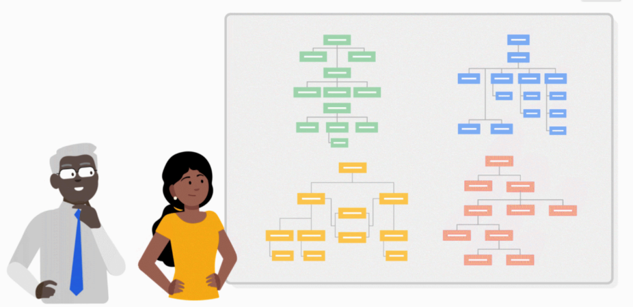

**Integrating project management and change management**

Change management is a major undertaking and a project in and of itself. When it comes to change management, you may not always be responsible for leading and planning the entire end-to-end process. There will be times when your manager, a team member, or another senior leader might be responsible for taking on that transition and successfully implementing the changes. However, just because you're not the one directly leading the change, there are still ways in which you can support and participate in the successful adoption of your project.

As a project manager, you can think of change management as necessary for the successful outcome of your project. Both change management and project management aim to increase the likelihood of project success. They also incorporate tools and processes to accomplish that goal. The most effective way to achieve a project goal is to integrate project management and change management, and it is your responsibility as a project manager to do so.

When you are thinking about change management as it relates to your project, begin by asking yourself the following questions:

* How will the organization react to change?
* Which influencers can affect change?
* What are the best means of communication?
* What change management practices will lead to the successful implementation of my project?

The answers to these questions will help you prepare for a variety of possible scenarios and allow you to craft solutions to effectively support the adoption of your project.

Let’s look at some best practices for approaching change management on your projects:

**Be proactive.** Proactive and inclusive change management planning can help keep any potentially impacted stakeholders aware of the upcoming changes.

* Incorporate change management into your project management steps. For example, you can schedule time during team meetings or create a feedback document to ensure that your team members know there is a place to voice their suggestions and concerns.
* You can also plan steps towards the end of your project to introduce the deliverable to stakeholders in the form of demonstrations, question and answer forums, or marketing videos. You can factor all of these decisions into your plan so that any potential changes are less likely to impact your timeline. If these steps have not been built into your plan, you can escalate and stress the importance of a change management plan to your stakeholders.

**Communicate about upcoming changes.** Communication should occur regularly among impacted stakeholders, the change management team, and the project team. Check in and communicate throughout the project about how the changes will provide a better experience for end users of the project deliverables. In this way, you support the process by providing everyone with the information they need to feel prepared to adjust to changes once the project is ready to launch.

**Follow a consistent process.** Following a clear change management process helps maintain consistency each time there is a change. The change management process should be established and documented early on in your project to guide how the project will handle change. Your organization may also have an overarching change management plan that can be adopted for your project. This may include when the promotion of the change should happen, when training should occur, when the launch or release will occur, and corresponding steps for each phase of the process.

**Practice empathy.** Changes are inevitable, but we are often resistant to them. By being empathetic to the challenges and anxiety change can bring, you can support the process in subtle ways.

**Use tools.** Incorporating tools to assist in the adoption of a change can be very helpful. Here are a few examples you can use on your next project:

* **Feedback mechanisms**, such as surveys, can capture input from stakeholders.
* **[Flowcharts](https://www.lucidchart.com/pages/what-is-a-flowchart-tutorial" \t "_blank)** can visualize the project's development process.
* **[Culture mapping](https://www.strategyzer.com/blog/posts/2015/10/13/the-culture-map-a-systematic-intentional-tool-for-designing-great-company-culture" \t "_blank)** can illustrate the company's culture and how the company's values, norms, and employees behavior may be affected by the change.

As the project manager, you are responsible for successfully delivering projects. As you hone the skill set you acquire throughout this program, you will find that change management is essential to your projects’ success.

# Corporate and project governance

**Governance** in business is the management framework within which decisions are made and accountability and responsibility are determined. In simple terms, governance is understanding who is in charge. In this reading, we will discuss corporate governance and project governance. It is important to learn how corporate and project governance are related since you may have to speak about governance in an interview. Additionally, you will need to understand how your project relates to the governance structure of the organization.

## ****Corporate governance****

Each organization is governed by its own set of standards and practices that direct and control its actions. Those standards and practices are called **corporate governance**, and they will influence your projects. Corporate governance is the framework by which an organization achieves its goals and objectives. Corporate governance is also a way to balance the requirements of the various corporate entities, such as stakeholders, management, and customers. Corporate governance affects every part of an organization, including action plans, internal and external controls, and performance measurements.

Governance and change management go hand-in-hand. Think back to the previous videos on change management. To successfully implement change management, it is essential that you understand the structure and culture of the organization. Effective governance in change management provides clearly defined roles and responsibilities during change. This enables the people within the organization to have a precise understanding of who makes decisions and of the relationship between those managing and participating in the change management process.

Another example of governance within an organization is the creation and use of **steering committees**. Steering committees decide on the priorities of an organization and manage the general course of its operations. The steering committee essentially acts as an advisory board or council to help the project manager and the company make and approve strategic decisions that affect both the company and the project.

## ****Project governance****

As a project manager, you will be responsible for **project governance**. Project governance is the framework for how project decisions are made. Project governance helps keep projects running smoothly, on time, and within budget. Project governance involves all the key elements that make a project successful. It tells you what activities an organization does and who is responsible for those activities. Project governance covers policies, regulations, functions, processes, procedures, and responsibilities.

## ****How project and corporate governance intersect****

Project governance needs to be tailored to your organization's specific needs. These needs will influence how you implement and monitor the governance framework on your project. Project governance concerns those areas of corporate governance that are specifically related to project activities. Effective project governance ensures that an organization’s projects are aligned to the organization’s larger objectives, are delivered efficiently, and are sustainable. This includes:

* Considering the long- and short-term interests of your organization
* Making thoughtful decisions about which projects to take on and avoiding projects if you do not have sufficient resources
* Providing timely, relevant, and reliable information to the board of directors and other major stakeholders
* Eliciting the input and buy-in of senior managers since they are the decision-makers
* During the initiation phase, prioritizing clear, reachable, and sustainable goals in order to reduce confusion and conflict
* During the planning phase, assigning ownership and accountability to an experienced team to deliver, monitor, and control the process
* During the execution phase, learning from mistakes and adapting to new or improved knowledge

Corporate governance can involve clearing many hurdles before making decisions. These decisions can influence not only a single project, but the entire corporation.

At the same time, corporate governance can help support project governance, as it provides oversight on compliance and mitigating risk and offers guidance and direction for project managers. Good corporate governance can also help project managers secure resources, get issues addressed, avoid delays in decision-making, get buy-in from stakeholders, and achieve visibility for projects on the executive level.

## ****Key takeaway****

You should think about an organization’s culture and structure when you are interviewing for a new role and as you begin a new role or project. You should consider an organization’s governance processes and practices in the same way. This will help you understand how decisions are made, who is responsible for what, and what are the potential issues and areas of concern.

How to uncover job opportunities

Starting a new career means not only developing a new skill set but also learning how to relate your previous experience and skills to the new role you’re pursuing. If you’re ready to start your journey on a new career path, this reading will help you position yourself for success in your job search. You’ll learn how to understand what your potential employer is looking for and how to connect your background to their needs. The strategies outlined below are designed to help you become a strong job candidate, even if you don’t have directly relevant experience.

The first step is to fully understand the role you’re targeting.



**Understand your target role**

One of the primary challenges for anyone looking to launch a new career is how to stand out against candidates who already have experience in the field. Overcoming this challenge begins with developing a comprehensive understanding of the role you’re targeting. You'll need to understand the role in the context of any company you’re applying to, and more broadly as well. Having a holistic understanding of what it takes to succeed in your target role will help you determine your suitability for the role, and identify any steps you can take to improve your chances of getting hired.

To understand everything from minimum must-have requirements to skills that might help you stand out from the crowd, you can begin by researching and analyzing job descriptions across different organizations. Below you’ll find our recommended strategy for how to approach this process effectively.

**Analyze job listings**

The first part of the process is to gather information from multiple job listings:

* **Pull up ten job descriptions for your target role**. To do this, you can use job boards like Indeed, Glassdoor, and LinkedIn. Make sure the roles you select come from different companies, share similar titles, and are roles you would actually apply for. In each job description, you should be able to identify a section listing requirements for the role.
* **Combine all the job requirements**. To do this, create a new Google document and copy over all the required responsibilities from all ten job descriptions.
* **Order requirements based on appearance frequency.** Certain requirements will likely appear in multiple descriptions. The more commonly they appear, the more likely it is that they’re essential for the role. Put the most frequently appearing requirements at the top of your list. For example, a requirement that appears in all ten descriptions would go at the very top.

After completing these steps, you should have a clearer picture of which requirements are most common and important for the role. You may also have questions:

* **Why do requirements differ across job descriptions?**  One of the most common reasons for this has to do with overly general job titles, or job titles that don’t necessarily communicate the specific scope of a given role at a particular company. For example, a program manager at one company might be focused on customer management, while at another company, the emphasis might be on project management. A Data Analyst might primarily use SQL at one company and Python at another. Because of these differences, it’s important to look beyond job titles. This is why we recommend the process outlined above—to help ensure you’re targeting the exact roles that are right for you—and that you understand the requirements for those exact roles.
* **Why are some requirements higher on my list than I thought they would be, while others I expected to see barely show up at all?** If you’re surprised by your results, you may need to spend more time learning what the role really entails, as you may have some preconceptions about the role that require adjusting. You might also need to do additional research to ensure you’re targeting the right roles in your job search.
* **How do I know if I’m really right for my target role?** It’s perfectly normal to experience self-doubt at this stage of the process. Remember, this is a new career for you. You’re not expected to know everything about the role, and it’s likely that your existing skills and experience won’t line up perfectly. The more you learn about the role, the better you’ll understand what’s required for success, and the more you’ll know about how to prepare yourself for that success.

**Create your professional inventory**

For this next step, you can temporarily set aside the master list of role requirements you previously created. The focus here will be on your existing professional qualifications, and any other skills or experience you possess that might be relevant to your target role and of value to a potential employer. To begin, assemble a comprehensive list of the following:

* **Technical (hard) skills**. These are skills relating to a specific task or situation such as programming, technical writing, project management, and more.
* **Non-technical (interpersonal) skills.** These are the skills that enable people to navigate their environment, work well with others, perform well, and achieve their goals. They include skills like communication, leadership, team management, and more.
* **Personal qualities.** These are positive attributes and personality traits such as being honest, having a good sense of humor, and being dependable. You can also include your professional interests on this list.
* **Education.** This includes any post-secondary education, certifications, or independent classes completed online or offline.

**Tip**: You do not need to limit your professional inventory to skills and qualities developed through professional experience. Consider any volunteer, extracurricular, or personal experiences that might help a hiring manager understand your capabilities.

Once you’ve created your inventory of skills and experience, you’re ready to line these up against your requirements list.

**Match your profile to the job requirements**

The concluding step in this process is to match your profile to the job requirements. The goal here is to make it easy for any hiring manager to see why you’re a great fit for their role. You’ll accomplish this by learning what to emphasize and focus on in your search, on your resume, and during interviews.

To begin, go through your professional inventory of skills and experience, highlighting each item in green, orange, or red, depending on its relevance to your target role. Relevance is determined by whether a given skill appears on your role requirements list, how high it appears on your list, and how directly it aligns with your list.

For example, let’s say you’re interested in a program manager role. If you’re skilled at using project management software, and project management software skills are high on your job requirements list, then highlight that item in green. If you have some experience with tools that do not consistently show up on job descriptions but could still be relevant, highlight these skills in orange.

* **Green**should be used for skills that are directly relevant to your target role. You should look for roles that emphasize these skills. You should also highlight these skills on your resume, and be prepared to discuss them in an interview.
* **Orange**should be used to identify those skills and experiences that are relevant for the role but not necessarily in a direct way. These are generally your transferable skills—skills that you bring with you from past experiences that can help you succeed in your new role. Plan to have to explain these to recruiters and hiring managers, as their relevance may not be immediately evident.
* **Red** should be used for items that are not relevant for your job search. De-prioritize these skills, and steer clear of highlighting them on your resume and focusing on them during interviews.

Of these three categories, the orange items are where you’ll need to focus extra attention. When it comes to transferable skills, you have to do the convincing, as you can’t count on a recruiter or hiring manager making the connection. For example, no job description for a project manager role calls for waitstaff experience. However, that project manager job description will likely mention excellent communication skills—which you would have developed during your hospitality career. When applying for the project manager role, make sure your resume specifically mentions excellent communication in addition to listing “waiter” or “waitress” as your previous occupation. Once you’ve categorized your skills and experience based on how well they align with the requirements for your target role, you’re ready to move your job search forward.

Performing a cost-benefit analysis

Previously, you learned that a **cost-benefit analysis** is the process of adding up the expected value of a project—the benefits—and comparing them to the dollar costs. In this reading, we will discuss the benefits of conducting a cost-benefit analysis, guiding questions to help you and your stakeholders conduct one, and how to calculate return on investment (ROI).

**The benefits of a cost-benefit analysis**

A cost-benefit analysis can minimize risks and maximize gains for projects and organizations. It can help you communicate clearly with stakeholders and executives and keep your project on track. Because this type of analysis uses objective data, it can help reduce biases and keep stakeholder self-interest from influencing decisions.

Comparing a project’s benefits to its costs can help you make a strong business case to stakeholders and leadership and ensure your organization pursues the most profitable or useful projects. Organizations use cost-benefit analyses to reduce waste and invest their resources responsibly.

**Guiding questions for a cost-benefit analysis**

When you’re pursuing a project, the benefits should outweigh the costs. It’s important for you and your stakeholders to consider questions like the ones that follow early on, while you prepare the proposal. To determine the benefits of a project, you might ask:

* What value will this project create?
* How much money could this project save our organization?
* How much money will it bring in from existing customers?
* How much time will it save?
* How will it improve the customer experience?

And to determine the costs of a project, consider questions such as:

* How much time will people have to spend on this project?
* What are the one-time costs?
* Are there any ongoing costs?
* What about long-term costs?

You might also consider questions about **intangible benefits**. These are gains that are not quantifiable, such as:

* **Customer satisfaction**. Will the project increase customer retention, causing them to spend more on the company’s products or services?
* **Employee satisfaction**. Is the project likely to improve employee morale, reducing turnover?
* **Employee productivity**. Will the project reduce employee’s overtime hours, saving the company money?
* **Brand perception**. Is the project likely to improve the company’s brand perception and recognition, attracting more customers or providing a competitive advantage?

You can also flip these questions to consider **intangible *costs***. These are costs that are not quantifiable. For example, might the project put customer retention, employee satisfaction, or brand perception at risk?

When assigning values to tangible or intangible costs and benefits, you can reference similar past projects, conduct industry research, or consult with experts.

**Calculating costs and benefits**

The process of calculating costs and benefits is also called calculating **return on investment**, or **ROI**. There are many ways to determine a project’s ROI, but the easiest way is to compare the upfront and ongoing costs to its benefits over time. One common ROI formula is:



In this formula, **G** represents the financial gains you expect from the project, and **C** represents the upfront and ongoing costs of your investment in the project.

For example, imagine your project costs $6,000 up front plus $25 per month for 12 months. This equals $300 per year, but you estimate that the project will bring in $10,000 in revenue over the course of that year. Using the formula above, you calculate the ROI as: ($10,000 - $6,300) ÷ $6,300 = 0.58 = 58%

The ROI comes to 0.58, or 58%. You consider this to be a strong ROI, so you decide to pursue the project.

**Key takeaway**

Performing a cost-benefit analysis can help you and your stakeholders determine if it makes sense to take on a new project by evaluating if its benefits outweigh its costs. When conducting cost-benefit analyses for your prospective projects, you can use the guiding questions and ROI formula provided in this reading as a reference.

SMART goals: Making goals meaningful

In this lesson you are learning to define and create measurable project goals and deliverables. Now, let's focus on SMART goals.

**Specific, Measurable, Attainable, Relevant,** and **Time-bound (SMART)** goals are very helpful for ensuring project success. As you start your career in project management, you may not directly set the project goals, but you should be able to clarify and understand them. SMART goals help you see the full scope of a goal, determine its feasibility, and clearly define project success in concrete terms.  Let’s recap what we discussed in the previous video by taking a look at a breakdown of the criteria for SMART goals below:

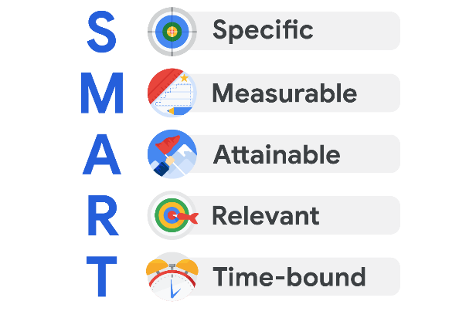

* **Specific:** The objective has no ambiguity for the project team to misinterpret.
* **Measurable:** Metrics help the project team determine when the objective is met.
* **Attainable:** The project team agrees the objective is realistic.
* **Relevant:** The goal fits the organization’s strategic plan and supports the project charter.
* **Time-bound:** The project team documents a date to achieve the goal.

You may see variations on what each letter in the “SMART” acronym stands for. (For example, you may see “actionable” or “achievable” instead of “attainable” or “realistic” instead of “relevant.”) However, the general intent of each of these terms—to make sure the goal is within reach—is always similar.

**Focusing on the "M" in SMART**

Let’s take a moment to zoom in on the **M** in SMART, which stands for **measurable**. Having measurable goals allows you to assess the success of your project based on quantifiable or tangiblemetrics, such as dollar amounts, number of outputs, quantities, etc. Measurable goals are important because they leave little room for confusion around expectations from stakeholders.

Not every metric will have value, so you will have to determine which metrics make sense for the project. For example, measuring how many meetings the software engineers on your project attend on a weekly basis may not be the most valuable metric for a productivity goal. Alternatively, you might measure other aspects of the engineers’ productivity, such as a particular number of features created per engineer or a specific number of issues flagged per day.

**Defining a SMART goal**

Let’s explore an example related to making a personal goal measurable. Imagine you are looking to make a career change, and you set a goal to complete a Google Career Certificate. You can **measure** the success of this goal because after completing the entire program, you will receive a certificate—a tangible outcome.

Now, let’s determine how to make the remaining elements of this goal SMART. In this example, your **specific** goal is to attain aGoogle Career Certificate. You can make this goal **attainable** by deciding that you will complete one course per month. This goal is **relevant** because it supports your desire to make a career change. Finally, you can make this goal **time-bound** by deciding that you will complete the program within six months.

After defining each of these components, your SMART goal then becomes: Obtain a Google Career Certificate by taking one course per month within the next six months.

**Key takeaway**

Determining metrics can be extremely helpful in capturing statuses, successes, delays, and more in a project. As a project manager, identifying meaningful metrics can help move the project toward its goal. Additionally, by defining each element of a project goal to make it SMART, you can determine what success means for that goal and how to achieve it.

# Creating OKRs for your project

### In this lesson, you are learning to define and create measurable project goals and deliverables. This reading will focus on creating effective **objectives and key results (OKRs)** and how to implement them into your project.

## ****What are OKRs?****

OKR stands for objectives and key results. They combine a goal and a metric to determine a measurable outcome.

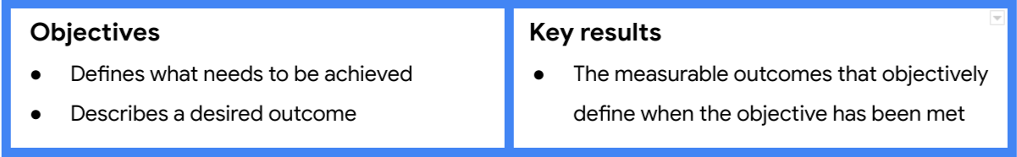

Objectives: Defines what needs to be achieved; describes a desired outcome. Key results: The measurable outcomes that objectively define when the objective has been met. Company-wide OKRs are used to set an ultimate goal for an entire organization, while team, department, and project-level OKRs describe the focused results each group will need to achieve in order to support the organization.

## ****OKRs and project management****

As a project manager, OKRs can help you expand upon project goals and further clarify the deliverables you’ll need from the project to accomplish those goals. Project-level OKRs help establish the appropriate scope for your team so that you can say “no” to requests that may get in the way of them meeting their objectives. You can also create and use project-level OKRs to help motivate your team since OKRs are intended to challenge you to push past what’s easily achievable.

## ****Creating OKRs for your project****

### **Set your objectives**

Project objectives should be aspirational, aligned with organizational goals, action-oriented, concrete, and significant. Consider the vision you and your stakeholders have for your project and determine what you want the project team to accomplish in 3–6 months.

**Examples:**

* Build the most secure data security software
* Continuously improve web analytics and conversions
* Provide a top-performing service
* Make a universally-available app
* Increase market reach
* Achieve top sales among competitors in the region

Strong **objectives** meet the following criteria. They are:

* Aspirational
* Aligned with organizational goals
* Action-oriented
* Concrete
* Significant

To help shape each objective, ask yourself and your team:

* Does the objective help in achieving the project’s overall goals?
* Does the objective align with company and departmental OKRs?
* Is the objective inspiring and motivational?
* Will achieving the objective make a significant impact?

### **Develop key results**

Next, add 2–3 key results for each objective. Key results should be time-bound. They can be used to indicate the amount of progress to achieve within a shorter period or to define whether you’ve met your objective at the end of the project. They should also challenge you and your team to stretch yourselves to achieve more.

**Examples:**

* X% new signups within first quarter post launch
* Increase advertiser spend by X%
* New feature adoption is at least X%
* Maximum 2 critical bugs are reported by customers per Sprint
* Maintain newsletter unsubscribe rate at X%

Strong **key results** meet the following criteria:

* Results-oriented—**not** a task
* Measurable and verifiable
* Specific and time-bound
* Aggressive yet realistic

To help shape your key results, ask yourself and your team the following:

* What does success mean?
* What metrics would prove that we’ve successfully achieved the objective?

## ****OKR development best practices****

Here are some best practices to keep in mind when writing OKRs:

* Think of your objectives as being motivational and inspiring and your key results as being tactical and specific. The objective describes what you want to do and the key results describe how you’ll know you did it.
* As a general rule, try to develop around 2–-3  key results for each objective.
* Be sure to document your OKRs and link to them in your project plan.

## ****OKRs versus SMART goals****

Earlier in this lesson, you learned how to craft SMART goals for your project. While SMART goals and OKRs have some similarities, there are key differences, as well. The following article describes how SMART goals and OKRs are similar, how they differ, and when you might want to use one or the other:  [Understanding the Unique Utility of OKRs vs. SMART Goals](https://www.smartsheet.com/content/okr-vs-smart-goals)

# Gathering information to define scope

In this lesson, you are learning to define project scope status and differentiate in-scope, out-of-scope, and scope creep factors that affect reaching the project goal. Let’s focus here on how to identify vital elements of a project’s scope and examine the right questions to ask in order to define it.

## ****Asking scope-defining questions****

Imagine that while working in a restaurant management group, your manager calls and asks you to “update the dining space,” then quickly hangs up the phone without providing further instruction. In this initial handoff from the manager, you are missing a lot of information. How do you even know what to ask?

Let’s quickly recap the concept of scope. The scope provides the boundaries for your project. You define the scope to help identify necessary resources, resource costs, and a schedule for the project. In the situation we just described, here are some questions you might ask your manager in order to get the information you need to define the scope of the project:

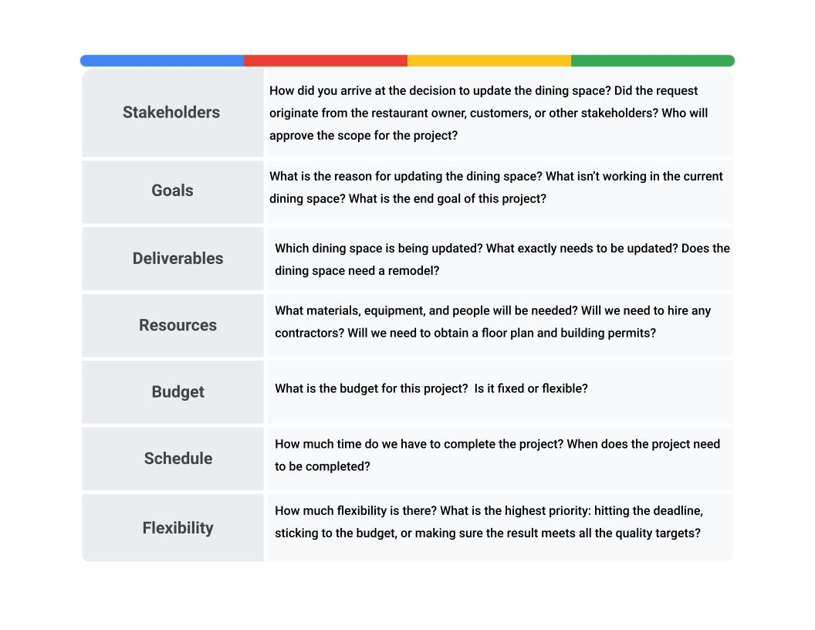

## ****Key takeaway****

Taking the time to ask questions and ensure that you understand the scope of the project will help reduce expenses, rework, frustration, and confusion. Make sure you understand the who, what, when, where, why, and how as it applies to the scope. If you are missing any of that information, focus your questions on those elements. The initiation phase of the project sets the foundation for the project, so ensuring that you understand the scope and expectations during this stage is essential.

# Strategies for controlling scope creep

In this lesson, we have discussed the importance of defining and documenting a project’s scope and how to identify scope creep factors that can affect reaching a project’s goal. In this reading, we will focus on how to control scope creep.

## ****Scope management best practices****

The scope of a project can get out of control quickly—so quickly that you may not even notice it. **Scope creep** is when a project’s work starts to grow beyond what was originally agreed upon during the initiation phase. Scope creep can put stress on you, your team, and your organization, and it can put your project at risk. The effects of scope creep can hinder every aspect of the project, from the schedule to the budget to the resources, and ultimately, its overall success. Here are some best practices for scope management and controlling scope creep:

* **Define your project’s requirements.** Communicate with your stakeholders or customers to find out exactly what they want from the project and document those requirements during the initiation phase.
* **Set a clear project schedule.** Time and task management are essential for sticking to your project’s scope. Your schedule should outline all of your project’s requirements and the tasks that are necessary to achieve them.
* **Determine what is out of scope.** Make sure your stakeholders, customers, and project team understand when proposed changes are out of scope. Come to a clear agreement about the potential impacts to the project and document your agreement.
* **Provide** **alternatives.** Suggest alternative solutions to your customer or stakeholder. You can also help them consider how their proposed changes might create additional risks. Perform a cost-benefit analysis, if necessary.
* **Set up a change control process.** During the course of your project, some changes are inevitable. Determine the process for how each change will be defined, reviewed, and approved (or rejected) before you add it to your project plan. Make sure your project team is aware of this process.
* **Learn how to say no.** Sometimes you will have to say no to proposed changes. Saying no to a key stakeholder or customer can be uncomfortable, but it can be necessary to protect your project’s scope and its overall quality. If you are asked to take on additional tasks, explain how they will interfere with the budget, timeline, and/or resources defined in your initial project requirements.
* **Collect** **costs for out-of-scope work.** If out-of-scope work is required, be sure todocument all costs incurred. That includes costs for work indirectly impacted by the increased scope. Be sure to indicate what the charges are for.

## ****Key takeaway****

You can only avoid scope creep if everyone involved in the project understands and agrees on responsibilities, boundaries, and timelines. Avoiding scope creep also requires clear communication, expectation management, and a well-defined path to your desired outcome. Following the strategies discussed here can help you proactively manage scope creep before it creeps into your project!

# Reviewing the Triple Constraint

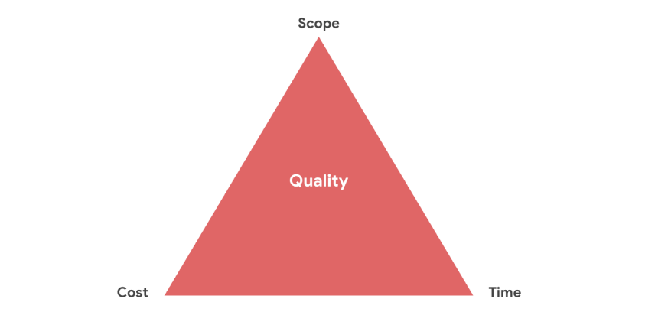

As you’ve just learned, project managers may refer to the **triple constraint model** to manage scope and control scope creep. It can serve as a valuable tool to help you negotiate priorities and consider trade-offs.

# Don't forget to land: Measuring project success

In this lesson, you are learning to distinguish the difference between a project launch and a project landing. Let’s focus here on the difference between launches and landings and how to ensure that your project will be completed successfully.

You will often hear companies celebrating the launch of a new product, service, or initiative, and it is important to remember that even when your project is out in the world, your work isn’t complete. When working on a project, the goal isn’t simply to launch it, but to landit. Landings occur once your project achieves a measure of success. As project managers, landings are what we strive for and what we celebrate. They are the ultimate reward for all of our efforts.



## ****Launching vs. landing a project****

In project management, a project “launching” means you have delivered the finalresults of the project to the client or user. You can’t solely base project success on when the client accepts the project, though. Your work on a project won’t be complete until you “land”it by thoroughly measuring the results. This is when the **success criteria** and the metrics you defined initially when setting SMART goals will come in handy.

Teams should be clear on what they are trying to accomplish, beyond just launching something to users. Will your project increase retention? Will your project speed up a product feature? Depending on the product and situation, the answers will differ, but it is important that your team aligns and works toward the same measurable goal.

## ****Launch first, land later****

Let’s consider an example: imagine you are a project manager for an eco-friendly organization. Your organization asks you to create a training program for middle school students in your county to teach them about the impacts of recycling. The county's goal is to increase recycling by 20% over the next five years. You gather your team and start developing the learning content to build out this training program. It takes you and your team one year to complete the research, development, and production of this training. When you hand over the training to the school district, you are launching the project. In order to know your project actually landed at the intended goal, you need to check back in periodically over the next five years to see if the training program is on target to produce a 20% increase in recycling in the county.

## ****Launch and forget****

A common mistake of many project teams is to “launch and forget” the results. This happens when a project manager delivers the project to the client and the client accepts the project delivery, but the project manager doesn’t assess if the project deliverables satisfy the customer or user. In the example above, if you didn’t check back periodically over five years to assess the results, you would have only launched—but not landed—the project. Launching and landings work in tandem to ensure true success.

A project landing shouldn’t create more hurdles. If done correctly, a landing creates greater alignment within the teams on the end results you all desire, and it gives everybody on the team better visibility on how to achieve success.

## ****Key takeaway****

Launching your project to the client can be a very big moment for you. You handed over the project to your client and now you can take a step back and breathe. But make sure you land your project, as well. Look over your notes, talk with your team, meet with the client, and remember to return to your intended deliverables and metrics to help you measure success.

Tracking and communicating success criteria

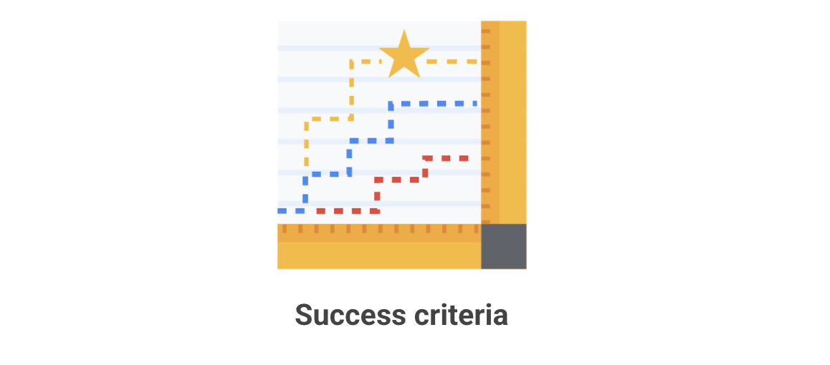

We recently covered the topic about launching and landing projects, and now we will turn our focus to ensuring that our landings are successful.

Recall that SMART goals are **S**pecific, **M**easurable, **A**ttainable, **R**elevant, and **T**ime-bound and help keep a project on track for success.

We can also determine the success of a project by the quality of the product, the ability to fulfill the needs of your customers, and the need to meet the expectations of your stakeholders. For this reading, we will discuss these particular success criteria, the metrics we use to track them, and how and why we communicate our findings.

**Product quality**

The product, or final result, of a project has its own set of attributes that define success. The product attributes that are necessary for the product’s success include completeness in features, quality of features, unit cost, usability, etc. The extent that a product is complete will contribute to the product’s success. This can apply to any project in which you deliver a product or tangible outcome at the end. To keep us on track for success, we can create a list of product requirements to ensure that you do not miss anything. For example, if the project produces word processing software, you need basic features like text entry, formatting, saving, and printing. Since you require each feature to have a functional word processor by today’s standards, you include these features on your checklist.

To measure the success of a product, consider including these metrics on your checklist:

* Track if you implemented the product’s priority requirements
* Track and assess the product’s number of technical issues or defects
* Measure the percentage of features you delivered or released at the end of the project

**What is important to the customers or stakeholders**

We have to pay attention to product metrics, but we also have to be mindful of stakeholder and customer additional expectations for features and objectives. In the word processor example, a stakeholder may want to add an additional functionality to easily create tables in a document with text. Additionally, a strategic goal of the organization could be to create word processor software with more collaborative ability than the word processors currently on the market. Each component is necessary in order to meet customer and stakeholder expectations. Think about what needs the project satisfies for your stakeholders or customers. These strategic goals tie back to the business case and the reason you initiated the project in the first place. Often, you can measure the fulfillment of strategic goals via user or customer metrics. Metrics to consider include:

* Evaluating user engagement with the product
* Measuring stakeholder and customer satisfaction via surveys
* Tracking user adoption of the product by using sales data

**Document, align, and communicate success**

Understanding where we are and where we are going helps the project team determine if they are on track. As you learned in the video on this topic, you need to get clarity from stakeholders on the project requirements and expectations. There are many people involved with any project, and success will look different for each of them. You want to ask questions, such as: Who ultimately says whether or not the project is successful? What criteria will be measured to determine success? What is the success of this project based on? It is best practice to get the key stakeholders or the steering committee to review and approve your success criteria. This becomes a mutual agreement on how all parties define the success of the project.

**Key takeaway**

Remember, all projects encounter change. All parties must have continuous access and alignment to the success criteria agreed upon to avoid scope creep (uncontrolled change of the project’s scope) or failed expectations at the end of the project. It’s important to document success criteria upfront and continue to report on it throughout the project.

# Using OKRs to evaluate progress

In this lesson, you are learning to define a project’s **success criteria**, the measurable attributes project managers use to determine whether or not a project was successful as a whole. This reading will focus on using **OKRs** to evaluate a project’s progress.

## Objectives and Key Results (OKRs)

You have learned that OKRs—Objectives and Key Results--combine a goal and a metric to determine a measurable outcome. Setting OKRs is a technique that can help project teams define, communicate, and measure shared success criteria.

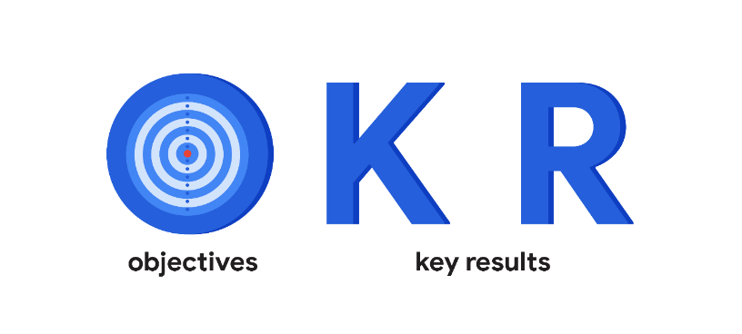



Objectives: Defines what needs to be achieved; describes a desired outcome. Key results: The measurable outcomes that objectively define when the objective has been met

## ****Communicating and tracking OKRs****

Conducting regular check-ins and actively tracking progress with your team can help ensure that objectives are being met and that any issues are resolved as soon as possible.

**Share your OKRs with your team.** Once you’ve created OKRs for your project, it’s important to communicate them to your team so that everyone knows how to focus and align their efforts. You can do this by sharing a digital document, presenting them in a meeting, or adding them to an internal website. OKRs can help your project team stick to its goals, monitor which are falling short, and be continuously motivated to meet project objectives.

**Assign owners.** Assign an owner to every key result so that everybody knows who’s responsible for what. This helps add clarity and increases accountability.

## ****Measuring progress****

Measuring your OKRs is an important part of tracking and sharing your progress. One shortcut to determining the status of a project is to score or grade your OKRs. While scores or grades don’t provide a complete assessment of a project’s success, they’re helpful tools for determining how close you came to achieving your objectives. You can then share your OKR scores with project stakeholders and team members as part of your overall project updates.

**Determine how you will score your OKRs.** OKRs can be scored in different ways. You can score based on a percentage of the objective completed, the completion of certain milestones, or a scale of 1 to 10, for example. You can also use a “traffic light” scoring approach, where red means you didn’t make any progress, yellow means you made some progress, and green means you completed your objective. The simplest approach to scoring OKRs is the “yes/no” method, with “yes” meaning you achieved your objective and “no” meaning you didn’t. Using this approach, a key result such as “Launch a new widget marketing campaign” might be graded a 1 or 0 depending on whether it was launched (1) or not (0). A more advanced scoring approach is to grade your key results on a scale. With this method, if a key result was to “Launch six new features” and only three new features were launched, the OKR might be graded 0.5. Generally, if the KR helped you achieve the objective, your OKR should receive a higher score; if it didn't, your OKR should receive a lower score. At Google, OKRs are usually graded on a scale of 0.0 to 1.0, with 1.0 meaning the objective was fully achieved. Each individual key result is graded and then the grades are averaged to determine the score for that OKR. **Set your scoring expectations.** With Google’s 0.0–1.0 scale, the expectation is to set ambitious OKRs and aim to achieve an average of at least 0.6 to 0.7 across all OKRs. For OKRs graded according to percentage achieved, the sweet spot is somewhere in the 60–70% range. Scoring lower may mean the team is not achieving what it could be. Scoring higher may mean the aspirational goals are not being set high enough.

**Schedule checkpoints.** It’s important to regularly communicate the status of project OKRs with your team and senior managers. For example, it can be helpful to have monthly check-ins on the progress of OKRs to give both individuals and your team a sense of where they are. Typically, at the end of the quarter, you’ll grade each of your OKRs to evaluate how well the team did to achieve its goals.

## ****Key takeaway****

OKRs can help you define and measure your project’s success criteria. In order for OKRs to be used to effectively meet your project’s success criteria, it’s important to share them with your team, assign owners to each key result to ensure accountability, measure your OKRs’ progress by scoring them, and track your OKRs’ progress by scheduling regular check-ins with your team.

# Review: The building blocks of a project dream team

In the previous video, we explored some considerations for choosing your project team and assigning their roles and responsibilities. Let’s recap what you learned and expand upon what to think about when building your project team.



## ****Too big, too small, or just right?****

Once you lay the foundation for your project by outlining your goals and expectations, it is time to build your dream team! Though before we can build our dream team, we need to figure out how many people we need. This number will largely depend on the size of the project itself. Complex projects with large divisions of work will usually require larger project teams. Simple projects with straightforward expectations may only require a few people on the project team. As a project manager, it is your job to help find the right balance based on what is needed.

## ****The right skills and abilities to fill the role****

Multiple roles exist in every project. On smaller teams, multiple roles may be filled by one person. To meet the needs of more specialized projects, project managers might require people who have the necessary **technical skills.** Technical skills are the skills specific to the task that needs to be performed. For example, on the Office Green project, necessary technical skills may include indoor landscaping design for the layout of the plants within the offices and floral design of plant arranging.

Technical skills are highly valued, but they are not the only skills that are important for high functioning teams. Interpersonal skills, also known as people skills or soft skills, such as patience and conflict mediation, can help team members. This allows the team to blend their technical expertise with collaborative skills in order to get the job done. When a team applies their interpersonal skills, they can minimize team-related issues.

**Problem-solving skills** are a must for all team members, especially when it comes to large, complex projects. As a project manager, you will not be able to solve every problem for your team. At some point, they will need to use their own judgment to problem-solve and get the work done.

An underrated skill set for project team members are **leadership skills.** Strong leadership skills help team members navigate organizational boundaries and effectively communicate with stakeholders to generate buy-in.

## ****Who is available?****

In projects, the availability of your team is always a big concern. This is especially true in Matrix organizations, where team members have multiple bosses. It is not uncommon to pull a team member onto another project before your project is complete. In a perfect world, you only pick those who can stay on the project for its entire life cycle. You may find that you don’t get to pick certain members of your team at all, which is called a pre-assignment. In these cases, the sponsor assigns team members to your project.

Keep in mind that you need to value diversity early on when building your team. On diverse teams, everyone is able to use their unique professional and personal experiences to contribute to a more successful project. Diversity is best leveraged when it is acknowledged and highlighted as an asset. Many people avoid discussing their differences, but if you encourage those conversations, you will find a richer understanding and greater creativity that comes from people working together across identity differences. To do this effectively, it is important to dedicate time early on in the team building process to develop trust between team members. Team members who understand one another are more likely to trust each other and feel safe sharing different points of view or offer a competing perspective. This will also allow them to more easily offer constructive feedback or be supportive if the team dynamics face challenges at any point.

## ****What motivates them?****

Be sure to take note of the motivation level of your team members and the impact it may have on your project. Just because a person is pre-assigned to a project, doesn’t necessarily mean they have low interest in it, but a person who proactively volunteered for it may have additional motivation to do the work.

As a project manager, it is your responsibility to engage your team and keep them motivated. This is where your influence as a leader is required to keep the team engaged and ready to overcome any obstacles that may appear. Engaging in a respectful manner and maintaining a positive outlook with your team during times of adversity are simple ways to keep your team motivated.

## ****Key takeaway****

In summary, team size, skills, availability, and motivation are the building blocks to creating your very own dream team. Always keep in mind that a project manager does not just select dream teams, they create dream teams through collaboration under great leadership. This is the leadership that you will provide as a project manager.

# Essential project roles

In this lesson, you are learning to define project roles and responsibilities. Let’s now build on what you have learned about building your project team and focus on how to further identify the core roles and responsibilities that are critical to any project.

## ****The project manager****

Although all team members are responsible for their individual parts of the project, the project manager is responsible for the overall success of the team, and ultimately, the project as a whole. A project manager understands that paying close attention to team dynamics is essential to successfully completing a project, and they use team-building techniques, motivation, influencing, decision-making, and coaching skills, to keep their teams strong.

Project managers integrate all project work by developing the project management plan, directing the work, documenting reports, controlling change, and monitoring quality.

In addition, project managers are responsible for balancing the scope, schedule, and cost of a project by managing engagement with stakeholders. When managing engagement with stakeholders, project managers rely on strong communication skills, political and cultural awareness, negotiation, trust-building, and conflict management skills.



## ****Stakeholders****

Have you ever heard the phrase “the stakes are high"? When we talk about “stakes,” we are referring to the important parts of a business, situation, or project that might be at risk if something goes wrong. To hold stake in a business, situation, or project means you are invested in its success. There will often be several parties that will hold stake in the outcome of a project. Each group’s level of investment will differ based on how the outcome of the project may impact them**.** Stakeholders are often divided into two groups: **primary stakeholders,** also known as key stakeholders, and **secondary stakeholders.** A primary stakeholder is directly affected by the outcome of the project, while a secondary stakeholder is indirectly affected by the outcome of the project.

Primary stakeholders usually include team members, senior leaders, and customers. For example, imagine that you are a project manager for a construction company that is commissioned to build out a new event space for a local catering company. On this project, the owners of the catering company would be primary stakeholders since they are paying for the project.

Another primary stakeholder could be the CEO of your construction company. If the CEO likes to be directly involved with projects for local businesses like the catering company, that would make them a primary stakeholder.

An example of a secondary stakeholder might be the project’s point of contact in legal. While the project outcome might not affect them directly, the project itself would impact their work when they process the contract. Each project will have a different set of stakeholders, which is why it’s important for the project manager to know who they are, what they need, and how to communicate with them.

## ****Project team members****

Every successful team needs strong leadership and membership, and project management is no exception! Project team members are also considered primary stakeholders, since they play a crucial role in getting the job done. Your team members will vary depending on the type, complexity, and size of the project. It’s important to consider these variables as you select your project team and begin to work with them. Remember that choosing teammates with the right technical skills and interpersonal skills will be valuable as you work to meet your project goals. If you are not able to select your project team, be sure to champion diversity and build trust to create harmony within the team.

## ****Sponsor****

The **project sponsor** is another primary stakeholder. A sponsor initiates the project and is responsible for presenting a business case for its existence, signing the project charter, and releasing resources to the project manager. The sponsor is very important to the project, so it’s critical to communicate with them frequently throughout all project phases. In our construction company example, the CEO could also be the project sponsor.

## ****Key takeaway****

Although the roles involved in each project will vary, all projects will include a project manager and primary stakeholders who are directly impacted by the project’s outcome, such as team members, senior leaders, the customer, and the project sponsor. Secondary stakeholders, whose work less directly impacts the project, may also play a role. Keep these roles in mind as we take a closer look at the importance of stakeholders.

# Prioritizing stakeholders and generating their buy-in

In this lesson, you are learning to complete a stakeholder analysis and explain its significance. Let’s focus here on how to prioritize the various types of stakeholders that can exist on a project, generate stakeholder buy-in, and manage their expectations.

## ****Conducting a stakeholder analysis****

**Stakeholders** are an essential part of any project. A project manager’s ability to balance stakeholder requirements, get their buy-in, and understand when and how to involve them is key to successfully fulfilling a project.

It is key to keep stakeholders organized in order to understand when and how to involve them at the right time. In an earlier video, we introduced the **stakeholder analysis,** a useful tool that project managers use to understand stakeholders’ needs and help minimize hiccups during your project life cycle.

Let’s review the key steps in the stakeholder analysis:

1. Make a list of all the stakeholders the project impacts. When generating this list, ask yourself: Who is invested in the project? Who is impacted by this project? Who contributes to this project?
2. Determine the level of interest and influence for each stakeholder—this step helps you determine who your key stakeholders are. The higher the level of interest and influence, the more important it will be to prioritize their needs throughout the project.
3. Assess stakeholders’ ability to participate and then find ways to involve them. Various types of projects will yield various types of stakeholders—some will be **active stakeholders** with more opinions and touchpoints and others will be **passive stakeholders,** preferring only high-level updates and not involved in the day-to-day. That said, just because a stakeholder does not participate as often as others does not mean they are not important. There are lots of factors that will play a role in determining a stakeholder’s ability to participate in a project, like physical distance from the project and their existing workload.

**Pro tip:** You might want to form a **steering committee** during some projects. A steering committee is a collection of key stakeholders who have a high level of power and interest in a project. A steering committee can influence multiple departments within the organization, which means that they have the potential to release a greater number of resources to the project manager.

## ****Visualizing your analysis****

A **power grid** shows stakeholder interest in the project versus their influence over the project. This four-quadrant tool helps project managers evaluate how to manage their stakeholders. It is used to determine the appropriate level of engagement required by the project team needed to gain the stakeholders’ trust and buy-in.

Take the time at the start of the project to establish your stakeholder approach. List the stakeholders and then place them into the appropriate places on the grid. Being able to visualize their placement will help you manage communications and expectations. Having a quick reference tool to drive your communication actions will also allow you to have the ability to spend more time doing other tasks on your project.

**Pro tip:** While these tools help organize information, they do not necessarily make the difference between successful and unsuccessful stakeholder engagement. What will make for successful stakeholder engagement is the project manager’s ability to know their stakeholders’ motivations and inspirations. This takes time, interpersonal skills, and insight into the organization’s internal political workings. Remember, each project is different, and your project may need tweaks along the way as you grow as a project manager. Making necessary changes means you are doing something right. Just make sure to check in and ensure that you are well on track, engaging your stakeholders successfully, and delivering on your project!

## ****Generating stakeholder buy-in****

Once you organize and assess your stakeholders, it is time to start making some decisions on whose buy-in is absolutely necessary for success, whose requirements deserve the most attention, and what level of communication each stakeholder will require.

Gaining key stakeholder buy-in is essential to ensuring that your project is not deprioritized or deprived of resources.

Tips for gaining key stakeholder buy-in include:

* Clearly mapping the work of the project to the goals of the stakeholder.
* Describing how the project aligns with the goals of the stakeholder's department or team.
* Listening to feedback from the stakeholder and finding ways to incorporate their feedback into the project's charter where appropriate.

Manage your stakeholders’ expectations by presenting a realistic view of your team’s abilities. Do not over-promise and under-deliver!

Building out a RACI chart

A **RACI chart** can be an extremely effective way to define project roles, give direction to each team member and stakeholder, and ensure work gets done efficiently. Having a RACI chart available throughout the duration of your project as a quick visual can be invaluable. In this reading, we will cover the function of a RACI chart and its components and explore how project managers use RACI charts to define and document project roles and responsibilities.

**Elements of a RACI chart**

A RACI chart creates clear roles and gives direction to each team member and stakeholder. Over your career, you may hear a RACI chart referred to as a Responsibility Assignment Matrix (RAM), RACI diagram,orRACI matrix. The ultimate goal of this chart is to clarify each person’s role on your project. First, let’s break down each of the roles people can be assigned:

**R**: Responsible: who gets the work done

**A**: Accountable: who makes sure the work is done

**C**: Consulted: who gives input or feedback on work

**I**: Informed: who needs to know the outcome

Note that RACI charts can be organized in different ways, depending on personal preference, number of tasks being assigned, and number of people involved. In the previous video, we showed you one RACI chart format. The template below shows another way a typical RACI chart might be organized.

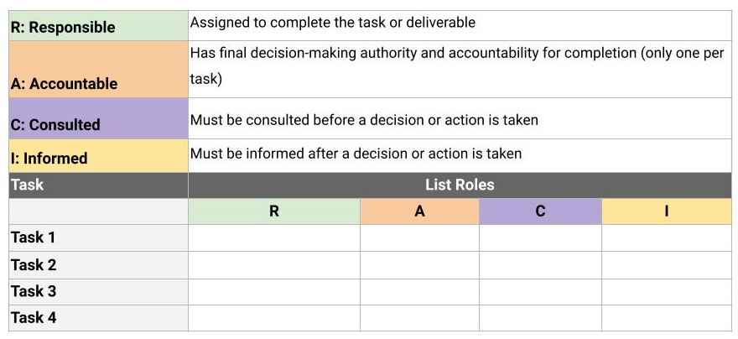

Let’s further examine each of the roles and how to determine which team member should be assigned to which role.

**Responsible**

Individuals who are assigned the “responsible” role for a task are the ones who are actually doing the work to complete the task. Every task needs at least one responsible party. It’s a best practice to try to limit the number of team members assigned to a task’s  responsible role, but in some cases, you may have more than one.

A couple of questions to ask yourself when determining which person or people should be placed in the responsible role for a given task are:

* What department does the work fall under?
* Who will perform the work?

It is helpful to evaluate the people on your team to determine the role that suits them. Remember that you may need to list roles rather than names, if some people take on more than one role.

Let’s dig deeper into our example with Office Green. Our task is to develop price points for the project, and the Financial Analyst will complete the work for this task. Therefore, we will list “Financial Analyst” in the responsible role for this task in the RACI chart.

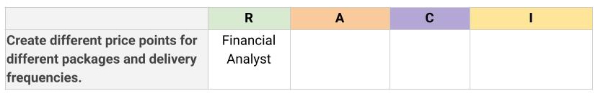

**Accountable**

The “accountable”person isresponsible for making sure the task gets done. It is important to have only one individual accountable for each task. This helps clarify ownership of the task. The accountable person ultimately has the authority to approve the deliverable of the responsible party. In order to determine who should be tagged as the accountable team member, consider:

* Who will delegate the task to be completed?
* Who will review the work to determine if the task is complete?

You may encounter a situation where the responsible party is also accountable, but where possible, it is helpful to separate these roles. Ensuring that accountability is not sharedensures that there is no confusion on who the ownership belongs to.

Continuing with our Office Green example, you have assigned the “accountable” role to the Head of Finance. The Head of Finance has to make sure the project stays in budget and makes a profit, so they have the ultimate authority over the price points for the product. Therefore, they will need to approve the Financial Analyst’s work on the task.

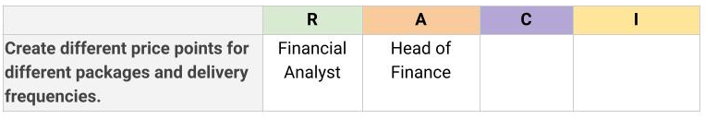

**Consulted**

Team members or stakeholders who are placed in the “consulted” role have useful information to help complete the task. There is no maximum or minimum number of people who can be assigned a “consulted” role, but it’s important that each person has a reason for being there. Here are a few ways you can help identify who is appropriate for the role:

* Who will the task impact?
* Who will have input or feedback for the responsible person to help the work be completed?
* Who are the subject matter experts (SMEs) for the task?

The consulted people will be in frequent, two-way communication with the responsible party, so it is key to make sure that the right people are in this role to help accomplish the task efficiently and correctly.

Back to the project at Office Green, we’ve got a “responsible” Financial Analyst and an “accountable” Head of Finance. Who else would need to provide input on the product’s price points? Whose decisions and feedback will directly affect the task? The Director of Product will need to be consulted on the matter, as they oversee all product offerings. This person will have information about potential changes to the product and how these changes might affect price points.

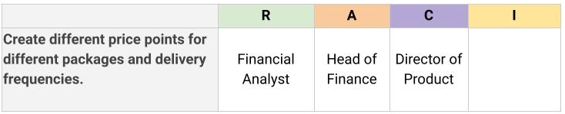

**Informed**

Individuals who are identified as needing to be “informed” need to know thefinal decisions that were made andwhen atask is completed. It is common to have many people assigned to this category and for some team members to be informed on most tasks. Team members or stakeholders here will not be asked for feedback, so it is key to make sure people who are in this group only require status updates and do not need to provide any direct feedback for the completion of the effort. Key questions to ask yourself in order to ensure that you have appropriately captured individuals in the “informed” role are:

* Who cares about this task’s completion?
* Who will be affected by the outcome?

Now that you’ve determined who is responsible, accountable, and consulted on the Office Green project task, it is time to determine who needs to be informed about the task. Your Financial Analyst has set the price points with input from the Director of Product, and the Head of Finance has approved. You will now need to inform the Sales Team about the final price points, as they will need this information to sell the product.

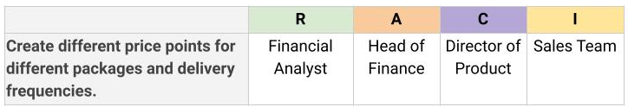

**Pro tip**: You could end up with a large number of team members and stakeholders who are placed in the “informed” role. If so, make sure that you have a plan to keep them informed that is not labor-intensive. Something as easy as view-only access to your project plan or meeting notes could prevent you from having to create separate communications along the way.

**Key takeaway**

The RACI chart is a valuable tool. It can help you define and document project roles and responsibilities, give direction to each team member and stakeholder, and ensure work gets done efficiently. A RACI chart can also help you analyze and balance the workload of your team. While it may take many revisions to make sure that your team members and stakeholders are being placed into the right roles in your RACI chart, doing this work up front helps save time and prevent miscommunications later on.

# Getting the most out of a RACI chart

In the previous video, you learned how critical a **RACI chart** is for creating clear roles and giving direction to each team member on a project. In this reading, we will further explore the function and components of RACI charts and how to use them to communicate responsibilities to project teams.

## ****Definition and structure****

Determining who is **R**esponsible, **A**ccountable, **C**onsulted and **I**nformed on your projects allows you to keep control of the stakeholders roles on your project.

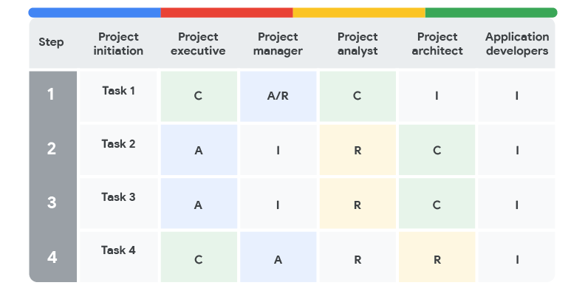

## ****Workload balance****

Are there too many tasks assigned to one stakeholder? When you complete your chart, it is a good idea to go back through and tally the number of Rs assigned to each stakeholder. This can help you identify potentially overloading one team member with work. Using a RACI chart to determine responsibility for tasks can help mitigate single points of failure (known as creating **silos**, where the knowledge and responsibility for a task falls on one person) and allow you, as the project manager, to delegate tasks and avoid burnout. Maintaining workload balance is a critical part of project management. It is easy to fall into the pattern of relying on your top performers to keep the project moving forward. But this isn’t always healthy for the project or your team. If you find that you don’t have the right people to assign responsibilities to, take a step back and evaluate your team.

## ****Put your RACI into practice****

Once you have created your RACI chart, it is time to put it into practice. You will first need to share your RACI chart with your sponsors and stakeholders to get buy-in and sign-off. When you get stakeholder buy-in, you will be able to set clear expectations for your team and ensure that everyone is aligned on their responsibilities.

You can document your team and stakeholders’ acknowledgment of these expectations through the project charter, meeting notes, and in the RACI chart itself. Think back to a time when you were expected to do something you did not agree with, or weren’t clear on. That disagreement or lack of clarity made it difficult to do your best work, right? Getting buy-in and continually checking in with your stakeholders and your team is the way to avoid this potential pitfall!

As you take the time to ensure that each task has an owner identified with the appropriate level of engagement, you are streamlining your communication and decision-making process over the life cycle of your project.

## ****When should you use a RACI chart?****

If you are wondering if you should use a RACI chart on your project, it is a good idea to evaluate the complexity of the effort. For example, if you have a very small project team with a small amount of stakeholders, clearly defined roles, and a short timeline, introducing a RACI chart could possibly slow down the project. However, larger projects, or even projects that involve a large number of stakeholders, could greatly benefit from a RACI chart. It is always a good idea to work through the creation of a RACI chart and evaluate the outcome. Even if you do not end up using the RACI chart, you will have a better understanding of the project, and your effort will contribute to your project management experience overall.

Managing resources to get the job done



As we continue learning the tools and techniques that will help you succeed in project management, let’s consider the importance of **project resources**. Project resourcesare who and what you depend on to complete a project, including budget, materials,and people.While each resource is a separate entity, they all depend on one another—your team cannot do the work without materials, and you cannot purchase materials without a budget. In this reading, we will discuss some key project resources and tips for managing them.

**Budget**

Have you ever created a budget for yourself or your family? If you have, you know that a budget includes a wide variety of expenses. For example, a monthly personal budget can contain items that include anything from food to transportation costs to rent. With only a certain amount of funding to cover each expense, it is important to closely monitor your spending to avoid going over budget. If you go over in one category of your budget, you will impact the others and will need to make adjustments. As a project manager, you will take the same general approach with your project budget. Common aspects of your project budget will include:

* Team: the cost of the people performing the work
* Services: any outside vendors helping your project
* Materials: any tangible items purchased to complete the project

Throughout your project management career, you will encounter various types of projects with a wide range of budgets. Some budgets will have no margin for error, whereas other budgets may be more flexible. Regardless of this variability, budget issues will inevitably arise, so it is important to make sure that the budget is aligned with the project scope and the stakeholders’ asks.

**People**

People are a vital resource on your project; you cannot complete your project on your own! You will need to rely on a strong team of people with a variety of skill sets and specialties to get the job done. As a project manager, make sure that you have commitmentandbuy-in on the number of hours it will take for your resources to complete their tasks. Additionally, you will find the best partners on a project are people who are aligned to the goals of the project or who are most interested in the project's work.

**Materials**

Materials can be different on every project. For example, if you were working on an IT project, materials could include hard drives and computers to handle the coding efforts. You can also have materials that are intangible. For example, on the same IT project, online storage, software programs, or employee training may also be considered materials. It is important to account for any and all potential materials in order to execute a successful project with the right people and within budget.

**Key takeaway**

Your project resources include things like the budget, people, and materials. As a project manager, remembering that your resources are dependent on one another is key to understanding the function of each resource and determining how to manage all of them. Take the time to interview stakeholders and potential team members about what resources they think they will need in order to deliver the project. They may have an idea of materials they require that you may not have accounted for within the budget, for example, or can identify people with expertise that would make them an asset to the project team.

Next, we will discuss project charters,which are an important tool that project managers use to gain clarity on the resources that they will need for a project.

Project charters: Elements and formats

A **project charter** clearly defines the project and outlines the necessary details for the project to reach its goals. A well-documented project charter can be a project manager’s secret weapon to success. In this reading, we will go over the function, key elements, and significance of a project charter and learn how to create one.

The charter is the formal way that the project’s goals, values, benefits, and details are captured. You can think of the charter as the compass for your project sinceyou will use it throughout the life cycle of the project. Many stakeholders will look to your project charter to ensure that you are indeed aligned with strategic goals and set up for achieving the desired end goal. Since the project charter carries so much importance, it is important to incorporate the right amount of detail while omitting miscellaneous elements.

As with any of your project documents, it is a good idea to collaboratewith your team and stakeholders early and often. Developing the project charter in collaboration with both groups can help you make sure that your project charter addresses your key stakeholders’ most important concerns and keeps your team aligned. Be sure to use thebusiness case—the reason for initiating the project—as the guiding direction to your project charter. Project charters can vary from organization to organization and from project to project. It is key for a project manager to identify the best type of charter for the project in order to capture the relevant information and set your project up for success. Project charters will vary but usually include some combination of the following key information:

* introduction/project summary
* goals/objectives
* business case/benefits and costs
* project team
* scope
* success criteria
* major requirements or key deliverables
* budget
* schedule/timeline or milestones
* constraints and assumptions
* risks
* OKRs
* approvals

You will likely use many different project charter formats throughout your project management career. One example is a condensed, simplified document, like the one you'll learn about in the upcoming video and the one linked in the activities. A short and simple project charter can be used on smaller projects that are not very complex.

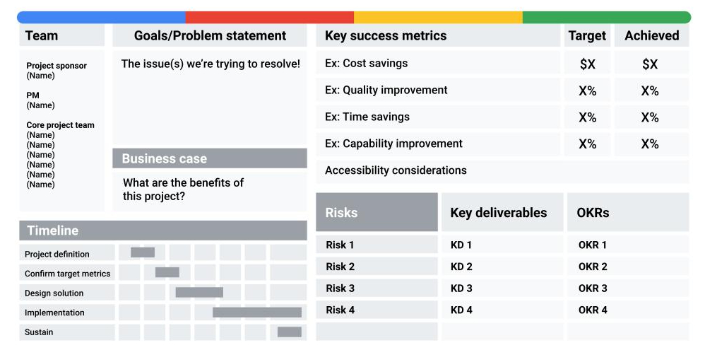

For more complex projects, you may link to additional analysis or documents. You can house these items in the appendix.

Your organization may have a unique template for you to use, or you may have the flexibility to leverage one you come across in your career. As your project progresses, you may also encounter revisions to your project charter—and that is okay. Remember, it is a living document; let it grow with your project, and **review and revisit it often** to ensure you are aligned.

Introducing new tools to a team

Project management tools and processes are always evolving. In this reading, we will discuss the importance of choosing the right tools for a project and the implications of introducing new tools to your team.

As a project manager, it is important to be open to implementing new tools that may be beneficial to a project's outcome. You will experience change in lots of forms throughout your project’s life cycle, and navigating change is essential. But if you choose to implement a tool that your team is unfamiliar with—especially if you decide to roll it out midway through a project—your team may be hesitant. People embrace change differently, particularly if the change will directly impact their routine and the way they work. Simply put: Change can be met with resistance.

Before you introduce a new tool to your team, you should be sure that this change is actually going to benefit the project, and ensure that those involved in your project understand the benefits of this change. Demonstrating to your teammates and stakeholders that you understand the tool and have evaluated its competency will help build trust, especially if this new tool is replacing an existing tool. Taking the time to introduce the new tool to your team members will also demonstrate that you have the best interest of the team in mind—not just the success of the project.



Here are some important considerations and keys to successfully introducing new tools:

* **Discuss the tool early and often, if possible.** The team should not feel blindsided by a new change. Make sure they know the change is coming as early as possible. This will help them prepare for an introduction or migration to the new tool.
* **Ask for feedback from key stakeholders.** You could get great feedback on features that you may have overlooked without asking for their expertise. You can solicit this feedback by requesting their input about functionality or have them list features in order of priority. The key is to create an opportunity for stakeholders to provide their feedback and allow you to incorporate their feedback into next steps.
* **Involve the key stakeholders in demonstrations as you get closer to making the final decision on the project tracking tool.** You will be able to leverage key stakeholders' acceptance by letting them test the product or sign up for a trial run. It is also important to make sure that the tool is actually going to meet the mark and provide a meaningful change for the project. You may want to pull in key users from your team to test and familiarize themselves with the tool prior to rolling it out. This will allow the team to get on board with your plans or discuss their concerns beforehand. This will also highlight in-house experts for future training, assistance, and implementation.
* **Ensure the tool is fully functional before the team is introduced to it.** Whenever possible, hold off from introducing the tool if it still has any issues. Make sure the tool is accessible for all users. Keep in mind, your team members may resist a tool that doesn’t live up to how it is supposed to function. This will impact implementation and acceptance fairly significantly, so put your best tool forward!
* **Set up training for the tool as needed before you ask the team to actually use it.** Everyone has different levels of comfort with different tools. It is your job as the project manager to ensure that each team members’ needs are addressed. Setting up training also helps create positive first impressions, which will lead to higher productivity and quicker, more successful implementation and acceptance.

Remember, some pushback is normal, but successful project managers should take the steps to prepare and mitigate any friction for their team when possible.

**Pro tip:** If time allows, plan for a period of transition if you are replacing an existing tool. It is common to allow both tools to operate during this period. You will need to “sunset,” or retire, the existing tool eventually, but allowing for a period of transition between using the old tool and the new tool can help stakeholders and team members feel more at ease and give them time to gain familiarity with the new tool. Be prepared for productivity to be impacted as the team transitions from one tool to another.

Demonstrating your knowledge of project management tools



During an interview for a project manager position, the interviewer may ask you to discuss the project management tools you are familiar with or have used in the past. There are many types of project management tools that you will come across during your career. These tools will continue to grow and change as technology improves. Being able to talk about these tools, and how you use them, will be crucial to landing the role.

In addition to the interviewer asking general questions about tools, they may ask more specific questions, like “How do you know if a project is off track?” It’s important to tie this answer back to the types of scheduling tools you have learned about in this course. If you haven’t had experience working with certain scheduling tools, like Smartsheet or digital spreadsheets—try to leverage real-life experience.

For example, have you ever planned for a move? If so, you can discuss how you planned your timeline and scheduled vendors so that you could meet your move date. Did you use a spreadsheet to keep track of your budget, schedule, and belongings? This experience demonstrates you understand how to use tools. It also demonstrates that you know the importance of creating, monitoring, and managing the project schedule to deliver results at project completion.

Another related question the interviewer may ask could be, “How do you execute tasks within your timeline?” This is a great opportunity to demonstrate your ability to be productive by sharing your experience with tools, such as digital documents or spreadsheets. These tools help you create project artifacts, track tasks, and store project details in one place! You can also use them as a collaboration tool because they are easily shareable with teammates and stakeholders and allow for real-time updates.

Finally, there are special project management tools, also called work management tools, that put all the benefits discussed above into one place. Project management tools such as Asana, Monday.com, Basecamp, and Trello are among some of the top ranked tools for managing projects.  These tools help you plan, track, and complete work across many project phases. They often have visually appealing layouts and automated features that save time and create efficiency in a project manager’s day-to-day tasks.  Explaining your knowledge of these tools—and how they benefit the project manager, team, and company—in an interview is a great way to demonstrate that you are qualified for the role.

**Pro tip:** Learn more by trying free tutorials or trial versions of popular project management tools. By navigating project management software, you will be able to explain the uses and functionality of these types of tools firsthand. Here are some examples to get started:

* [Asana](https://asana.com/) and [Asana Guide](https://asana.com/guide)
* [Basecamp](https://basecamp.com/)
* [Trello](https://trello.com/en-US)
* [Jira](https://www.atlassian.com/software/jira)
* [ClickUp](https://www.clickup.com/)
* [Monday.com](https://monday.com/)
* [Microsoft Project](https://www.microsoft.com/en-us/microsoft-365/project/project-management-software) or [Project Libre](https://www.projectlibre.com/) (open source)
* [Smartsheet](https://www.smartsheet.com/) ([Demo](https://www.youtube.com/watch?v=quGpnXiCUms))

# Build a project management tool tracker

As you progress through this course, you will learn about different types of tools used by project managers and the organizations that hire them. Tools can include software applications like Adobe, Google, and Microsoft and specific work management tools like Jira and Asana. They can also include methodologies, techniques, formulas and concepts, and technologies related to project management.

This reading provides step-by-step instructions for creating a tracker for all of these types of tools. You can use your tracker to list the different tools you learn about, their descriptions and links, their features and benefits, and your level of experience with each. This way, you can easily identify the tools required for different roles and can determine where you might want to focus your professional development efforts.

## ****Developing your tool tracker spreadsheet****

Follow these steps to begin creating your project management tool tracker:

### **Step 1: Create a new spreadsheet**

Start by opening a new spreadsheet using your preferred method. Some of the information has already been filled in for you as an example. Feel free to modify your Tracker in the way that works best for you.

### **Step 2: Add column headers**

Consider the different types of information you’d like to track about each tool, and add these as **column headers** in your tracker. (The header is the top cell or cells in a column in the spreadsheet.) Here are some example column headers:

* Tool Name
* Description/Benefits
* Link to product website
* Link to course content in Coursera
* Cost to use
* Requirements (training/equipment)
* Your current experience with the tool
* Notes

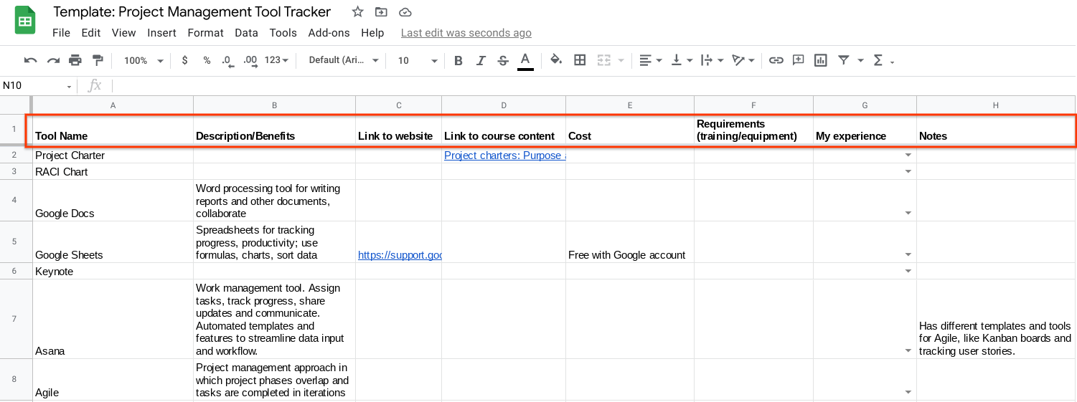

### **Step 3: Add tools and relevant information**

Review some of the course videos, readings, and activities so far that discuss project management tools. Select three or four tools and add the names to the tracker. Add any information you have about each tool to the different columns. To help you get started, the template has several tools listed that have already been mentioned in this course. Feel free to edit the list to include the tools that are most relevant to your progress.

You might not be able to fill in all the columns with information just from this course, so do your own research if necessary.

For example, we discuss the work management tool Asana in the video [Common project management tools](https://www.coursera.org/learn/project-initiation-google/lecture/T12Jz/common-project-management-tools), but we only cover some of the features and benefits. You can look up the Asana website online and add more information about what features are offered, along with pricing and system requirements.

### **Step 4: Format your sheet**

After you’ve added a few tools and some initial information, format your sheet by bolding column headers and adding drop-down lists, conditional formatting, or web links. Try out other formatting options like bolding, highlighting, or colors to make important text stand out. [Google Sheets training and help](https://support.google.com/a/users/answer/9282959#zippy=) contains articles with step-by-step directions for how to use all of these features and more.

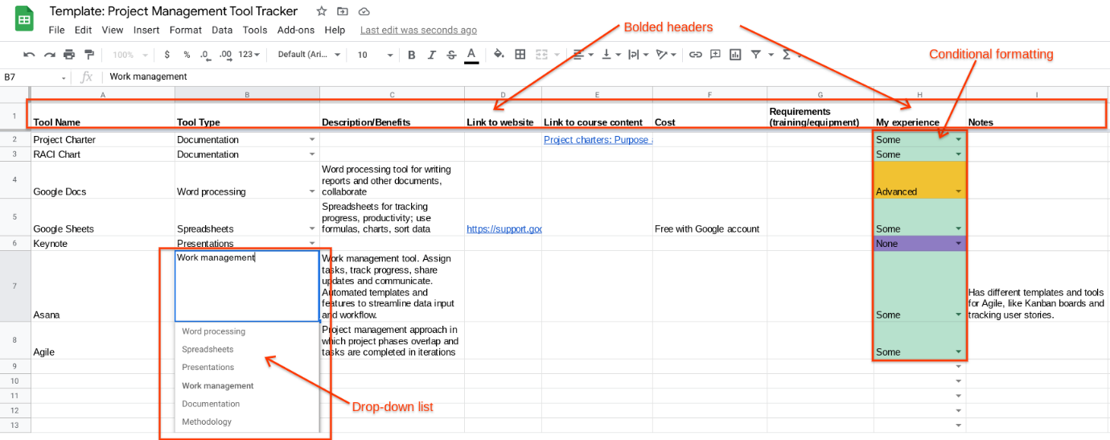

### **Step 5: Continue adding tools**

Continue to add more tools and information that’s relevant to your career goals. Search job listings and add tools, software, or specific knowledge needed for jobs you’re interested in.

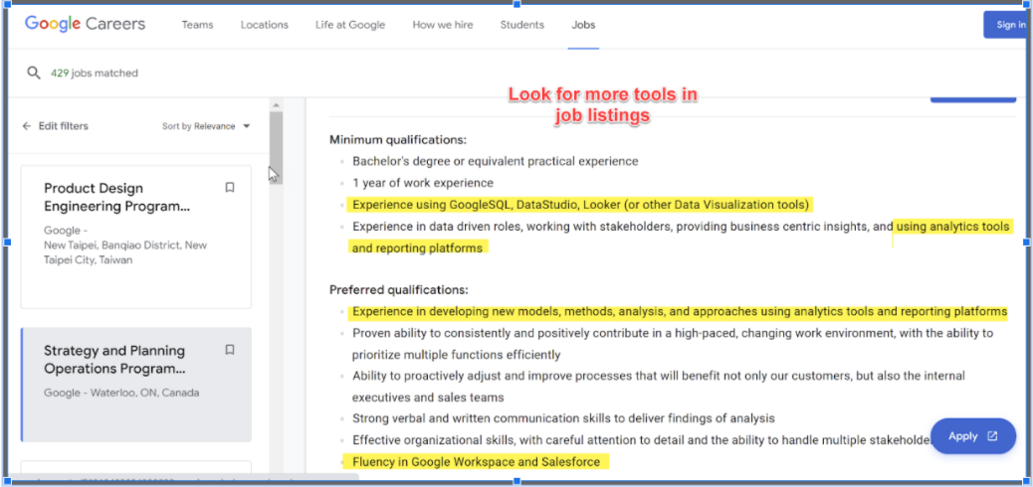

Tips for leading a successful kick-off meeting

In the previous video, you learned what a project **kick-off meeting** is and what it involves. As a reminder, a kick-off meeting is the first meeting among the project team, stakeholders, and the project sponsor at the start of a new project or new project phase. The purpose of a kick-off meeting is to ground everyone in a shared vision, ensure they understand the project’s goals and scope, and make sure that they are all on the same page about their roles and responsibilities on the project. The kick-off meeting is critical to a project’s overall success. It gets the team together to align on goals and visions for the project and sets the project up for success.

This reading will provide you with some tips for running an effective kick-off meeting.



**Kick-off meeting best practices**

* **Set the right time.** Choose a meeting time that works for everyone. Be mindful of time zone differences.
* **Set the right length.** Choose an appropriate meeting length—no more than one hour. You don’t want to waste people’s time, but you also don’t want to run out of time. Kick-off meetings work best when you first share key information and then spend any additional time on questions and team building.
* **Invite the right people.** Be strategic about including the appropriate people. The goal is to invite attendees who play a role in the development and execution of the project, such as all team members, stakeholders, and the project sponsor. You don’t want to leave anyone out, but you also don’t want to invite people who shouldn’t be there.
* **Designate a notetaker.** The discussion that takes place during the meeting is important. It is critical that you document any feedback, changes, or questions asked by attendees. If you are leading the meeting, designate someone else to take notes before the meeting starts. You can also use tools like Chorus Notetaker, Google Keep, Google Docs, or Microsoft OneNote.
* **Set the agenda.** To recap what we discussed in the video, a kick-off meeting agenda should generally include: introductions, the project background and purpose, project goals and scope, roles and responsibilities, the collaboration process and project tools, what comes next (expectations and action items), and time for questions and discussion.
* **Share the agenda**. Prior to the meeting, share the agenda with attendees via email and identify speakers for each topic. By sending the agenda in advance, everyone will have an idea of what to expect, time to prepare for anything they may need to present or discuss, and time to generate questions or ideas.
* **Stick to the agenda**. During meetings, discussions can sometimes go off topic or take longer than expected. As a project manager, it is your job to keep the meeting on track by redirecting discussions to the items on the agenda.
* **Follow up after the meeting**. After the meeting, make sure to send out a meeting summary featuring the meeting notes and any action items.

Setting milestones: Best practices

You have learned what milestones and tasks are and when, where, and how you will use them as a project manager. In this reading, we will explore best practices for setting milestones. But first, let’s revisit the definitions of tasks and milestones.

* A **project task** is an activity that needs to be accomplished within a set period of time and is assigned to one or more individuals for completion. The work of a project is broken down into many different project tasks.
* A **project** **milestone** is an important point within the project schedule that usually signifies the completion of a major deliverable. Milestones are significant checkpoints in your project, and keeping track of them helps ensure that your project is on schedule to meet its goals.

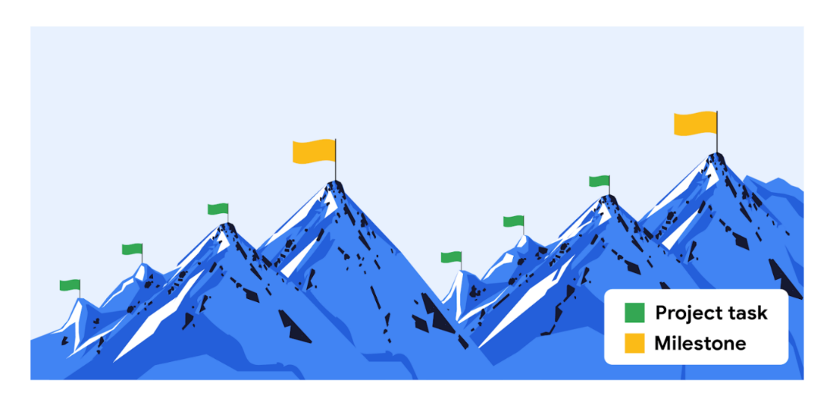

**Set tasks to identify milestones**

Setting tasks can help you clearly define milestones. You can do this in two ways:

1. **Top-down scheduling:** In this approach, the project manager lays out the higher-level milestones, then works to break down the effort into project tasks. The project manager works with their team to ensure that all tasks are captured.
2. **Bottom-up scheduling:** In this approach, the project manager looks at all of the individual tasks that need to be completed and then rolls those tasks into manageable chunks that lead to a milestone.

Most projects have many tasks that lead to milestones. For instance, if your milestone is to receive approval on the first draft of an article that you are writing, you might complete tasks such as “develop outline,” “write first draft,” and “send to the editor.” Then, you may have another set of tasks to achieve before reaching the milestone of revising the article. Milestones serve as check-in points along your project to make sure that you are headed in the right direction toward the end goal. Milestones also make projects more manageable.

**Integrate milestones into your project schedule**

There is not a consistent number of milestones in every project. Some projects will have a few milestones, while others may have dozens. Rather than aiming to hit a certain number of milestones, try to set milestones for the most important events in your project. Review your project schedule and identify important moments or checkpoints. In other words, pinpoint where in your project you will achieve major goals and make those points your milestones.

**Milestone-setting pitfalls**

Here are some things to avoid when setting milestones:

* **Don’t set too many milestones**. When there are too many milestones, their importance is downplayed. And, if milestones are too small or too specific, you may end up with too many, making the project look much bigger than it really is to your team and stakeholders.
* **Don’t mistake tasks for milestones**. Remember that milestones should represent moments in time, and in order to map out how you will get to those moments, you need to assign smaller tasks to each milestone.
* **Don’t list your milestones and tasks separately.** Make sure that tasks and milestones can be visualized together in one place, such as a project plan. This will help ensure that you are hitting your deadlines and milestones.

**Key takeaways**

Your approach to setting milestones may differ from project to project, but most projects will have at least one milestone and several smaller tasks associated with each milestone. Setting clearly-defined, distinct tasks, and milestones, integrating them into your project schedule, and using a tool that visualizes them together will help organize your project and drive it forward.

Breaking down the work breakdown structure

In the previous video, you were introduced to a major component of the planning phase: the creation of a **work breakdown structure** (WBS). A WBS is a deliverable-oriented breakdown of a project into smaller components. It’s a tool that sorts the milestones and tasks of a project into a hierarchy, in the order they need to be completed.

A thorough WBS gives you a visual representation of a project and the tasks required to deliver each milestone. It makes it easier to understand all of the essential project tasks, such as estimating costs, developing a schedule, assigning roles and responsibilities, and tracking progress. Think of each piece of information as part of the overall project puzzle—you can’t successfully navigate through the tasks without understanding how they all fit together. For instance, many smaller tasks may ladder up to a larger task or milestone.

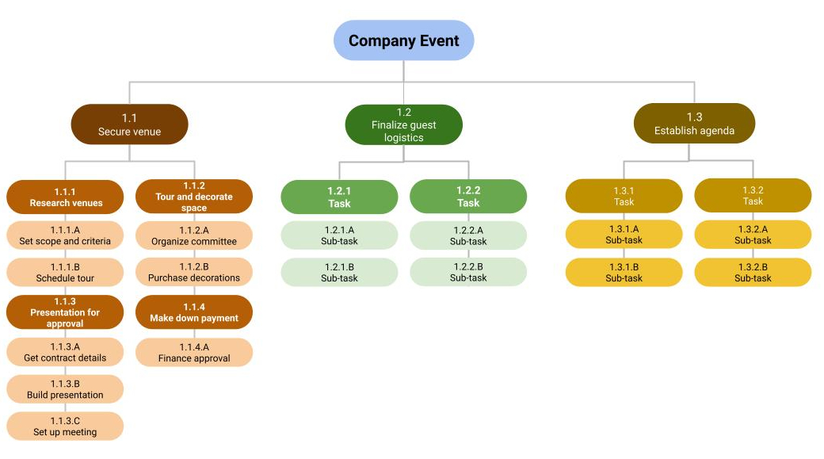

**Steps to build a WBS**

As a reminder, here are three main steps to follow when creating a WBS:

* **Start with the high-level, overarching project picture. Brainstorm with your team to list the major deliverables and milestones.** Example: Imagine you are planning a company event. Your major milestones might include categories like “secure venue,”  “finalize guest logistics,” and “establish agenda.”
* **Identify the tasks that need to be performed in order to meet those milestones.**Example: You could break a milestone like “secure venue” down into tasks like “research venues,” “tour and decorate space,” “make down payment,” and so on.
* **Examine those tasks and break them down further into sub-tasks.** Example: You could break down a task like “tour and decorate space” further into sub-tasks like “organize decorating committee,” “purchase decorations,” “assign decorating responsibilities,” and so on.

Putting together the pieces of a project plan

Every project plan is a living artifact that serves as your team’s roadmap throughout the project. We have covered some common elements of project plans, including tasks, milestones, people, documentation, and time. Let’s look at how these elements intersect with other important components to create a comprehensive plan for your project.

**How project plan components are connected**

You have learned that at the center of the project plan is the project schedule, which helps you estimate the amount of time it will take to complete the project and provides the team with a way to track the project’s progress against your goals. In addition to the schedule, you should also include the following components in your project plan:

* Scope and goals
* Work Breakdown Structure (WBS)
* Budget
* Management plans

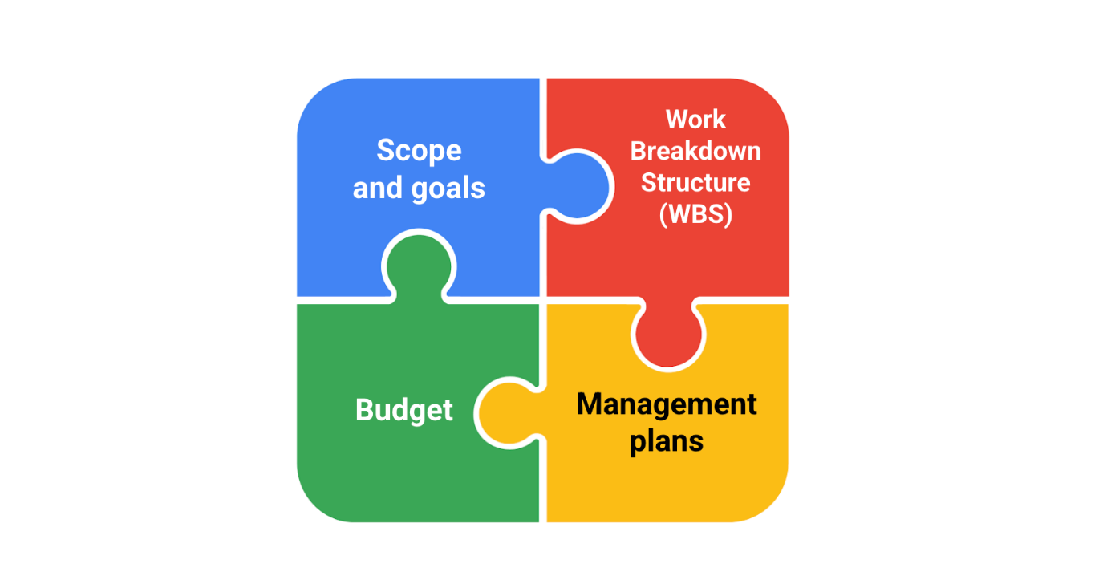

**Project scope and goals**

Both the project scope and goals will be captured initially in your **project charter**, the document that clearly defines the key details of your project. You can link your project charter in your project plan. Having details about the project’s scope and goals easily accessible can help remind your team of the objectives they are trying to accomplish and if anything is asked of them that goes beyond what was initially agreed upon in order to achieve those objectives.

**Work Breakdown Structure (WBS)**

As a reminder, a **Work Breakdown Structure** is a tool that sorts the milestones and tasks of a project in a hierarchy, in the order they need to be completed. The WBS is key to your project plan since it breaks the work down into more manageable pieces. In your project plan, the tasks should be visible in one place with clear descriptions, owners, and due dates. This will allow you and your team to understand who is responsible for which tasks and when each task is supposed to be completed. Your project plan should also contain detailed milestones and statuses related to these tasks, which will help you and your team members visualize project progress.

In addition to the WBS, further documentation—such as a RACI chart—will help define roles and responsibilities and would be useful to add to your project plan. Keeping this documentation stored or linked in one place is a best practice for transparency and effective communication.

**Budget**

Throughout the life cycle of your project, the budget will need to be managed and monitored. The project budget is often linked to the project plan because it is heavily dependent on key elements of the project. Linking these components allows for smoother management and visibility.

Depending on the size of your project and your organization, you may not be the primary person responsible for managing the project budget. For instance, if your project is at a large organization and the funds are managed by another department, you may not have as much autonomy or insight into all of the budget elements. As a result, you may not be able to monitor the budget closely. If someone in another department is managing the budget, make sure to have regular check-ins with them to ensure that you are aware of how you are tracking.

**Management plans**

Management plans—such as the change management plan, risk management plan, and communication plan—are all integral to keeping a project organized and on track and should be linked in your project plan. These plans will be discussed in detail in the coming lessons of this course.

**Key takeaway**

Project scope and goals, the Work Breakdown Structure (WBS), the budget, and management plans are all important components of your project plan. They help define how basic project plan elements—including tasks, milestones, people, documentation, and time—will be structured and utilized in your project. However, no one project plan will be the same. At Google, we work with a variety of different tools and templates to create and manage project plans. It is important to know your end goals and what is essential to you and your team in order to pull the relevant pieces of the project together.

# Case study: Run fast, pay later

**Time estimation** is used to predict the amount of time that will be required to complete a task. We have talked about how a central part of being a project manager involves planning. Carefully performing key steps of your planning process, such as time estimation, can have a big impact on the success of your project. Conversely, flawed time estimation is the root cause of many failed projects. That means many projects fail because project managers and teams fail to accurately estimate the time that it will take to complete tasks. Let’s discuss the following case study, which discusses how inaccurate time estimation can affect a project.

## ****Run fast, pay later: A case study on time estimation****



Kendra just scored a project manager role on a new project. It was a highly competitive bid, and the company and Kendra are eager to do a great job.

Kendra realized immediately that the timeline for the project would be almost impossible to execute. However, this was the first big project she was asked to manage. Therefore, instead of letting management know about the project’s impossible timeline, Kendra kept quiet and was determined to make it work. She rushed through the planning phase to get the team moving since time was ticking towards the project completion date. Kendra created all of the planning documents without input from her team or other stakeholders, with the sole intention of reaching the deadline.

During the team meeting, Kendra presented her project plan to the team. Right away, team members expressed their concerns with the timeline. They felt like there wasn’t enough time to complete their work, and they worried that the timeline didn’t incorporate enough time for reviews. Kendra documented the team’s concerns, but instructed them to simply work faster and make it happen.

As the project went on, the project faced schedule delays and other issues due to rework, previously unaccounted for tasks, stressed team members, and concerned stakeholders. Ultimately, the project missed its deadline. Later, the company did a retrospective to determine where things went wrong, and Kendra learned a lot of important lessons.

## ****Analysis of the case study****

Let’s break down the project planning process Kendra took and identify any missteps and corrective actions that would have helped set her team up for success.

### **Escalating concerns**

Kendra sensed the project timeline was problematic right from the start of the project. Instead of gathering information to support her concerns and sharing it with management, she decided to keep the issue to herself. She moved faster towards the goal instead of slowing down and planning the project thoroughly.

### **Working carefully**

If Kendra had taken the time to work carefully through the planning process, she may have been able to build a more realistic project plan to deliver the best product to the customer. She might also have identified potential time-saving activities that could have helped her team meet the project deadline. Thorough and careful planning with her team could have helped Kendra identify problems and solutions in advance, such as:

* **Elimination of tasks**. It is possible that all of the tasks initially listed didn’t need to be completed. There may have been unnecessary work added in, and the team could have completed the project without it.
* **Increased team size**. Kendra could have addressed the potential schedule risk by requesting more resources early on in the project rather than trying to execute without the necessary resources.
* **Streamlining of activities**. There may have been some tasks that could have been done in parallel, or at least not in sequential order.

### **Gathering input from the team**

Kendra should have brought together team members, peers, and management to help build and review her project plan, especially given the challenges of meeting the proposed project timeline. Kendra also didn’t take action to address the concerns of the team members who were responsible for completing the tasks within the estimated time.

In this case study, the project manager faced the repercussions of careless time estimates that resulted in rework and unplanned work. Most times, you can take a pain point in a project—like concerns about timelines—and turn it into an opportunity to be flexible and modify the plan to steer the project in a better direction.

## ****Key takeaway****

Be realistic when estimating time and effort for a project. Take the time to carefully evaluate potential risks and the impact on the work, and talk to your team members about these challenges. Don’t be afraid to escalate potential concerns to management. Optimism is a trait of a great project manager and leader, but it can adversely affect your projects when it comes to time estimation.

# Overcoming the planning fallacy

It is human nature to underestimate the amount of time and effort it takes to complete a task—from anything as simple as walking the dog to something as complex as completing a project. People generally want to remain hopeful about a positive outcome, and this is a great quality to have as a person. But as a project manager, this kind of optimism can also be a deficiency, especially during the planning phase of a project. Let’s examine a theory known as the **planning fallacy** to better understand how to set yourself up for success in the planning phase.

## ****The planning fallacy and optimism bias****

The idea of the planning fallacy was first introduced in a 1977 paper written by Daniel Kahneman and Amos Tversky, two foundational figures in the field of behavioral economics. The planning fallacy describes our tendency to underestimate the amount of time it will take to complete a task, as well as the costs and risks associated with that task, due to **optimism bias**. Optimism bias is when a person believes that they are less likely to experience a negative event. For example, when you are planning to walk your dog in between meetings, you might think that you can do it faster than you actually can. Optimism bias is what tells you that you are going to be able to walk your dog without being late for your next meeting. If you don’t consider things that might affect the time it will take you to walk your dog—the weather, the chance of them running into another dog and wanting to play, or the fact that they frequently get distracted while sniffing around—you might be late for your next meeting, or you might miss it altogether!

The planning fallacy can happen to anyone, regardless of whether or not they have experience completing similar tasks. Whether this is your first time walking your dog or your hundredth, you still have to consider the different factors that can affect how long it will take you to complete the walk. This same principle applies in project management. You may be brand new to this kind of project or you may have managed tons of similar projects before; either way, you still need to be careful not to underestimate the time it will take to complete each task on this particular project. As a project manager, you should aim to balance being aware of the planning fallacy with keeping an optimistic attitude about the project, even as things change. Be optimistically realistic: Push for the best outcomes while planning for the proper time it may take to accomplish each task.

## ****Avoiding the planning fallacy: A case study****

Think about the planning fallacy in relation to yourself as a project manager. If you have planned massive efforts in your project plan with an optimism bias, this planning fallacy could have a major impact on your project execution. You could set your team up for failure by not giving them enough time to complete their tasks, causing work to have to be redone or missing opportunities to execute the project more efficiently.

Let’s examine how this happens. David is a project manager responsible for a home construction project. Let’s check out his Work Breakdown Structure (WBS):

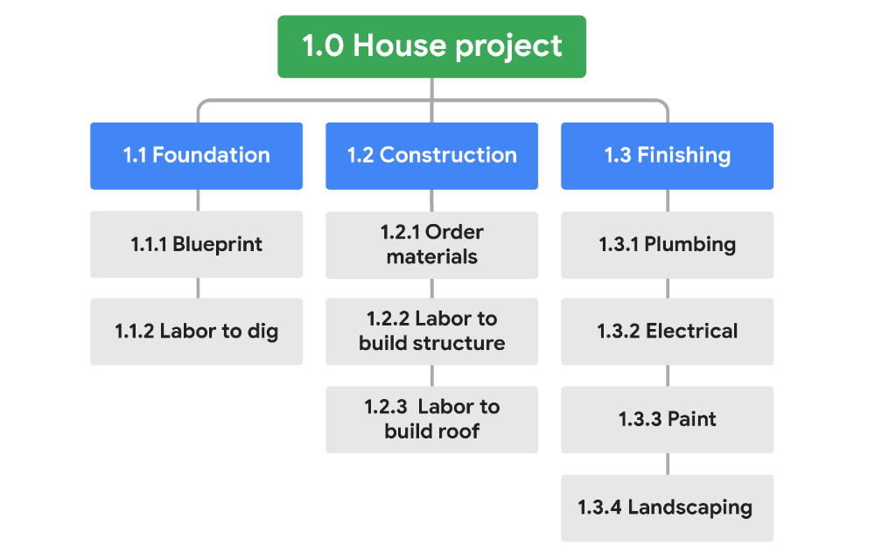

Image of a WBS diagram with tasks and milestones for building a house. Project title 1.0 House project. Milestone 1.1 Foundation, 1.2 Construction, and 1.2 Finishing. There are tasks underneath each milestone: 1.1.1 Blueprint, 1.1.2 Labor to dig, 1.2.1 Order materials, 1.2.2 Labor to build structure, 1.2.3 Labor to build roof. 1.3.1 Plumbing, 1.3.2 Electrical, 1.3.3 Pain, 1.3.4 Landscaping

Working through his plan, David knows that certain things need to happen for the house to be completed. He has to order materials, the materials have to be delivered, the contractor has to actually build the house, and there needs to be time for completing finishing touches and adjustments. The time estimations for those major tasks might break down like this:

| **Task** | **Estimated Duration** |
| --- | --- |
| Foundation | 2 weeks |
| Construction | 4 weeks |
| Adjustments | 4 weeks |

After creating a WBS and a time estimation chart, David estimates that the construction project will take a total of ten weeks. This sounds perfect because it meets his delivery requirement. If David is unaware of the planning fallacy, he may think his plan is solid and that his team is on their way to building the house within the target timeline!

Fortunately, David is mindful of the planning fallacy. He examines the time estimates more carefully. He considers risks like weather delays or crew members calling out sick, which could set the project’s completion date back. He meets with his team members and other stakeholders to help him uncover other possible risks that could affect the project timeline. After carefully gathering information, he adjusts the time estimates, adding **task buffers** to some of the project tasks to account for the potential risks.

## ****Key takeaways****

Being on the lookout for “what-ifs” is a key project management skill. Considering situations that could affect whether or not the project is completed on time can help you overcome the planning fallacy. Also, you will always have a project team in your corner, so make sure you use them as resources to help uncover possible risks. Remember to be “optimistically realistic” and push for the best outcome while still planning for the proper time to accomplish each task.

# Creating a critical path

As you’ve just learned, the **critical path** refers to the list of required project milestones you must reach to complete the project schedule, as well as the mandatory tasks that contribute to the completion of each milestone. You can think of the critical path as a framework that tells you, the project manager, where you are, where you are headed, and when you will get there.

## ****Why the critical path is critical****

The critical path helps you determine the essential tasks that need to be completed on your project to meet your end goal and how long each task will take. The critical path also provides a quick reference for critical tasks by revealing which tasks will impact your project completion date negatively if their scheduled finish dates are late or missed. A critical path can help you define the resources you need, your project baselines, and any flexibility you have in the schedule.

## ****How to create a critical path****

Each project you work on will be different, but there are some general steps for creating a critical path that are applicable to most projects.

### **Step 1: Capture all tasks**

When you first start working on your project schedule, you will capture all of the tasks associated with the completion of the effort. Remember to use the key planning documents you have created to get you to this point, such as your **work breakdown structure (WBS).** The main goal in this step is to make sure that you aren’t missing a key piece of work that is required to complete your project. When creating a critical path, focus on the essential, “need to do” tasks, rather than the “nice to do” tasks that aren’t essential for the completion of the project. Here is an example of critical tasks for building the structure of a house:

| **Task** |
| --- |
| A) Excavation |
| B) Foundation |
| C) Framing |
| D) Roof |
| E) Plumbing |
| F) Heating, ventilation, and air conditioning (HVAC) |
| G) Electrical |
| H) Insulation |
| I) Drywall + Paint |
| J) Flooring |

### **Step 2: Set dependencies**

Now that you have captured all of your critical tasks in list form, arrange those tasksin order of completion by identifying dependencies. To determine **dependencies**, figure out which tasks must be completed before other tasks can start. For example, you can’t paint the outside of a house before the house is built, so the task of framing the walls must come before the task of painting them. Identifying dependencies is key to a successful project schedule. To figure out dependencies for each task, ask:

* Which task needs to take place before this task?
* Which task can be finished at the same time as this task?
* Which task needs to happen right after this task?

Once you have answered these questions, you can list these dependencies next to your list of tasks:

| **Task** | **Dependency** |
| --- | --- |
| A) Excavation |  |
| B) Foundation | A) Excavation |
| C) Framing | B) Foundation |
| D) Roof | C) Framing |
| E) Plumbing | C) Framing |
| F) HVAC | C) Framing |
| G) Electrical | C) Framing |
| H) Insulation | E) Plumbing, F) HVAC, G) Electrical |
| I) Drywall + Paint | H) Insulation |
| J) Flooring | I) Drywall + Paint |

### **Step 3: Create a network diagram**

One common way to visualize the critical path is by creating a **network diagram**. Network diagrams, like the example below, sequence tasks in the order in which they need to be completed, based on their dependencies. These diagrams help visualize:

* The path of the work from the start of the project (excavation) to the end of the project (flooring)
* Which tasks can be performed in parallel (e.g., HVAC and plumbing) and in sequence (e.g., plumbing then insulation)
* Which non-essential tasks are NOT on the critical path

**Step 4: Make time estimates**

After determining tasks and dependencies, consult key stakeholders to get accurate time estimates for each task. This is a crucial step in determining your critical path. If your time estimates are significantly off, it may cause the length of your critical path to change. Time estimates can be reviewed and updated throughout the project, as necessary.

| **Task** | **Duration** | **Dependency** |
| --- | --- | --- |
| A) Excavation | 1 Day |  |
| B) Foundation | 3 Days | A) Excavation |
| C) Framing | 15 Days | B) Foundation |
| D) Roof | 3 Days | C) Framing |
| E) Plumbing | 4 Days | C) Framing |
| F) HVAC | 3 Days | C) Framing |
| G) Electrical | 3 Days | C) Framing |
| H) Insulation | 2 Days | E) Plumbing, F) HVAC, G) Electrical |
| I) Drywall + Paint | 15 Days | H) Insulation |
| J) Flooring | 7 Days | I) Drywall + Paint |

**Step 5: Find the critical path**

Now that you have your estimated durations for each task, add that information to your network diagram:

If you add up the durations for all of your “essential” tasks and calculate the longest possible path, you can determine your critical path. In your calculation, only include the tasks that, if they go unfinished, will impact the project’s finish date. In this example, if the “non-essential” tasks—like landscaping and driveway pavement—are not completed, the house structure completion date will not be impacted.

You can also calculate the critical path using two common approaches: the **forward pass** and the **backward pass**. These techniques are useful if you are asked to identify the **earliest and latest start dates** (the earliest and latest dates on which you can begin working on a task) or the **slack** (the amount of time that task can be delayed past its earliest start date without delaying the project).

* The **forward pass** refers to when you start at the beginning of your project task list and add up the duration of the tasks on the critical path to the end of your project. When using this approach, start with the first task you have identified that needs to be completed before anything else can start.
* The **backward pass** is the opposite—start with the final task or milestone and move backwards through your schedule to determine the shortest path to completion. When there is a hard deadline, working backwards can help you determine which tasks are actually critical. You may be able to cut some tasks—or complete them later—in order to meet your deadline.

Creating a project plan: Tools and templates

**Project plans** are critical because they are used to capture the scope and time it takes to complete a project. The project plan is essentially the project’s blueprint—it lays out all of the activities and milestones that your team needs to achieve in order to successfully complete the project. Project plans come in various shapes, sizes, and forms. Depending on the project you are managing, the template you use may vary, and some companies even have standard templates they require their project managers to use.

In the previous videos, you learned about various tools and techniques to create a project plan. But how do you know which tools and techniques to use and when? As a general rule, it is best to use a spreadsheet for a simple project and project management software for a more complex project. Regardless of what tool you use, be sure to include this key information:

* **Task ID numbers** or **task names**: You might end up with dozens, hundreds, or even thousands of tasks in a project. Assigning a task ID or name makes it easy to find and reference a task when communicating with team members and stakeholders.
* **Task durations:** A task duration is the amount of time you estimate that task should take. Adding task durations to your project plan helps you organize and prioritize the tasks in the project to help ensure you hit your goal on time.
* **Start and finish dates:** Including start and finish dates for each task helps you track whether you are progressing on time or not.
* **Who is responsible for what:** Including each team member’s role and responsibilities helps promote clarity and efficiency. As a best practice, assign an owner to each task, as well.

**Using a spreadsheet to build a project plan**

Spreadsheets are an excellent tool to use for project plans, particularly for projects that are less complex and that have a clear assignment of tasks. Spreadsheets can require a lot of manual input of information, but as a project manager, you may find that you like the control that spreadsheets provide. Spreadsheets are also customizable, so you can tailor them to your project’s needs.

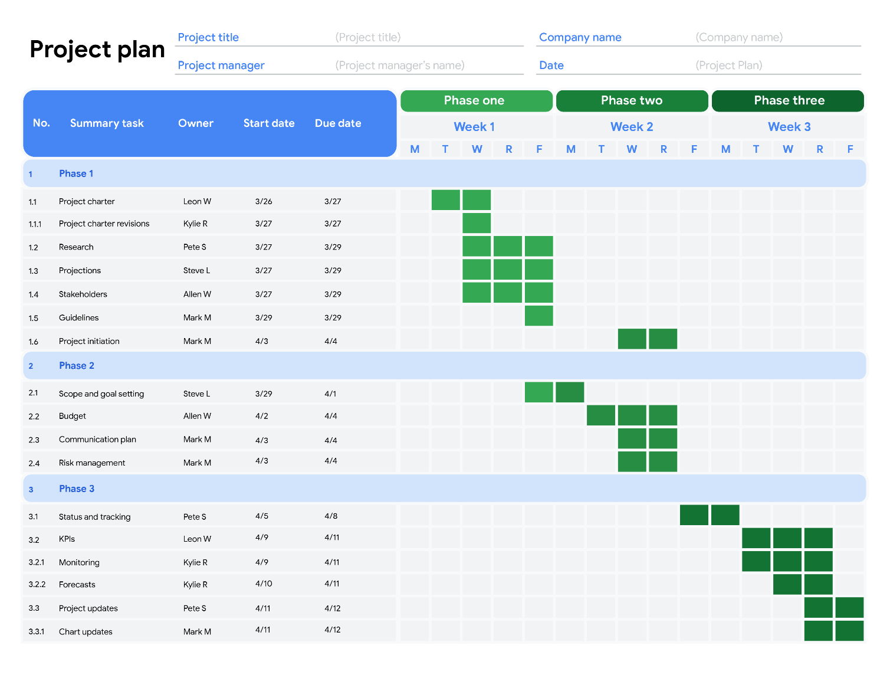

**Pro tip:** It is important to incorporate your **Work Breakdown Structure (WBS)** numbers into your project plan. In this example, the ID numbers directly relate to the WBS numbers, which is a helpful way to maintain consistency.

**Work management tools**

There are many work management tool options available for you to utilize when planning your project. We covered some of these in previous videos, but as a refresher, it is important to keep in mind that every company, project manager, and customer has a work management tool preference. You may come across tools like [Smartsheet](https://www.smartsheet.com/), [Asana](https://asana.com/guide/videos/anatomy-of-projects-and-tasks-chapter), [Jira](https://www.atlassian.com/software/jira/guides/getting-started/basics), [Trello](https://blog.trello.com/press-play-the-trello-tutorial-video-series-is-here), and many more**.** These tools allow for collaboration and communication at a task level.

**Key takeaway**

The tool you use to create your project plan should help you collect and track project details, manage your schedule, and visualize how your project is progressing. A clear, thorough, and organized project plan can help create the recipe for project management success.

# Introduction to Kanban boards

**Kanban boards** are a visual tool used to manage tasks and workflows. Kanban boards can be created on whiteboards, magnetic boards, poster boards, computer programs, and more. Tasks associated with the project are written on cards. These cards are placed in columns, which represent the progress made.

Although Kanban boards are useful for all kinds of projects, they are typically most suitable for project teams working in an **Agile** project management approach. You may remember that Agile project management is an iterative approach to managing projects that focuses on continuous releases and incorporates customer feedback with every iteration. Once you become a project manager and have created your project plan, you can decide whether a Kanban board is right for your project.

## ****Purposes of a Kanban board****

Kanban boards are used to:

* Give a quick visual understanding of work details and provide critical task information.
* Facilitate handoffs between stakeholders, such as between development and testing resources or between team members who work on related tasks.
* Help with capturing metrics and improving workflows.

## ****Using a Kanban board****

Before creating a board, it is best practice to gather the necessary information and lay out key elements, such as tasks, status, dates, and durations. That information is useful when building your board.

Let’s turn our focus to an example of a Kanban board below. Each colored rectangle is associated with a task. The tasks are represented horizontally across the effort timeline. Each column represents where the task is in relation to its completion. So as a task is started, it will move from to do, to in progress. When the project is almost ready to be released or complete, it will move to testing, and when it is tested and approved, it will move to done. Note that this is just one example of a Kanban board, and depending on the tool you use—such as software or a physical board—you can customize your board using various columns and cards. The board can also have rows for resources (team or person), to help visualize who is actively working on what.

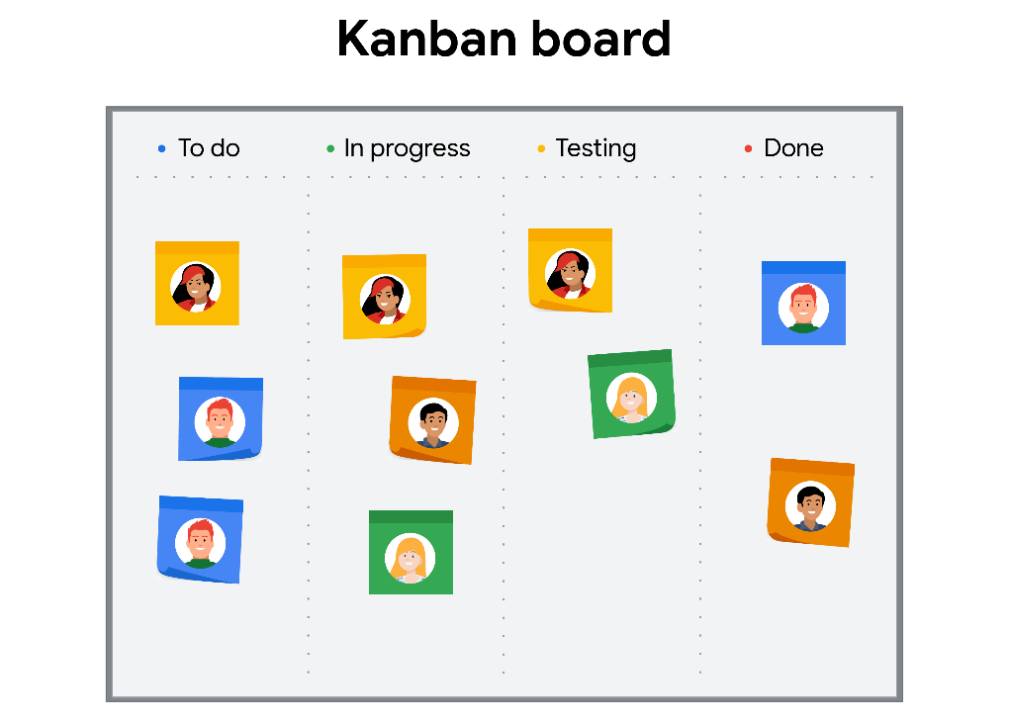

## ****Creating cards****

Cards will vary in style—you can even use sticky notes on a whiteboard—but most cards will contain a few key details about the task that they represent. When using physical cards, teams often use both sides. Here is what both sides of the card should include:

### **Front**

* **Title and unique identifier:** Make sure you have a quick reference for tasks and ID numbers.
* **Description of work:** Briefly describe the task to be accomplished. Remember that this is intended to be captured on something no larger than an index card.
* **Estimation of effort:** Estimate the amount of work it will take to complete the task. For example, you can write “small,” “medium,” or “large” to indicate the level of effort you think that task will involve.
* **Who is assigned to the task:** Indicate who is responsible for completing the task; ideally, one person per card.

### **Back**

* **Start date:** Include the start date of the task for use in metrics, tracking, and ensuring that your time estimate is accurate.
* **Blocked days:** Indicate which days your task may be halted. A task can become blocked if it can’t continue to be worked on. For example, if you were supposed to receive a deliverable and it hasn’t been delivered yet, then your day may be blocked for this particular task.
* **Finish date:** As with any plan, it is important to track when the task is supposed to be finished. This allows you to ensure that your project is still on track to reach the end goal.

## ****Kanban board software****

If you opt to use a software tool rather than a physical board, you have a few options. [Asana](https://asana.com/campaign/fac/do?&utm_campaign=Brand--NAMER--EN--Core--Desktop--Exact&utm_source=google&utm_medium=pd_cpc_br&gclid=CjwKCAiA_eb-BRB2EiwAGBnXXgSNmZBNteYCx_qCSNCrwIX88E1-ylvrWVp2Eo1v40T-_zJlrRJMLhoC_rAQAvD_BwE&gclsrc=aw.ds) and [Trello](https://trello.com/?&aceid=&adposition=&adgroup=105703214328&campaign=9843285532&creative=437184392320&device=c&keyword=trello&matchtype=e&network=g&placement=&ds_kids=p53016490704&ds_e=GOOGLE&ds_eid=700000001557344&ds_e1=GOOGLE&gclid=CjwKCAiA_eb-BRB2EiwAGBnXXu8rFvvUGLWv9hf9VmEdhuDwsBvv6vGL87E3W6ooJyfhEo6HjHYqBxoC06sQAvD_BwE&gclsrc=aw.ds) are both great software tools to use if you are looking to introduce Kanban to your project. There are many options, so take the time to evaluate which is best for you and your project.

# Project budgeting 101

A **project budget** is the estimated monetary resources needed to achieve a project's goals and objectives. In previous lessons, we covered a wide range of information related to project budgets. Let’s recap to make sure you have the information and tools you need to create and manage your project’s budget.

Budgets are typically created in the **initiation** and **planning phases** of your project. As with any other project management document, you need to continue to review and control the budget throughout the life cycle of your project. Your budget is more than just how much it will cost to complete the project—it is a helpful tool to reference when communicating with stakeholders and can double as a tracker for your project’s progress. Budgets also help controlyour costs and act as the baselinefor the financial portion of the project.

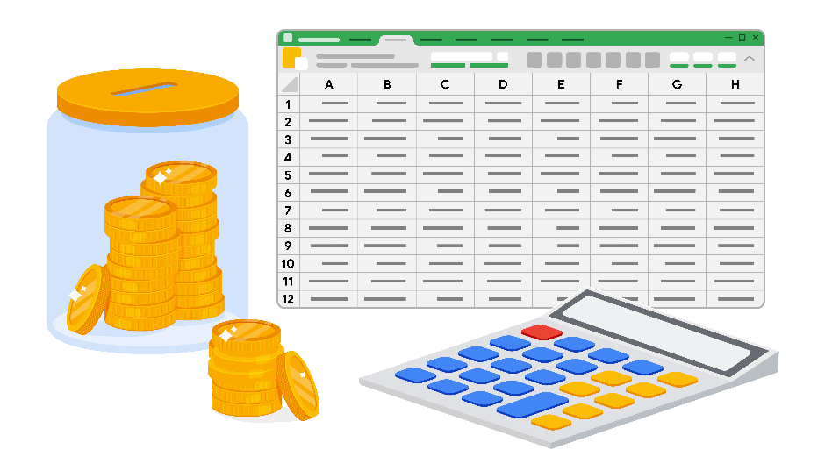

## ****Project budgeting best practices****

Here are a few tips to consider when creating your project budget:

* **Reference historical data:** Your project may be similar to a previous project your organization has worked on. It is important to review how that project’s budget was handled, find out what went well, and learn from any previous mistakes.
* **Utilize your team, mentors, or manager:** Get into the habit of asking for your team to double check your work to give you additional sets of eyes on your documents.
* **Time-phase** **your budget**: Time-phased budgeting allows you to allocate costs for project tasks over the projected timeline in which those expenses are planned to take place. By looking at your tasks against a timeline, you can track and compare planned versus actual costs over time and manage changes to your budget as necessary.
* **Check, check, and double check:** Make sure that your budget is accurate and error-free. Your budget will likely require approval from another department, such as finance or senior management, so do your best to ensure that it is as straightforward to understand as possible and that all of your calculations are correct.

## ****Categorize different types of costs****

There are different types of costs that your project will incur. For example, you may need to account for both **direct costs** and **indirect costs** in your project budget. Categorize these different types of costs in your budget so that you can ensure you are meeting the requirements of your organization and customer.

### **Direct costs**

These are costs for items that are necessary in order to complete your project. These costs can include:

* Wages and salaries of employees and contractors
* Materials costs
* Equipment rental costs
* Software licenses
* Project-related travel and transportation costs
* Staff training

### **Indirect costs**

These are costs for items which do not directly lead to the completion of your project but are still essential for the project team to do their work. They are also referred to as **overhead costs**. These costs can include:

* Administrative costs
* Utilities
* Insurance
* General office equipment
* Security

## ****Develop a baseline budget****

A **baseline budget** is an estimate of project costs that you start with at the beginning of your project. Once you have created a budget for your project and gotten it approved, you should publish this baseline and use it to compare against actual performance progress. This will give you insight into how your project budget is doing and allow you to make informed adjustments.

It is important to continually monitor your project budget and make changes if necessary. Be aware that budget updates can require the same approvals as your initial budget. Also, you should “re-baseline” your budget if you make significant changes. Re-baselining refers to when you update or modify a project's baseline as a result of any approved change to the schedule, cost, or deliverable content. For example, if you have a significant change in your project scope, your budget will likely be impacted. In this instance, you would need to re-baseline in order to adhere to a realistic budget.

## ****Perform a reserve analysis****

A reserve analysis will help you account for any buffer funds you may need. First, review all potential risks to your project and determine if you need to add buffer funds, also referred to as a contingency budget. These funds are necessary because new costs that you did not expect are likely to happen throughout the project. You may also want to account for cost of quality in your overall project budget. The cost of quality refers to all of the costs that are incurred to deliver a quality product or service, which can extend beyond material resources. This includes preventing or addressing issues with products, processes, or tasks, & internal and external failure costs. One example would be having to redesign a product or service due to defects. A defect could mean refunds to customers, time and money required to create a new product or service, and multiple other potential costs affecting the client.

## ****Key takeaways****

Budgeting in the project management world is a complex process involving many different parties and documentation, but following the best practices described in this reading can help break it down. Remember to use historical data and time-phasing, and reach out to your team for support. Make sure you are capturing all of the components of your budget, including direct and indirect costs. Finally, be sure to baseline your budget so you know where your money is being used and when. These tips can help set you up for budget management success.

# Helpful budget templates

In the previous lessons, you learned that projects come in all shapes and sizes—and so do their budgets. Budgets can be created in a simple spreadsheet or with more complex software programs. Determining which tool is right for you and your project will require input from your organization and your customer.

## ****Budget spreadsheet templates****

Budget templates are a useful tool for helping you estimate, track, and maintain a project budget. Below, you will find a few different budget templates that you can use for future projects. Each of these templates is formatted in a digital spreadsheet.

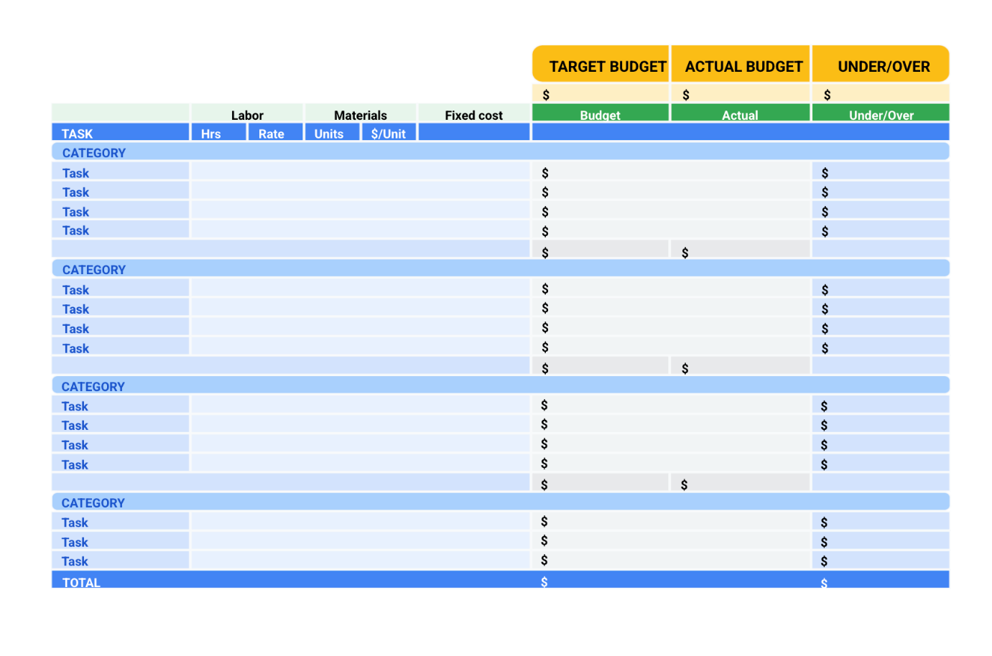

## ****Spreadsheet skills for budgeting****

When using a spreadsheet to track a budget, there are basic skills you will need to learn. Understanding how to use SUM and AVERAGE formulas, tables, and filters are just a few of the spreadsheet skills that will make your job as a project manager much easier. Make sure to check the course resources on spreadsheets for an introduction to these skills.

Tips for the procurement process

As you have learned, **procurement** means obtaining all of the materials, services, and supplies required to complete the project. You have just learned about the procurement process in project management. To recap, there are five steps in the typical procurement process:

1. **Initiating:** planning what you need to meet your project goals
2. **Selecting:** deciding which supplies and vendors to use
3. **Contract writing:** developing, reviewing, and signing contracts
4. **Controlling:** making payments and maintaining and ensuring quality
5. **Completing:** measuring your success

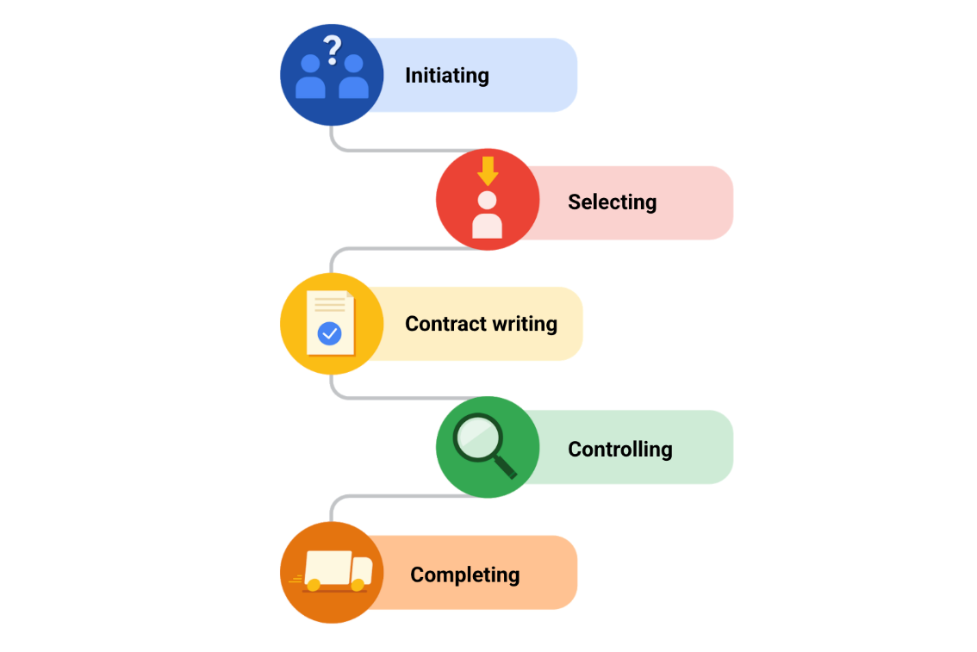

During each step of the procurement process, there are some tips that can help you save time and money while ensuring your project’s success.

**Tips for initiating**

While planning your project, figure out which materials, resources, and supplies you will need to get the job done. During this step, you will decide which items will be internally procured and which items will be externally outsourced. Once you’ve decided which items you need to outsource, compare each of those items specifications, components, quality measurements, standards, and characteristics with your project’s requirements. You may find that some of the items have features you don’t need. If you can identify those unnecessary features, you will know exactly what you want and don’t want in an item, possibly reducing your total cost.

**Tips for selecting**

Now that you have outlined what you need for your project, you need to determine vendors to source these items. Research and assess various vendors and suppliers, and try to find out if your preferred vendors have a reputation for delivering quality work on time. After you’ve identified your preferred vendors and suppliers, interview them to learn more about their products and services. If possible, make site visits to see exactly how each vendor runs their business in person.

**Tips for contract writing**

Contract writing requires excellent attention to detail, so pay close attention to the inclusions and exclusions in the vendor’s offer. There may be some items included in the vendor’s price that you can provide in-house at low or no additional cost. For example, the vendor’s offer may include charges for storing materials, using certain equipment, or labor. These are all things that you may be able to provide from your organization’s resources, so you can opt to save costs with the vendor on those items by using in-house materials and resources.

Sometimes, the vendor may write the contract. In this case, checking carefully for clarity and accuracy ensures that you know exactly what you are getting from the vendor. Whether the contract is written by you or by the vendor, you will almost always want to consult with a legal and compliance team to ensure that everything in the contract is ethical and legal.

**Tips for controlling**

The procurement process isn’t over when the contracts are signed. The next step is to ensure that the work is being done according to the terms of the contract. You will need to periodically review the performance and quality of each vendor. When communicating with vendors, remain professional but firm to ensure that all project requirements are being fulfilled and that all major milestones are being met on time and at cost.

Building and maintaining a good relationship with your vendors benefits the team and the overall project. This relationship will make it easier to make adjustments and contract revisions if the need arises. Taking certain measures, like conducting regular check-in meetings, will ensure that the work is being completed according to plan.

**Tips for completing**

In the completing step of the procurement process, you will measure the success of your procurements. Ask yourself:

* Were the materials created good quality?
* Were there any issues with labor contracts?
* How were your relationships with vendors?

During this step, it is also important to document any lessons learned. It is likely that you will be involved in another project similar to this one in the future. Take notes about how the procurement process went so you can use this information on a future project.

**Key takeaways**

Procurement is an ongoing process that can be repeated during the life cycle of a project. You may initiate the procurement process several times over if you need additional deliverables. To do so, you will likely evaluate your current vendors—or select new ones if necessary. If you change vendors or contract terms, you will have to write new contracts. It is important to periodically review the quality of each vendor during the controlling phase and, once everything is finished, document the lessons you learned during the completion phase.

# Avoiding ethical traps in procurement

Now that you have learned about the importance of ethics when conducting procurements, let’s talk about some potential ethical traps you might face and how to navigate them.

## ****Understanding ethical traps****

An **ethical trap** is an ethical dilemma that causes us to make a certain decision without regard for our ethical principles. You may face ethical traps throughout the course of a project. However, ethics can be of particular concern when it comes to procurement. As you have learned, project managers must take precautions to ensure that they and their suppliers are following ethical principles during the procurement process.

## ****Common ethical traps****

Sometimes, potential ethical issues can be overlooked or can be considered the necessary cost of doing business. This is a dangerous line of thinking since these types of assumptions can put your project, company, and career at risk. To review what we discussed in the video, a few of the most common ethical traps that exist when conducting procurements are corruption and bribery, sole-supplier sourcing, and interactions with state-owned agencies.

### **Corruption and bribery**

You may be confronted with different types of corruption when going through the procurement process. One form of corruption is when a vendor seeks to reduce the competition for a contract during the bidding process. A company may attempt to bribe members within the organization to sway their decision into a favorable outcome for the vendor. Bribes may include things like money, gifts, tickets to events, and more. Another type of corruption scheme is to offer a certain percentage of an awarded contract—also known as a kickback—to an official who can ensure that their company wins the bid.

### **Sole-supplier sourcing**

In some situations, having a vendor who a company is already familiar with smooths the procurement process and works well for both parties. Ethical issues arise when other vendors aren’t even allowed to bid for contracts for which they are similarly qualified. With **sole-supplier sourcing**, vendors may reach out to buyers before a bid is even requested. When the buyer’s organization decides to work with that vendor based on their previously-established relationship, that limits competition before the bidding has even begun. When this happens, companies and the public miss out on the advantages of competition, such as reasonable pricing, product quality standards, or speedy delivery options.

### **Interactions with state-owned entities**

There are some instances in which government agencies require an organization to adhere to stricter ethical standards than they might have otherwise. Most government regulatory agencies exist because a company or an entire industry has ranked profits over their workers or the environment. Governmental agencies such as the Food and Drug Administration and The Occupational Safety and Health Administration, for example, keep businesses within legal and ethical standards. If you are unfamiliar with any governmental restrictions that may affect your industry, organization, or project, you could unintentionally fall into an ethical trap.

## ****Avoiding ethical traps****

Here are some guidelines that will help you avoid falling into ethical traps when it comes to procurement: **Understand the legal requirements for your procurements.**

Every country has regulations to adhere to when conducting business in that country. Be sure to research the legal and ethical requirements based on your project and procurement needs, and if your organization has a legal team, make sure to lean on them for support and advice.

### **Stick to your ethical codes.**

Honesty, responsibility, respect, and fairness are the values that underpin ethical behavior in the project management profession. The Project Management Institute’s (PMI) [**code of ethics**](https://www.pmi.org/about/ethics/code) provides detailed guidelines to help ensure you maintain ethical conduct in your projects.

### **Test your ethics.**

When you face an ethical dilemma, ask yourself questions in each of the following categories:

* **Shame:** Would you be ashamed if someone knew what you did?
* **Community:** Would you want your friends to know the decision you made?
* **Legal:** Would you face legal action if you took this action?
* **Situation:** Would your actions be justified in this situation?
* **Consequence:** Would a negative outcome be worth your actions?

## ****Key takeaway****

Making a decision when facing an ethical dilemma can be challenging. But learning the legal requirements for your procurements, sticking to a professional code of ethics, and testing yourself on the ethics of your decision making can help you avoid ethical traps and conduct your procurements honestly, responsibly, and fairly.

# Phases of risk management

In a previous video, you learned that **risk management** is the process of identifying and evaluating potential risks and issues that could impact your project. Risk management is an ongoing practice throughout the life cycle of your project. It typically involves some variation of these five steps:

1. Identify the risk.
2. Analyze the risk.
3. Evaluate the risk.
4. Treat the risk.
5. Monitor and control the risk.

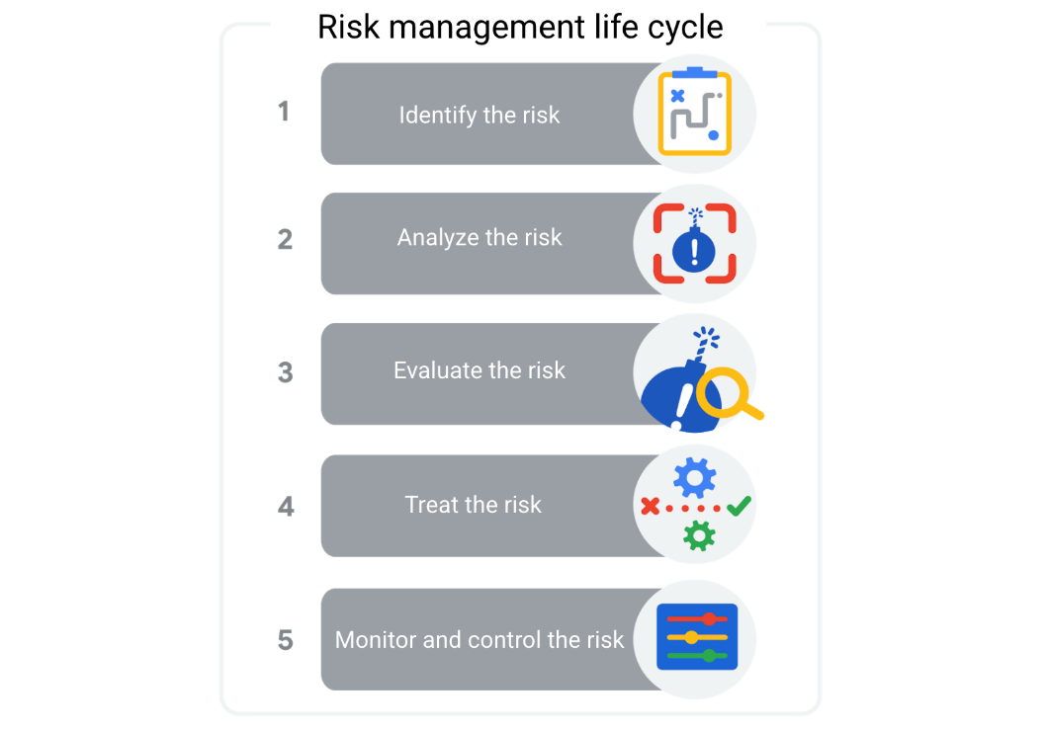

Let’s break these down:

1. **Identify the risk.** The first phase of the risk management process is to identify and define potential project risks with your team. After all, you can only manage risks if you know what they are.

2. **Analyze the risk**. After identifying the risks, determine their likelihood and potential impact to your project. Serious risks with a high probability of occurring pose the greatest threat.

3. **Evaluate the risk**. Next, use the results of your risk analysis to determine which risks to prioritize.

4. **Treat the risk**. During this phase, make a plan for how to treat and manage each risk. You might choose to ignore minor risks, but serious risks need detailed mitigation plans.

5. **Monitor and control the risk.** Finally, assign team members to monitor, track, and mitigate risks if the need arises.

In the upcoming videos and activities, you will learn about each of these phases in more detail and use tools and templates to navigate the risk management process.

Uncover opportunities using risk management

When you think about risks, it is likely that you automatically think of potential negative events. But when identifying risks, it is important to also consider the good things that could happen, which are considered **opportunities**. An opportunity is a potential positive outcome of a risk. It is important to recognize opportunities and to capitalize on them as they appear so you can reach your project goals faster, more cheaply, or with less effort. Some examples of opportunities include:

* Completing a milestone ahead of schedule
* Discounted materials
* Availability of additional resources (people, investments, equipment)



**How to recognize an opportunity**

An **opportunity** is a potential positive outcome that may bring additional value to a project. You can use the same tools and techniques that you use in risk management—identify, analyze, evaluate, treat, and control—to add potential opportunities to your risk management plan. You need to know what to do if things go wrong, but you should also make plans to seize opportunities. By using techniques such as brainstorming and drawing on project history or prior experience, you can identify potential opportunities and outline how you will take advantage of them if they occur.

# How to create a fishbone diagram

Previously, you learned about some tools to help you identify risks. In this reading, we will dive deeper into how to create and use one of those tools: the **fishbone diagram**.

Fishbone diagrams—also known as **Ishikawa diagrams** or **cause-and-effect diagrams**—were developed by Japanese organizational theorist Kaoru Ishikawa in the 1960s to measure quality control processes in the shipbuilding industry. Fishbone diagrams are a visual way to look at cause and effect. They are called fishbone diagrams because they have a similar shape to a fish skeleton.

Fishbone diagrams help the team to brainstorm potential causes of a problem or risk and sort them into useful categories. These categories show the areas that you should focus on to mitigate that risk. Fishbone diagrams are also very helpful in finding the root cause of a problem. A **root cause** is the initial cause of a situation that introduces a problem or risk. The purpose of using fishbone diagrams in risk management is to identify the root cause of a potential problem for a project or program.

**Case study: Using a fishbone diagram to identify causes of risks**

Miguel is a project manager at Office Supply Inc. He is in the planning phase for an upcoming summer promotion project, which will include free delivery of products. Unfortunately, in the past, the company has had trouble delivering its products to downtown office buildings on time. Miguel builds a fishbone diagram to see if he can identify some of the possible causes of this problem in order to mitigate this risk on the current project. He follows these steps to build his diagram:

### **Step 1) Define the problem**

First, Miguel clearly defines what the problem entails. In this case, Miguel states the problem as “trouble delivering products to downtown office buildings on time.” Then he adds the problem to the head of his fishbone diagram.

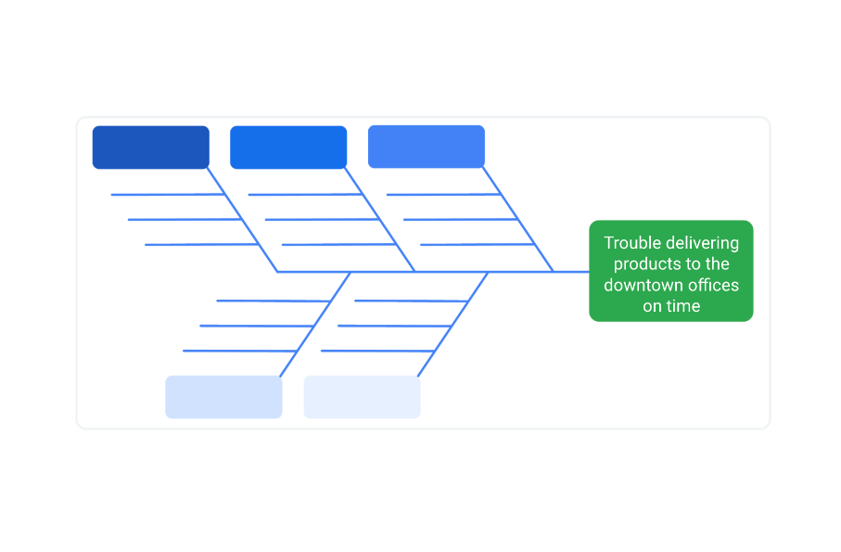

### **Step 2) Identify the categories**

In this step, Miguel thinks of the types of categories that could be causing the problem. These categories will change depending on the type of problem or industry. Some common examples of categories include “people,” “technology,” “materials,” “transportation,” “money,” “time,” “environment,” and “procedures.”

For the delivery problem at Office Supply Inc., Miguel lists the categories “people,” “technology,” “materials,” “transportation,” and “environment” at the top and bottom of the lists to the left of the problem in his fishbone diagram.

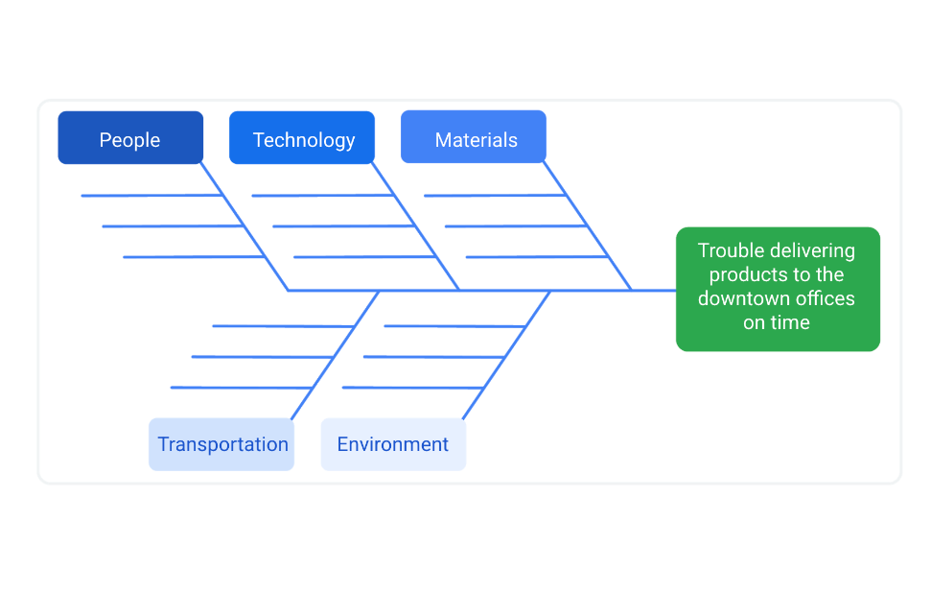

Fishbone diagram with the categories and problem filled out listed in the reading. Categories include “people,” “technology,” “materials,” “transportation,” “money,” “time,” “environment,” and “procedures.”

### **Step 3) Brainstorm the causes**

Now that Miguel has identified possible categories that relate to the risk, he brainstorms areas of concern within each category. He reaches out to his team for help in identifying these possible causes. Then, Miguel fills in the lists with some of the causes that could be related to each category.

**Pro tip:** Brainstorming should be a judgment-free zone. Encourage the flow of information related to the categories and try not to rule things out. When dealing with human factors, steer clear of naming individuals; instead, focus solely on behaviors.

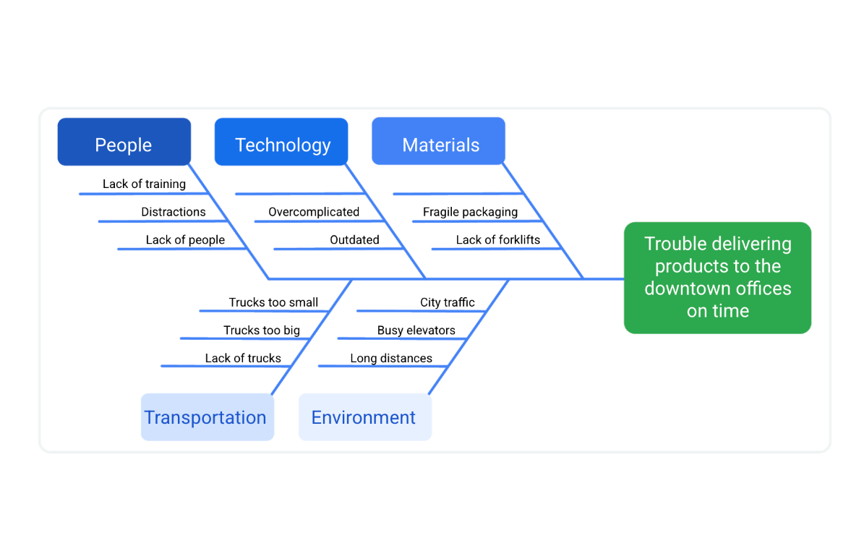

Fishbone diagram with the categories, possible causes, and problem filled out listed in the reading. New causes for "people" include lack of training, distractions, lack of people. For "technology" include overcomplicated and outdated. For "materials" include fragile packaging and lack of forklifts. For "transportation" includes trucks too small, trucks too big, and lack of trucks. For "environment" includes city traffic, busy elevators, and long distances.

### **Step 4) Analyze the causes**

Now that Miguel has discovered several possible causes for the delivery problems to downtown offices, he analyzes those causes. He needs to identify the root cause of the existing problem so he can figure out how to mitigate it for the current project.

Note that one cause of a problem isn’t necessarily theroot cause. For example, Miguel has identified that a lack of forklifts is a problem. Having more forklifts would allow the company to get the products on and off of the trucks more quickly. However, after calculating the amount of time it takes to unload and load the products, Miguel realizes that adding more forklifts won’t significantly reduce the amount of time to get the products from the warehouse to downtown offices. Therefore, this is one cause of the problem, but it is not the root cause.

On the other hand, Miguel has noticed that there is no set schedule for sending out deliveries. Since the problem only exists in the city instead of in the suburban areas, he realizes that traffic must also be playing a role in the late deliveries. Therefore, changing the schedule so that the delivery times are before the city’s rush hour may help fix the problem.

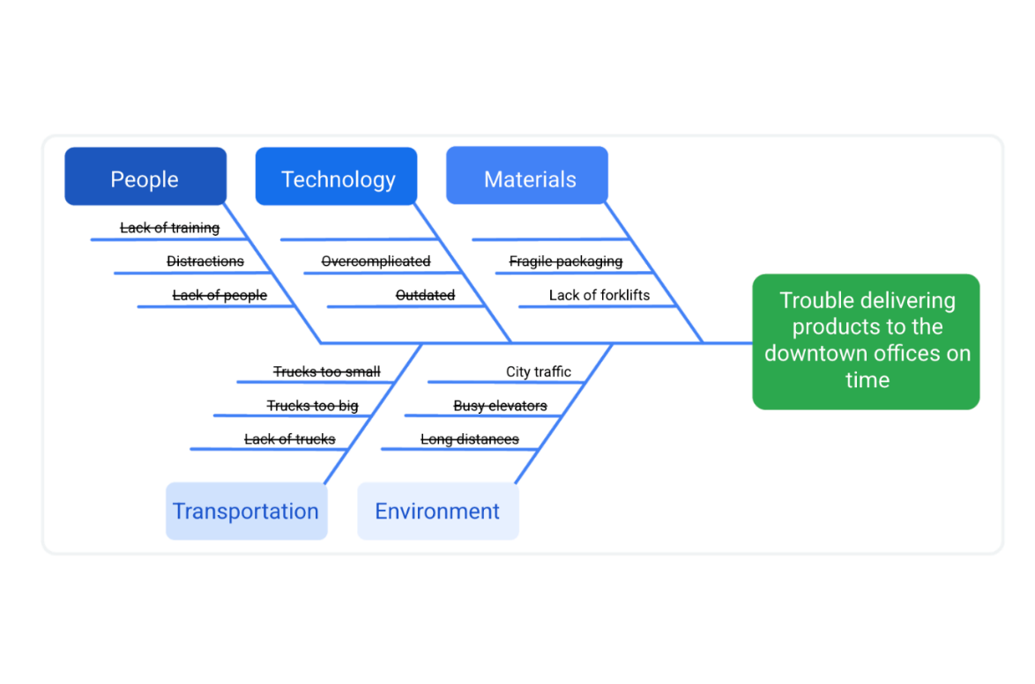

**Pro tip**: Fishbone diagrams are tools that can be useful during any phase of the project. When you use them in risk planning, you are trying to identify the possible causes of a problem that may or may not occur. When you use them in the execution phase, you are trying to find the root cause of an issue that has already occurred.

## ****Key takeaway****

Identifying risks and measuring their potential impact on a project can be a complex task. You can help visualize these issues by creating fishbone diagrams. To recap, the steps to create a fishbone diagram are:

* Define the problem
* Identify the categories
* Brainstorm the causes
* Analyze the causes

Once you’ve developed a fishbone diagram to help find a problem’s root cause and measure its potential impact on the project, you can then move on to determining how to mitigate the risk.

# Managing single point of failure risks

Previously, you learned how to use various tools and strategies to identify and manage risks as you plan your project. In this reading, we will discuss how to manage risks with the highest potential of impacting your project.

## ****Single point of failure risks****

Once you have identified your risks and ranked them, give special attention to the risks that could have a catastrophic effect on your team’s ability to complete the project. A **single point of failure** isarisk that, if it were to materialize, could cause a significant amount of disruption to your project and could even shut it down. You should plan for these risks early on in the project.

For example, a lot of projects use **subject matter experts** (**SMEs**)—team members with a deep understanding of a particular job, process, department, function, technology, machine, material, or type of equipment. SMEs are involved to advise you throughout the project life cycle. Having only one SME familiar with a critical system on your team is an example of a single point of failure risk. This SME will only offer one perspective, and if they are the only person advising on the system, there is no one to offer another perspective.

## ****Case study: Using mitigation strategies to manage single point of failure risks****

Let’s imagine that Office Green uses plant seeds from a company in South America for the majority of its offerings. The plants produced by these seeds are in high demand by Office Green’s customers. However, the local government on the suppliers’ end just announced that it would be imposing a new tax on the exporting of seeds and produce. As a result, the price of the seeds suddenly becomes so high that it is difficult for the company to supply the seeds to Office Green, putting the project at risk of not having these seeds available to purchase.

Let’s look at how these four risk mitigation strategies can be used for managing single point of failure risks in the Office Green example:

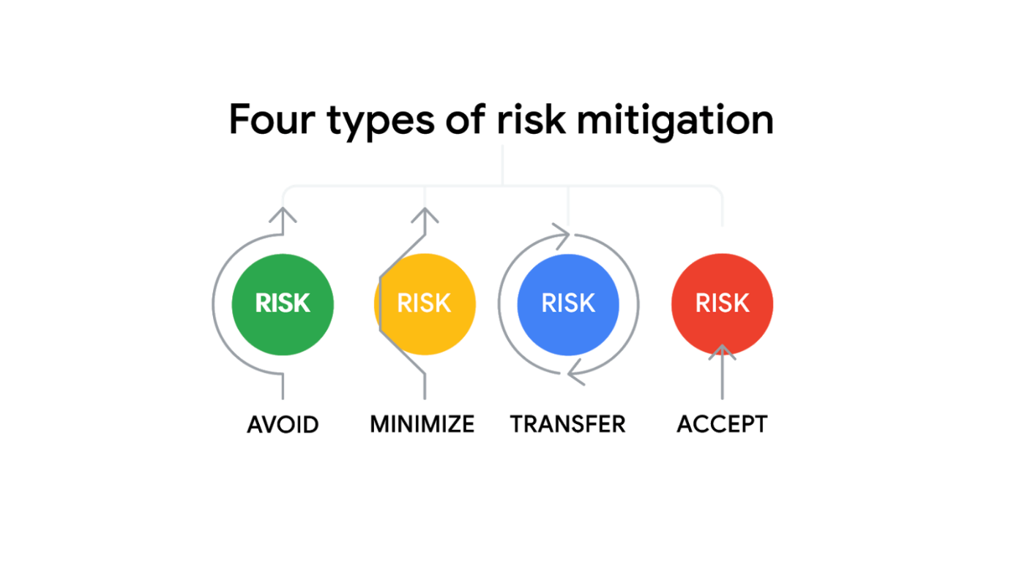

### **Avoid**

This strategy seeks to sidestep—or avoid—the situation as a whole. In the Office Green example, the team could avoid this risk entirely by considering using another seed that is widely available in several locations.

### **Minimize**

Mitigating a risk involves trying to minimize the catastrophic effects that it could have on the project. The key to minimizing risk starts with realizing that the risk exists. That is why you will usually hear mitigation strategies referred to as workarounds. What if the Office Green team decided to use both the original South American supplier and another supplier from a neighboring country? More than likely, the change in taxation and regulation wouldn’t affect both companies, and this would provide Office Green some flexibility without having to completely eliminate their preferred supplier.

### **Transfer**

The strategy of transferring shifts theresponsibility of handling the risk to someone else. The Office Green team could find a supplier in North America that uses the seeds from several other South American countries and purchase the seeds from them instead. This transfers the ownership of South American regulatory risks and costs to that supplier.

### **Accept**

Lastly, you can accept the risk as the normal cost of doing business. **Active** **acceptance of risk** usually means setting aside extra funds to pay your way out of trouble. **Passive** **acceptance of risk** is the “do nothing” approach. While passive acceptance may be reasonable for smaller risks, it is not recommended for most single point of failure risks. It is also important to be proactive and mitigate risks ahead of time whenever possible, as this may save you from having to accept risks. In the Office Green scenario, the project manager could schedule a meeting with project stakeholders to discuss the increase in South American taxes and how it could impact the project cost. Then, they might decide to actively accept the risk by setting aside additional funds to source the seeds from another supplier, if necessary, or to passively accept the risk of not receiving the seeds at all this season.

## ****Key takeaway****

If you have strategies you can rely on for avoiding, minimizing, transferring, and acceptingproject risks—including single point of failure risks—you will be in a better position to protect your project from the possible impact of these risks.

# Visualizing dependency relationships

In the video, you learned to identify several types of risks. In this reading, we will be discussing the different types of dependencies that can play a critical role in our project’s success.

## ****Types of dependencies****

**Dependencies** are a relationship between two project tasks in which the completion or the initiation of one is reliant on the completion or initiation of the other. Let’s explore four common types of dependencies:

### **Finish to Start (FS)**

In this type of relationship between two tasks, Task A must be completed before Task B can start. This is the most common dependency in project management. It follows the natural progression from one task to another.

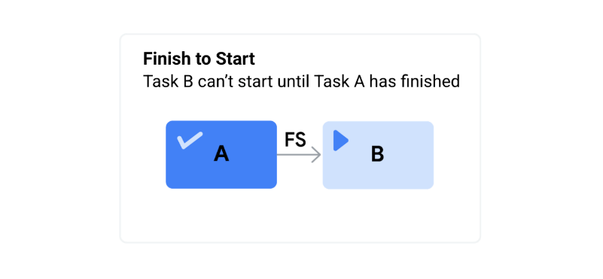

**Example:** Imagine you are getting ready to have some friends over for dinner. You can’t start putting on your shoes (Task B) until you’ve finished putting on your socks (Task A).

Task A: **Finish** putting on your socks. →Task B: **Start** putting on your shoes.

### **Finish to Finish (FF)**

In this model, Task A must finish before Task B can finish. (This type of dependency is not common.)

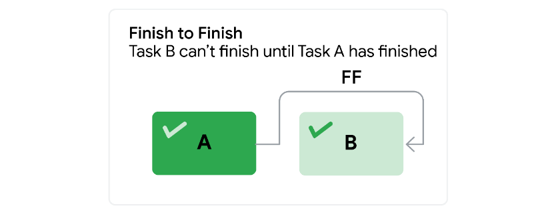

**Example:** Earlier in the day, you baked a cake. You can’t finish decorating the cake (Task B) until you finish making the icing (Task A).

Task A: **Finish** making the icing. →Task B: **Finish** decorating the cake.

### **Start to Start (SS)**

In this model, Task A can’t begin until Task B begins. This means Tasks A and B start at the same time and run in parallel.

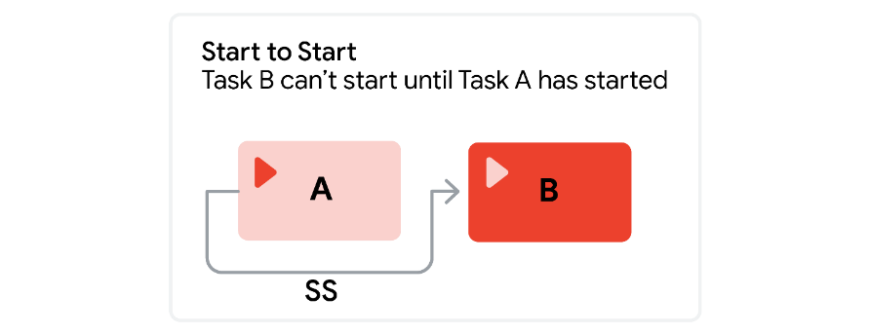

**Example:**  You need to take the train home after work. You can’t get on the train (Task B) until you pay for the train ride (Task A).

Task A: **Start** by paying for your train ride. →Task B: **Start** going home by boarding the train.

### **Start to Finish (SF)**

In this model, Task A must begin before Task B can be completed.

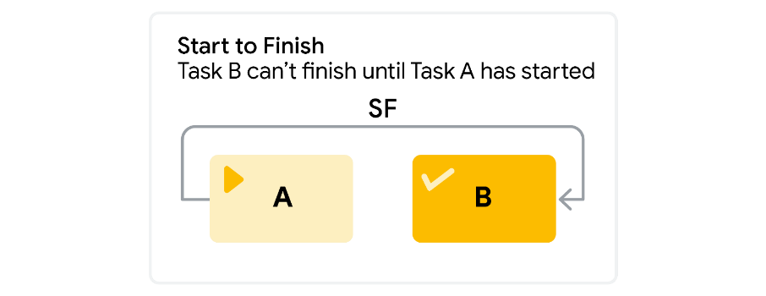

**Example:**   One of your friends calls to tell you he’ll be late. He can’t finish his shift (Task B) and leave work until his coworker arrives to start her shift (Task A).

Task A: Your friend’s coworker **starts** her shift. →Task B: Your friend **finishes** his shift.

## ****Dependency graphs****

As a project manager, you will use these dependencies to visually represent the flow of work during your project. Let’s examine how to use a dependency graph with an everyday example. Imagine you are making peanut butter and jelly sandwiches for the kids who will be coming to your dinner, and you want to use dependency relationships to map your activities on a graph.

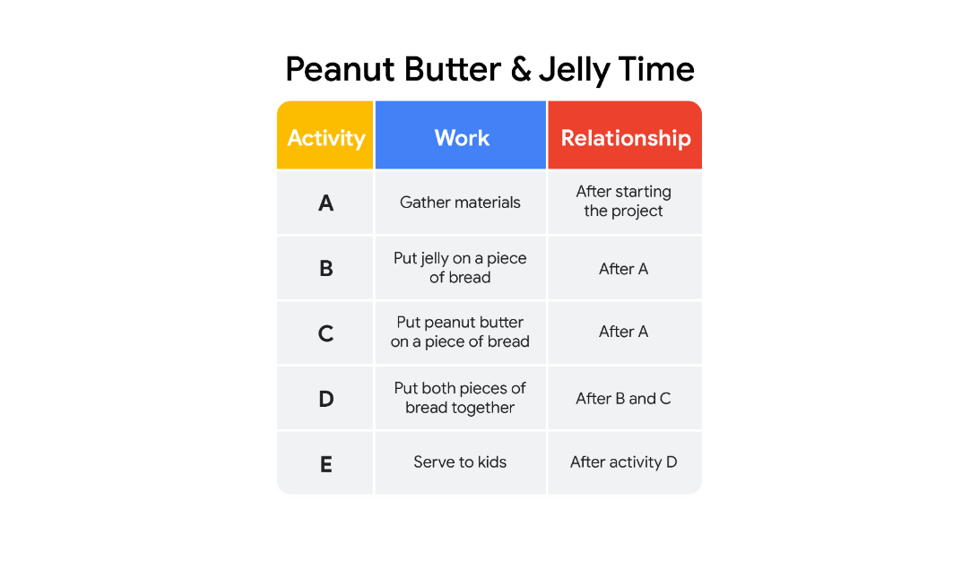

Activity A: Gather Materials. Relationship: After starting the project Activity B: Put jelly on a piece of bread. Relationship: After A Activity C: Put peanut butter on a piece of bread. Relationship: After A Activity D: Put both pieces of bread together. Relationship: After B and C Activity E: Serve to kids. Relationship: After activity D

Let’s break each task down to create your dependency graph:

1. When you start your sandwiches, you need to gather your materials: bread, knife, jelly, peanut butter, plates, and napkins (Task A).
2. At this point, you can put jelly on one piece of bread (Task B) and peanut butter on the other piece of bread (Task C).

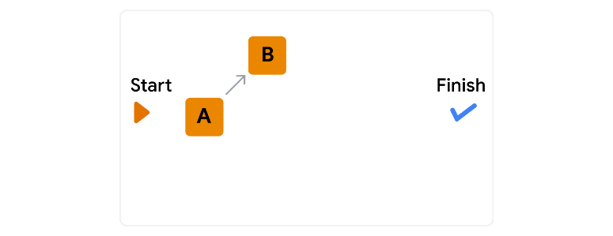

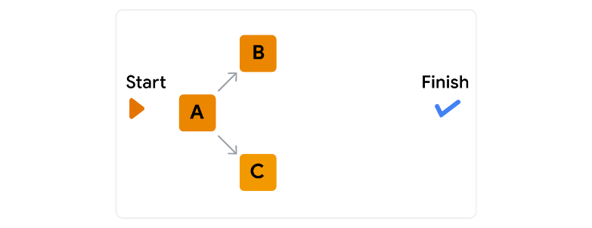

3. Now you need to put both pieces of bread together (Task D).

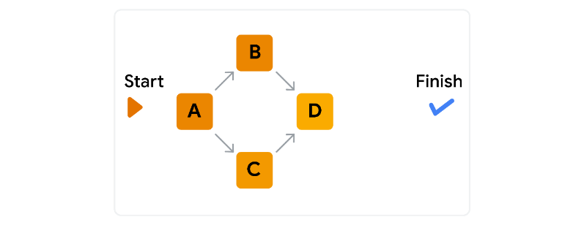

4. Finally, you can put the sandwich on a plate and serve it (Task E).

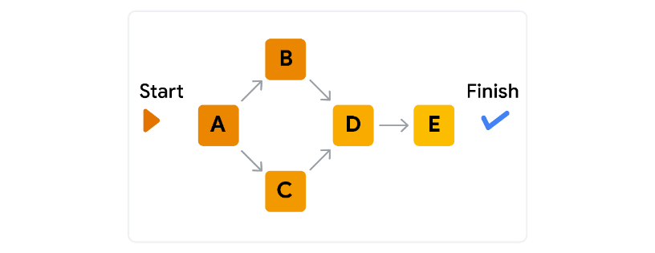

## ****Key takeaways****

There are four types of task dependencies:

* Finish to Start
* Finish to Finish
* Start to Start
* Start to Finish

A dependency graph can help you visualize these different dependencies and the flow of the work that needs to be done on a project. They can also help you identify any risk associated with them.

Tips for effective communication

In the previous videos, you learned that communication is key to any successful project. As a project manager, you are central to that communication, which is an ongoing process throughout the life cycle of a project. A good project manager must be effective in communicating with all stakeholders and team members through various mediums.

As the project manager, it is important to develop a communication plan for the duration of your project. Good communication helps your project run smoothly, leads to better outcomes, and supports a healthy team culture. You can use these four tips to foster effective communication within your team:

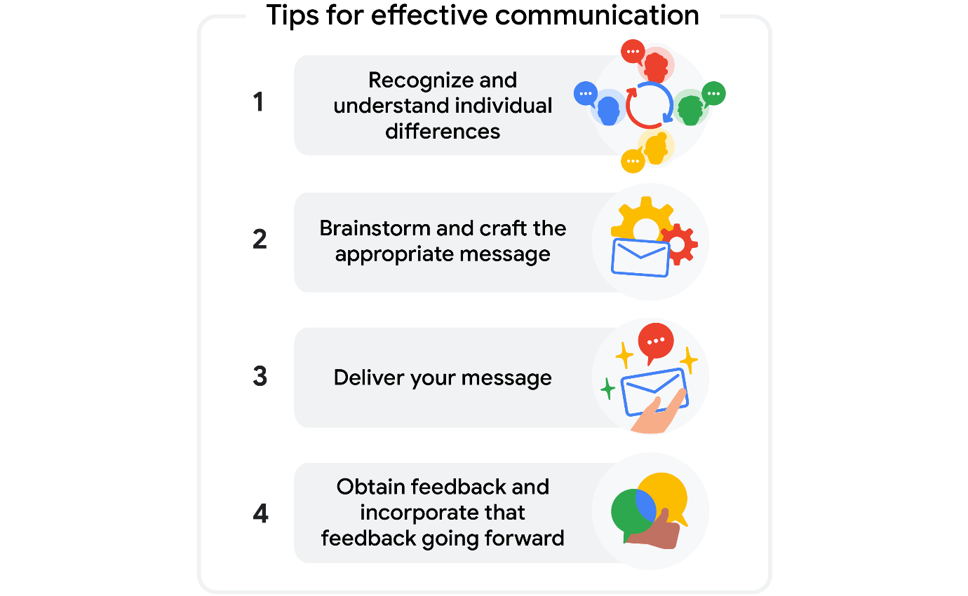

**Recognize and understand individual differences**

You can encourage open, inclusive communication by:

* Not making assumptions about your audience’s backgrounds, identities, or experiences.
* Being mindful of your own biases.
* Using appropriate, professional, and neutral language.
* Including, respecting, and being curious about diverse points of view.

As the project manager, you will undoubtedly work with a diverse group of team members and stakeholders on each project. You will need to understand each team member’s background, experiences, perspectives, and biases—as well as your own—to  communicate effectively.

**Brainstorm and craft the appropriate message**

Communicate the right message by thinking about your intended audience. With whom are you communicating? In your communications, always be clear about your reasons for reaching out:

* What channels can your audience use to contact you or the team?
* Are you conveying information?
* Are you asking for input?
* Are you clarifying an issue?
* Are you resolving a problem?

Some team members may require detailed information, while others may only need an overview of the situation. No matter your audience, you should be sure to identify the purpose of the message, state the information or request clearly and concisely, and stay on topic.

**Deliver your message**

As you craft your message, think about which methods are available and appropriate for communicating with various members of your team, whether that is in person, in a video conference, over the phone, via email, or in a meeting. Choosing the right method is especially important if you have team members or stakeholders in different regions and time zones. Also, be sure to:

* Avoid including any sensitive or potentially private information.
* Assume everyone at the company will receive the communication.

**Obtain feedback and incorporate that feedback going forward**

Communication doesn’t end when you deliver your message, so be sure to follow up with your audience by:

* Checking to make sure your message was clear.
* Asking them for feedback.
* Encouraging open communication.
* Responding to questions quickly.

In this final step, you will obtain feedback from your audience to ensure that your message was received as you intended.

**Key takeaways**

You now have the steps to communicate effectively as a project manager! You have learned how to foster open, inclusive communication by recognizing and understanding individual differences among your team members. You know how to craft and deliver an appropriate message and the importance of obtaining and addressing feedback. Most importantly, make sure your communications are clear, honest, relevant, and frequent. Following these guidelines will set you up for successful communication throughout your projects.

# Best practices for building a communication plan

In this reading, we will reinforce the top tips to keep in mind when creating a communication plan to ensure that it is an effective tool for you and your project team.

## ****Tips for creating your communication plan****

### **Identify, identify, identify**

Before you begin creating the plan, answer these questions to ensure that you have all of the relevant information:

* **Project stakeholders**: Have you created a RACI chart or stakeholder map of all your stakeholders? Who is your audience? Who will need to be informed at different points during the project life cycle?
* **Communication frequency and method**: When and how often should you check in with your stakeholders? What methods of communication do they prefer? How much detail does each stakeholder need?
* **Goals**: What is the goal of your communication? Do you need a response? Are you trying to encourage engagement or simply providing an update?
* **Barriers**: Are there any time zone limitations? Language barriers? Do some stakeholders require time to reply or respond (e.g., an executive)? Are there any privacy or internet access issues? **ocument and develop**

Choose a tool or template to document all of your communication needs, and begin developing your plan. Once you understand the basic elements (stakeholders, communication methods, goals, and barriers), it’s time to work out the details! Here are some tips:

* **Add a column for notes.** Project management is not one-size-fits-all, and there are a lot of pieces that need to be tracked. For instance, if you are reaching out to a senior leader or executive, do you need to copy anyone else on the email? If a stakeholder is out of office or unavailable on certain dates, do you have a backup plan? Add notes to set reminders and any additional relevant details.
* **Use formatting to highlight any key details in the plan.** Is there a launch announcement or an urgent decision needed for the project to move forward? Highlight these pivotal elements in a different font color or size to stress their importance.
* **Ensure that the team can access your document.** Share the plan with your team. Allowing your team to review the document ensures that they are aware of the plan and gives them a chance to offer feedback. Sharing the document also serves as an extra check to make sure you aren’t missing any crucial pieces.
* **Test your plan.** If you are sending a team-wide email or link, send a test email to yourself or a colleague. If you are planning a virtual presentation, be sure to test the visual, audio, and other technical aspects in advance. That way, you can minimize any technical problems.

### **Check in:** Once your communication plan is out in the world, check in with your audience about the effectiveness of your plan. Scheduling routine check-ins will help you understand what is and is not working so you can improve your plan. You want to ensure that your communication plan gets the right information to the right stakeholders at the right time. Additionally, make sure to double check that key stakeholders have not changed over time.

Evaluate where you may be over- or under-sharing information or missing stakeholders. You can do this through:

* Anonymous survey forms
* Polls or open feedback sessions during team meetings
* One-on-one conversations and check-ins with key stakeholders

Keep these tips in mind as you build your next communication plan and you will be set for communication success!

# Tailoring a resume for project management

You can save this reading for future reference. Feel free to download a PDF version of this reading below:

As you prepare for your job search, you will need to create or update your resume to reflect your experience in order to apply for project management roles. You have learned so much during this course, and it is important that your resume reflects that. An effective resume highlights your skills and experience and is tailored to the position you are applying for. Let’s explore how to make your resume stand out by incorporating your new project management skills and your previous experience.

## ****Tailor the content****

* **Identify what is important to the potential employer.** What does the employer want to know about you? Make sure that you carefully read the job description and notice which skills are mentioned. You can also read several job descriptions for the same type of role to identify which skills and requirements show up frequently. For instance, although specifics will vary by role and employer, many project management-related roles require the ability to effectively organize and coordinate across teams and projects, manage multiple tasks simultaneously, and communicate effectively. You should take note of these skills and be sure to highlight them using similar terms on your resume.
* **Create one master project management resume** **to edit and tailor to each job application**. You should make sure that the order of your skills and qualifications matches the job description. In doing this, you are making sure that the things that are most important to the employer are at the top.
* **Match the language used in the job description.** Some employers use automation software to filter resumes. If the job description uses keywords like procurement and risk management, make sure your resume uses those keywords, too.
* **Use project management terminology.**  This will help the person reading your resume understand how your past experience is relevant to a project management position.
* **Decide what not to include on your resume.** You may have some skills that are important to you, but those same skills may confuse or distract the hiring managers reading your resume.
* **Highlight how your past experience and skills are relevant to project management**. If you have been working as a construction foreman but want to begin managing construction projects, your planning and staff management skills will be essential in your new role. Make sure to point out how those skills will be beneficial to the employer.

## ****Choose an appropriate format****

No matter what layout or template you choose for your resume, there are several things you should keep in mind

* The design of your resume should be simple and easy to understand for both human and artificial intelligence readers. You don’t want your resume to be discarded before a real person has a chance to read it!
* Your resume should be easy to read and should convey all of the important information in short bullet points.
* Your resume should be one- to two-pages long and contain only the last ten to fifteen years of relevant experience. It is appropriate to use two columns on a one-page resume, but if your resume is two pages, be sure to use the entire width of the page.

## ****Update the relevant sections****

Once you have determined the appropriate format for your resume, you will need to update each of your resume’s major sections, which include:

* Contact information
* Professional summary
* Core competencies
* Professional experience
* Education and certifications

**Pro tip*:*** Resumes should be written in the third person and should not contain personal pronouns.

Let’s discuss how to incorporate your new skills into these sections of your resume.

### **Contact information**

Your header should contain your contact information and should go at the top of your resume.

**Your header should include the following information:**

* Your name in a larger font than the rest of your resume
* The city and state you live in (you do not need to include your street address for privacy purposes)
* Your phone number and a link to your email address
* Link to your LinkedIn profile URL
* Links to any other personal websites or portfolios, if applicable to the role you are applying for

**Your header should be relevant, simple, and easy to read.** Here is an example of a resume header:

### **Professional summary**

Below your header, include a professional summary.

* **Use your summary to set the tone.** Your summary should be one to three lines and should clearly state why you are the best candidate for the position. It should highlight the most important things you want the reader to know about you. If you are applying for a new role, you will want to update your industry specialty. You likely have experience that can be related to project management, and you will want to incorporate that relevant experience into your new professional summary. Make sure you tailor your description of yourself to the role you are applying for.
* **Merge the description of the role you are applying for with your past experience.** Here is an example:
* Project manager with two years of demonstrated success in a project scoping and planning. Skilled in cross-functional collaboration and project execution. Articulate communicator who thrives in a results-driven collaborative environment.
* **Use keywords from the job description** **to describe yourself.** If the job description states that the company is looking for a candidate with knowledge of both traditional and Agile approaches, you should add that to your resume—you have gained that knowledge with this certification.

Once you have your professional introduction, your next sentence should explain how your unique expertise will make you valuable to the employer.

**Pro tip:** Don’t forget to use this section to highlight something that makes you stand out from other applicants. Use an accomplishment from a previous role to show the employer what you can offer them. Take a look at this example of a professional summary section:

Solutions-driven individual with experience in solving complex problems, working with cross-functional teams, and executing strategies. Proficient in managing supplier relationships, administering contracts, and learning new technologies. Highly effective at coaching and mentoring Agile teams.

Now that you have your heading and professional summary updates, let’s move on to the core competencies section of your resume.

### **Core competencies**

Your core competencies should be a bulleted list of the most relevant skills applicable to the position you are applying for.

**Pro tip:** Scan the job description for core competencies you have gained during this certification, as well as your past experience, and use those skills as bullet points in this section. Make sure to keep this section relatively short, with four to eight bullets. Here is an example of a project management resume core competencies section:

Project management Contract management Risk planning Project scoping and planning Process improvement

Now that you have highlighted who you are and what makes you the best candidate for the job, it is time to tell the story of what you have accomplished throughout your career in the professional experience section.

### **Professional experience**

The professional experience section of your resume provides a summary of the roles and positions you have held in your career. List at least three positions in reverse chronological order and only include what is most relevant to the position you are applying for.

Your professional experience will not change much from previous resumes, because you can’t change the past roles you have held. However, you can possibly rewrite some of your bullets to relate them to project management. For example, let’s say you worked as a retail store general manager for the last five years and would like to transition to a project manager role at the corporate level. You might include bullets like the following examples:

* Managed five employee schedules and store budget of $50,000
* Led a team of ten employees and received “Store of the Year” award
* Planned, procured, and reconciled inventory shipping and receiving

Make sure you are tying the industry lingo back to your previous experience to show the reader—usually a hiring manager—how your skills relate to project management. Use terms like developed, tracked, managed, and monitored to show the reader that your past experience translates to a project management role.

**Pro tip:** Make sure your resume conveys how your past accomplishments are valuable to the role you are applying for. Show the reader how you can make a difference in their organization. An easy way to remember this is through the P.A.R.I.S. framework:

* **P**roblem that needed to be solved
* **A**ction(s) I took
* **R**esult of action(s)
* **I**mpact on project (users, quality, etc.)
* **S**upporting evidence (awards, bonus, etc.)

Below is an example of a professional experience section from a project manager’s resume:

### **Education and certifications**

Now that the majority of your resume has been updated with your new skills and knowledge, it is time to update your Education and Certifications section. In this  section of your resume, you should include any degrees beyond your high school diploma in reverse chronological order. For each degree, list the degree you earned, institution, location, and date of graduation. This section should also list any professional certifications or credentials you hold. It is here where you will list this new project management certification. Here is an example of an education and credentials section of a project management resume:

Your resume is now updated and ready to use for project management position applications! You have revised your professional summary, added newly-acquired core competencies, related past professional experience to project management, and added this certification to your resume.

**Pro tip:** It is always a good idea to have someone review your resume for any spelling or grammatical errors. Recruiters and hiring managers often toss resumes aside that contain typos. Once you are sure your resume is error-free, it is time to start your job search!

# OKRs for personal and professional development

As you prepare for a new career in project management, it’s also a great time to set some personal OKRs (objectives and key results) to track your progress towards achieving your own personal goals.

# ****OKR Review****

OKR stands for objectives and key results. They combine a goal and a metric to determine a measurable outcome.

| **Objective** | **Key Results** |
| --- | --- |
| Defines what needs to be achieved | The measurable outcomes that objectively define when the  objective has been met |
| Describes a desired outcome |  |

## ****Benefits of setting personal OKRs****

Many of us set New Year’s resolutions each year, only to find that by February, we are not much closer to accomplishing those goals than we were on January 1st. Setting personal OKRs is a strategy that can help you define clear, measurable goals for yourself and create an action plan for achieving them. Just like with company- or project-level OKRs, setting personal OKRs can turn vague and ambiguous goals into quantifiable and measurable metrics. Whether it’s a personal fitness goal, a desire to spend more time with your family, or a goal to complete this certificate program, setting personal OKRs for these goals can make it easier to track their progress and determine when you’ve achieved them.

# ****Write your own OKRs****

Follow the steps outlined below to help you craft your own personal OKRs. You can use this [OKR template](https://docs.google.com/document/d/1jRK5I_uI92hJG5efVYlY33ZrExtcx9KMkgWWVQNipKc/template/preview?resourcekey=0--0jhg573V_kexTynrd2U6g), or if you don’t have a Google account, you can download the template directly from the attachment below.

## ****Define your “why”****

Before you start on your objectives—your “what”—consider your “why.” This is your mission. Why are you setting goals? For example, if you have a goal to complete this course, why is that important to you? Write that down and use it to inspire and focus your objectives.

## ****Determine your “what”****

### Brainstorm possible objectives

Now that you have a clear sense of why these goals are important to you, you can start drafting your objectives. Think about the things you most want or need to accomplish in the next 30–90 days.

To help you generate a list of possible objectives, consider the following:

* What are the most important things I need to get done?
* What do I need to take action on?
* What do I need to start doing or changing?
* What do I want to improve or work on in my life or career?

Based on your responses to these questions, brainstorm a list of 3–5 possible objectives that relate to your mission.

### Refine your objectives

Review your list of possible objectives and revise them to make sure they meet the following criteria:

* **Aspirational**: Is the objective inspiring and motivational? Does it ask you to challenge yourself and accomplish something you haven’t before?
* **Aligned with organizational goals**: In this case, YOU are the organization, so your objectives should align with the mission you defined earlier. Does the objective help you in achieving your overall goals?
* **Action-oriented**: Does the objective indicate making a change or taking action?
* **Concrete**: Is the objective clearly stated? Would someone else understand what the objective is hoping to accomplish?
* **Significant**: Will achieving the objective make a significant impact toward your personal or professional development?

| **Mission: Be an ideal candidate for promotion or hire.** |
| --- |
| **Objective:** Deliver engaging presentations |
| **Objective:** Increase my work pace |
| **Objective:** Learn new skills and practices beyond the job description |

## ****Develop the “how”****

Next, it’s time to add key results, which describe how you’ll achieve your objective. They also define what it means to successfully meet your objective.

### Draft and refine your key results

Working with one objective at a time, brainstorm a list of 2–5 key results. To help you generate your list, consider the following:

* How would you define success for this objective?
* What metrics would prove that you’ve successfully achieved the objective?

Once you have a few key results, review and revise them so they meet the following criteria:

* **Results-oriented**—not a task: Do the key results state the overall outcome, rather than individual steps to get there?
* **Measurable and verifiable**: Do the key results include specific, objective metrics?
* **Specific and time-bound**: Have you clearly defined what needs to happen and by when?
* **Aggressive yet realistic**: Do the stated results stretch you but still account for potential challenges or unexpected events that could arise?

| **Key Results:** |
| --- |
| Attend a public speaking workshop by the end of the 1st quarter. |
| Watch at least one TEDTalk per week. |
| Deliver one presentation every two months and collect feedback. |
| **Key Results:** |
| Block out 90 minutes each day to work on top-priority tasks. |
| Delegate items to other team members to focus my time on higher priority tasks. |
| Take on one additional project this quarter while maintaining the same number of work hours. |

| **Key Results:** |
| --- |
| Earn one more relevant additional certifications before the end of the 1st quarter. |
| Attend three networking events and schedule two coffee or lunch meetings per month with potential  mentors. |
| Improve industry knowledge by attending 1 new workshop, conference, or presentation each month. |

Creating OKRs can be an empowering way to take ownership of your goals and find meaning in your personal and professional life. Start by defining your mission, or the overall reason for creating goals and why they’re important. Then determine your objectives, or what you want to achieve. Then, develop key results that will make it clear how and when you’ve made progress and achieved success.

# Choose the right tracking method for your project

So far, you've learned about the importance of tracking project progress. You’ve also reviewed some of the different tracking methods used by project managers, like project plans, Gantt and Burndown charts, and Roadmaps. This reading will explore and compare these popular tracking methods in more detail so you can feel more confident choosing the best method for your projects.

# ****Gantt charts****

The Gantt chart is one of the most popular tracking methods and can be used for all types of projects. Gantt charts typically live in your project charter and are updated as the project progresses.

Gantt charts are useful for:

* Helping a team stay on schedule
* Projects with lots of tasks, dependencies, and milestones
* Projects with large teams, because ownership and responsibilities are explicitly laid out visually

**Roadmaps**

Roadmaps are another common tracking method. Like Gantt charts, Roadmaps also track both individual and project progress toward milestones. However, Roadmaps are best suited for tracking big milestones in your project. Roadmaps are useful for:

* High-level tracking of large milestones. Roadmaps outline the project as a whole and provide an overall snapshot of key points—just like an actual roadmap contains points of interest and mile markers.
* Illustrating to your team or key stakeholders how a project should evolve over time

Roadmaps can be built using different tools. You can create a Roadmap in a document.

**Burndown charts**

Burndown charts are typically used by Agile Scrum teams. Burndown charts reveal how quickly your team is working by displaying how much work is left and how much time remains to complete the work. The main uses of a Burndown chart are to keep the project team on top of targeted completion dates and make them aware of scope creep if it occurs. The chart should be displayed so everyone can see it and needs to be updated regularly in order to be effective. Burndown charts are useful for:

* Projects that require a detailed review of tasks
* Projects where finishing on time is the top priority

A Burndown chart helps you, as a project manager, understand how your team works and what influences their ability to complete tasks on time. This way, you can address issues right away, before they become major problems. They also help you plan more efficiently for the next project by identifying potential problem areas.

Project status reports

In this lesson, you are learning to identify and compare various types of tracking methods. This reading will cover **project status reports** and how you can use them to track and communicate common project elements in a snapshot.

**Key components of a project status report**

A project status report gives an overview of all of the project’s common elements and summarizes them in a snapshot. It is an efficient communication tool to convey the latest status in one place for the team and stakeholders.

Most status reports contain the following components:

* **Project name:** The project name should be specific to the purpose of the project so that the overall goal of the project can be understood at-a-glance.
* **Date:** You will create project status reports many times during the course of a project’s implementation phase. Reports can be created weekly or monthly—it all depends on the stakeholders’ needs and pace of the project. Adding the date to each status report acts as a reference point for your audience and also creates a history log of the project’s status over time.
* **Summary:** The summary condenses the project’s goals, schedule, highlights, and lowlights in one central place for easy stakeholder visibility. Usually, the summary section will be followed by, or grouped with, the timeline summary and the overall project status.
* **Status:** As you can imagine, status is a crucial piece. The status of the project illustrates your actual progress versus your planned progress. In project management, a common way to depict this is through **RAG** (red, amber, green), or Red-Yellow-Green, status reporting**.** RAG follows a traffic light pattern to indicate progress and status. Red indicates that there are issues that need resolution and that the project may be delayed or go significantly over budget. Amber/Yellow means that there are potential issues with schedule or budget, but that the issues can likely be resolved with corrective actions. And green means the schedule and budget are doing fine and that the project is on track. You can use RAG to indicate the overall project status, as well as milestone status. Every project team and stakeholder may have a slightly different perspective on what the colors mean and how urgent it is to escalate issues when they see an amber/yellow or red status, so it’s important to make sure everyone understands what the different color statuses mean for your project.
* **Milestones and tasks:** A summary of the project’s major milestones thus far and current tasks helps the team and stakeholders easily visualize the progress of those elements. In a project plan, you will typically depict the tasks and milestones as ‘not started,’ ‘in progress’ or ‘completed*’* at an item-by-item level. But, in the project status report, it is common to summarize these items into two categories to better communicate the status. You’ll use **key accomplishments** to detail what has happened, and **upcoming** to detail what big milestones you will accomplish next.
* **Issues:** The issues include your project's current roadblocks and potential risks. Status reports are an important opportunity to set expectations with your stakeholders. If your project status is red or amber, you can flag what is preventing you from being where you planned to be. You can also use this opportunity to state your plan to get the project back to green, and ask for any resources or help you may need to do so. You will learn more about communicating big risks and issues in the upcoming videos.

**Project status report types**

With those key elements in mind, you can format your report in a variety of ways depending on your audience and what you need to communicate.

If you need to share a status report with your team for a project that contains multiple layers of complexity, it may be best to format the report in a **spreadsheet** in order to keep track of all the moving parts.

If you simply need to communicate updates to senior stakeholders, your status report may be best formatted as a **slideshow**, like the one below, containing only an overview of the most key points.

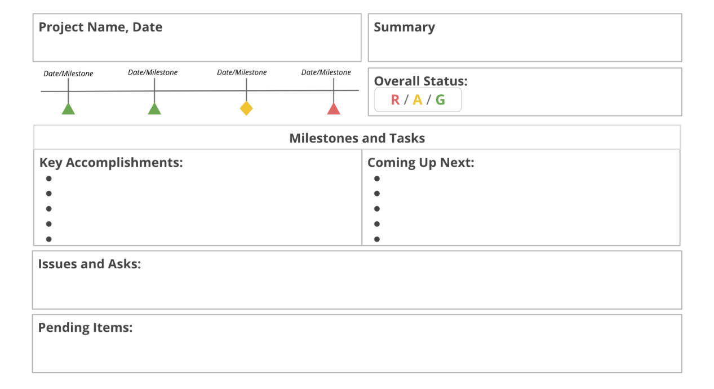

**Key takeaways**

To recap, project status reports are a powerful tool to:

* Improve and simplify communication across the team.
* Keep everyone, including key stakeholders, informed.
* Request more resources and support (if needed).
* Create structure and transparency by recording the project status in a centralized place.

## ****The project: Paw Snacks Puppy Treats****

Paw Snacks is an online retailer of tasty and nutritious pet treats. Over the course of three years, the business has grown from a small startup to a 350-person organization. Paw Snacks wants to expand its offerings even further by adding a new line of treats for puppies.



## ****The issue****

Six weeks before the new product line is scheduled to debut, Naja, the project manager leading the launch, receives a frantic phone call from a manager at the commercial bakery hired to produce the treats. The bakery manager informs Naja that the bone-shaped cookie cutters required to shape the treats have not yet arrived. Naja knows that baking needs to start the following day in order to stay on schedule for the launch.

Naja thanks the bakery manager for the warning and asks her teammate, Abe, to call the cookie cutter manufacturer to check on the status of their order. Abe learns that the order is delayed due to a product shortage and that the cookie cutters are now expected to arrive at the bakery two days after the original expected delivery date.

Naja recognizes that this delay threatens her team’s ability to launch their product on time. Even worse, her team doesn’t have the option to push the launch date, since the Paw Snacks marketing team has already purchased nonrefundable advertising placements for the day of the launch. Luckily, Naja and her team are already prepared for an issue like this one.

## ****Planning for risks ahead of time****

Months earlier, long before the team started work on the project, Naja and her team brainstormed potential risks that could impact the project. They created a **risk register**, a table or chart that contains a list of risks and is often paired with a probability and impact matrix. During the process, the team determined that a delay in the cookie cutter order had a medium probability of occurring and would result in a high impact on the project. Naja added the risk to the risk register and assigned Abe to create a **mitigation plan**, which outlines steps to decrease the chances of a risk occurring or decrease the impact of a risk if it does occur. This plan would indicate how the team would handle an issue if it were to materialize. The mitigation plan was then approved by the project sponsor and other stakeholders.

## ****Managing the issue****

Now that the cookie cutter issue has occurred, Naja and Abe consult the mitigation plan for this particular risk. In this case, Abe identified two options for handling the risk: The first option is to work with the bakery to slightly decrease the number of treats produced in order to make up for the two days they have lost due to the cookie cutter delay. The second option is to place an order with a second bakery to help speed up the pace of production. Naja and Abe discuss the two plans and settle on option one to avoid the work of bringing in a second bakery.

Before moving ahead with the plan, Naja and Abe meet to brainstorm potential risks associated with the new plan. Together, they determine that a smaller order of dog treats will likely have a minor—but manageable—impact on the organization’s projected growth for 2021. They determine that the best course of action is to accept the risk to avoid delaying the project further. To ensure that the project stakeholders are aware of and comfortable with this change, Naja requests a meeting with her project sponsor to communicate the plan, outline the minor risk to projected growth, and recommend accepting the risk. The sponsor agrees and approves Naja’s new plan.

Naja tasks Abe with communicating the adjusted plan to the bakery manager. Though baking begins two days behind schedule, Naja’s new plan helps ensure that the team is prepared to launch the new line on time.

|  |
| --- |
| **Pro tip**: While the term mitigation plan is used more often in project management, you may also hear the  term **contingency plan**. These terms are often used interchangeably, but there are some key differences.  A mitigation plan is a planned risk response strategy. If a project manager is able to identify the potential  known risks that impact any of the key project parameters (schedule, cost, or scope), they should make a  plan to mitigate those risks early in the project. A contingency plan, on the other hand, is mostly related  to funds the project manager keeps aside (outside of the planned project budget ) to support any of these  known risk response plans if they go beyond the planned amount or to manage any unforeseen risks  during execution. |

## ****Key takeaway****

In this case study, early risk management planning enabled Naja to act quickly when an issue presented itself at a pivotal time during the project execution phase.

By consulting an existing mitigation plan and weighing two options for moving forward, Naja and Abe were able to make an informed decision about the best path forward. Naja also communicated the growth-related risks associated with the plan to the project sponsor in a timely fashion.

As you manage projects of your own, issues will come up again and again. When you do the heavy lifting of risk management planning before starting work on the project, you will be better equipped to respond to problems quickly.

# Writing an effective escalation email

In this lesson, you are learning how to communicate risks and changes to your team and stakeholders. In the previous video, you were introduced to **escalation**: the process of enlisting the help of higher level project leadership or management to remove an obstacle, clarify or reinforce priorities, and validate next steps.

There are many ways to escalate a risk, and it is important to set escalation standards with your stakeholders before beginning work on a project. In this reading, we will focus on the **escalation email**, and go over best practices for writing one.

## ****Escalation email best practices****

All projects—even those managed by experienced project managers—occasionally have problems. Your role as the project manager is to help resolve problems and remove barriers that prevent your team from making progress toward your goals. While many problems might be small enough to resolve within your core team, other problems—like a major change in your budget or timeline—may need to be brought to stakeholders for a final decision. Detailing these problems, their potential impact, and the support you need in a clear and direct email to your audience can be an effective communication tool.

Effective escalation emails:

* Maintain a friendly tone
* State your connection to the project
* Explain the problem
* Explain the consequences
* Make a request

Let’s discuss these five keys to writing a strong escalation email.

### **Maintain a friendly tone**

When drafting an escalation email, you may feel tempted to get straight to the point, especially when dealing with a stressful and time-sensitive problem. But keep in mind that it is important to address issues with grace. Consider opening your email with a simple show of goodwill, such as “I hope you’re doing well.” When describing the issue, aim for a blameless tone. Above all, keep the email friendly and professional. After all, you are asking for the recipient’s help. Be sure to close your email by thanking the recipient for their time.

### **State your connection to the project**

Introduce yourself early in the email if you have less familiarity with the project stakeholders. Be sure to clearly state your name, role, and relationship to the project. This helps the reader understand why you are reaching out. Keep your introduction brief and to the point—a single sentence should suffice. If you know the person on the receiving end of the escalation email, you can simply reinforce your responsibility on the project before getting straight to the problem.

### **Explain the problem**

Once you greet your recipient and briefly introduce yourself, explain the issue at hand. Clearly state the problem you need to solve. Provide enough context for the reader to understand the issue, but aim to keep your message as concise as possible. Avoid long, dense paragraphs that may obscure your message and tempt the reader to skim.

### **Explain the consequences**

After explaining the problem, clearly outline the consequences. Describe specifically how this issue is negatively impacting the project or how it has the potential to negatively impact the project later in the project timeline. Again, keep your explanation concise and your tone friendly.

### **Propose a course of action and make a request**

This is the central piece of a strong escalation email. In this section, you propose a solution (or solutions) and state what you need from the recipient. A thoughtful solution accompanied by a clear request lets the recipient know how they can help and moves you toward a resolution.

### **Putting it all together**

Let’s see how these best practices come together to form a strong escalation email. In the scenario that prompts the email, Sayid, a project manager from a company that sells gift baskets, is having a quality control issue with one of the items in a line of holiday baskets. If the issue is not rectified soon, the product launch will have to be delayed and the company will lose money. In the annotated email example below, Sayid explains the issue to his internal stakeholders and requests a meeting with them.

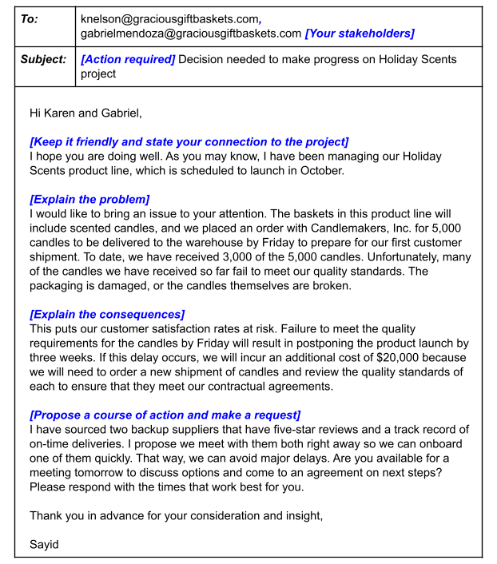

## ****Key takeaway****

In this example, Sayid maintains a friendly tone, clearly explains the problem and its potential consequences, and makes a clear request of the recipients. The email is also brief and to the point.

To recap, effective escalation emails apply these five best practices:

* Maintain a friendly tone
* State your connection to the project
* Explain the problem
* Explain the consequences
* Make a request

Escalation is a useful skill for solving problems quickly, and sending a strong escalation email that applies these best practices can help get your team the help it needs.

# Recap: Quality management concepts

You are learning to define quality in your projects. **Quality** is when the outlined requirements for the deliverable are fulfilled and meet or exceed the needs and expectations of customers.

In this reading, we’ll review the four main concepts of **quality management** we discussed in the previous video: quality standards, quality planning, quality assurance, and quality control.

* **Quality standards** provide requirements, specifications, or guidelines that can be used to ensure that products, processes, or services are fit for achieving the desired outcome. These standards must be met in order for the product, process, or service to be considered successful by the organization and the customer. You will set quality standards with your team and your customer at the beginning of your project. Well-defined standards lead to less rework and schedule delays throughout your project.
* **Quality planning** involves the actions of you or your team to establish and conduct a process for identifying and determining exactly which standards of quality are relevant to the project as a whole and how to satisfy them. During this process, you'll plan the procedures to achieve the quality standards for your project.
* **Quality assurance**, or QA,is a review process that evaluates whether the project is moving toward delivering a high-quality service or product. It includes regular audits to confirm that everything is going to plan and that the necessary procedures are being followed. Quality assurance helps you make sure that you and your customers are getting the exact product you contracted for.
* **Quality control**, or QC,involves monitoring project results and delivery to determine if they are meeting desired results. It includes the techniques that are used to ensure quality standards are maintained when a problem is identified. Quality control is a subset of quality assurance activities. While QA seeks to prevent defects before they occur, QC aims to identify defects after they have happened and also entails taking corrective action to resolve these issues.

# User acceptance testing: Goals, best practices, and management

In the previous video, you learned about different ways to measure customer satisfaction, including feedback surveys and **user acceptance testing (UAT)**. This reading will focus on why conducting UAT is essential to the successful launch of any product, service, or software. We will also discuss some best practices for effective UAT and how to manage the feedback you receive.

## ****The goals of UAT****

To recap, UAT is testing that helps a business make sure that a product, service, or process works for its users. The main objectives of UAT are to:

* Demonstrate that the product, service, or process is behaving in expected ways in real-world scenarios.
* Show that the product, service, or process is working  as intended.
* Identify issues that need to be addressed before considering the project as done.

UAT simulates real-world conditions, so when the feature works as intended during the testing process, you can be more confident that your product, service, or process will work properly once it is launched. It allows a project team to gather detailed information about how users interact with a product, service, or process. UAT helps the team answer such questions as: Do users recognize its purpose and uses? How do they interact with it? How much time do users take to interact with it? Do they notice all of its features? Is the product, service, or process accessible to everyone? UAT also allows the project team to record information about how users feel about their experience with a product, service, or process. Through testing, the team can learn about the emotions it evokes, identities it conveys, appeal it holds, and so on.

## ****Best practices for effective UAT****

In order to achieve these goals, UAT needs to be conducted thoughtfully. These best practices can help you administer effective UAT:

* **Define and write down your acceptance criteria**. **Acceptance criteria** are pre-established standards or requirements that a product, service, or process must meet. Write down these requirements for each item that you intend to test. For example, if your project is to create a new employee handbook for your small business, you may set acceptance criteria that the handbook must be a digital PDF that is accessible on mobile devices and desktop.
* **Create the test cases for each item that you are testing**. A **test case** is a sequence of steps and its expected results. It usually consists of a series of actions that the user can perform to find out if the product, service, or process behaved the way it was supposed to. Continuing with the employee handbook example, you could create a test case process in which the user would click to download the PDF of the handbook on their mobile device or desktop to ensure that they could access it without issues.
* **Select your users carefully**. It is important to choose users who will actually be the end users of the product, service, or process.
* **Write the UAT scripts based on user stories**. These scripts will be delivered to the users during the testing process. A **user story** is an informal, general explanation of a feature written from the perspective of the end user. In our employee handbook example, a user story might be: As a new employee, I want to be able to use the handbook to easily locate the vacation policy and share it with my team via email.
* **Communicate with users and let them know what to expect**. If you can prepare users ahead of time, there will be fewer questions, issues, or delays during the testing process.
* **Prepare the testing environment for UAT**. Ensure that the users have proper credentials and access, and try out these credentials ahead of time to ensure they work.
* **Provide a step-by-step plan to help guide users through the testing process.** It will be helpful for users to have some clear, easy-to-follow instructions that will help focus their attention on the right places. You can create this plan in a digital document or spreadsheet and share with them ahead of time.
* **Compile notes in a single document and record any issues that are discovered**. You can create a digital spreadsheet or document that corresponds to your plan. It can have designated areas to track issues for each item that is tested, including the users’ opinions on the severity of each issue. This will help you prioritize fixes.

## ****Managing UAT feedback****

Users provide feedback after performing UAT. This feedback might include positive comments, bug reports, and change requests. As the project manager, you can address the different types of feedback as follows:

* **Bugs or issues:** Users might report technical issues, also known as **bugs**, or other types of issues after performing UAT. You can track and monitor these issues in a spreadsheet or equivalent system and prioritize which issues to fix. For instance, critical issues, such as not being able to access, download, or search the employee handbook, need to be prioritized over non-critical issues, such as feedback on the cover art of the handbook.
* **Change requests:** Sometimes the user might suggest minor changes to the product, service, or process after UAT. These types of requests or changes should also be managed and prioritized. Depending on the type and volume of the requests, you may want to share this data with your primary stakeholders, and you may also need to adjust your project timeline to implement these new requests.

## ****Key takeaway****

User acceptance testing is a powerful tool to ensure that your project outcome is desirable and successful. Be sure to leave time in the schedule for proper testing and issue resolution.

# Common data metrics for project management

There are many types of project data you can use to determine your team’s progress and efficiency, evaluate the success of your project, and inform project decisions. While you don't need to be a data expert, knowing how to measure, track, and evaluate the right kind of data will help you deliver the most value and impact. This reading will recap some of the common types of data from the previous video and introduce a few more key data points that can help you manage projects and work with stakeholders. This reading will also introduce a few ways to interpret the data so that you can reduce risks and make the right decisions about your teams and projects.

# ****The benefits of analyzing data in project management****



As a project manager, you can use data daily to make better decisions, solve problems, improve performance and processes, and understand your users.

For example, if you have data on customer buying patterns, you can identify your best-selling products, and you'll be able to make smarter decisions when placing new product orders with your suppliers. This data will also help you better understand your users and their preferences so you can improve your product offerings and performance.

You can also use project team data to help you refine your processes. For example, if your team is experiencing an issue, analyzing data from your project tracker about the number of tasks completed, escalations, or internal process problems can help you find the source. This will allow you to make an informed decision about where to focus your efforts to improve processes.

Through critical analysis, application, and execution, data becomes a powerful tool to guide any project in the right direction.

# ****Data, metrics, and analytics****



Three images: Numbers grouped in a circle to represent data; a graph with rulers lining the x and y axis to represent metrics; two people working on a puzzle to represent analytics.

**Data** is information. It’s the numbers and feedback available to you about different aspects of your project. **Metrics** are how you measure your data. They define the important or specific information (data) you need to know about your project, such as productivity, quality, or engagement. Once you determine your project's metrics, you analyze the data according to those metrics to find patterns and answer questions about your project. This process is called **analytics**: using data to answer questions, discover relationships, and predict unknown outcomes.

When analyzing data, ask: What do the metrics mean to you? How do you want to use the metrics you've chosen? Can you find patterns to make predictions about your project? Can you find ways to improve—or **optimize**—certain aspects of your project? What lessons can you draw from your project's data?

What follows are some common categories of metrics used in project management and a brief explanation of what they are and how they're useful to a project. Keep in mind that your use of different metrics isn’t limited to these categories. All of your project data is interrelated. The same metric can also provide different information when applied to different aspects of your project.

## ****Productivity metrics****



Productivity metrics typically measure progress and output over time. They allow you to track—or predict—the effectiveness and efficiency of your project team.

To track your team's productivity over time, analyze the **number of tasks or milestones completed** in a given time frame. Ask questions like, what percentage of tasks are completed on time, and how long do they usually take? Or, if tasks were not completed on time, how much longer than anticipated did it take to complete all the tasks?

**On-time completion rates** can help illustrate to clients and stakeholders how the project is progressing and when they can expect certain deliverables to be ready. If your project's completion rates are high, it means you're doing a good job of meeting your completion goals. If the rates are low, it means you're missing deadlines. Analyzing data can help you make decisions about things like improving or implementing new processes, or re-evaluating how you estimate project scope, complexity, and timeline.

Calculating **duration** (how long something takes) can be useful for setting and evaluating tasks and milestones and determining if you'll meet project deadlines.Tracking task duration can improve the accuracy of estimating a project's timeline. This data is broken down into hours, days, weeks, months, and sometimes years.

You can also analyze current information to predict future outcomes and make **projections** (or **forecasts**) about productivity trends, project durations, costs, performance or quality. This kind of data empowers you to proactively manage your project and its resources and measure the accuracy of your projections over time. For example, analyzing your team's overall **performance** or **velocity** can answer questions such as, is the team completing its tasks and milestones? What percentage of tasks is the team finishing on time?

Predicting the future may be impossible, but building a better understanding of it and refining your method for making projections is achievable and valuable.

## ****Quality metrics****



Quality metrics relate to achieving acceptable outcomes and can include metrics such as number of changes, issues, and cost variance, all of which affect quality.

**Changes** refer to differences in any aspect of the project from what was originally planned or required. **Issues** are problems that may affect task completion—and often result in a change. Track the number of changes and issues to identify patterns, refine processes, and share information about the project with stakeholders.

**Cost** or **budget variance** is the difference between the actual amount of money spent on a project and the amount that was budgeted for the project. Over time, this data can help you understand how well you're estimating budgets for your projects. A low variance means you've estimated your project budget accurately. A high variance means you should reevaluate your estimation process. You could be under- or over-estimating costs for your budget, or you may not be tracking expenses effectively.

### **Happiness and satisfaction**



Project managers at Google use a sub-set of metrics called **happiness metrics** that also relate to quality**.** These are metrics that relate to different aspects of the user's overall satisfaction with a product or service, like **visual appeal**, how likely they are to **recommend**, and **ease of use**. Happiness metrics can generally be captured with a well-designed survey or by tracking revenue generated, customer retention, or product returns.

**Customer satisfaction scores** reflect user **attitudes**, **satisfaction**, or perceived **ease of use.** These scores measure how well the project delivered what it set out to do and how well it satisfies customer and stakeholder needs. Customer satisfaction scores generally represent a combined metric—the sum of several different happiness metrics. For example, on a satisfaction survey, a customer might separately rate a product's appearance as 6/10, ease of use as 7/10, and likeness to recommend or use again as 8/10. The overall customer satisfaction score would then be 7/10.

You will need to determine what scores are acceptable for your project by discussing with stakeholders what the most important aspects of the project are.

### **Adoption and engagement**



Another set of metrics related to quality are adoption and engagement. **Adoption** refers to whether or not a product, service or process is accepted and used. **Engagement** refers to the degree to which it is used—the frequency of use, amount of time spent using it, and the range of use. It might help to think of these in terms of throwing a party: your adoption metrics would reveal to you whether or not people accepted the invitation and showed up. The engagement metrics would tell you how active they were at the party—whether they participated in activities or interacted with other attendees, if they invited their friends to come with them, and how long they stayed.

**Adoption metrics** for a product or service release, like an app, software program, delivery service, or gym membership, would be similar to the party example. However, they can be a bit more complex if you need to track metrics for more than one thing, like whether users make additional purchases or sign up for premium features.

Each project will need to define its own set of successful adoption metrics, such as:

* Conversion rates
* Time to value (TTV)
* Onboarding completion rates
* Frequency of purchases
* Providing feedback (rating the product or service)
* Completing a profile

**Engagement metrics** tell you to what degree a product, service, or process is being used. They reveal the frequency and type of customer interaction and participation over time. Engagement metrics might include the daily usage rate of a design feature or tracking orders and customer interactions.

As a project manager, you're not only concerned with the end user's level of engagement. It's just as important to monitor stakeholder and team member engagement as well. Measuring stakeholder participation by tracking the **frequency of communication**, **responses** to emails or updates, **attendance** at meetings, or **level of input** can give you a sense of whether or not stakeholders are finding value in the project. A lack of meaningful engagement could put your project at risk. Stakeholders may not be aware of changes or the overall progress of the project, and therefore the final outcome of the project may not meet their expectations. Measuring team member engagement is vital to the success of your project because the more engaged they are, the more productive they are, and the more likely they are to produce high-quality results.

Ideally, you want your adoption and engagement metrics to increase or to at least meet the goal metrics that were established with stakeholders earlier in the project.  If there is no increase, or the metrics drop, then your rates are low and therefore not as successful. Check out the resources below for a more in-depth understanding of how and why to measure adoption and engagement.

## ****Key takeaway****

Data, metrics and analytics are all important to the success of your project. You'll need to have some familiarity with how to collect and measure data, and how to use the data to tell you about different aspects of your project. Depending on the project and its unique goals, some metrics will be more important than others. It's your job to make sure you understand which metrics your stakeholders are most interested in and what elements impact your team's ability to deliver quality results on time and within budget.

# Data ethics considerations

As a project manager, data collection and analysis will be a key part of your projects. As you’ve learned, you’ll collect data from a variety of sources, including focus groups, interviews and questionnaires. The data you collect will usually hold **PII (personally identifiable information)**—information that could be used to directly identify, contact, or locate an individual. A lot of times, you will also need to report on the data you collect to stakeholders, customers, and your project team. Collecting, analyzing, and sharing this data in an ethical way is extremely important for maintaining the integrity of your organization, your projects, and your position.

**Data ethics** is the study and evaluation of moral challenges related to data collection and analysis. This includes generating, recording, curating, processing, sharing, and using data in order to come up with ethical solutions.

Businesses apply data ethics practices so they can:

* Comply with regulations
* Show that they are trustworthy
* Ensure fair and reasonable data usage
* Minimize biases
* Develop a positive public perception

Data ethics is rooted in several principles. In this reading, we will focus on two of these principles: **data privacy** and **data bias**.

## ****Data privacy****

**Data privacy** is a key part of data ethics. Data privacy deals with the proper handling of data. This includes the purpose of data collection and processing, privacy preferences, the way organizations manage personal data, and the rights of individuals. It focuses on making sure the ways we collect, process, share, archive, and delete data are all in accordance with the law.

As a project manager, it is your responsibility to protect the data you collect. You can help ensure the privacy of data collected from users, stakeholders, and others for your projects by:

* **Increasing data privacy awareness**. Make sure every member of your project team—plus the vendors, contractors, and other stakeholders from outside of your company—are made aware of your organization's data security and privacy protocols.
* **Using security tools**. Free security tools, like encrypted storage solutions and password managers, can decrease your project’s vulnerability to a data breach. In a lot of applications, like ones that are part of Google Workspace and Microsoft OneDrive, privacy settings can be adjusted to only give access to specific individuals.
* **Anonymizing data**. Data anonymization refers to one or more techniques such as blanking, hashing, or masking personal and identifying information to protect the identities of people included in the data. This helps protect individuals’ personal information by keeping them anonymous. Once the information has been anonymized, it can then be used and shared freely. Types of data that should be anonymized include names, telephone numbers, social security numbers, email addresses, photographs, and account numbers.

## ****Data bias****

Another important data ethics practice is making sure that the data you collect does not indicate any biases. **Data bias** is a type of error that tends to skew results in a certain direction. Maybe the questions on your survey had a particular slant to influence answers, or maybe your sample group was not fully representative of the population you want to study. Bias can also happen if a sample group lacks inclusivity. For example, if your sample does not include people with disabilities. The way you collect data can also bias a dataset. Say you give people only a short time to answer questions, this can lead to rushed responses. When people are rushed, they tend to make more mistakes, which can affect the quality of their data and create biased outcomes. As a project manager, you have to think about bias and fairness from the moment you start collecting data to the time you present your conclusions.

### **Types of biases**

There are different types of biases to keep in mind when setting up your data collection processes. Here are four of the most common types of biases that could impact your data:

* **Sampling bias** is when a sample is not representative of the population as a whole. For example, maybe your sample did not include people above the age of 65. Or maybe you excluded people from certain socioeconomic groups.
* **Observer bias** is the tendency for different people to observe things differently. For example, stakeholders from different parts of the world might view the same data differently and draw different conclusions from it.
* **Interpretation bias** is the tendency to always interpret situations that don’t have obvious answers in a strictly positive or negative way, when, in fact there is more than one way to understand the data. Data that does not provide an obvious set of conclusions makes some people feel anxious, which can lead to interpretation bias. For example, a team member might interpret inconclusive survey results negatively, while other team members might be able to think more carefully and assess the data from different angles.
* **Confirmation bias** is the tendency to search for or interpret information in a way that confirms pre-existing beliefs. For example, you might ask only specific stakeholders for feedback on parts of your project because you know they are the most likely to have the same perspective as you.

Each of these types of bias affect the way you collect and make sense of the data, so it is important to be aware of them when setting up your data collection processes.

## ****Key takeaway****

According to the Project Management Institute’s [Code of Ethics & Professional Conduct](https://www.pmi.org/about/ethics/code#:~:text=Ethics%20is%20about%20making%20the,absolutely%20dependent%20on%20ethical%20choices.), “Ethics is about making the best possible decisions concerning people, resources, and the environment. Ethical choices diminish risk, advance positive results, increase trust, determine long term success, and build reputations. Leadership is absolutely dependent on ethical choices."

A key way you can show your leadership skills is by exercising sound judgment when it comes to data ethics. In order to tell a project’s data-informed story to stakeholders, project team members, and others in an ethical way, you have to make sure you think about both privacy and bias-related concerns in how you conduct, analyze, and share that data.

# The six steps of data analysis

In an earlier video, you learned that **data analysis** is the process of collecting and organizing information to help draw conclusions, solve problems, make informed decisions, and support your goals. In this reading, we will go over the key parts of the data analysis process.

There are six main steps involved in data analysis: **Ask, prepare, process, analyze, share** and **act**. Let’s break these down one by one.

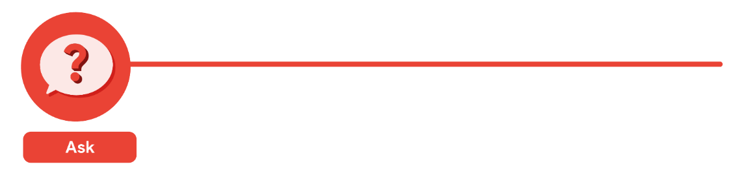

During the **Ask** phase, ask key questions to help frame your analysis, starting with: What is the problem? When defining the problem, look at the current state of the business and identify how it is different from the ideal state. Usually, there is an obstacle in the way or something wrong that needs to be fixed.  At this stage, you want to be as specific as possible. You also want to stay focused on the problem itself, not just the symptoms. For example, imagine you are doing data analysis for a gym that is losing memberships. You could ask: Why do we keep losing members? But a better and more specific question would be: What factors are negatively impacting the member experience? That way, when you set off to do your research, you know exactly what to look for.

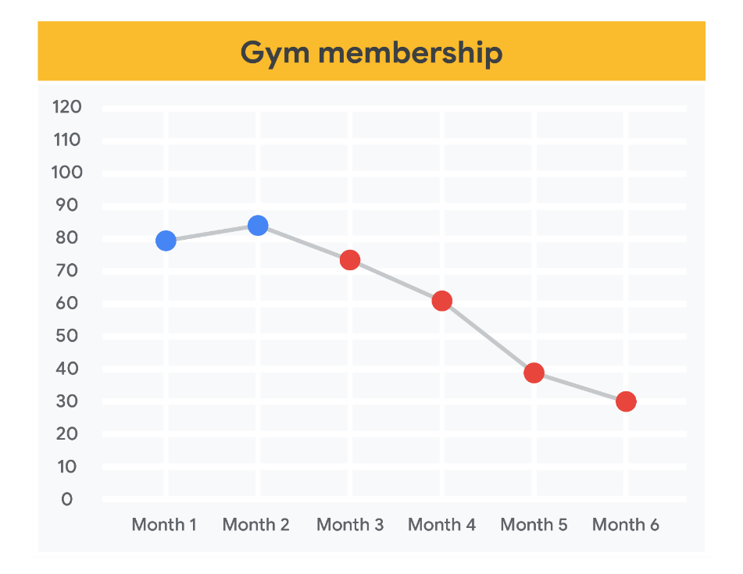

Another part of the **Ask** stage is identifying your stakeholders and understanding their expectations. There can be lots of stakeholders on a project, and each of them can make decisions, influence actions, and weigh in on strategies. Each stakeholder will also have specific goals they want to meet. It is pretty common for a stakeholder to come to you with a problem that needs solving. But before you begin your analysis, you need to be clear about what they are asking of you. For example, if your manager assigns you a project related to analyzing the gym’s business risk, it would be a good idea to confirm whether they want you to analyze all types of risks that could affect the gym or just risks related to weather or seasonal trends.

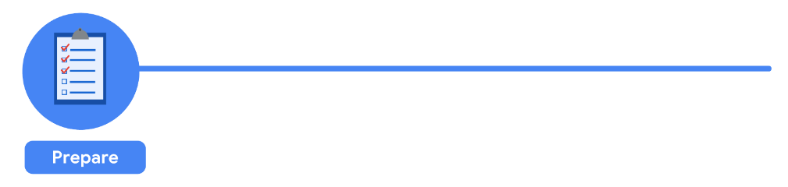

After you have a clear direction, it is time to move to the **Prepare** stage. This is where you collect and store the data you will use for the upcoming analysis process.

Let’s turn back to our gym membership example. To collect data on the member experience, you decide to send surveys to the gym’s members asking for feedback about their experience. To make sure you get specific answers, you ask them to offer feedback in three distinct categories: upkeep of the facility, customer service, and membership cost**.** You also leave room for them to write in a response. When you get the member surveys back, it is important that you have an organized system for tracking and filing them.

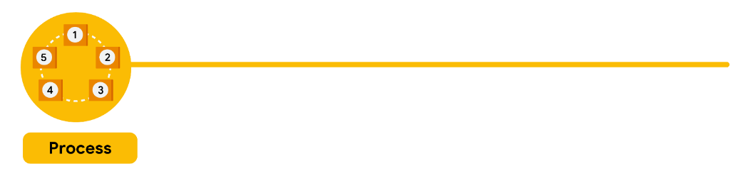

This stage is when it is time to **Process** your data. In this step, you will “clean” your data, which means you will enter your data into a spreadsheet, or another tool of your choice, and eliminate any inconsistencies and inaccuracies that can get in the way of results.  While collecting data, be sure to get rid of any duplicate responses or biased data. This helps you know that any decisions made from the analysis are based on facts and that they are fair and unbiased. For example, if you noticed duplicate responses from a single gym member when sorting through the surveys, you would need to get rid of the copies to be sure your data set is accurate.

During this stage, it is also important to check the data you prepared to make sure it is complete and correct and that there are no typos or other errors.

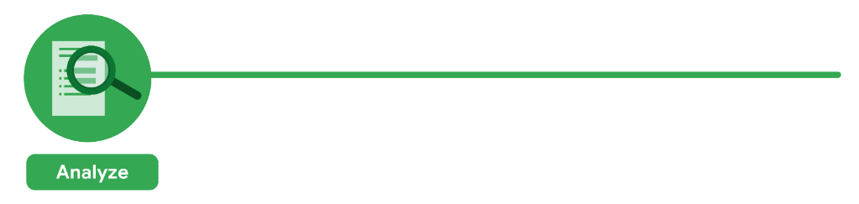

Now it is time to **Analyze**. In this stage, you take a close look at your data to draw conclusions, make predictions, and decide on next steps. Here, you will transform and organize the data in a way that highlights the full scope of the results so you can figure out what it all means. You can create visualizations using charts and graphs to determine if there are any trends or patterns within the data or any need for additional research.

In our gym membership example, let’s say you notice 50% of the members wrote in an additional response on the survey citing that the equipment is outdated. The survey also showed that 75% of the responses cited  “expensive membership fees.” When looking at the 50% of responses citing “outdated equipment” and 75% of responses citing “expensive membership fees” side by side on a graph, you may be able to deduce that these responses inform one another. Members feel like the experience just isn’t worth the price. You might conclude that the gym should invest in new equipment if they want to keep members and add value to the membership fee.

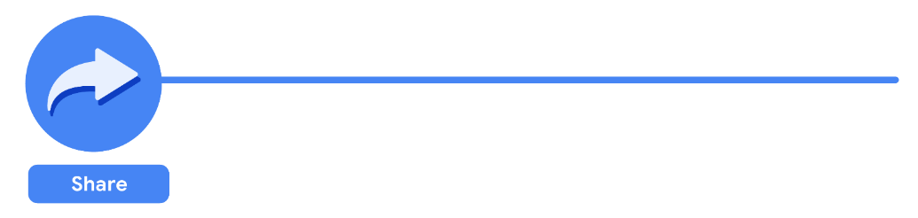

Once you have asked questions to figure out the problem—then prepared, processed, and analyzed the data—it is time to **Share** your findings. In this stage, you use **data visualization** to organize your data in a format that is clear and digestible for your audience. When sharing, you can offer the insights you gained during your analysis to help stakeholders make effective, data-driven decisions for solving the problem.

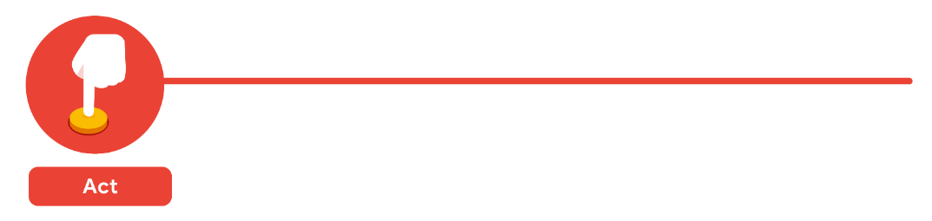

And finally, you are ready to **Act**!In the final stage of your data analysis, the business takes all of the insights you have provided and puts them into action to solve the original business problem.

Conducting a data analysis is an essential process for understanding a business’ needs and challenges and determining effective solutions. These six foundational steps—**ask, prepare, process, analyze, share,** and **act**—will help set you up for success!

# Different ways to visualize data

Earlier, we discussed best practices for collecting and analyzing data. When it is time to present your data to your audience, you don’t just want to tell them about your findings and what they mean, you want to show them. **Data visualization** helps us organize data and turn it into information that is clear and easy for our audience to digest. In this reading, we will go over a variety of charts and graphs you can use to visually represent data.

## ****Visualizing your data****

Before translating your data into a chart or graph, you should be clear on what you want to show your audience. Figure out what data you want to use and why. You might want to **inform** your audience about a new trend or a valuable piece of information, or **show relationships** between data sets. Or maybe you need to **compare values,** understand the **composition** of something, or **analyze trends and behaviors over set periods of time.**

The type of data you have, and the information you want to show or understand, will help you figure out the right data visualization to use. Let's go over some scenarios and discuss which charts and graphs would be best for each.

## ****Show relationships****

A **scatter plot**, sometimes referred to as a scatter chart or scatter graph, uses dots to represent values for two different variables. The position of each dot on the horizontal and vertical axis indicates values for an individual data point. Scatter plots will sometimes have a line drawn across its center. This line is known as the trend line and highlights the direction the points are trending towards.

Scatter plots show the relationship between data sets, and can help us understand the impact of one factor on another. For example, the scatterplot below shows the relationship between the life expectancy of people living in a country and how happy those people are. The first variable, the happiness score, is reflected on the vertical axis —also called the **y-axis.** The second variable, life expectancy, is on the horizontal axis —also called the **x-axis.** By looking at this scatterplot, we can tell that as a person’s happiness score increases, so does their life expectancy.

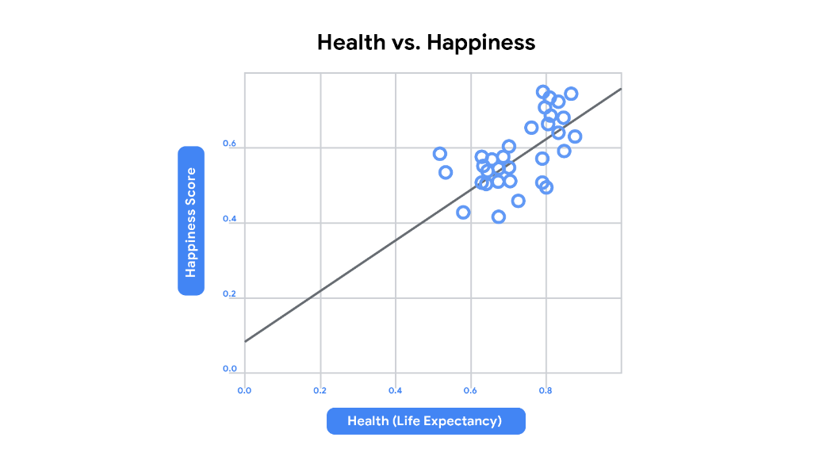

### **Scatter plot best practices:**

* Start the y-axis at 0 to represent data accurately.

## ****Comparing values****

**Bar graphs** use size contrast to compare two or more values. In the example below, the time of day is compared to someone’s level of motivation throughout the whole work day. By comparing this data, we can tell that this person’s motivation is low at the beginning of the work day, and gets higher and higher by the end. Bar graphs are also a great way to clarify trends and identify patterns.

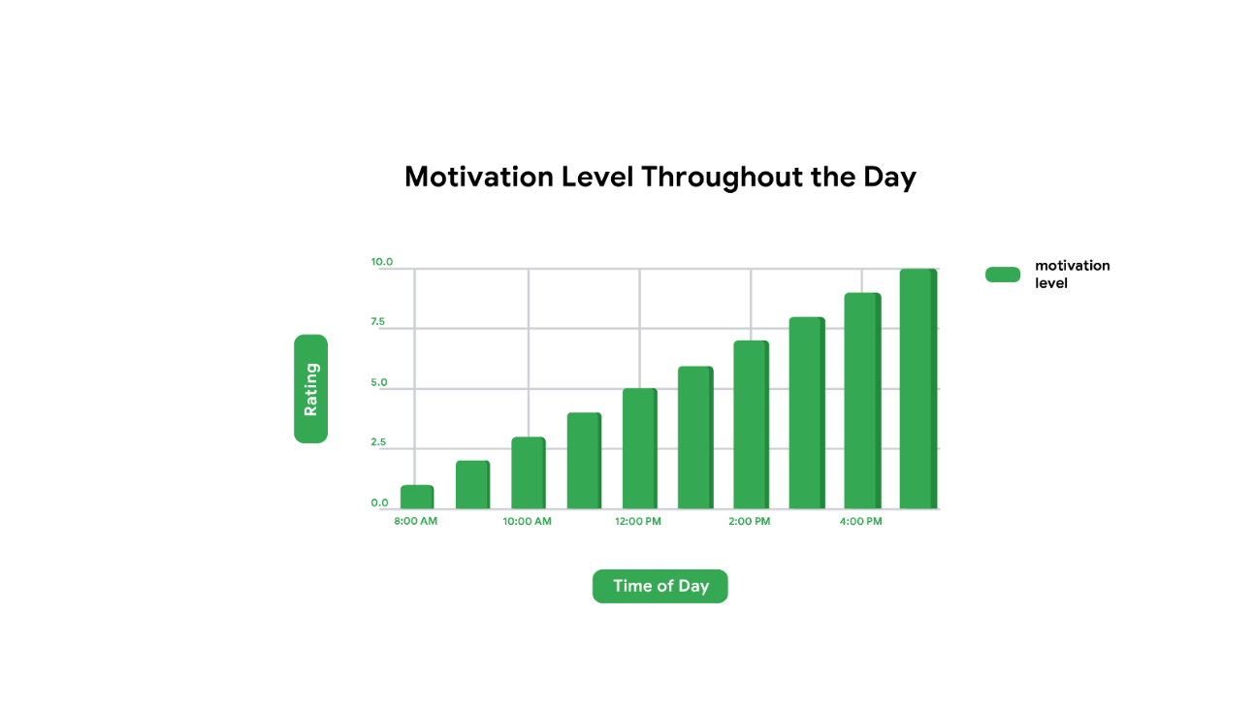

### **Bar graph best practices:**

* Use consistent colors throughout the chart
* Use accent colors to highlight important data points or changes over time
* Use horizontal labels so it is easier to read

## ****Demonstrating composition****

Now let’s check out another visualization you will probably recognize—the **pie chart.** Pie charts show us the **composition** of something. In other words, how much each part of something makes up the whole. The **pie chart** below shows us all the activities that make up someone’s day. Half of it is spent working, which is shown by the amount of space that the blue section takes up. From a quick glance at this pie chart, you can easily tell which activities make up a good chunk of the day and which ones take up less time.

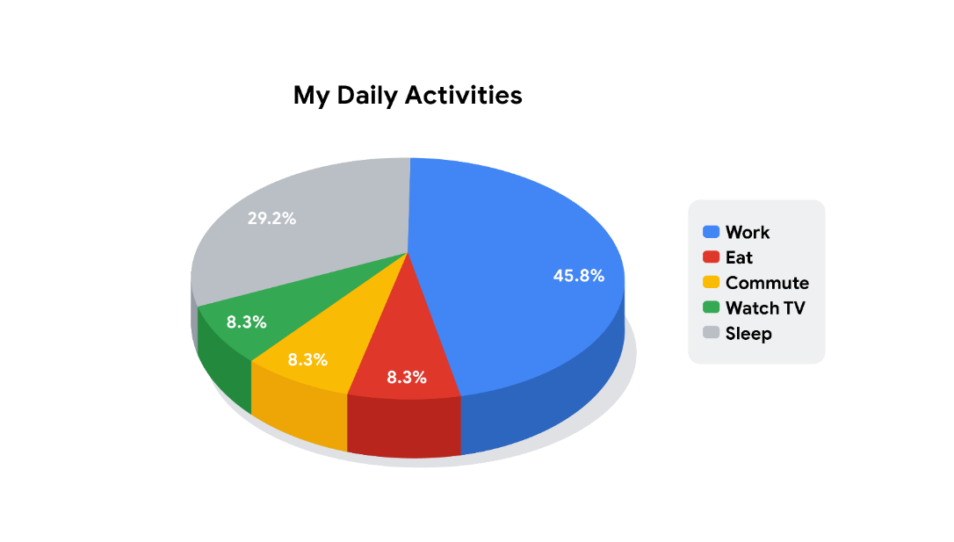

### **Pie chart best practices:**

* Avoid including too many categories so it is easy to compare slices
* Make sure that the slice values add up to 100%
* Order slices according to their size

## ****Analyzing trends and behaviors****

Tracking trends can help us understand shifts or changes in our data. **Line graphs** are a great tool for visually showing change over time, but they can be paired with other factors, too. In the line graph below, we are using two lines to compare the popularity of cats and dogs over a period of time. Because the graph is using two different line colors, we can instantly tell that dogs are more popular than cats. We will talk more about using colors and patterns to make visualizations more accessible to audiences later, too. Even as the lines move up and down, there is a general trend upwards, and the line for dogs always stays higher than the line for cats.

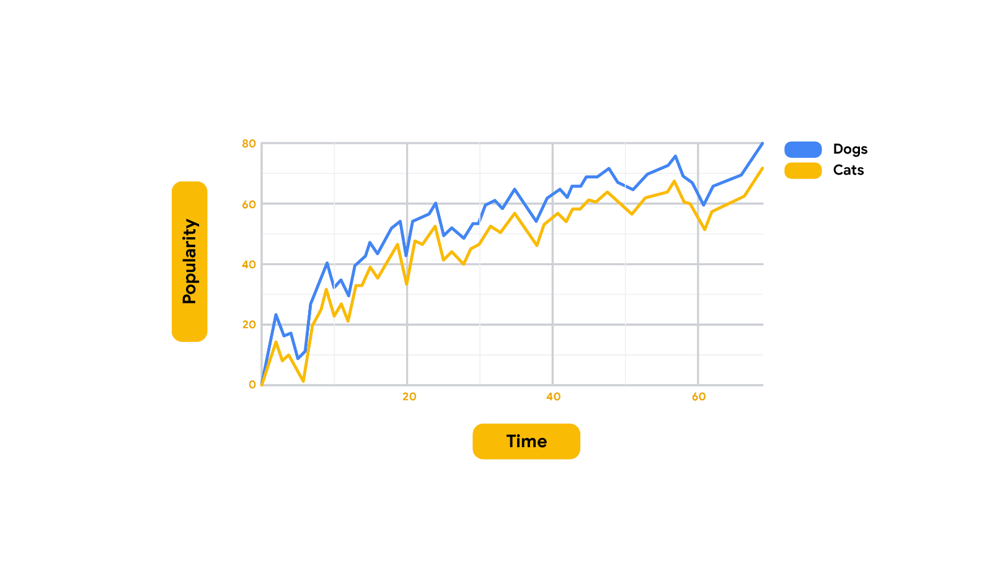

### **Line graph best practices:**

* To avoid clutter, don't show more than four categories.
* Organize highly variable data at the top of the chart to make it easy to read

Scatterplots, bar graphs, pie charts, and line graphs are common data visualizations you will use throughout your career as a project manager. To practice creating these charts, check out [this step-by-step overview for creating charts using Google Sheets](https://support.google.com/docs/answer/63824?co=GENIE.Platform%3DDesktop&hl=en) or this [resource](https://support.microsoft.com/en-us/office/create-a-chart-from-start-to-finish-0baf399e-dd61-4e18-8a73-b3fd5d5680c2) for Microsoft Excel.

# Preparing an effective presentation

At various points throughout a project, you will likely be required to deliver a presentation to team members, key stakeholders, senior leaders, or customers. Use the following tips and best practices to help you prepare an effective presentation.



## ****Preparation****

### **Get clear on your goals and the purpose of your presentation.**

Be clear and specific about what you want to get out of the meeting, then frame the discussion with that goal in mind. For instance, “We need two engineers who have worked in this industry before,” instead of “We need more resources.”

### **Seek input and set expectations.**

Ask your manager or check with stakeholders regarding your presentation goals. Get their input and feedback ahead of time.

* If you were invited to present, make sure you understand in advance exactly what the requestor is hoping to gain from your presentation.

### **Create a delivery plan.**

Identify a headline for each slide, which is the one-sentence main point that you are trying to illustrate with that slide.

* Create a couple of supporting points that add interest to the headline, such as anecdotes, charts, data, etc.
* Build in signposts. These are ways to clue the audience in to where you are going and what to expect with your presentation.
* Limit the number of slides in the main presentation. At the same time, consider creating backup slides for potential challenges, difficult questions, trade-offs, or alternative solutions. You can hide these backup slides at the end of your presentation if you don’t need them, or add them into your presentation if you do.

### **Be mindful of your audience’s time.**

Invite only participants who need to be there.

* Send the presentation ahead of time, if possible.

### **Develop a strategy for making your presentation memorable.**

Use stories and repeat key points.

* Start with a strong intro. Spend extra prep time on the beginning. The beginning is when your nerves are typically the highest, and delivering the introduction successfully can help you quickly gain confidence.

## ****Practice****

### **Guide your audience through your presentation.**

Help them notice what you notice, and transition between slides by using phrases like “Building on this point . . .” or “As I mentioned before . . .”

### **Do a mock presentation with your team.**

If there will be more than one presenter, coordinate what each person will cover and how you will manage handoffs.

* Practice a question-and-answer (Q&A) session, anticipating the kinds of questions your participants might ask so you are prepared with a quick and confident response. In addition, practice what you will say if you are asked a question that you don’t know the answer to.
* Be prepared to run the whole meeting yourself. If a co-presenter fails to show up, are you prepared to step in?

### **Schedule time to practice.**

* Once you’ve outlined what you want to say, practice it—ideally in front of a mirror—or record yourself. This may help you identify awkward phrasing that could be improved and other issues.

### **Be prepared for surprises.**

Show that you can adapt and that you know your subject matter.

* If time runs short, can you quickly summarize the key points?
* Can you pivot the content according to what is most important to your audience?

## ****Presentation and pace****

### **Get right to the point.**

Identify what problem you are solving and state it up front.

* Tell the audience why you are in the room with them and what you will be covering.
* Lay down the ground rules. For example, how do you want to handle questions and comments? Will you take them throughout your presentation or afterwards?

### **Check your pace.**

Be mindful of clues from your audience and adjust accordingly.

## ****Follow up****

* If appropriate, send a follow up email with summary notes, action items, and time frames.
* Debrief with your manager or key audience members on what they heard from the presentation.  Ask them what went well and what could have gone better.
* Review next steps.

# Providing “air cover” to your team

As you have learned so far, project managers build teams that meet project goals in many different ways, from delegating responsibility and prioritizing tasks to promoting trust and psychological safety.

But there is another skill great project managers have that we will cover in this reading: the ability to provide **air cover** to protect their team. Air cover refers to support for and protection of a team in the face of out-of-scope requests or criticism from leadership.

## ****What is air cover?****

A lot of what we have covered throughout this program has focused on leading and managing a project team. Much of project management involves overseeing the work of others, but it also involves managing the needs and expectations of those above you. Those people are your stakeholders, project sponsors, and other leaders within your organization.

Though the needs and requests of your stakeholders are crucial to the project’s success, there may come a time when you will need to prioritize the needs of your team over the wants of your stakeholders. This is called providing “air cover” for your team, and it is an important part of managing a project. The ability to effectively provide air cover requires a trusting relationship between a project manager and their stakeholders. In this relationship, the project manager aims to demonstrate their abilities to lead a team and communicate effectively.

There is some risk involved in providing air cover. Sometimes a project manager provides air cover and the project team is still unable to deliver on the goals of the project. In this case, stakeholders may question the project manager’s ability to complete projects successfully. So, when preparing to defend your team against out-of-scope requests, be sure that you are confident in your team’s progress toward the project goal.

## ****Providing air cover: A case study****

Imagine, for example, that you are a project manager for a brand of coffee sold in supermarkets throughout your region. You and your team have been tasked with launching three new flavors of ground coffee: vanilla, hazelnut, and mocha.



However, well into the execution phase, your project sponsor sets a meeting with you to make an out-of-scope request: They would like to add a caramel-flavored coffee to the product lineup. Your team is already at maximum capacity preparing to launch the agreed-upon flavors, and a fourth flavor would add an unreasonable amount of work and stress to your very busy team.

Let’s discuss how you might provide air cover for your team in a situation like this one.

### **Saying “No” without explicitly saying “No”**

One way to provide air cover to your team is to say “no” to your sponsor’s request without explicitly saying “no.”

There are a few ways to do this:

* You can gently push back with a polite explanation that their request won’t be possible to complete under the current constraints—the scope, time, and/or cost—of the project.
* You can politely offer to get back to the stakeholder with your response. This gives you time to better understand the request and to consult with trusted team members to lay out the benefits and costs of this request. And, if you are lucky, this might even give the stakeholder the opportunity to reconsider their request or forget about it entirely.

Whether you choose to push back immediately or get back to your stakeholder with your response, it is crucial to offer alternative solutions. Maybe the project timeline can expand to accommodate the request. Or maybe you and your team have a strong relationship with another team at the organization that can help fulfill the request. Whatever the alternative, brainstorming other options can help soften the blow and provide stakeholders with new ideas.

For example, you consider telling your sponsor that the current project timeline will only allow for the launch of three new coffee flavors, and that the launch of a fourth flavor would only be possible by pushing the launch date back by two months. If you were to respond to your sponsor in this way, you would be both gently refusing their request and offering them an alternative that could work for your team.

While a simple “no” response might frustrate the person making the request, gentle pushback paired with alternative options can protect your team from new work while preserving your professional relationship with stakeholders. If your stakeholders trust your leadership abilities and perspective, then they will be more likely to accept your pushback and alternative solutions.

### **Intervening from behind the scenes**

Another way project managers provide air cover for their teams is to master the challenge of delicately intervening from behind the scenes when a stakeholder is making unrealistic requests or offering unreasonable critiques.

Continuing with our coffee company example, you know how hard your team has been working to launch the new products. To avoid causing the extra stress that might come with the knowledge that the stakeholder wants to increase their workload, you avoid sharing this request with your entire project team.

This doesn’t mean you need to come up with a solution all by yourself, however. Instead of calling a team meeting to discuss the stakeholder’s request for a new flavor, you consult with only two trusted members of your team to help brainstorm solutions. One of these team members mentions that they know two new flavors are slated to be added to the fall product lineup in six months, and that perhaps the caramel flavor could be launched then instead of with the current group. This would give your team more time to work on developing the product while still fulfilling the stakeholder’s request.

Ultimately, you bring the suggestions of adding the flavor to the fall product lineup or pushing back the launch date of the current lineup to the project sponsor, and they accept your solution to launch the new flavor in the fall.

Managing the expectations of your stakeholder while looping in relevant teammates on a need-to-know basis was essential here. This allowed your team to focus on their work without the possibility of an increased workload or an unnecessary distraction.

## ****Key takeaway****

Providing air cover for your team takes practice. It requires a careful balance of the needs of your stakeholders and the needs of your project team. As you become more experienced in leading projects, you will develop a stronger sense of how to manage nuanced situations like these and provide the air cover your team needs to do their best work.

# A framework for ethical decision-making

**Ethical leadership** is a form of leadership that promotes and values honesty, justice, respect, community, and integrity. As the leader of a project team, you will be expected to help your team succeed by leading with ethics. Building respect and trust with the teams you work with—from individuals to external partners to project stakeholders—begins with practicing ethical conduct. In this reading, you’ll gain an understanding of a common framework for ethical decision-making that can help you ensure your actions align with the ethical standards of your organization.

## ****Ethics within your organization****

**Ethics** can be defined as the principles of conduct governing an individual or a group. However, there is no single, universally-accepted grouping of ethical standards—these definitions differ based on the culture and community at your company. In the working world, ethical standards may differ based on profession, industry, and organization. Usually, an organization will have its own code of conduct which specifies the standards to which it holds its employees accountable.

Here at Google, our code of conduct makes clear the expectations that we have for our employees and board members. It is possible that the organizations you will join throughout your career will have codes of conduct, too.

Part of the challenge of leading with ethics is ensuring that your actions align with the ethical standards of your community, both within your organization and beyond it. In your role as a project manager, a clear framework for ethical decision-making can help guide you to make positive decisions throughout your project.

## ****A common framework for ethical decision-making****

The [Markkula Center for Applied Ethics at Santa Clara University](https://www.scu.edu/ethics/ethics-resources/ethical-decision-making/) developed the following framework as a helpful guide for ethical decision-making.

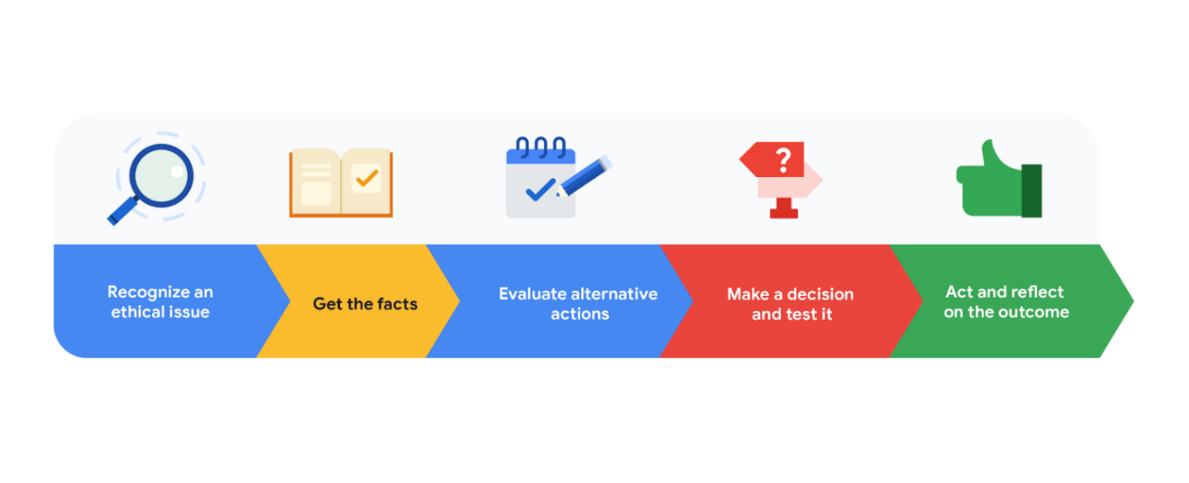

### **Recognize an ethical issue**

According to this framework, you can begin to question the ethics of an issue by asking yourself questions about the nature of the issue. Could your decision negatively impact another person or group of people? Does the issue go beyond what is legal or efficient? From there, you can proceed onto fact gathering. **Example**: A vendor you have worked with in the past sends you a generous holiday gift shortly before you are about to select a vendor for a particular task in your project. If you accept the gift, would others be negatively impacted? To determine the answer to this question, get more facts.

### **Get the facts**

Decide what you should do about the issue, and seek answers as needed. Consult with the right people to consider all of the options available to you. **Example**: Continuing with the example above, you should check to see if your company has ethics guidelines regarding accepting gifts from external parties. If not, consult with your HR representative about the matter.

### **Evaluate alternative actions**

You can evaluate alternative actions by asking yourself the following questions:

* “Which option will produce the most good and do the least harm?”
* “Which option best respects the rights of all who have a stake?”
* “Which option treats people equally or proportionally?”
* “Which option best serves the community as a whole, not just some members?”
* “Which option leads me to act as the sort of person I want to be?”

Note that your answers to these questions are subjective, and you may want to elicit the opinion of others before deciding on an alternative action. **Example**: In the case of the vendor gift example, the answer to the question “Which option treats people equally or proportionally?” might be “decline the gift,” given that accepting it might influence your decision about who to award the contract to.

### **Make a decision and test it**

Once you have chosen an option, test it by imagining the reaction to your choice from a person whose opinion you value. **Example**: Once you have decided to decline the gift, discuss your decision with your manager, HR representative, or a trusted colleague.

### **Act and reflect on the outcome**

Consider how to carry out your decision with thoughtfulness and care, and after you act, consider the results of your decision. **Example**: Respectfully decline the vendor’s gift, noting your reason (for example, your company’s ethical guidelines state that employees are not permitted to accept gifts valued at more than $20 from vendors or contractors).

## ****Key takeaway****

A framework like this one can help you feel better-equipped to make ethical decisions regarding your project and team, which is a central component of ethical leadership.

Like so much of project management, ethical leadership takes diligence and practice, and it is crucial to build this skill. As you become more comfortable leading project teams, you will strengthen your ability to make decisions that you can feel good about. Gaining trust and respect from the people you work with can make it easier to influence without authority. If those around you trust your decision-making, they may be more likely to try to help you achieve project goals, even if you aren’t their direct manager.

# Creating an effective influencing statement

Introductions in literature are important. Think of the opening lines of a good book—they help set the tone for what the reader can expect going forward. Introductions are important in project management too, especially when you are hoping to influence a stakeholder to consider and approve a new plan or idea. In this reading, we will help you apply techniques you can use to influence others. We will take you through the steps of creating a strong **influencing statement** that opens the conversation and sets you up for success with your audience.

## ****What is influencing?****

First, let’s review what it means to influence another person. **Influencing** is the ability to alter another person’s thinking or behaviors. If you have ever tried to persuade another person to understand your point of view, then you know that influencing is easier said than done.

## ****Conger’s four steps****

In his article, The Necessary Art of Persuasion, Jay A. Conger identified four steps to effectively influence another person to consider new ideas.

As you learned earlier, those steps are:

1. **Establish credibility**
2. **Frame for common ground**
3. **Provide evidence**
4. **Connect emotionally**

Throughout your career in project management, there will be times when you will need to influence someone to consider an idea, approve a plan, or complete a project task. Conger’s four steps provide a useful framework for thoughtfully approaching conversations that are important to project success and influencing stakeholders. Let’s explore each step further before applying them to an influencing statement:

### **1. Establish credibility:** When trying to persuade another person to listen to you, it helps to establish credibility. Ask yourself, why should this person listen to you? According to Conger, it is best to draw credibility from both expertise and relationships. You can build credibility by showing a level of expertise on the topic at hand. It also helps to have “a history of sound judgement.” If you find that you lack expertise on a subject, don’t worry! You can work to increase your knowledge through education or research, or you can even ask an expert for help. You can also build credibility through strong relationships with your audience and others around you. Conger found that influential leaders tend to show their trustworthiness and willingness to do right by their colleagues over time, and in turn, people are more likely to listen to them.

### **2. Frame for common ground:** The next step in effectively persuading people is to frame for common ground. You can do this by making a case for how your idea would benefit your audience, and you can determine how your ideas will benefit your audience by gaining a strong understanding of them and what they value. Pay close attention to what matters to your audience by listening carefully and gathering information during meetings and conversations. Then they frame your ideas based on your audience’s needs and interests.

### **3. Provide evidence:**

The third step is to provide evidence that supports your ideas. As Conger notes, though numbers are important, the best persuaders pair numbers with vivid language**.** They share stories, examples, and metaphors to help influence their audiences. Using vivid language can help bring your figures to life and draw stakeholders’ interest to your proposal.

### **4. Connect emotionally:** The fourth step is to connect emotionally with your audience. In this step, you illustrate that you are emotionally invested in the idea that you are presenting. But crucially, Conger notes, you must also do your best to determine and match the emotional state of your audience.

## ****Applying Conger’s steps to an influencing statement****

Conger’s four steps—establish credibility, frame for common ground, provide evidence, and connect emotionally—are meant to be applied throughout important conversations with those whom you aim to influence. But to set yourself up for success during these conversations, you can apply the four steps to the influencing statement that sets the stage for your idea.

Let’s discuss how Conger’s four steps come together in the following example:

Carmen is a project manager at a small marketing agency. She would like to convince a human resources director at her organization to approve a new process for onboarding new graphic design employees. Though the company has an existing onboarding process, this process is the same for all new hires, regardless of role. As a project manager working in the human resources department, she learns that it is hard for newly-hired graphic designers to onboard since there are only a few people who hold graphic design roles at the company. Carmen identifies that there is a lack of information available for new graphic design hires to turn to for learning about procedures and software specific to their role. Carmen would like to propose that all new graphic design hires receive a digital welcome packet containing guidelines for installing software, processes to be aware of, and other design-specific onboarding documents. Carmen developed a similar process in her role at a previous company, and it received a positive response from employees. She thinks a similar process will work for her new organization too, so she sets up time with her director to present her idea. To influence her director to approve the new process, Carmen opens her presentation with a strong influencing statement:

I’d like to propose a new onboarding process for graphic design hires.

**(Provide evidence)** In reviewing our new hire surveys, 80% of recent graphic design hires have assigned a negative rating to our onboarding process. When I followed up  with respondents, I learned that our graphic designers lack access to relevant information that could help them acclimate to our organization faster. To address this issue, I would like to create a digital welcome packet containing design-specific onboarding documentation.

**(Frame for common ground)** I have met with leaders on the graphic design team to discuss this idea, and they agreed that a design-specific onboarding process might help increase the productivity of new hires, since a better onboarding process would enable them to be better prepared to take on projects in their first few weeks on the job.

**(Establish credibility)** In my previous role, I designed a similar, role-specific onboarding process, which increased our new hire satisfaction rates by 60%. I think a new process could benefit employees here, as well.

**(Connect emotionally)** It can be overwhelming to join a new company. A smoother, more personalized onboarding experience might help set the tone for the kind of support new graphic design hires can expect from our team.

## ****Key takeaway****

In this influencing statement, the project manager:

* **Provided evidence** from company surveys to set the stage for her proposal.
* **Framed for common ground** by noting how a new onboarding process might increase employee productivity.
* **Established credibility** by outlining her previous experience with launching similar processes.
* **Connected emotionally** by encouraging her audience to reflect on past experiences they may have endured as a new hire.

By opening with a strong influencing statement, you can set yourself up for a successful conversation that is more likely to persuade your audience and achieve your goals.

# Principles of effective email writing



Email has long been the primary method of communication for many people in business, yet messages are easy to misunderstand or ignore. In this reading, we will discuss four principles of effective email writing that will help your emails to stand out, be remembered, and elicit the response you need. These principles are:

* State what you want clearly.
* Keep the content short and concise.
* Structure your writing.
* Check grammar, punctuation, and spelling.

## ****Principles of effective email writing****

### **State what you want clearly**

When you set out to compose an email, it is because there is something that you want from your reader. You might want to receive a simple answer, to persuade someone of something, or to arrange a meeting. Before composing an email, think about what you want, when you need what you want, and the best way to get what you want when you want it.

Here are some tips on how to clearly state what you want in your email:

* Include your request in the subject line of your email.
* State your request within the first two paragraphs of your email message.
* Indicate the specific call-to-action associated with your request (for example, reply, review, RSVP).
* Write clear, concise sentences when providing details.
* Define terms. Avoid using acronyms and terminology that users may not know. Provide additional information as necessary to avoid misunderstanding.

### **Keep the content concise**

Make your words work for you. Remove any writing that doesn’t help to define what you want or contribute to your reader's needs.

* Summarize the content you want to convey, and remove anything in your email that doesn’t contribute to your goal.
* Aim to write “question-less” and “self-standing” emails. This means that the message contains enough information to stand on its own. The reader shouldn’t have any questions about what you want and when you want it.
* Know your audience. Some people—such as executives and other busy leadership—may not want to read emails of more than a few sentences or click on external links for further information. Try to tailor your emails accordingly.

### **Structure your writing**

Structure has to do with the visual flow, or aesthetics, of your email. A well-structured email conveys critical information to the reader quickly and allows them to scan the explanatory text—or ignore it altogether. Here are some tips for effectively structuring your email:

* **Use bullets**. Bullets break up the visual flow. If you have more than one of something, consider using bullets. Write strong action verbs at the start of each bullet.
* **Use labels**. Labels help guide the reader to what information is most important.
* **Add hyperlinks**. Hyperlinks allow readers to directly access additional information, rather than adding lengthy details to your email.
* **Write a strong topic sentence**. Place the main idea of the paragraph in the topic sentence.

### **Check grammar, punctuation, and spelling**

Grammar, punctuation, and spelling are critical. Turning grammar and spelling suggestions on in your email application can help you quickly identify errors. Be sure to correct any errors before sending off.

## ****Applying effective email writing principles****

In order to learn how to apply these principles, let’s check out the following example email:

Issac was given the task of sending an email about the company’s annual team building retreat. Please note: Blue, underlined text indicates a hyperlink to an external site or document.

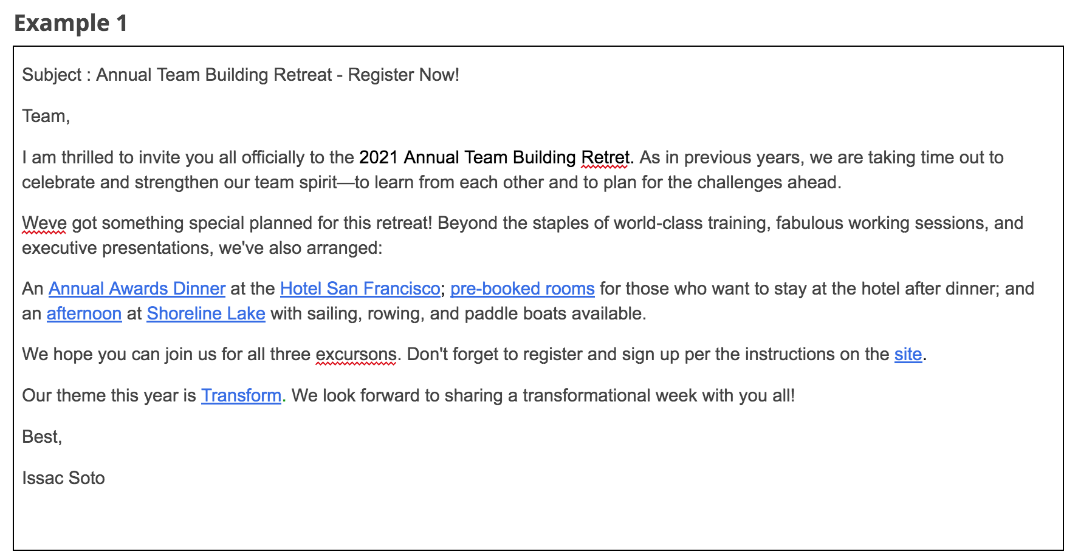Subject: Annual Team Building Retreat - Register Now! Team, I am thrilled to invite you all officially to the 2021 Annual Team Building Retreat. As in previous years, we are taking time out to celebrate and strengthen our team spirit—to learn from each other and to plan for the challenges ahead. We’ve got something special planned for this retreat! Beyond the staples of world-class training, fabulous working sessions, and executive presentations, we've also arranged: An Annual Awards Dinner at the Hotel San Francisco; pre-booked rooms for those who want to stay at the hotel after dinner; and an afternoon at Shoreline Lake with sailing, rowing, and paddle boats available. We hope you can join us for all three excursions. Don't forget to register and sign up per the instructions on the site. Our theme this year is Transform. We look forward to sharing a transformational week with you all! Best, Issac Soto

This email example is not as effective as it could be. The date and location of the event are not included. The main link Issac wants the reader to click—to register for the event—is buried at the bottom of the email. The other links in the message are also overwhelming because there are so many. There are no bullets or labels to help organize the information. Additionally, there are a few spelling and punctuation errors.

Let’s examine how Issac’s email could be revised to be more effective.

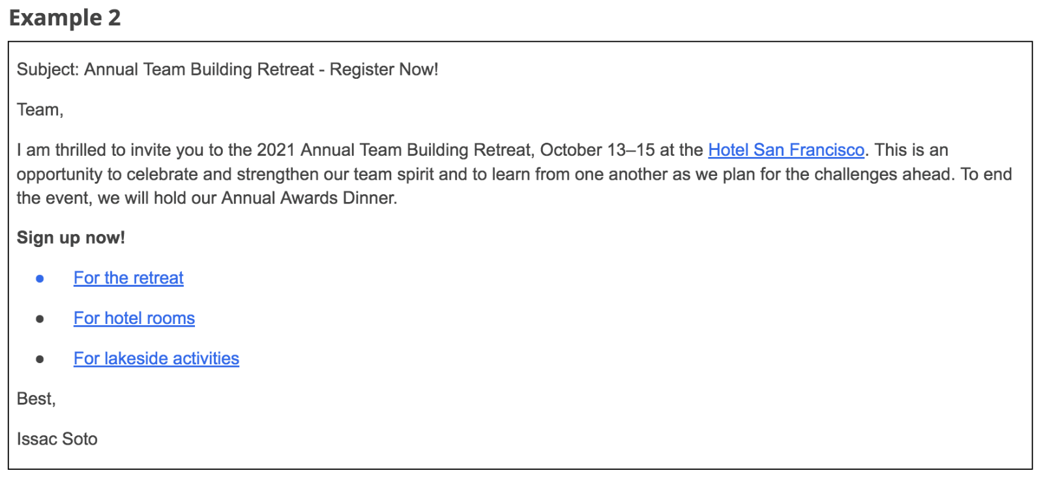Subject: Annual Team Building Retreat - Register Now! Team, I am thrilled to invite you to the 2021 Annual Team Building Retreat, October 13–15 at the Hotel San Francisco. This is an opportunity to celebrate and strengthen our team spirit and to learn from one another as we plan for the challenges ahead. To end the event, we will hold our Annual Awards Dinner. Sign up now! For the retreat for hotel rooms for lakeside activities Best, Issac Soto

In this example, there is a clear, concise description of what the email is about at the very beginning of the email. The dates and location of the event are clearly stated at the beginning of the email. The opening paragraph is directly followed by a label in bold: **Sign up now!** Then, bullet points help set apart the hyperlinks for better visibility, and the hyperlinks clearly state what the reader will access when they click. Lastly, the grammar, spelling, and punctuation are all accurate.

## ****Key takeaway****

When you write an email, think about the people you are sending it to and what they need in order to quickly read and correctly understand it. Remember to:

1. State what you want clearly.
2. Keep the content concise.
3. Structure your writing.
4. Check grammar, punctuation, and spelling.

Keeping these principles in mind when you draft emails will help you communicate more effectively with your team members, stakeholders, customers, and others. It can also demonstrate your level of professionalism and competence and inspire others’ confidence in your abilities.

# Facilitating inclusive and accessible meetings

## ****Creating an inclusive environment****

Inclusion of employees from different backgrounds and identities is extremely important for any organization looking to build a strong sense of connection in the workplace. Also, when team members feel included, they tend to want to do their best work. This is great for the organization, too. Creating an inclusive environment can be particularly challenging in meetings because they can be intimidating for participants. As a project manager, it is part of your job to facilitate meetings that are inclusive of all participants and that create a sense of emotional safety and value for everyone’s active input. In order to help facilitate inclusive meetings that feel empowering to everyone, you should put procedures in place that are consistently followed and predictable.

* **Formalize initial check-ins for the group that build understanding and ensure everyone knows their input is needed.** Create a process that consistently asks each person for an update on their work and/or how they are doing in their daily lives. Questions should be open-ended and vary over time to include some humor, analogies, and “finish the sentence” opportunities. As the project manager, your modeling will set the tone for the team dynamic, so always check-in with your team and model professionalism, vulnerability, and empathy. Popular check-ins include: “A highlight of my week has been . . .” and “This week I have gratitude for . . .”
* **Give everyone your full attention**. Listen carefully to what everyone has to say and be careful not to interrupt someone who is speaking. Body language—such as maintaining eye contact and turning your body in the direction of a speaker—can help someone feel safe in voicing their opinion. Avoid head shaking, looking away, or looking at your phone when someone is speaking.
* **Help all participants to be heard**. Solicit ideas from participants, and ask questions to encourage participation. If someone gets interrupted, redirect everyone’s attention to that person and prompt them to finish their thought. If someone has not spoken yet, ask them what they think. It is important to note that, for some people, speaking up in meetings can be daunting. This can be especially true in virtual meetings or conference calls. This is also true for people who are not the majority in the room and may feel like they are representing an entire group of people who look, sound, or present like them. You may also find that people who are entry-level may be nervous about speaking up too since they are just beginning their careers. You can help people feel more comfortable and supported by letting them know ahead of time that they will be asked to share during a meeting so that they can prepare in advance. You can also solicit input after a meeting from anyone who did not speak.
* **Help participants feel comfortable sharing different perspectives.** Encourage differing or opposing ideas by making clear that alternate viewpoints are valued. To set the tone for this, start the meeting by encouraging competing perspectives. Try to get at least three points of view on an issue that might have some variation in the room. Follow up after the meeting with a request for additional thoughts.
* **Use images that reflect the diversity of the world.** In your presentation materials and handouts, select images that illustrate diversity in race, gender, age, ability, cultural background, religion, geographical location, and so on. The people in your images should represent diverse backgrounds to further support inclusion, allowing everyone in the room to feel welcome and represented.



## ****Making meetings accessible to everyone****

Meetings can’t be inclusive if not everyone can fully participate. It is important to make sure that your meetings are accessible to everyone. Accessible means that something is easily used, accessed, or adapted for use by people experiencing disabilities. In meetings, this means that people experiencing disabilities are not excluded from participating or understanding the information shared.

When planning your meetings, you should consider the needs of people experiencing the following types of disabilities:

* **Visual impairments and blindness**
* **Hearing loss and deafness**
* **Mobility disabilities**, which means having difficulty getting around, such as people who require wheelchairs or canes

These tips can help you ensure that the following participants have full access to your meetings:

## ****People with visual impairments****

### **Presentation materials**

* Use a large font size (minimum 22 points).
* Use high-contrast colors.
* Provide alternative text descriptions for all images, pictures, graphics, tables, and so on.
* Provide low-vision or blind attendees with an accessible electronic format of the presentation.
* Provide presentation materials in an accessible electronic format to participants ahead of time.
* Describe all meaningful graphics in your presentation (such as photos, images, charts, and illustrations).

### **Handouts and printed materials**

* Use a large font size (minimum 18 points).
* Use black lettering on white, matte paper.
* Use a simple font and avoid compressed fonts and italics.
* Use 1.25 to double spacing between lines.

## ****People with hearing impairments****

* Always face the person you are communicating with. This is especially helpful for audience members who are speech readers.
* Speak clearly, at a moderate pace and volume, and allow the other person time to respond. Avoid exaggerating, slowing your speech, or speaking loudly.
* Ask for clarification if you don’t understand something the person is communicating.
* Include all of the information presented in a spoken presentation on slides.
* Add closed captions or subtitles to videos. [YouTube Help](https://support.google.com/youtube/answer/2734796?hl=en) provides instructions for adding your own closed captions to your videos.

## ****People with mobility impairments****

* Provide ample circulation space in your meeting room so that people using mobility devices can easily pass through.
* Offer accessible seating locations throughout the room.
* For presentations, use half-round seating so that all participants may face in the direction of the speaker.

## ****Key takeaway****

Creating meetings that are inclusive and accessible to all participants will improve your team’s engagement, productivity, and morale.

Checklist for productive meetings



You may have attended a few meetings that you did not think were the best use of your time. Frequent and unproductive meetings tend to have a negative impact on individual and team productivity and well-being. In this reading, you will learn best practices for ensuring productivity before, during and after meetings.

Plenty of things can make meetings unproductive, but an internal study at Google revealed that productive meetings have three elements in common:

1. Active participation from attendees
2. A clear and concise agenda that is followed throughout
3. The correct attendees (meaning the participants can contribute to achieving the meeting’s goal)

Follow this checklist to help achieve these aims and facilitate more productive meetings for you and your project team:

**Before the meeting**

* Prepare an agenda that states the purpose and goals of the meeting, and share the agenda with participants.
* Only invite people who need to be thereand who can help reach the goals of the meeting. Make participants’ roles and responsibilities for the meeting clear. Add non-essential participants as optional to the meeting invitation.
* If you are working with people in different time zones, share the time zone burden by alternating recurring meeting times.
* Evaluate the need for the meeting and cancel if it isn’t necessary. Consider whether the meeting content can be covered via email.
* Schedule shorter meetings. Meetings tend to expand to the time allotted to them, so try to get more done in a shorter amount of time.
* Set aside time to prepare for the meeting. Read the necessary materials, review the agenda, and come ready to participate.

**During the meeting**

* At the beginning of the meeting, clearly state the meeting goals.Stick to the agenda throughout the meeting to avoid getting derailed**.** For recurring meetings, review the action items from the previous meeting to ensure accountability.
* Encourage participants to put phones and laptops away during meetings and silence notifications, if possible.
* Practice and demonstrate active listening. Respond verbally (e.g., “That makes sense. Tell us more.”) and non-verbally (through head nodding and eye contact) to show engagement.
* Encourage participation and give everyone a chance to speak**,** including remote participants. Ask open-ended questions like, “What does everyone think?” instead of “Does everyone agree?”
* Help everyone relax and feel more comfortableby starting meetings with open-ended, personal questions like, “How was your weekend?”
* Capture key points, action items, and decisions from the meeting, and assign action items to the appropriate meeting participants.

**After the meeting**

* Recap key decisions, action items, timelines, and notes and send out to participants.
* Schedule necessary follow-up meetings with relevant context.
* Assess the need for and frequency of recurring meetings. Schedule meetings less frequently, if possible.

**Pro Tip**: If you are new to the company or team, find out about and try to apply their typical meeting practices before making any major changes.

**Key takeaway**

Productive meetings generally require active participation from attendees, a clear and concise agenda that is followed throughout, and the correct attendees. Following the best practices for before, during, and after meetings described here can help you have more productive meetings. When less time is needed for meetings because meetings are more productive, more time can be devoted to project tasks.

# Case study: The impact of skipping project closure steps

In the video, we discussed the importance of the last phase of the project life cycle: closing the project. You learned that, in order to close a project, you must ensure that:

* All work is done.
* All agreed-upon project management processes have been executed.
* You have received formal recognition and agreement from key stakeholders that the project is done.

In this reading, we will discuss the impact of skipping important project closure steps.

Sometimes project closure is improperly conducted or never happens at all. This can have a major impact on your organization’s overall profitability and success. Skipping the closure phase can compromise a project that had otherwise been running smoothly. No matter how successful the project may look in its final stages, your job as a project manager is not complete until all steps of the closure phase have been completed.

## ****Case study: Tilly’s Toys****

In order to better understand what can happen when a project is not properly closed out, let’s examine a possible scenario: Tilly’s Toys, a small children’s toy manufacturer, developed a new interactive piggy bank that speaks and plays songs to help children learn number recognition, counting, and adding. Below are several oversights that occurred as a result of not properly closing out the project.

### **Oversight #1: Not all of the work was completed.**

**What happened**: When Tilly’s Toys received the final toy box from the packager, they realized that it did not include the safety disclaimer that the toy includes small parts and should not be used by children under the age of three. The design of this disclaimer had been included in the original Statement of Work but was never completed.

**Impact on the organization**: When the missing disclaimer was discovered, Tilly’s Toys was not able to use any of the boxes that had been created. They incurred significant costs to have the packager create all new boxes including the disclaimer. Having to recreate the boxes also meant that they were not able to meet their original launch date, which would have had the toys in stores before the holiday season. This oversight cost the organization additional revenue and extended the project timeline and resources.

### **Oversight #2: The organization did not complete an important agreed upon project management process.**

**What happened**: Tilly’s Toys customer, a regional chain of toy stores, required that all contractors working on the project sign a non-disclosure agreement (NDA). The NDA stated that the contractors would not disclose any information about the toy until its launch date. One of the educational experts contracted to review the toy was never given this NDA. Not having received—or signed—this important form, the contractor posted about the new toy on social media months before the toy’s launch date.

**Impact on the organization**: Sharing information with the public before the toy was launched was a breach of contract between Tilly’s Toys and their customer. This breach put Tilly’s Toys at significant legal risk.

### **Oversight #3: Stakeholders and the project manager did not provide formal recognition and agreement that the project was done.**

**What happened**: Ames, the project manager, communicated with the customer throughout the toy’s development about their objectives for the toy. After the previous oversights were rectified and Ames assumed his team was done with the project, he released the team to work on other projects. Shortly after, the customer sent a list of additional changes they wanted to see in the toy’s design.

**Impact on the organization**: Ames had to tell the customer that it was too late to implement their design requests. The customer was unhappy and told Ames that they may consider using a different toy manufacturer in the future.

## ****Avoiding the impact of project closure oversights****

 Oversights or skipping steps in the closing phase of a project can:

* Impact the product’s or service’s scheduled launch dates.
* Put your organization at legal risk.
* Result in significant financial losses to your organization.
* Undermine your team's credibility, and yours.
* Damage your relationship with the customer or client.

All of the steps of the project life cycle—initiating the project, making a plan, executing and completing tasks, and closing the project—are essential for a successful outcome. Unfortunately, closing the project is a phase that too often gets skipped, which can negatively impact both the project manager and their organization. To avoid these issues, make sure to plan for this phase just as you would any of the other project life cycle phases.

# Adopting an Agile mindset: The Agile Manifesto

In the previous video, we described Agile project management as an approach to project and team management based on the Agile Manifesto. In this reading, we will introduce you to that manifesto, which is made up of four values and 12 principles that define the mindset that all Agile teams should strive for.

## ****The history of Agile****

Agile as a project management approach was introduced to the world in 2001 in the United States. At a ski resort in the Wasatch mountains of Utah, 17 self-proclaimed organizational anarchists came together and combined several lightweight processes to create what we know today as the **Agile Manifesto**. The creators of Agile intended it to be a set of values and principles that would improve upon and transform existing software development processes, but companies in various industries quickly saw the value of Agile, too. Soon, Agile was adopted across all fields.

## ****Agile values and principles****

In the last video, you explored the [Agile Manifesto](http://agilemanifesto.org/)—the guiding force behind all Agile teams—in-depth. You learned that Agile is a highly collaborative approach suited for very complex and competitive projects. In this reading, we’ll briefly explore the four values and 12 principles of the Agile Manifesto.

The Agile values refer to the following four statements:

* **Individuals and interactions** over processes and tools
* **Working software** over comprehensive documentation
* **Customer collaboration** over contract negotiation
* **Responding to change** over following a plan

Agile experts see these values as important underpinnings of the highest performing teams, and every team member should strive to live by these values to apply the full benefits of Agile.

The same is true for the 12 principles, which are at the core of every Agile project:

* **“Our highest priority is to satisfy the customer through early and continuous delivery of valuable software.”** Whether you are working to create a product for your company or for a customer, chances are that someone is awaiting its delivery. If that delivery is delayed, the result is that the customer, user, or organization is left waiting for that added value to their lives and workflows. Agile emphasizes that delivering value to users early and often creates a steady value stream, increasing you and your customer’s success. This will build trust and confidence through continuous feedback as well as early business value realization.
* **“Welcome changing requirements, even late in development. Agile processes harness change for the customer’s competitive advantage.”** When working in Agile, it’s important to be agile. That means being able to move swiftly, shifting direction whenever necessary. That also means that you and your team are constantly scanning your environment to make sure necessary changes are factored into the plans. Acknowledging and embracing that your plans may change (once, twice, or several times) ensures that you and your customers are maximizing your success.
* **“Deliver working software frequently, from a couple of weeks to a couple of months, with a preference to the shorter timescale.”** Delivering your product in small, frequent increments is important because it allows time and regular opportunities for stakeholders—including customers—to give feedback on its progress. This ensures that the team never spends too much time going down the wrong path.
* **“Business people and developers must work together daily throughout the project.”** Removing barriers between developers and people focused on the business side of the project, builds trust and understanding and ensures that the developers, or those building the solution, are in tune with the needs of the users.
* **“Build projects around motivated individuals. Give them the environment and support they need, and trust them to get the job done.”** A successful Agile team includes team members that not only trust each other to get the work done but are also trusted by their sponsors and executives to get the work done. Teams build better solutions when they are empowered and motivated to deliver difficult projects.
* **“The most efficient and effective method of conveying information to and within a development is face-to-face conversation.”** There isn’t anything quite like face-to-face communication. Face-to-face communication allows us to catch certain cues, body language, and facial expressions that are sometimes lost when using forms of communication like email, chat, or the phone. However, we can’t always be face-to-face. Establishing effective communication norms—no matter the format—is essential to effective teams.
* **“Working software is the primary measure of progress.”** In Agile teams, the main way to demonstrate meaningful completion of work is to show a working piece of the solution. In software teams, that might mean a functional piece of software. In non-software teams, that might mean a critical portion of the solution that is ready to be demonstrated to users or their representatives in order to collect feedback. This is in contrast to traditional or Waterfall projects, where the completion of project documents could be used to measure progress. In Agile project management, it is not enough to say that the team is 80% done with an activity if there is no working, demonstrable artifact available to review.
* **“Agile processes promote sustainable development. The sponsors, developers, and users should be able to maintain a constant pace indefinitely.”** Maintaining a steady but careful pace will prevent errors along the way. Also, you never want your team to feel overworked or overwhelmed. On the flip side, a team that is underutilized may become bored and lose the creative spark to innovate. The Agile ideal is to achieve a steady pace of effort for the team that avoids overtime and burnout.
* **“Continuous attention to technical excellence and good design enhances agility.”** This principle conveys that just because the team is working fast doesn’t mean they sacrifice quality. By emphasizing quality and design throughout the project development phase, the agility, efficiency, and speed of the team will be increased. When a team delivers a well-built solution, they can quickly respond to user feedback and new information. However, if the product is low quality, implementing changes can become problematic, complex, and slow down the entire team.
* **“Simplicity—the art of maximizing the amount of work not done—is essential.”** The team should avoid implementing extra features into the solution that weren’t explicitly requested by the user or product owner. This includes removing procedures that are no longer necessary, and reducing unnecessary documentation.
* **“The best architectures, requirements, and designs emerge from self-organizing teams.”** Team members should be able to get their work done by designing their own work processes and practices, without a manager dictating how they operate. Team members should also feel empowered to speak up with questions, concerns, or feedback.
* **“At regular intervals, the team reflects on how to become more effective, then tunes and adjusts its behavior accordingly.”** In Agile, it is important to acknowledge that learning from successes and failures is continuous. No team is perfect. There will be mistakes, challenges, trials, and triumphs. Teams should reflect on all of these different aspects of their activities so that they can make necessary adjustments.

The founding principles of Scrum

Although **Scrum** was first used to describe Agile content in 1986 in the Harvard Business Review, the term originates from the internationally loved sport, rugby. In rugby, a “scrum” involves players huddling closely together with their heads down while trying to gain possession of the ball. Then, the players work together in order to achieve their shared goal: to get the ball across the line and score!



The original Harvard Business Review paper, written by Hirotaka Takeuchi and Ikujiri Nonaka and titled [*The New New Product Development Game*](https://hbr.org/1986/01/the-new-new-product-development-game), introduces Scrum in the chapter “Moving the Scrum downfield.” Throughout the paper, the authors continue to point out which characteristics of a team help to move the Scrum downfield. Those are:

* **Built-in instability:** In the Scrum world, teams are given the freedom to achieve important outcomes with “challenging requirements.” Takeuchi and Nonaka explain that this gives teams “an element of tension” necessary to “carry out a project of strategic importance to the company.”
* **Self-organizing teams:** Scrum Teams were intended to operate like their own start-up, with a unique order that lacks true hierarchy. These teams are considered self-organizing when they exhibit autonomy, continuous growth, and collaboration.
* **Overlapping development phases:** Individuals on a Scrum Team must “work toward synchronizing their pace to meet deadlines.” At some point throughout the process, each individual’s pace starts to overlap with others, and eventually, a collective pace is formed within the team.
* **Multi-learning:** Scrum is a framework that relies heavily on trial and error. Scrum Team members also aim to stay up-to-date with changing market conditions and can then respond quickly to those conditions.
* **Subtle control:** As we mentioned, Scrum Teams are self-organizing and operate like a start-up, but that doesn’t mean there is no structure at all. By creating checkpoints throughout the project to analyze team interactions and progress, Scrum Teams maintain control without hindering creativity.
* **Organizational transfer of learning:** On Scrum Teams, everyone is encouraged to learn skills that may be new to them as they support other team members.

The authors’ main point was that “each element, by itself, does not bring about speed and flexibility. But taken as a whole, the characteristics can produce a powerful new set of dynamics that will make a difference.” Though these concepts were first introduced in 1986, they still remain remarkably true for Scrum Teams today.

# The Spotify model

Because of their flexible approach, Spotify—a music streaming company with millions of listeners—is known in the Agile project management field for setting the standard pretty high. In this reading, you will learn about the Spotify model and the importance of being flexible when scaling an Agile team.

Spotify has been able to do what so many other companies dream of doing, and they’ve done it as their team size scaled. How did they do it? Agile coaches Henrik Kniberg and Anders Ivarsson have instilled an overall approach of the constant blending of methods and adapting as time goes on.

## ****The Spotify model****

[The Spotify model](https://blog.crisp.se/wp-content/uploads/2012/11/SpotifyScaling.pdf) encourages innovation, collaboration, and productivity while maintaining autonomy, quality, and necessary communication. It does so by using a unique organization system that features Squads, Tribes, Chapters, and Guilds.

At Spotify, teams are broken down into what they call **Squads**. A Squad is like a Scrum Team and is supposed to feel like its own start-up within the company. Squads are self-organizing and collocated. They work together to achieve a long-term mission. At Spotify, a Squad may be in charge of a task such as improving the app’s usability for Android, improving the Spotify radio experience, or providing payment solutions. Just like a Scrum Team, the Squad doesn't have a formal leader, but they do have a Product Owner. Product Owners collaborate with one another to maintain a roadmap to track Spotify’s progress as a whole. Each team also has access to an Agile coach to encourage continuous improvements**. Tribes** are collections of squads that work in a specific area and are meant to have less than 100 people. **Chapters** are small groups of people across a tribe that have similar skills and work in the same general competency area. **Guilds** are the largest group, comprised of people across the organization who want to share knowledge, tools, code, and practices.

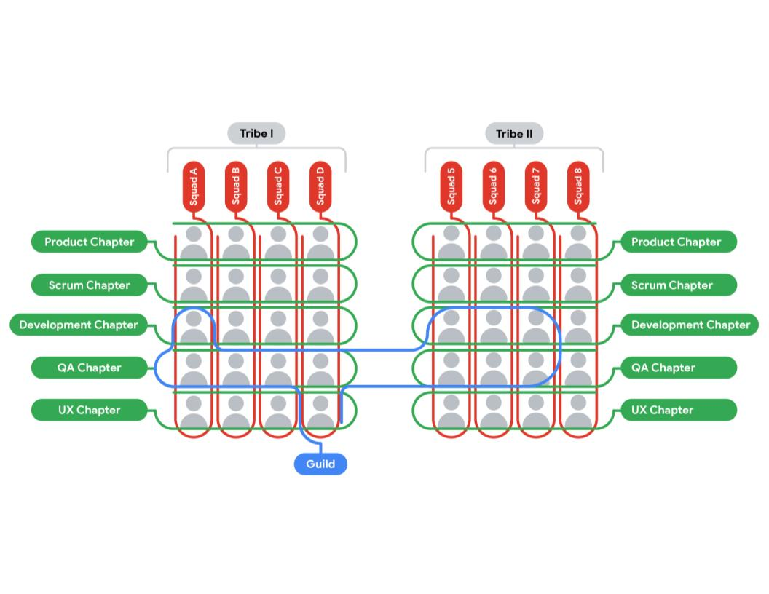

## ****Be inspired by the Spotify model, but don’t emulate it****

Each team requires differences in their workflow and systems. It is never a good idea to try to copy and paste an exact model to your team just because it worked for another team. In fact, some people have tried copying Spotify’s model and found that it was not a suitable model for their team at all.

## ****Key takeaways****

* **You must always be able to adapt based on your team’s preferences and goals.** The Spotify team started in Squads, but as they scaled, they added new types of groups within the organization—without disrupting the existing Squads. They continued to do so until they found the perfect balance of collaboration and ownership.
* **Always examine the needs of your project and organization.** What works for Spotify may not be an exact fit for your team. If you are on a team that needs scaling, be inspired by this model, but use the aspects that work best for your organization.
* **Don’t be afraid of trial and error.** If you try something and it doesn’t feel quite right, you can easily adjust.
* **You should never consider yourself done improving.** There are always changes that can be made for the better.

Just as Agile has core values that teams must adhere to,

Scrum has its own set of pillars that act as a foundation for Scrum Teams.

I'll go through the three pillars of Scrum in this video.

Reproduza o vídeo começando em ::13 e siga a transcrição0:13

Let's start by looking at the theory behind Scrum so

that we could learn the various methods and understand why they're effective.

First, what is Scrum?

The Scrum Guide defines Scrum as a framework for developing, delivering, and

sustaining complex products.

That means a team can use Scrum to create valuable products for their users,

even when the environment or industry they're in is hard to predict

and there are many risks.

Scrum uses an iterative and incremental approach.

Iterative refers to the fact that project processes are repeated.

We discussed this a bit in the last module,

but as a reminder, iterative means that the project works in time boxes or

iterations.

Incremental refers to the work being divided into smaller chunks that build

on each other.

The product is built over time through work done during each iteration.

Reproduza o vídeo começando em :1:10 e siga a transcrição1:10

Each of these instances of the product is called an increment.

Iterations and increments allow us to keep checking in on our progress throughout

the life cycle of the project.

This helps us become more predictable and manage the uncertainty in our project.

Reproduza o vídeo começando em :1:27 e siga a transcrição1:27

Scrum is founded on a scientific theory called empiricism.

This is a fancy word for a simple concept:

that true knowledge comes from actual, lived experience.

The Scrum founders emphasize that we shouldn't try to assume that things will

go exactly as planned or try to predict the future in an uncertain world. Instead,

if you're using Scrum, you're ensuring that each decision you make in your project is

based on real experience and hard data.

So each iteration and increment is understood as a mini-experiment where we

can learn really valuable things to help improve the project.

Reproduza o vídeo começando em :2:5 e siga a transcrição2:05

Empiricism is built on three foundational pillars.

Those pillars are transparency, inspection, and adaptation,

and they're also the three pillars of Scrum.

Reproduza o vídeo começando em :2:16 e siga a transcrição2:16

First, there's transparency.

Transparency means that we make the most significant aspects of our work visible to

those responsible for the outcome.

Everyone must be transparent.

This includes everyone from Scrum Team members to senior sponsors, and

even our users.

It's easier to be transparent with a small team.

And luckily, Scrum Teams are deliberately small—ranging between three and

nine people.

This way, you avoid mixed signals, breakdowns of communication, and

unnecessary complications.

Transparency inside a Scrum Team is critical to the team's productivity and

the project's completion.

Reproduza o vídeo começando em :2:55 e siga a transcrição2:55

In terms of transparency outside of the team,

being transparent with all stakeholders, including customers, sponsors, and

management builds a level of trust between everyone involved.

Transparency also encourages more collaboration and fewer mistakes.

Reproduza o vídeo começando em :3:12 e siga a transcrição3:12

The second pillar of Scrum is inspection.

Inspection refers to conducting timely checks towards the outcome of a Sprint

goal to detect undesirable variances.

This means that we're always checking in on our progress and deliverables so

that we can detect any undesirable changes.

When teams work in an Agile way, a stakeholder review of their work is

a necessary opportunity for growth and progress.

The more inspections that take place,

the more improvement a team experiences in their work.

There's real value to be gained from deliberate inspection while you have

a chance to change and improve.

Reproduza o vídeo começando em :3:48 e siga a transcrição3:48

Inspection also propels our next pillar: adaptation.

Adaptation means that we're continuously searching for ways to adjust our project,

product, or processes to minimize any further deviation or issues.

In Scrum, and in Agile as a whole, for that matter, we embrace change so

that we are always improving.

So when we adapt, we change aspects that do not work or could be better.

Reproduza o vídeo começando em :4:13 e siga a transcrição4:13

Transparency and inspection gives Scrum Teams the information and

opportunity they need to identify improvements or changes.

Although adaptation includes immediate fixes to problems,

it may also be about implementing a change

so future projects don't repeat past mistakes.

Reproduza o vídeo começando em :4:31 e siga a transcrição4:31

Now you know the three pillars that act as a foundation to Scrum: transparency,

inspection, and adaptation.

In the next video, we'll visit the five values that all Scrum teams adhere to. Meet

you there.

# The Scrum Guide

In the last video, you learned that the Scrum Guide acts as the main source of truth for Scrum teams and contains everything you need to know about Scrum. You also learned that Scrum is a framework within the foundational project management philosophy called Agile. The Scrum Guide defines Scrum as “A framework within which people can address complex adaptive problems, while productively and creatively delivering products of the highest possible value.” This reading will review the Scrum pillars and values and then provide links to the Scrum Guide and further reading about Scrum.

## ****Pillars and values****

To recap, every person on a Scrum team subscribes to the three pillars and the five values of Scrum. **The three pillars of Scrum are:**

* Transparency
* Inspection
* Adaptation

**The five values of Scrum are:**

* Courage
* Commitment
* Focus
* Openness
* Respect

In order for a team to succeed, it is incredibly important that every team member follow these core pillars and values.

Scrum only has a few rules and practices that are easy to follow. It is also easy to understand. However, Scrum can be challenging to master because mastery depends on being able to embody, live, and promote the pillars and values of Scrum.

Understanding Scrum Team roles

Each Scrum Team member plays a vital role in the project’s success. In order to help a project get to the finish line, you will need to understand what each of these roles entail. In this reading, you will learn how the responsibilities of the Scrum Master, Product Owner, and Development Team differ from one another.

**The Scrum Master**

One key responsibility of the **Scrum Master** is to help the team understand and follow Scrum theory. More specifically, according to the Scrum Guide, “The Scrum Master is accountable for establishing Scrum as defined in the Scrum Guide. They do this by helping everyone understand Scrum theory and practice, both within the Scrum Team and the Organization. The Scrum Master is accountable for the Scrum Team’s effectiveness. They do this by enabling the Scrum Team to improve its practices, within the Scrum framework.” The Scrum Master makes sure that important meetings occur, like the Daily Scrum. In the same way that a coach would be aware of the game clock, the Scrum Master is tasked with making sure that the meeting is kept within the appropriate **timebox**. A timebox is a Scrum concept that refers to the estimated duration for an event.

The Scrum Master acts as a coach to the Scrum Team—they encourage the team to build the product in the time frame. They also support the team by creating a collaborative environment so the project’s goals are achieved. The Scrum Master’s duties include:

* Coaching the team members in self-management and cross-functionality
* Helping the Scrum Team focus on creating high-value Increments that meet the **Definition of Done** (an agreed upon set of items that must be completed before a project or user story can be considered complete)
* Causing the removal of impediments to the Scrum Team’s progress
* Ensuring that all Scrum events take place and are positive, productive, and kept within the **timebox** (a Scrum concept that refers to the estimated duration for an event)

**Scrum Master vs. project manager**

The role of the Scrum Master is sometimes confused with the role of the project manager. While the two roles share related skills and qualities, they are very different roles.

A Scrum Master is responsible for helping the team understand Scrum theory and practice. They ensure Scrum events take place and help the team focus on delivering value by removing impediments. But unlike a traditional project manager, they do not take on the management of changes in scope or priorities. Additionally, Scrum Masters do not maintain traditional project artifacts like Gantt charts.

**The Product Owner**

According to the Scrum Guide, “The **Product Owner** is responsible for maximizing the value of the product resulting from work of the Scrum Team. How this is done may vary widely across organizations, Scrum Teams, and individuals.” Product Owners maximize the value of the product by representing and expressing the voice of the customer throughout the project duration. A product isn’t useful to its customers if that product doesn’t fulfill their expectations and meet their needs. The Product Owner’s duties include:

* Developing and explicitly communicating the Product Goal
* Creating and clearly communicating **Product Backlog** items (The Product Backlog contains all of the features, requirements, and activities associated with deliverables to achieve the goal of the project.)
* Ensuring that the Product Backlog is transparent, visible, and understood

**Product Owner vs. project manager**

In traditional project management, scope management is the primary responsibility of the project manager. But in Scrum, the definition and management of product scope falls to the Product Owner. Conversely, the Product Owner isn’t responsible for team performance—they aren’t considered to be a manager. The project manager leads the project team to meet the project’s objectives and oversees tasks and progress.

There are also similarities between the Product Owner and project manager roles. For instance, both roles are tasked with stakeholder management. This means they both must practice and facilitate effective communication among team members and stakeholders.

Additionally, in many companies—including Google—the definition of product or solution scope is the responsibility of a separate role called a **product manager**. So, it is important when joining any new company to discover how that company approaches the area of product definition, requirements development, and user research to understand what they consider to be the domain of the project manager.



**The Development Team**

The **Development Team**, also referred to as **Developers**, is made up of the people who do the work to build the product. According to the Scrum Guide, Developers are “the people in the Scrum Team that are committed to creating any aspect of a usable Increment each Sprint.” Their responsibilities include:

* Creating a plan for the Sprint, the **Sprint Backlog** (the set of Product Backlog items that are selected to be completed during the upcoming Sprint)
* Instilling quality by adhering to a Definition of Done
* Adapting their plan each day toward the Sprint Goal
* Holding each other accountable as professionals
* Executing sprints by designing, building, and testing Product Backlog items in increments

An important aspect of the Development Team that is worth highlighting is that they are cross-functional, meaning that you will have team members who are specialists in different disciplines. In a software team, that might mean having a web developer, a database developer, and a user experience specialist. In a marketing team, that might mean having writers, editors, search engine optimization specialists, and business analysts.

**The roles working together**

The Scrum roles fit together, and each brings their unique qualities, skills, and responsibilities jointly to lead to successful Scrum projects. It is crucial for everyone on the team to understand their role and how they work together to deliver value to their users and customers. When the team has this shared understanding, they can better support each other during the practices of Scrum.

**Necessary traits for each role**

Overall, you will want people on your team who are interested in constant collaboration and improvement. More specifically, it is great to have team members who value feedback, bring energy and fun to the team, and can admit and learn from their mistakes. Let’s look at what traits each team member should exhibit:

The Product Owner should be able to confidently provide the team with general direction, requirements, and objectives for the project but will allow the team to determine how to accomplish these goals. Your team will want a Product Owner who promotes the product vision and prioritizes the product backlog to maximize the value for the customer. In order to deliver on this, the Product Owner should be organized and have strong communication skills.

The Scrum Master should have strong leadership skills that enable them to be efficient facilitators and negotiators who know how to resolve conflict. Your team will want a Scrum Master who aims to effectively coach the Development Team, facilitate events, and eliminate distractions that may impede the team’s progress.

When it comes to the Development Team, you will want individuals who remain focused on completing deliverables and producing a superior final product. Since the team is self-organizing and cross-functional, you will want people who are eager to work together and not afraid to compromise for the greater good of the product.

# Product Backlog: The Scrum Guide overview

## ****Product Backlog and Product Goal****

In this lesson, you are learning about an important Scrum artifact: the **Product Backlog**.To recap, the Product Backlog is an ordered list of what needs to be done to improve a product. It is the single authoritative source for items the Scrum Team works on. During Product Backlog refinement, items are broken down and further defined by adding details. These details can vary, but often include such attributes as description, value, order, estimate, and size.

The **Product Goal** is the long-term objective for the Scrum Team, and it is included in the Product Backlog. The rest of the Product Backlog defines what tasks will fulfill the Product Goal.

# The components of user stories and epics

In the previous video, we introduced user stories and epics. **User stories** are short, simple descriptions of a deliverable told from the perspective of the user. Creating user stories helps the team develop a solution that is always centered around the user’s needs and overall experience.

You also learned that **epics** are a collection of user stories. Think of the concept of user stories in terms of books or films. A story is one single narrative, while an epic is a set of several related, independent stories. Each story tells a specific chronicle, while an epic gives a high-level view of the overall arc.

## ****User stories****

The driving factor behind every Scrum project is putting the customer first. User stories are a key component of ensuring that customers are satisfied with the product. A team writes a user story from the perspective of the user. Not only do user stories provide insight into what goals the user wants to achieve, but they enable collaboration, inspire creative solutions, and create momentum by giving the team a small win when the stories are developed.

When writing user stories, you will need to include the following components:

* **User persona.** What is your user like? What is their relation to the project? What goals do they have?
* **Definition of Done.** This refers to an agreed upon set of items that must be completed before a user story can be considered complete.
* **Tasks.** What are the key activities needed to complete the user story?
* **Any feedback already provided.** If you are adding features to an existing product and you have already received feedback from customers on a past iteration, make sure to consider this feedback.

## ****I.N.V.E.S.T.****

Recall from the video that your user stories should meet the **I.N.V.E.S.T.** criteria:

* **Independent:** The story’s completion is not dependent on another story.
* **Negotiable:** There is room for discussion about this item.
* **Valuable:** Completing the user story has to deliver value.
* **Estimable:** The Definition of Done must be clear so that the team can give each user story an estimate.
* **Small:** Each user story needs to be able to fit within a planned Sprint.
* **Testable**: A test can be conducted to check that it meets the criteria.

Let’s imagine you are working on a project for a local library. The library hopes to launch a website so that customers can read reviews before they check out books from the branch. The typical template for a user story looks like this: **As a *<user role>*, I want this *<action>* so that I can get this *<value>.*** Therefore, an example user story for this situation might read: ***As an avid reader, I want to be able to read reviews before I check out a book from my local branch so that I know I am getting a book I am interested in.***

## ****Epics****

An epic’s purpose is to help manage related user stories. In this [post](https://www.mountaingoatsoftware.com/blog/stories-epics-and-themes), Mike Cohn, the inventor of the term “epic” as it relates to Scrum, describes epic as a “very large user story”—one that could not be delivered within a single iteration and may need to be split into smaller stories. The team should discuss together and reach a shared view of how to write and capture their user stories and epics. Keep in mind, epics are just larger user stories that are there to help organize the project.

Let’s imagine you are creating user stories and epics based on the previous example. User stories may include customers wanting to read reviews of books on the website or wanting to add books to their cart. These user stories could fall into the “website creation” epic.

Another user story could be that customers want to walk into the library and easily find the non-fiction section. This would fall under the “organization of the physical space” epic.

So rather than those various user stories appearing in a list together, they are organized into sections, or epics.

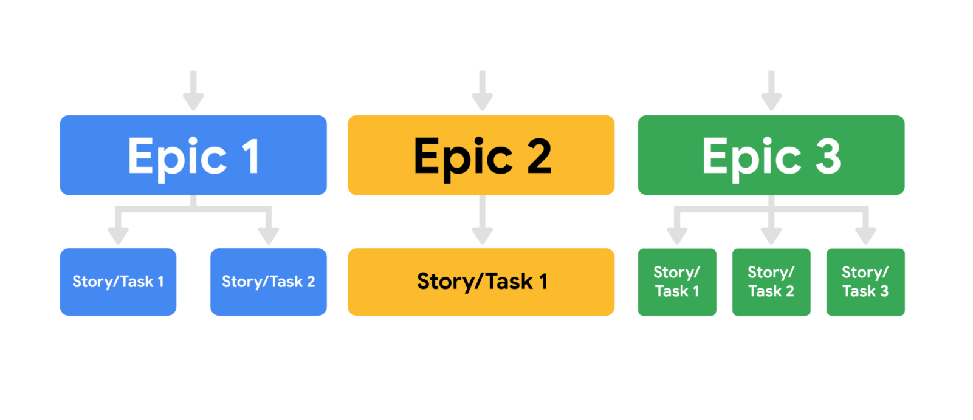Testing 1234

It’s important to note that while the Product Owner can write user stories and epics, a Developer can also write them as long as the Product Owner remains accountable for the Product Backlog item.

## ****Key takeaway****

Epics allow you to keep track of large, loosely-defined ideas, while user stories are a much smaller unit of work, inspired directly from the end user or customer. Both user stories and epics help teams ensure they are delivering value to the customer.

Agile effort estimation techniques

There are all kinds of techniques to use when estimating effort in an Agile way. Effective relative effort estimation leads to successful and predictable sprint outcomes, which leads to a successful project overall. Generally speaking, the main steps to Agile estimation are the same, even if the specific approach varies. Some examples of Agile estimation techniques are:

* Planning Poker™
* Dot Voting
* The Bucket System
* Large/Uncertain/Small
* Ordering Method
* Affinity Mapping



**Planning Poker™**

This particular method is well-known and commonly used when Scrum teams have to make effort estimates for a small number of items (under 10). Planning Poker is consensus-based, meaning that everyone has to agree on the number chosen. In this technique, each individual has a deck of cards with numbers from the Fibonacci sequence on them. The Fibonacci sequence is where a number is the sum of the last two numbers (e.g., 0, 1, 2, 3, 5, 8, 13, and so on).

Sometimes, Planning Poker decks also include cards with coffee cups and question marks on them. The question mark card means that the person doesn’t understand what is being discussed or doesn’t have enough information to draw a conclusion. The coffee cup card means that the person needs a break.

The Planning Poker strategy is used in Sprint Planning meetings. As each Product Backlog item/user story is discussed, each team member lays a card face down on the table. Then, everyone turns their card over at the same time and the team discusses the estimates, particularly when they are far apart from one another. By first hiding the estimates, the group avoids any bias that is presented when numbers are said aloud. Sometimes, when hearing numbers aloud, people react to that estimate or the estimator themselves, and it changes what their initial thought may have been. In Planning Poker, teams can easily avoid that bias.

**Dot Voting**

Dot Voting, like Planning Poker, is also good for sprints with a low number of Sprint Backlog items. In Dot Voting, each team member starts with small dot stickers, color-coded by the estimated effort required (e.g., S=green, M=blue, L=orange, XL=red). The items or user stories are written out on pieces of paper placed around a table or put up on the wall. Then, team members walk around the table and add their colored stickers to the items.

**The Bucket System**

The Bucket System is helpful for backlogs with many items since it can be done very quickly. In fact, a couple hundred items can be estimated in just one hour with the Bucket System. The Bucket System is an effective strategy for sizing items because it explores each item in terms of pre-determined "buckets" of complexity. Keep in mind that these buckets are metaphorical; this strategy doesn't require the use of actual buckets, and instead uses sticky notes or note cards as buckets.

In this technique, the team starts by setting up a line of note cards down the center of the table, each marked with a number representing a level of effort. Then, the team writes each item or user story on a card. Each person draws and reads a random item,  then places it somewhere along the line of numbered note cards. There is no need to discuss further with the team. If a person draws an item that they do not understand, then they can offer it to someone else to place. Additionally, if a person finds an item that they think does not fit where it was placed, they can discuss it with the team until a consensus about a more accurate placement is reached. Team members should spend no more than 120 seconds on each item.

**Large/Uncertain/Small**

Large/Uncertain/Small is another quick method of rough estimation. It is great for product backlogs that have several similar or comparable items.

This is the same general idea as the Bucket System, but instead of several buckets, you only use three categories: large, uncertain, and small. Starting with the simpler, more obvious user stories, the team places the items in one of the categories. Then, the team discusses and places more complex items until each is assigned to a category.

**Ordering Method**

The Ordering Method is ideal for projects with a smaller team and a large number of Product Backlog items. First, a scale is prepared and items are randomly placed ranging from low to high. Then, one at a time, each team member either moves any item one spot lower or higher on the scale or passes their turn. This continues until team members no longer want to move any items.

**Affinity Mapping**

Affinity Mapping is useful for teams that have more than 20 items in their Product Backlog.

A best practice is to conduct this technique using sticky notes placed onto a wall, whiteboard, or table. Each sticky note features a different user story or item. Using sticky notes allows the team to move user stories around in order to group them by similar theme, group, and pattern. The team begins by placing one sticky note on the board. Then, the team takes the next sticky note and discusses whether it is similar to the first item. Based on the team’s assessment, the second sticky note is placed in the first group or into its own group.

After all of the items are grouped (there should be anywhere from 3–10 groups total), the team gives a name to each group that represents the general theme of the items. Then, the groups are prioritized by importance so that the team knows which items to tackle first.

**Characteristics of effective estimation**

Regardless of which technique your team chooses, there are several important characteristics the techniques share that lead to effective estimation:

* **Avoids gathering false precision of estimates.** In Scrum, assigning rough estimates results in more accuracy across the project. Therefore, if the team focuses on identifying relative estimates—rather than a team having a lengthy debate about whether a task will take seven or 10 days of work—the team saves time and avoids potentially missing deadlines.
* **Avoids anchoring bias**. Many of these techniques (e.g., Planning Poker) keep the initial estimate private, which allows team members to form an independent opinion on the estimate before sharing their thoughts with the team. This prevents a known phenomenon called *anchoring bias*, where individuals find themselves compelled to put forth estimates similar to others in the room to avoid embarrassment.
* **Promotes inclusivity**. These group estimation techniques not only lead to better estimates but also help the team develop trust and cohesiveness.
* **Leads to effort discovery**. Estimating in these dynamic ways can help the team uncover strategies to get items completed which might otherwise not have been revealed.

**Key takeaway**

There are several strategies to enlist when it comes to estimating effort and ordering your Product Backlog. Any one of these techniques are useful. Choosing a particular strategy is just a matter of what your team prefers.

T-shirt sizes and story points

In the previous videos, you learned about T-shirt sizes and story points—the two most common units used to help teams estimate user stories in Agile projects. In this reading, we will explore the processes of estimating user stories in these units.

As a recap, **relative estimation** means to compare the effort estimated for completing a backlog item to the effort estimated for another backlog item. Doing this instead of trying to determine exactly how long a task will take allows your comparisons and estimates to be more accurate relative to one another.

**T-shirt sizes**

At first, T-shirt sizes may seem like a somewhat unusual way to measure an item or user story. But when you think about assigning estimations to items based on sizes (e.g., XS, S, M, L, XL, XXL), it is actually very helpful and easy. Some of the benefits to using this technique are that it is quick, well understood by Agile experts, and a good introduction for teams who are just learning relative estimation.

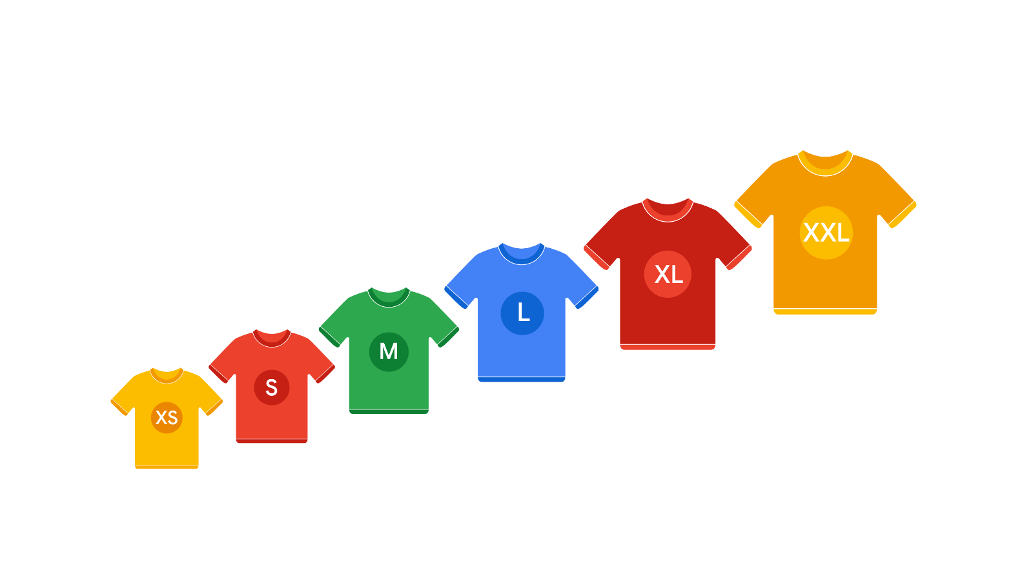

So what does the process of assigning T-shirt sizes entail? There are several specific techniques a team can try, but each generally follows these steps. The team:

* Agrees on the chosen scale and metrics to be used.
* Identifies at least one anchor backlog item. That item will be assigned a T-shirt size. Some teams will choose two anchor items—one at the top of the range and one at the bottom of the range.
* Sorts through the remaining backlog items and agrees on T-shirt sizes for each of them.

**Story points**

Using story points as the estimate unit is a little more advanced than T-shirt sizes, but it is essentially the same concept. This method is good for experienced teams. When using story points, teams usually use the Fibonacci sequence. As a reminder, this sequence comes from adding the two previous numbers in the sequence together. For example, 1 + 2 = 3 and 2 + 3 = 5. The important thing to notice about this sequence is that, as the list continues on, the numbers spread further apart from each other. Because of this, story points provide more accuracy and specificity than T-shirt sizes.

So what does the process of assigning story points entail? There are several specific techniques a team can try, but the basic steps are the same as with T-shirt sizes. The team:

* Agrees on the permitted points values. Some teams cap the size at a certain number, like 21. Some teams decide to jump from 21 to 100 as the next larger value. This is a team decision.
* Identifies at least one anchor backlog item and agrees to assign it a points value. Some teams will choose two anchor items, one at the top of the range and one at the bottom of the range.
* Sorts through the remaining backlog items as a team, agrees on an estimate for each item, and captures it in the backlog management system.

**Best practices**

Some best practices, regardless of the technique you use, include:

* Asking the Product Owner questions about the user story or item to ensure that there is enough information to estimate it.
* Discussing divergent estimates from various team members so that everyone has a chance to understand how to implement the item.
* Agreeing on the final T-shirt sizes or points value and capturing it in the system.
* If certain items fall into the larger T-shirt size or story points value range, discussing whether it makes sense to break them down into smaller pieces before moving on.

**Key takeaway**

Either of these effort estimation units are effective at estimating your items and user stories. As a team, it is important to spend the appropriate amount of time deciding which is best for you. If you are a less experienced team, try starting out with T-shirt sizes, but more advanced teams should feel free to use either method.

# The Sprint: The Scrum Guide overview

As a recap, please read this overview of the Sprint taken directly from the [2020 Scrum Guide](https://www.scrumguides.org/scrum-guide.html#the-sprint):

## ****The Sprint****

Sprints are the heartbeat of Scrum, where ideas are turned into value.

They are fixed length events of one month or less to create consistency. A new Sprint starts immediately after the conclusion of the previous Sprint.

All the work necessary to achieve the Product Goal, including Sprint Planning, Daily Scrums, Sprint Review, and Sprint Retrospective, happen within Sprints.

During the Sprint:

* No changes are made that would endanger the Sprint Goal;
* Quality does not decrease;
* The Product Backlog is refined as needed; and,
* Scope may be clarified and renegotiated with the Product Owner as more is learned.

Sprints enable predictability by ensuring inspection and adaptation of progress toward a Product Goal at least every calendar month. When a Sprint’s horizon is too long the Sprint Goal may become invalid, complexity may rise, and risk may increase. Shorter Sprints can be employed to generate more learning cycles and limit risk of cost and effort to a smaller time frame. Each Sprint may be considered a short project.

Various practices exist to forecast progress, like burn-downs, burn-ups, or cumulative flows. While proven useful, these do not replace the importance of empiricism. In complex environments, what will happen is unknown. Only what has already happened may be used for forward-looking decision making.

A Sprint could be cancelled if the Sprint Goal becomes obsolete. Only the Product Owner has the authority to cancel the Sprint.

# Releasable Increment versus Minimum Viable Product

You have learned that the **Product Increment** is what is produced after a given Sprint and is considered releasable. The Scrum Guide states that “An Increment is a concrete stepping stone toward the Product Goal. Each Increment is additive to all prior Increments and thoroughly verified, ensuring that all Increments work together. In order to provide value, the Increment must be usable.”

## ****Potentially releasable product increment****

Potentially **releasable** (or shippable) Product Increment is a handy way for teams to think about the desired result of a Sprint. The goal for every Sprint is to result in a completed, tested, ready-to-ship addition to the product or solution. This doesn’t mean the product will actually ship to customers—that is why they use the word “potentially.” Consider, for example, building an application for finding and adopting pets. Three features on the product backlog could be:

1. Presenting information about available pets
2. Rating potential matches based on adopters
3. Allowing user to contact the adoption center



It doesn’t make sense to ship any one of those features in isolation, but finishing a potentially releasable Product Increment is helpful because it enables the team to see one feature in its entirety rather than to work on bits and pieces of all three features with none of them actually completed. With a potentially releasable Product Increment, you will create a complete, working, tested implementation of one feature in a single sprint.

Having a potentially releasable Increment also allows the team to get early feedback on the product, ensure that the work is high quality, and have the opportunity to respond to change. You should always focus on a potentially releasable product increment as your sprint goal.

## ****Definition of Done****

A related term is the **Definition of Done**. The Definition of Done is a formal description of the state of the potentially releasable Product Increment and what it means when it meets the quality measures required for the product. It is the team’s agreed-upon requirements for any backlog item that is considered “done.” In software projects, teams often decide that “done” means the software has been completed, reviewed, and has passed testing. In a non-software project, a Definition of Done may be a document including a legal review with approval or a formalized closeout report. The important part of figuring out your team’s Definition of Done is to have an explicit, shared understanding of what being “done” entails.

But how do you know when a solution is shippable or releasable? In a Scrum Team, it is ultimately the decision of the Product Owner to ensure there is value before releasing an item. To determine this, they may consider a few things:

1. Is the increment complete?
2. Will it bring value and does it meet quality measures? Has it been well-tested?
3. Is it usable by the end user? Can we use their direct or indirect feedback to improve future versions of the product?

## ****Comparing Releasable Product Increment to Minimum Viable Product****

As you learned in the previous video, a **minimum viable product (MVP)** is a version of a product with just enough features to satisfy early customers. Eric Ries, an entrepreneur and author, coined the term in this [guide](http://www.startuplessonslearned.com/2009/08/minimum-viable-product-guide.html) and defined an MVP as “that version of a new product which allows a team to collect the maximum amount of validated learning about customers with the least effort.” In other words, gathering insights from an MVP enables quicker feedback from users than developing a full-featured product that may not be 100% tested or secure. Some examples of an MVP could be a landing page for your website or a “buy now” button that doesn't do anything other than register that someone has clicked it. A minimum viable product is a package of features that may take several sprints to develop, but every sprint’s goal is to produce a **product increment**. To differentiate between a potentially releasable increment and a MVP, let’s take our example of the online pet adoption app and the three features we discussed previously. We noted that each of these features on their own wasn’t a useful release of the solution. However, the Product Owner may decide that the MVP for this user experience is to implement these three requirements for cats only. By reducing the scope of the MVP, the Product Owner is able to release the solution into the marketplace and collect feedback from the users who wish to adopt cats. This feedback will be valuable not only for the cat adoption process but for any type of pet adoption in future iterations of the product.

## ****Key takeaway****

So can a releasable increment be an MVP? Yes!  Does it always have to be an MVP? Not necessarily. A Scrum Master or Product Owner is always making sure that the team is building potentially releasable increments of the solution or product. Then, the Product Owner uses those product increments and business insights to determine what will make up a valuable and viable release of the product to their customers. This is based on both user value delivered and the ability to gather feedback that will continuously improve the product.

Sprint Retrospectives: Pitfalls and best practices

Throughout this program, we have discussed **retrospectives**. Retrospectives are an integral aspect of project management, especially true when it comes to working in Scrum. As we mentioned in the previous video, retrospectives are one of the five Sprint events in Scrum. In this reading, you will learn some best practices to implement and pitfalls to avoid when conducting Sprint Retrospectives.

**Sprint Retrospectives**

As a refresher, retrospectives are workshops or meetings that give project teams time to reflect on a project and brainstorm potential future improvements. In the Scrum framework, **Sprint Retrospectives** occur at the end of each Sprint, which is usually every one-to-four weeks.

Sprint Retrospectives are a key practice that supports the Scrum theory and values. They are a critical moment to inspect and adapt to the outcomes produced within the Sprint timebox. Retrospectives occur much more often in Scrum than in traditional project management,  so it is important to consider some best practices and pitfalls to avoid to help make them engaging and productive for the entire team.

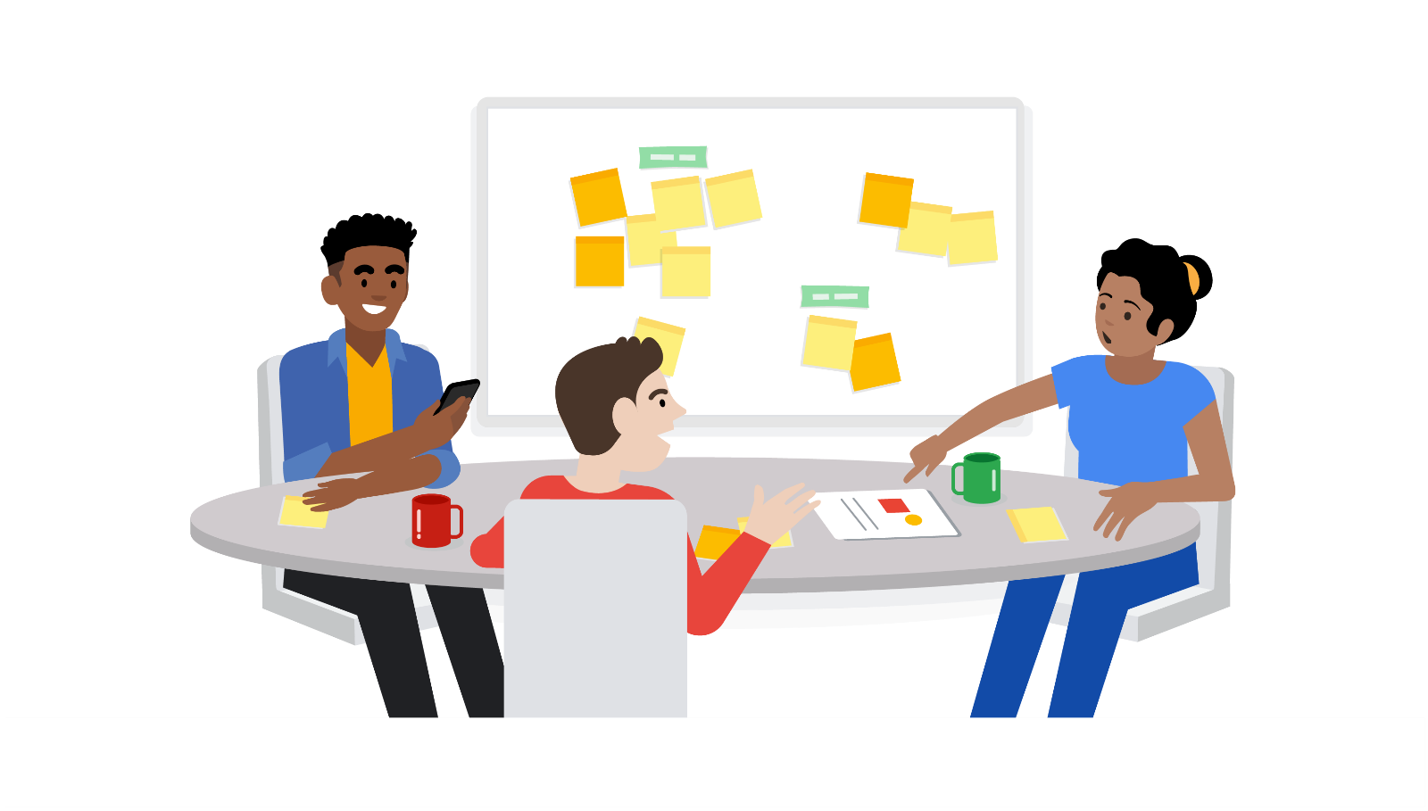

**Pitfalls**

* **Avoid too many gimmicks**. There are many fun games and exercises that can be used by a Scrum Master when facilitating a Sprint Retrospective. However, not all teams enjoy this style. Consider using these exercises only occasionally or when the team asks for new ways of doing retrospectives.
* **Try not to only focus on the negative.** Not only is it necessary for the team to recognize what’s not working well, it is also important to highlight where they exceeded expectations. This ensures that the team both avoids failures and repeats successes as well.
* **Avoid changing processes** **after each retrospective.** It is okay to keep a new process in place for a few Sprints before deciding whether it was useful or not. You can always make note of opportunities for change, but try to wait a few Sprints before implementing new changes.

**Best practices**

* **Ask open-ended, probing questions.** Ask questions that require thoughtful discussion rather than a yes-or-no answer. For example, ask, “How could we have better achieved our Sprint Goal?” rather than “Did we achieve the Sprint Goal?””
* **Consider diverse styles** **of communication and participation.** Make it easy for all team members to contribute their ideas and feedback. For example, not everyone feels comfortable speaking up in a large group. Try things like starting the retrospective with silent reflection by journaling or putting the team into pairs before starting a larger group conversation.
* **Cover the many aspects** **of the Sprint when conducting a retrospective.**

1. The productivity and efficiency of the team
2. The scope and understanding of the definition of done
3. Communication and interactions within the team
4. Stakeholder communication
5. Progress towards more long-range release plans

* **Consider reflecting periodically on Scrum theory and values** **by asking specific questions.** For example, ask, “How could the team become more transparent?” or “How did we abide by our Scrum values in this Sprint?”

# Interpreting velocity: Dos and Don'ts

In the previous video, we defined **velocity** as “The measure of how many points the team burns down in a given Sprint on average.” Velocity measures the amount of work a single team can be expected to complete during an iteration. When we refer to story points, we are referring to a unit of measurement that expresses the estimated effort required to implement that Product Backlog item. These story points are calibrated and decided on by the team.

## ****Calculating velocity****

As described in the video and readings, estimating effort can be done in a variety of units. Most often in Agile teams, story points or T-shirt sizes are used to estimate effort. If you use T-shirt sizes, your team will map those sizes to a numeric value for the purpose of calculating a team velocity.

When your team begins running Sprints or iterations, they won’t be able to accurately determine velocity because they will have no historical basis on which to calculate an average number of points completed in a Sprint. In their very first Sprint, your team will make a rough guess as to how many items they can complete just to get started. Once a few Sprints have been completed, your team will have a good measure of their velocity, and they will use that number to determine which items to include in their Sprint Backlog. This should be easy to do if your team has a properly prioritized and estimated backlog to work from. As you will recall from the videos, this process is called **backlog refinement**.

## ****Using velocity for good****

When interpreting velocity, it is important to keep a few things in mind. You may feel inclined to share velocity with members outside of your team or to use velocity as a performance or comparison metric. You may also feel inclined to use it to determine a projected delivery date. However, some Agile experts warn against these practices. Let’s discuss why.

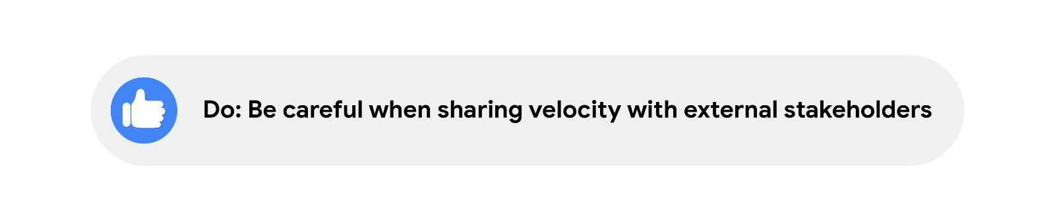

Velocity can be helpful for individuals outside of the Scrum team, but when sharing it with non-team members, be very careful. Since velocity is different for every team, a stakeholder may not have enough context to interpret it. Be sure to share relevant supporting materials to help add context. A good example of this is sharing the velocity with a corresponding date range and visualization that indicates trends over time. There may be dips and spikes in velocity that draw insights and encourage improvements in future projects.

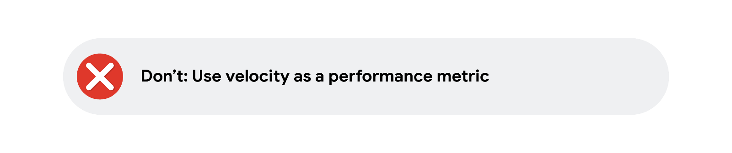

It is natural for individuals to want to quantify performance through data, but it can be detrimental for a team to feel that kind of pressure within their Sprints. There may be executives, sponsors, or stakeholders that want to use velocity as a performance metric, but this will only hurt the team by encouraging tactics like intimidation. If the team is worried about their velocity making it seem like they are underperforming, the team’s culture can become harmed as a result.

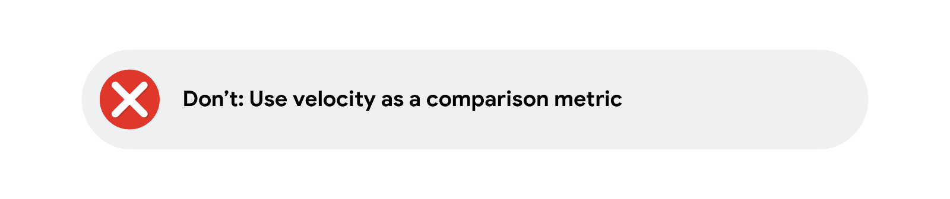

If you are leading a few different Scrum teams, you may be tempted to compare the two teams’ productivity based on their velocity. You may have the impulse to check which teams are completing the most story points per iteration. However, the weight of different story points is subjective because they are created by the team**.** One team may consider a story to be five points, but another team might consider it to be closer to three points. Therefore, judging productivity solely on velocity isn’t accurate or fair. Additionally, velocity is not a measure of value. One team’s velocity might differ from another team’s, but this variability is fine as long as both teams are delivering value to your stakeholders.

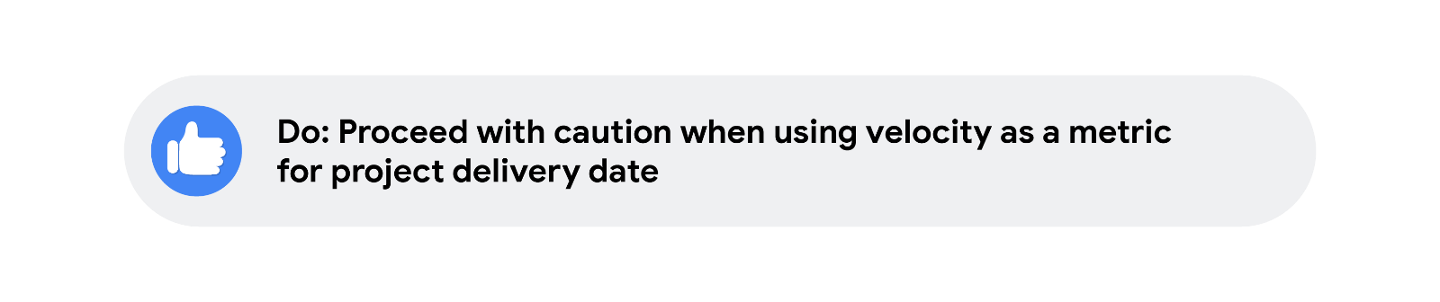

Using velocity to estimate the delivery date of a project spanning numerous Sprints can be tricky. Velocity can be used as a pressure point by external stakeholders who want to set a date for their product launch. Velocity can also create false expectations and a harshly competitive culture when the team doesn’t hit the estimated dates. Projecting deliverable dates is harmful because it can take a team several Sprints to really understand what they are capable of delivering in each iteration. Also, if you map out too many dates in advance, you aren’t able to account for the changes and issues that will arise. Therefore, make sure you are being careful not to use the estimated delivery dates as commitments.

# Case study: Forming a value-driven task force

In the previous video, you learned that value-driven delivery is critical to Agile and Scrum project management. In this reading, you will read a case study and analyze how Agile brought value to the organization.

## ****Learning from case studies****

As you pursue your career in project management, you will come across many resources for learning about other companies and their journeys to becoming Agile.

**Case studies**—in-depth, data-driven analyses of a business, community, or organization—are valuable tools for gaining key industry insights and learning from the successes and failures of your competitors.

When reading case studies, focus on the problem, the effect it had on the business or organization, and the pros and cons of the solutions reached to help you determine some applicable key takeaways.

As you read, ask yourself:

* What is the issue?
* What is the goal of the analysis?
* What is the context of the problem?
* What key facts should be considered?
* What alternatives are available to the decision-maker?
* What would you recommend, and why?

## ****Value-driven delivery at Sephora****

The case study linked below is about how the teams at Sephora, the multinational retailer of personal care and beauty products, created **value-driven delivery** by forming an Agile task force.

As the case study details, Sephora’s goal was to develop an organized and efficient process for rolling out customer-centered initiatives. The beauty retailer wanted to maximize their paid media and create custom messaging that was personalized to meet their customers’ needs.

Keep the questions above in mind as you read through the case study. Notice how the various roles and responsibilities were essential to the process and how the company brought people from across the organization together to ideate, test, and analyze.

When you are finished, think about how Scrum benefitted Sephora and how it improved their overall business model.

# Product roadmaps: Benefits, pitfalls, and best practices

As you learned in the previous video, roadmaps are an important part of any long-running project. In this reading, we will summarize the benefits of and best practices for developing a product roadmap, as well as highlight some of the pitfalls you might encounter.

You may see different types of roadmaps as you continue your project management career. Each team or company may interpret the roadmap slightly differently. Here are some of the various types:

* Project roadmap
* Product roadmap
* Value roadmap
* Lean roadmap
* Agile roadmap

Roadmaps are often represented visually and many try to fit the roadmap on one page so that reviewers can notice the big picture of the product timeline.

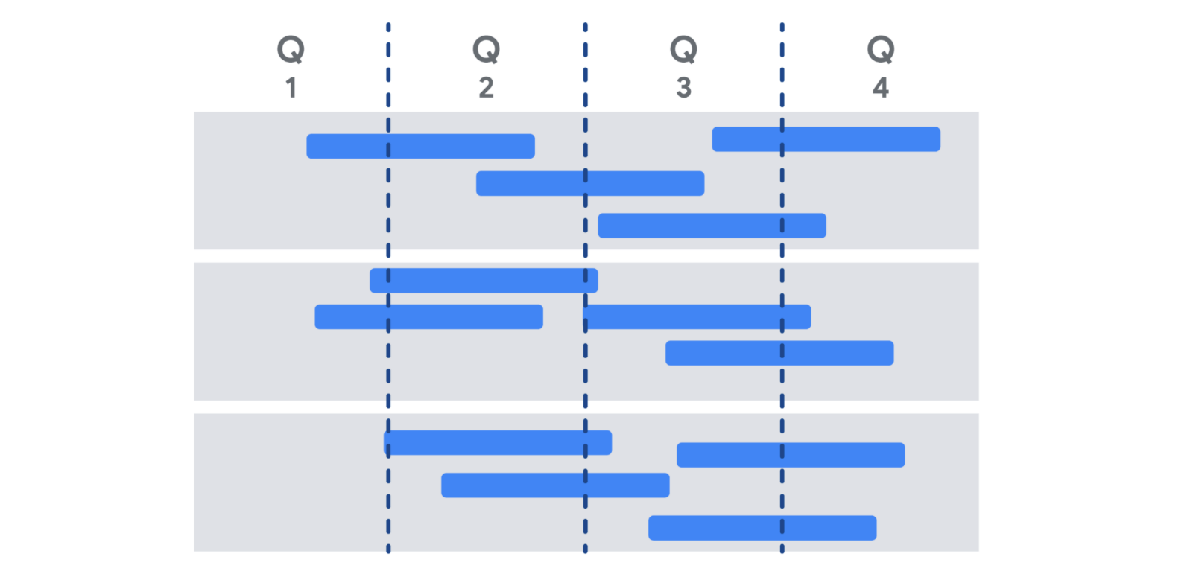

The **benefits** of developing and maintaining a product roadmap are numerous:

* Clarifying the sequence of deliverables
* Showing teams how their efforts relate to the north-star vision. In other words, their ultimate goal.
* Showing stakeholders the incremental value that will be achieved over the course of the project (rather than reviewing it as one big delivery at the end)
* Helping stakeholders roughly understand the layout of the work behind the deliverable

There are also some **pitfalls** around roadmaps to avoid:

* Letting stakeholders think the roadmap is set and unchangeable. This may cause stakeholders to impede teams’ ability to adapt in response to new information, as well as put a lot of pressure on teams to achieve deadlines no matter what it takes.
* Spending too much time fine-tuning delivery dates versus keeping them rough and improving specificity as the dates get closer
* Putting all the work into creating the roadmap rather than producing the deliverables

Here are some **best practices** to help you get the most from your roadmaps:

* Make it highly noticeable to the team and refer to it frequently.
* Clearly indicate the highest priority items.
* If possible, clearly indicate the highest value items.
* Make it visible to your wider stakeholder group so that they can use it for their planning.
* Conduct regular reviews of the roadmap with sponsors, stakeholders, and the team to ensure that it is still providing the blueprint for the project.

To learn more about some best practices for building product roadmaps, check out this article: [Product Roadmap First Principles](https://www.scrum.org/resources/blog/product-roadmap-first-principles-empower-scrum-teams-align-w-stakeholders)

## ****Key takeaway****

Roadmaps are important for any well-managed project, but they are especially useful to Agile teams. Having a shared roadmap about what the team is delivering over a longer time period is an important way to connect the work that the team does on the sprints with the broader vision for the project. This helps the team stay motivated through the rough patches and leads to a great sense of accomplishment as roadmap deliverables are achieved.

# The influencer change framework

In the previous video, we learned how to apply organizational change management techniques to your team in Agile or Scrum. In this reading, we will learn about the influencer **change framework** developed by Joseph Grenny, Kerry Patterson, David Maxfield, Ron McMillan, and Al Switzler in the book INFLUENCER: The New Science of Leading Change, which explores the power of influence in facilitating organizational change.

## ****What does it mean to be an influencer?****

These days, when we hear the word **influencer**, some might think of social media stardom. But being an influencer is bigger than getting “likes”—it is about someone’s ability to lead and influence others to change their behaviors, hearts, and minds to produce meaningful, sustainable results. As a project manager, you will be asked to lead efforts that require this level of change, and applying this model can lead to a big impact.

To influence is different than to persuade. Persuasion is short-term, while influence is lasting. In order to have real influence, you need others to trust you, consider you an authority, and have confidence in your decisions. As a project manager in Agile projects, you may use influence tofacilitate organizational change or to get a team to try a new tool, process, or technology.When facilitating organizational change, influence is the difference between temporary changes in behavior and deep change in culture and values.

## ****Three keys to influence****

The three keys to influence, as researched by the authors of this model, are to clarify measurable results, find vital behaviors, and use the six sources of influence. Let’s break each of these down.

## ****Clarify measurable results****

You can’t influence others to change until you know what you want, why you want it, and when you want it. You may recall that effective results are specific, measurable, achievable, relevant, and time-bound (S.M.A.R.T). When setting goals for a project, remember to ask yourself what the “why” entails. Are the results specific and measurable? Is it what you intended? Is it time-bound? Also, make sure the measures are visible and transparent to the entire team throughout the change.

## ****Find vital behaviors****

A **vital behavior** is the action an individual takes at a pivotal moment in the context of the change they are seeking. For example, if a member of the Development Team is seeking to increase involvement of the Product Owner throughout the development process, they might exhibit a vital behavior when they have just finished mocking up a new feature. Instead of just continuing on to the next item on their to-do list, they might send an email to the Product Owner to review their work and provide feedback. By choosing to include or exclude their Product Owner at a pivotal moment, the developer is taking a small action to enact the change they want to create.

As we have discussed, real change happens when you can change the behaviors of others. Whether you are changing the minds of your team, stakeholders, or customers, it is important to track their current behavior patterns and understand the behaviors you need them to adopt in order to make the change you are seeking.

To determine vital behaviors, you might consult experts, scan the best and most-cited articles and research, or perform a culture assessment by identifying norms and customs within the team. When identifying the behaviors, evaluate which behaviors are constructive to the change you wish to promote and notice examples of those who succeed where most others fail.

## ****Use the six sources of influence****

The authors of INFLUENCER: The New Science of Leading Change studied companies and individuals who were successful or unsuccessful with implementing change, and they identified six sources or factors that were correlated with successful change. When determining how to influence your target audience to create change, you should consider using all of these sources to increase your chances of success. You may even consider prioritizing these based on your knowledge of your audience. For example, some target audiences may be most swayed by financial incentives, while others may be more incentivized by social justice impacts.

Here are the six sources uncovered by the authors in their research, including a sample idea of how you can use these examples in your work in tandem with our Product Owner involvement scenario (described earlier):

1. **Personal motivation**: Are the individuals motivated internally to engage in the new behavior? Can you help them “love what they hate”?  Example: Ensure the Product Owner is timely, appreciative, and effective while giving their feedback.
2. **Personal ability**: Are the individuals capable of performing the behavior? Do they have the ability, knowledge, and skills to “do what they can't”? Example: Ensure that the developer knows how to use the available demo tools and can easily send a quick video of the new feature in their email to the Product Owner.
3. **Social motivation**: Are there social contacts or networks encouraging or discouraging this new behavior?  Example: Have the Development Team members remind each other in the Daily Scrum to email the Product Owner before they finalize the work.
4. **Social ability**: Does the team have resources within their social network to help them carry out the new behaviors? Example: Give the Development Team a tool to track all of their demos to the Product Owner during the Sprint.
5. **Structural motivation**: Are there rewards or incentives that they will receive if they perform the new behaviors?  Example: Provide a coffee gift card Sprint award that the Product Owner gets to award after each Sprint.
6. **Structural ability**: Are there environmental factors at play that either deter or support the new behavior? Can you make the incorrect behavior harder to do than the correct behavior? Example: Add a rule to the content management system that pre-populates the name of the Product Owner in the reviewer list.

## ****Key takeaway****

These three keys to influence make up the influencer change framework and will improve your chances of success with a change. Clarify measurable results, find vital behaviors, and leverage six sources of influence in tandem to lead an organization, team, or an individual to experience positive change.

Coaching versus managing in Agile

In the previous video, we learned about the importance of an Agile coach. In this reading, we will further explore the work of a coach and how it differs from that of a manager.

Both managing and coaching play important roles in project management. The difference in each approach is in communication. Management is about giving direction, while coaching is about teaching. Some situations will call for coaching, and others will call for management. As a project manager, it is important that you understand when each skill set is necessary for success.

**Managing**

So far, we have focused on the responsibilities of project managers. We know that project managers are tasked with delivering a project objective and solving problems as they arise. Project managers keep team members organized and on track. They streamline communication and give directions. This is very indicative of a traditional management approach. At its core, managing requires overseeing the work of others and can include:

* Onboarding and orienting new employees
* Conducting meetings
* Delegating tasks and assignments
* Monitoring progress and performance against those tasks
* Making high-level decisions

In Agile project management, however, teams are designed to be self-managing. A self-managing team has the autonomy to choose how best to accomplish their work, rather than being directed by others from the top down. Agile team members should also feel empowered and equipped to problem-solve on their own.

Even so, there are some cases where the decisive action of a manager is required. Examples include if there is an emergency that needs immediate action, if you are behind on a deadline, or if a client has very specific needs and you are the most familiar with them.In a results-driven project with little room for error, someone needs to step in and take the lead. That is where a managing approach comes in.

**Coaching**

Although managing seems inherent to project management, coaching is also an important part of the project management role.

Coaching is a two-way communication style aimed at influencing and developing team members’ skills, motivation, and judgment. Coaching empowers team members to arrive at solutions on their own by teaching them critical thinking and decision-making skills. This is achieved through offering feedback and providing opportunities for professional development. When challenges arise, coaches will offer guidance, then get out of the way. Coaches don’t jump in during times of crisis in a way that a manager would. Coaches ask questions to help team members arrive at conclusions on their own.

Coaches trust that their team members can make smart decisions, and trust can go a long way. When team members feel trusted, workplace satisfaction increases, and the quality of work improves.

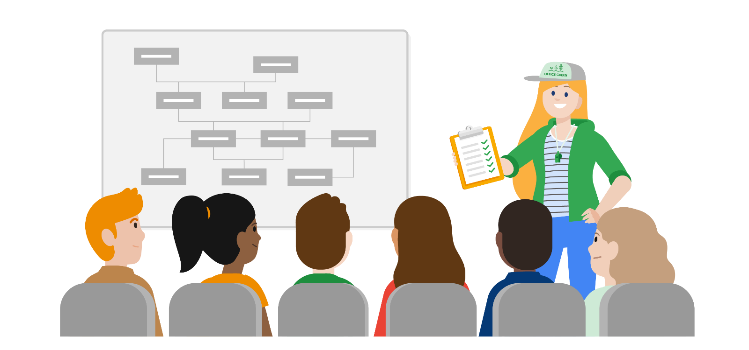

It is appropriate to use a coaching approach when a team member already has experience working on similar projects and is working on growing new competencies or is trying a new approach for the first time. Coaching is about building confidence and capabilities so that individuals can continuously grow and improve. There are a few principles to keep in mind when coaching:

1. **Motivate**: Coaches motivate team members to take action. They point out the value in others’ work and instill within them a sense of pride in what they do.
2. **Support:** Coaches are an accessible resource for their team to come to when they experience problems or if they have an idea they want their feedback on.
3. **Encourage and appreciate:** When someone on their team is struggling with a heavy workload, a coach will acknowledge and validate the weight of their efforts and assure them that they are capable of handling the challenges ahead.

Coaching is appropriate in many circumstances, especially when you need to build up the confidence of an individual or a team. The most effective leaders strike a healthy balance between managing and coaching based on the needs of the situation, individual, and project they are leading. Examples of where coaching would be helpful include when a team member is branching out into using a new technology or discipline that will turbocharge their career opportunities, when an individual’s behavior is having unintended consequences on the team dynamics that are not readily visible, or if a team is recovering from a setback.

Here’s a scenario where a project manager or Scrum Master should step in to coach a team: Imagine a Scrum team has failed to launch a product that meets the customer needs Sprint after Sprint. The Product Owner continues to communicate to the team that the features are not quite right, and they need to rework the product in the next Sprint or release. The team feels deflated, and they are showing signs of burnout because they keep working on the same three features. Here is a perfect opportunity to do some coaching with the whole team. Consider bringing them together for a working session and cycle through all three principles of coaching:

1. **Motivation:** Ask the team to brainstorm positive reasons why the customer is providing this feedback and why it matters to create an excellent end product.
2. **Support:** Work with the team to capture ideas on how to streamline the customer feedback process, such as a design Sprint with the customer in attendance.
3. **Encourage and appreciate:** Set up an event where the team celebrates the work they have accomplished so far, and make the event fun and inclusive for all team members.

**Key takeaway**

Managing and coaching are distinct leadership approaches that each yield different results, and both styles require effective communication. A managing style typically utilizes one-way communication to assign tasks and give directives. Coaching relies on open communication in both directions to help develop an employee’s or team’s skills, so they can become self-sufficient. Some team members and company cultures will naturally favor one style over another, but both are necessary leadership skills. As an Agile project manager or Scrum Master, you will use both styles. That said, in Agile and Scrum, a coaching style is usually the best initial option since it will increase the capabilities of the team, leading to more agility over time.

When deciding which approach to use, ask yourself:

1. What is the desired outcome?
2. What is the skill level of the team member who has encountered a problem?
3. What does the situation need now to reach the desired outcomes?

# Scaling Agile

In the preceding videos, we’ve covered how to run a Scrum team of up to nine team members. But what do you do if your team is larger than that? Or if the size of the product or solution is so large that multiple teams are required to do the work? In this reading, we will explore five frameworks that scale the Agile approach to address the needs of large initiatives or solutions: **Scaled Agile Framework (SAFe), Scrum of Scrums**, **Large Scale Scrum (LeSS)**, **Disciplined Agile Delivery (DAD)**, and the **Spotify Model**.

## ****Scaled Agile Framework (SAFe)****

The most popular scaled framework is the [**Scaled Agile Framework**](https://www.scaledagileframework.com/)or **SAFe**. SAFe is a Lean-Agile scaling framework that draws heavily on concepts from Kanban, Scrum, Extreme Programming (XP), DevOps, and Design Thinking methodologies. SAFe puts the goal of delivering value above all else—the first principle of SAFe is “take an economic view.” The framework organizes all work and teams into “Agile Release Trains” based on value streams; for example, sales. The SAFe framework is mature and provides detailed guidance on all elements of using SAFe, but some elements are more critical than others. Be sure to check back to the Agile principles and values in the manifesto to be sure you are preserving agility.

SAFe, like most Agile practices, is founded on a set of core values:

* **Alignment**: Synchronize the planning and execution of SAFe activities at all levels of the organization.
* **Built-in Quality**: Build quality into all stages of solution development.
* **Transparency**: Make execution activities visible at all levels to build trust among teams and across the organization.
* **Program Execution**: Focus on working systems and business outcomes.
* **Leadership**: Model the values and principles of SAFe.

Read this article to learn more about the [core values of SAfe](https://www.scaledagileframework.com/safe-core-values/#:~:text=The%20four%20Core%20Values%20of,participates%20in%20a%20SAFe%20portfolio).

## ****Scrum of Scrums****

[**Scrum of Scrums**](https://www.atlassian.com/agile/scrum/scrum-of-scrums) is a technique for integrating the work of multiple, smaller Scrum teams working on the same project or solution. Coordination among teams is critical to ensuring the deliverables from each team can be integrated into one larger, cohesive deliverable.

Scrum of Scrums involves the following elements:

* A group of at least 12 or more people divided into Scrum Teams of five to ten people each
* Scrum of Scrums meetings, which are held once a week, twice a week, or daily. These meetings follow the same format as a Daily Scrum meeting but focus on the Scrum team. In these meetings, you’ll discuss questions like: “What did the team do yesterday? What problems occurred, if any, that are negatively affecting your team? What does your team want to accomplish before we meet again? Is your team blocked from moving forward on any tasks?”
* A **Scrum Master** or designated “ambassador” for each team that participates in the Scrum of Scrums meetings and a **Scrum of Scrums Master** who focuses on the overall Scrum process across multiple teams
* Sprint Planning, Sprint Review, and Sprint Retrospective meetings

Beyond these very basic guidelines, there is no official framework or methodology to implement Scrum of Scrums. Scrum of Scrums assumes that teams have a good working understanding of Scrum and are able to apply the scaling principles to how they work. Building on this knowledge, they design and iterate their own approach to coordinate multiple teams working on the same product.

## ****Large-Scale Scrum (LeSS)****

[**Large-Scale Scrum (LeSS**](https://less.works/)) is a framework that aims to maximize the Scrum team’s ability to deliver value and reduce waste in larger organizations. LeSS grew out of more than 600 experiments that expanded the practice of Scrum to larger groups.

LeSS includes ten principles for applying the value, elements, and overall purpose of Scrum across an organization. These principles were designed to create more customer- and collaboration-focused teams. LeSS teams prioritize learning, transparency, and customer needs. The ten LeSS principles are:

1. **Large-scale Scrum is Scrum:** Apply the values and principles of Scrum to a larger team.
2. **Empirical process control:** Inspect, adapt, and learn from experience to improve processes.
3. **Transparency:** Ensure clarity and accessibility across a project.
4. **More with less:** Create only necessary processes, roles, artifacts, and waste when scaling.
5. **Whole-product focus:** Think holistically about the product, making sure that all the parts serve the whole.
6. **Customer-centric:** Keep the customer’s needs and values at the heart of your process.
7. **Continuous improvement towards perfection:** Improve the product—and your process—during every single Sprint.
8. **Systems thinking:** Think about the system as a whole; Don’t get lost in the details.
9. **Lean thinking:** Seek continuous improvement, aim for perfection, and respect people.
10. **Queuing theory:** Embrace the Lean principles of “flow,’ manage queue size,” and “minimize multitasking” to keep delivering value.

The LeSS toolkit provides two frameworks—one for up to about 50 people (called **Basic LeSS**) and one for 50–6000+ people (called **LeSS Huge**). More information on the LeSS frameworks can be found at [less.works](https://less.works/).

## ****Disciplined Agile Delivery (DAD)****

[**Disciplined Agile Delivery (DAD)**](https://www.pmi.org/disciplined-agile/process/introduction-to-dad) is a hybrid approach that combines the strategies from various Agile frameworks, including Kanban, LeSS, Lean Development, Extreme Programming, Agile Modeling, and more. DAD guides people through the process-related decisions that frameworks like SAFe and Scrum of Scrums leave open. DAD helps you develop a scaled Agile strategy based on context and desired outcomes.

DAD is organized into four “layers”:

1. **Foundations** discusses the principles, guidelines, Agile concepts, roles and team structure definitions, and Way of Working (WoW).
2. **Disciplined DevOps** ensures that solutions are delivered to customers effectively and safely, with data and security management always at the forefront.
3. **Value Streams** ensures that solutions are aligned with the organization's business strategy, connecting customers, sales, and portfolio management to the framework.
4. **Disciplined Agile Enterprise (DAE)** connects the industry marketplace with corporate governance and larger enterprise activities.

Project managers wishing to implement DAD can read more about the framework in this article: [Going Beyond Scrum](https://disciplinedagileconsortium.org/Resources/Documents/BeyondScrum.pdf).

## ****The Spotify Model****

Another approach you may encounter is the “Spotify Model,” which we discussed in a [previous reading.](https://www.coursera.org/learn/agile-project-management/supplement/Wco3A/the-spotify-model) It is important to note that Spotify’s model is not a true Agile framework. There is no standard guide on how to implement it. The model began as a description of how Spotify overcame the challenges of scaling Agile. By focusing their efforts on culture, team autonomy, communication, accountability, and quality, they increased their agility over time. Spotify’s approach has had a huge impact on workflows and team structures across the tech world. Some of the key components include:

* **Squads:** Like Scrum teams, Squads are autonomous teams of 6–12 people working toward the same outcome. All Squads include a coach (similar to a Scrum Master) and a Product Owner.
* **Tribes:** When multiple Squads work on the same feature area, they form a Tribe of 40–150 people. Each Tribe has a Tribe Lead who fosters collaboration and coordination.
* **Chapters:** Squads may be autonomous, but specialists (e.g., JavaScript developers) should still align across an organization. Chapters establish best practices and, where necessary, set standards.
* **Guilds:** Any group of people interested in a certain topic can form a Guild, where people with shared interests can come together as a community.

While some organizations have had success with this model, be aware that it evolved from Spotify’s already significant Agile experience. It is the product of extensive introspection and adaptation and draws heavily on the company’s culture of trust, transparency, and autonomy. Therefore, the value of Spotify’s approach to scaling is not in team names like Squads and Tribes but in how they developed practices that supported and served their organizational culture. To learn more about the Spotify Model, check out this [video](https://www.youtube.com/watch?v=4GK1NDTWbkY) from Henrik Kniberg.

## ****Best practices for scaling Agile****

No matter which framework you choose, it’s important to keep a few basic principles in mind:

* Treat scaling models like SAFe, Scrum of Scrums, LeSS, etc., as general frameworks, not instruction manuals.
* Different situations require different solutions. It’s okay to mix and match elements from multiple frameworks, as long as you apply the principles and values of the Agile Manifesto.
* Don’t try to scale without prior Agile experience. Going straight from Waterfall to scaled Agile can be risky without a knowledgeable guide.
* Finally, and most importantly, don’t scale if it isn’t necessary. The larger your team, the more complex and difficult your project becomes.

## ****Key takeaway****

Scaling Agile can be as simple as putting two Scrum teams together into a Scrum of Scrums configuration or as sophisticated as training an organization of thousands in the SAFe framework. When you have a large team or a big deliverable that requires multiple workstreams, think about how you can scale to suit your situation. Remember that you can modify SAFe, LeSS, and other scaled frameworks to meet the needs of each project. Make sure your team understands Agile principles before you try to scale since scaling inevitably introduces more waste and complexity.

# Stakeholder management: Tips and takeaways

**Stakeholder management** is the process of maintaining good relationships with the people who have the most influence on your work. Efficiently managing stakeholders is an integral part of every project because it encourages good communication, teamwork, trust among members, and so much more. Without effective stakeholder management, a project is less likely to be successful. Read on for some tips and best practices for effective stakeholder management.

## ****Stakeholder management during project initiation****

* **Identify all the stakeholders at the beginning of your project or initiative**. Get everyone involved as early as possible to set clear expectations, responsibilities, and boundaries. Identifying your stakeholders early on gives them ample time to voice any concerns they may have about the project or their role within it. If they feel a sense of ownership from the beginning, your stakeholders may be more likely to embrace their roles, give appropriate input, and help remove barriers to allow the project to move forward.
* **Keep the project vision clear**. The **project vision** describes the need the project is fulfilling. It is important to have a clear, specific project vision because, as we have learned, stakeholders may apply pressure to increase the requirements, shorten the timeline, or cut resources. Ensuring that stakeholders have agreed upon the vision—and, more specifically, what "done" looks like—provides clarity for everyone involved with the project. Including highly-influential stakeholders in the strategic planning processes will make sure that all team members are aligned with project vision.
* **Equip your stakeholders with user-friendly resources at all times.** This could mean creating a **one-pager** (a one-page document that provides an overview of your project) or weekly status report with the latest information and links to the main project artifacts. It may also mean ensuring everyone has access to necessary documentation.

## ****Stakeholder management throughout the project life cycle****

As you work your way through the project life cycle, you will have to maintain good relationships with all of your stakeholders to ensure they are satisfied and contributing to the team. The following strategies can help you get to know your stakeholders’ interests, concerns, and communication preferences and enlist their help throughout your project’s life cycle:

* **Find out what stakeholders care about and why**. Ask your stakeholders: What are your most important priorities and goals? What role would you like to play in this project? How will this project support you and your most important priorities?
* **Adjust your communication frequency and approach based on stakeholder roles and preferences.** Tell your stakeholders: Here’s how I plan to keep you informed—does that work for you?
* **Enlist the help of senior stakeholders when necessary.** Ask your stakeholders: Who else do you recommend I reach out to regarding this project?
* **Once stakeholders have a vested interest, bring project problems to them**. Ask your stakeholders: How would you handle this situation? What solutions come to mind?

## ****Key takeaway****

Stakeholders can be your biggest allies as a project manager. Practicing your stakeholder management skills can help you enlist your stakeholders' support and keep them engaged throughout your project.

# Negotiating scope with stakeholders

Even after you’ve established the project’s scope, some stakeholders may want to discuss adjusting it. They may feel that the project’s current scope will require too much work with too few resources, that the timeline isn’t realistic given the scope, or that the project requires additional tasks and objectives. When your stakeholders ask to revisit a project’s scope, you should meet with them so they can raise their concerns. Knowing how to effectively facilitate scope negotiations will allow you to reach solutions that are suitable for everyone.

## ****Tips for navigating scope with stakeholders****

* **Understand motivations.** Before your discussion, consider each stakeholder's motivations for wanting to adjust the project’s scope. Some of those motivations are budgetary (such as wanting to reduce the project’s costs), some are interpersonal (such as wanting more time to complete tasks), and some are related to personal career goals (such as maintaining their current position or striving for a promotion). Understanding your stakeholders’ motivations can help you work together to find a compromise.
* **Set the scene.** Start the discussion with a reflection on why you are meeting. Remind your stakeholders why you are engaged in this project, and assure them that you all share a common goal.
* **Listen first.** Hear what your stakeholders have to say before you present your views. This will demonstrate your desire to understand the other party’s perspective. Acknowledging their point of view may make it easier for them to accept your suggestions or solutions when their ideas or opinions differ from yours.
* **Ask questions to define goals.** Be thorough and ask as many questions as you feel necessary to understand what the stakeholder wants. This might include getting them to define their customer or business goals. Strive for getting specific, measurable details from your stakeholders, so that later, you’ll be able to determine whether you’ve successfully met their goals. Eliciting language that is measurable (rather than subjective or unclear) will help you define goals. An example of a specific, measurable goal could be: “We want to cut the amount of time it takes customers to sign up for our newsletter by at least 30 percent.”
* **Explain the “why” before the “what.”** When attempting to persuade stakeholders—or anyone, for that matter—to see things your way, explain the reasons for your request before describing what you want. For instance, start by explaining the value that could be added to your company or project by defining scope in a certain way. If stakeholders understand where you’re coming from first, they’re more likely to grant your request when you ask for it.
* **Do not oversell.** Sometimes it’s best to state your case and give others some time to respond. After you have presented your reasons, position, and request, withdraw slightly to give your audience time to process what you have said. Think of your silence, in this situation, as a sign of respect for your stakeholders; it shows them you want to hear from them. And, if they are quiet for a while, it means that you have stimulated thought.
* **Be creative.** Working to find alternative solutions can quickly turn a heavy negotiation into an inspiring team effort. To find real solutions to negotiation stalemates, think creatively about all the aspects of the project. You may find that there is more than one solution to differing opinions.
* **Do not make it personal.** Always focus on what is good for the project. If personal considerations enter into the discussion, reframe the conversation by bringing up objective facts.
* **Seek a win-win outcome.** Finally, consider what it will take for the other side to be satisfied. Then, try to identify a way to ensure you are satisfied as well. There will be times when one party may have to compromise more than the other,  but a **mutually beneficial agreement** (an agreement that benefits all parties involved) should always be the goal. The next reading will cover strategies for achieving mutually beneficial agreements with stakeholders.

# Achieving a win-win outcome

In the last reading, you learned about effective ways to negotiate a project’s scope with stakeholders. The goal when negotiating with stakeholders should always be achieving a win-win outcome, or a **mutually beneficial agreement**. This is an agreement that benefits all parties involved. Mutually beneficial agreements aren’t only for internal stakeholders, though. They are an important part of the process for negotiating with vendors, contractors, suppliers, and more.

## ****Best practices for reaching a mutually beneficial agreement****

* **Share information.** Sometimes in negotiations, one or both parties might think they need to withhold information in order to not give too much away. This isn’t very effective, though. It is best to strive for open lines of communication, where each party shares their worries and preferences. For instance, if your team’s last supplier provided you with low quality products, you might voice this as a concern so your expectations around quality are clear.
* **Ask questions and listen actively to responses.** Just like you shared your concerns and expectations, you can ask the other party questions to clarify what their concerns and expectations are. That way, both parties will have shared all the necessary information to achieve a mutually beneficial agreement.
* **Propose multiple options whenever possible.** In negotiations, presenting only one option or solution can set you up for failure because the other person might think your first offer is the only one. If the other party rejects all of your proposals, ask them to communicate which one they like best, as that may point you in the direction of finding a solution that works for everyone.

# Tips for defining project tasks

The process of identifying project tasks and defining them is one that requires practice. Breaking tasks down into workable parts is challenging because you have to decide which tasks may require additional subtasks and which tasks do not. For instance, if you are managing a cross-country move, you do not need to break down the task of unloading boxes from the car into which box should be moved first. However, you may need to break down the movers’ tasks into smaller, more detailed steps. As you progress in your career, you will get better at breaking tasks down. In the interim, here are some guidelines to help you improve this very important project management skill.

## ****Define project tasks in one or two sentences****

When writing descriptions of project tasks, keep them to one or two sentences long. If you find that a certain task description needs to be longer than one or two sentences, this indicates that the task is complex and could be broken down into smaller tasks or that it may need further clarification.

## ****Look at project task dependencies****

When looking at how you might break certain parts of the project down into tasks, consider task **dependencies**, or what has to be completed or handed off from one person to another before work on each task can begin. Identifying dependencies can help you decide how much a task needs to be broken down. For instance, if you are managing a project that includes an awards ceremony and one of the tasks is to set up the stage, the dependencies for this task could include getting estimates from an audiovisual (AV) contractor, procuring necessary equipment, and constructing the stage backdrop.

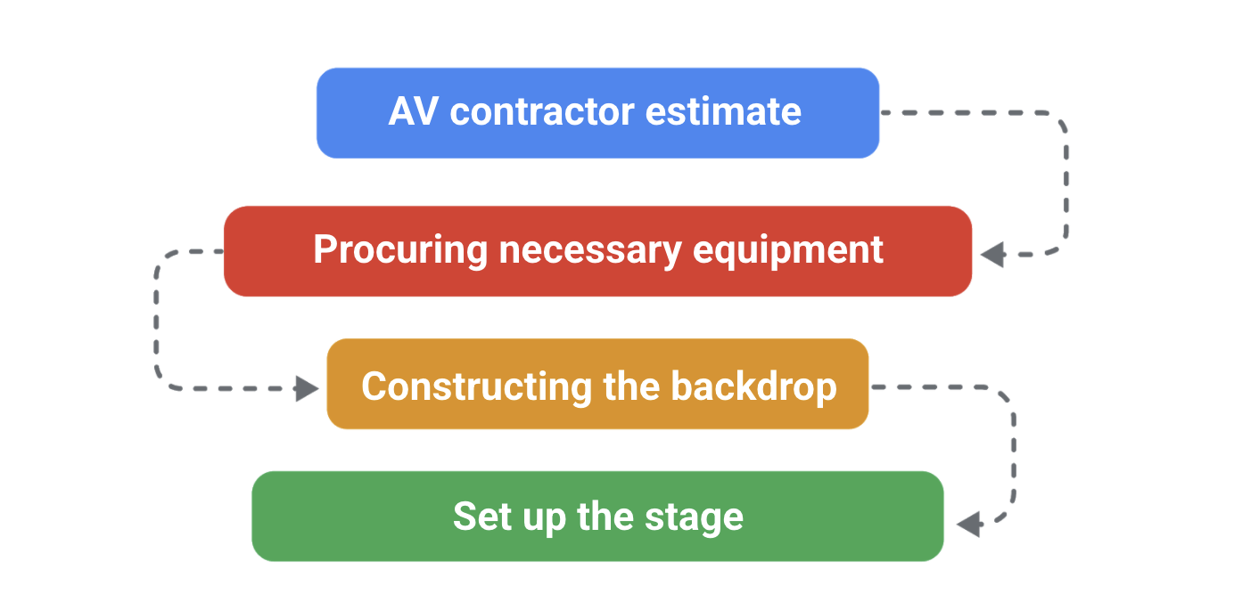

## ****Enlist help from team members****

It is often helpful for your team to be involved in the task breakdown process. You might have a meeting where you discuss each broad goal or major task with the team. This way, team members can present varying perspectives as they work together to break down tasks. For example, if someone on your team has had experience on a similar project, they may suggest a certain task actually be broken down into three different tasks.

## ****Define project tasks by the amount of time they will take to complete****

Defining project tasks by the amount of time they’re expected to take will reveal any especially lengthy tasks. If a task is expected to take a long time, it could indicate that there are additional subtasks that need to be defined. Identifying tasks by time is helpful for scheduling other tasks or events around the longer tasks. This strategy also helps you determine appropriate milestones, as milestones are often the culmination of a series of tasks. Acknowledging the completion of a large and lengthy task is also a great way to celebrate success, learn from the process, and keep the project on track.

## ****Identify project tasks by their “done” factors****

Begin with the end in mind: What does it mean for the task to be considered “done”? From there, you can work backwards to see if you’ve missed any steps and identify checkpoints for completion along the way.

# The three-point estimating technique

Estimating is a crucial aspect of project management. Project managers are expected to accurately estimate essential elements of the project, such as costs, scope, and time. There are many different estimation techniques that can be used, depending on what aspect of the project needs an estimate. Estimation techniques allow project managers to provide better forecasts to stakeholders and clients and more accurately budget the funds and resources they need for project success.

The three-point estimating technique can be used to help determine the most realistic time estimate for a task. It uses **optimistic**, **pessimistic**, and **most likely** calculations, meaning calculations are based on the “best case” (optimistic), “worst case” (pessimistic), and most probable scenarios.

## ****Three-point estimation****

In this technique, each task receives three estimates: optimistic, most likely, and pessimistic. Each of these three estimates is then associated with the corresponding amount of time that task is expected to take.

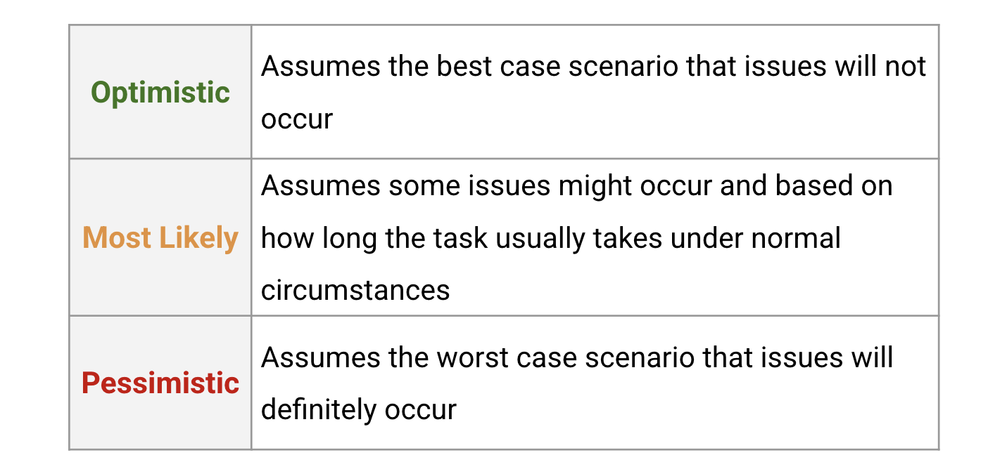Optimistic Assumes the best case scenario that issues will not occur Most Likely Assumes some issues might occur and based on how long the task usually takes under normal circumstances Pessimistic Assumes the worst case scenario that issues will definitely occur

## ****The three-point estimating process****

For each task, add a duration estimate in each category: optimistic, most likely, and pessimistic. You can get these estimates by doing research on the task or by asking a task expert. As a best practice, add notes about the conditions that determine each estimate.

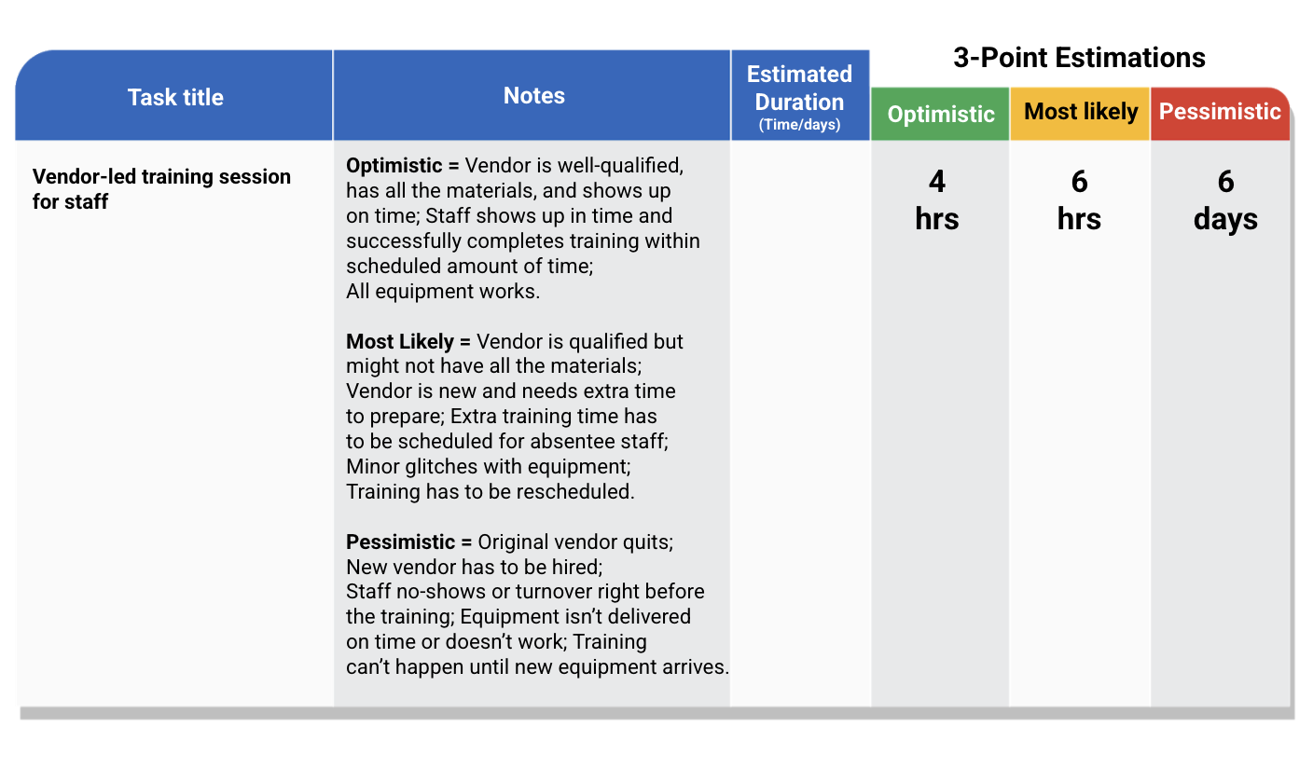Optimistic = Vendor is well-qualified, has all the materials, and shows up on time; Staff shows up in time and successfully completes training within scheduled amount of time; All equipment works. 4 Hours Most Likely = Vendor is qualified but might not have all the materials; Vendor is new and needs extra time to prepare; Extra training time has to be scheduled for absentee staff; Minor glitches with equipment; Training has to be rescheduled. 6 Hours Pessimistic = Original vendor quits; New vendor has to be hired; Staff no-shows or turnover right before the training; Equipment isn’t delivered on time or doesn’t work; Training can’t happen until new equipment arrives. 6 Days

## ****Determining a final estimate****

To determine your final estimate—the estimate you’re going to use in your project plan—examine the optimistic and pessimistic timing, then compare it with the most likely timing. Consider the conditions that are likely to exist while the task is being completed. Does it seem reasonable that the most likely time can be met? If your team has never completed this task before, or if dependencies for the task are unknown, then the final estimate should be closer to the pessimistic estimate. If your team is familiar with the task and you’re able to confirm the conditions for an optimistic estimate, then the final estimate can be closer to the optimistic estimate. Alternatively, simply use the most likely estimate, especially if the difference between the optimistic and pessimistic estimates is minimal (a few hours or no more than one or two days). A good practice is to build in a “buffer” that accounts for risks that are likely but still keeps the project progressing at an efficient rate.

## ****Three-point estimation formulas****

Some projects will require you to calculate specific numeric values for task time estimates. There are many online resources that provide more instruction for how to calculate estimates, but we’ve provided two popular formulas: the Triangular Distribution and the Beta (PERT) Distribution.

For each formula: E is Estimate (the final estimate you’ll assign to the task), o = optimistic estimate, p = pessimistic estimate, and m = most likely estimate.

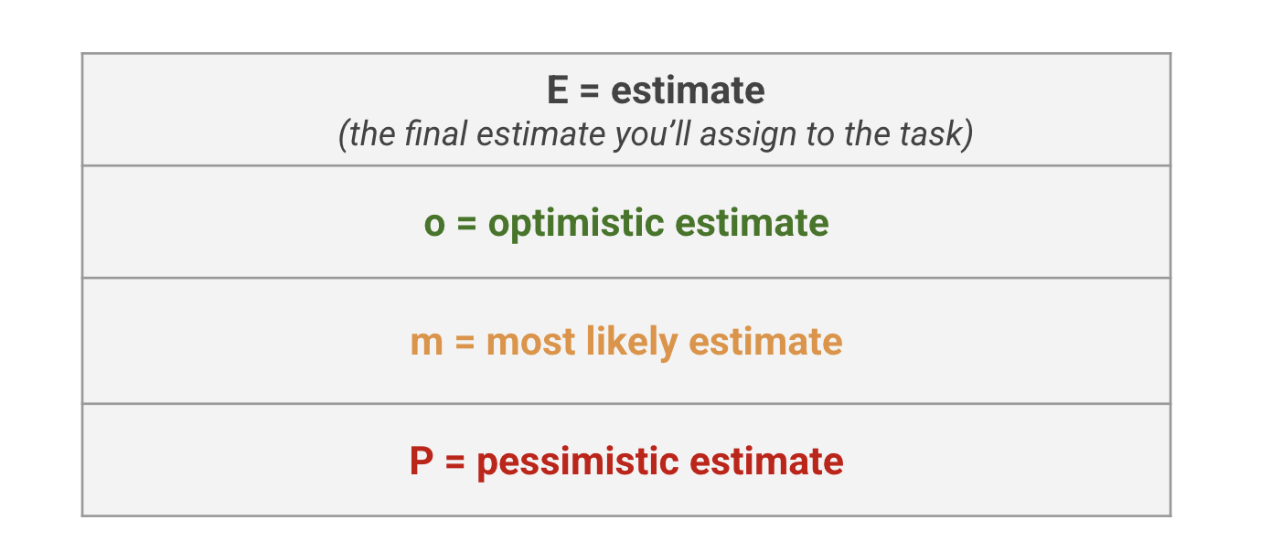

## ****The Triangular Distribution****

The weight of each estimate in this equation is identical, which means the most likely case does not affect the final estimate more than the optimistic or pessimistic estimates.

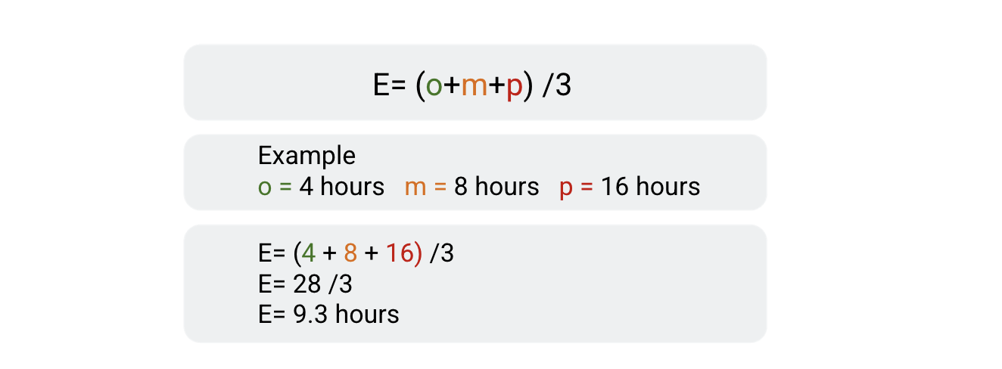

## ****The Beta (PERT) Distribution****

The Beta (PERT) distribution is a weighted average. The most likely estimate receives a multiplier of four, while the overall divisor is increased to six.

This method takes into account that the most likely case is more likely to occur, so it’s given more weight. The added weight is reflected in the multiplier of four.

Placing more weight on the most likely estimate increases the accuracy of the estimate. In most cases, the Beta (PERT) Distribution has been proven to be more accurate than three-point estimating and is often used to calculate both cost and time estimates.

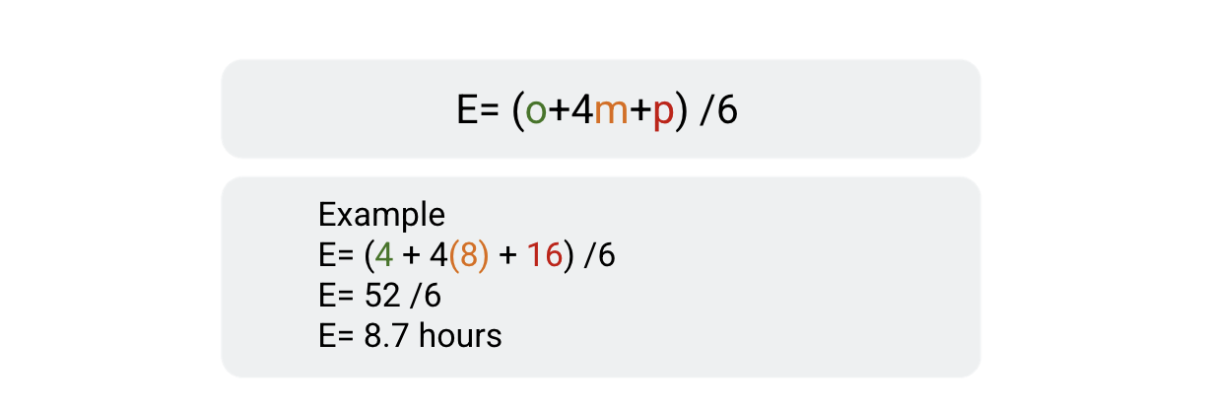

# Evaluation presentations: Components and tips

In a prior activity, you created survey questions for your evaluation. Once you've administered your survey and collected all the data for your evaluation, you'll have all the information you need to prepare an **evaluation presentation**. An evaluation presentation examines how well your project is working according to an identified set of standards.

## ****What to include in your evaluation presentation****

### **Introduction**

The introduction serves as a summary of your presentation and includes an overview of the project’s goals and desired outcomes. It should include a summary of your findings, lessons learned, and recommendations moving forward. This is a very important section of your presentation, but keep it brief. Your introduction should be no more than a paragraph and only include the most necessary information.

### **What is being evaluated and why**

Here is where you will state the purpose of the evaluation. Remember, in the context of project quality management, the purpose of evaluation is to measure how well your project is meeting the established quality standards. Presenting evaluation findings to your stakeholders shows them how well the project is meeting quality standards and informs them of the project’s success. To do this:

* State the goal, milestone, or deliverable that is being evaluated and the quality standards that were defined for that aspect of the project.
* Include the evaluation questions and indicators that were used to evaluate each quality standard.

**Pro tip:** Remember, your stakeholders have limited time. When preparing your presentation, only select the most important standards and questions.

### **Evaluation findings**

Now it’s time to state your findings. Give each standard its own section within this portion of the presentation, and summarize what the findings mean for each standard. Make a clear judgement about the findings: What did you learn? What can you take away from the data? Tell the story of what the data means for the future of the project and for the stakeholders.

* Example: **"**The data reveals that 36% of users felt their dining experience was negatively impacted by the tablets." It’s up to you to synthesize that data and determine why that might be. Maybe it’s because the tablet software wasn’t installed properly, resulting in glitchy technology. Or maybe it’s because the staff wasn’t trained effectively, and therefore the ordering process was seriously delayed. Maybe some customers just don’t want tablets taking their orders, and they prefer to deal with wait staff. Explain what the data means in a way that allows stakeholders to make decisions or declare this aspect of the project successful or not.

**Pro tip:** Visualize the data with graphs or charts to quickly convey the message of the findings.

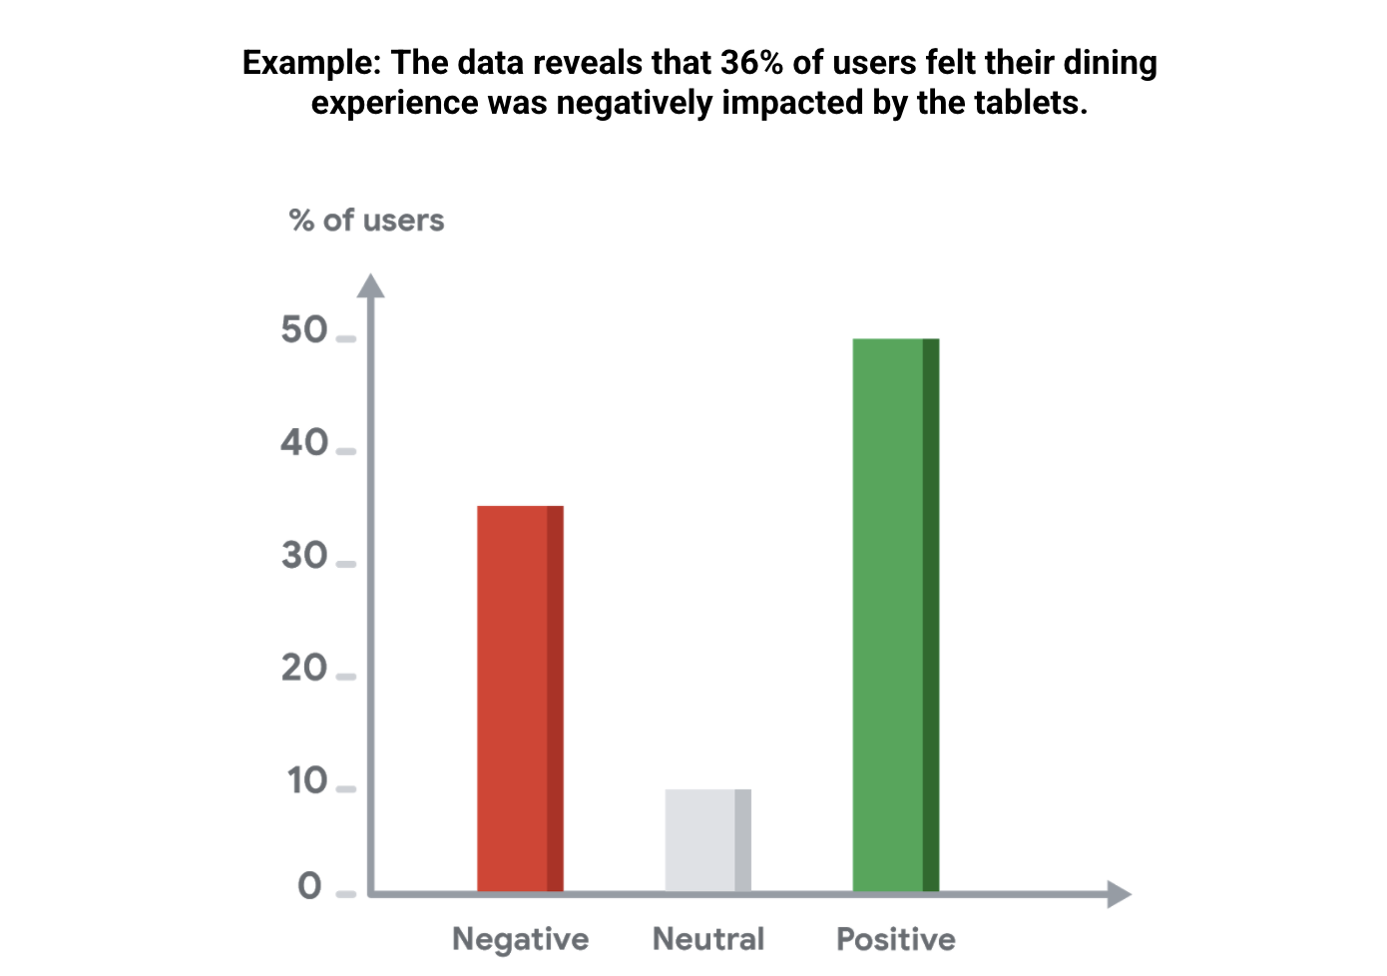

### **Conclusion with recommendations**

In your conclusion, state your findings again and propose a couple of recommendations for how to apply the findings to the next phase of the project. You can also outline how these findings may be used in future projects.

## ****How to format your presentation****

Slide-based presentations can be created using digital applications like Google Slides or Microsoft PowerPoint. This type of presentation uses images and succinct bullet points to provide the necessary information to stakeholders. Slide-based presentations typically include summarized information rather than lengthy, in-depth paragraphs. They are great tools for high-level presentations, when your stakeholders do not need to know every single project detail.

## ****Additional tips****

* **Tailor communications to stakeholders**:When it comes to communicating important milestones to stakeholders, consider whom you are presenting to. Tailor your presentation to your audience in a way that they will understand and enjoy.
* **Start with an interesting hook**: Begin your presentation with an ice breaker, joke, or an interesting visual aid to get your stakeholders’ attention right away.
* **Use visuals throughout your presentation**:The use of visuals creates interest and keeps the audience engaged in your presentation.